COMMUNITY EMPOWERMENT (SCOTLAND) ACT 2015
ASSET TRANSFER REQUEST FORM

IMPORTANT NOTES:
This is a standard asset transfer request form which can be used to make a request to any relevant authority. Relevant authorities may also provide their own forms in their own style.
You do not need to use this form or a relevant authority’s form to make an asset transfer request, but using a form will help you to make sure you include all the required information.
You should read the asset transfer guidance provided by the Scottish Government before making a request. Relevant authorities may also provide additional guidance on their schemes.
You are strongly advised to contact the relevant authority and discuss your proposals with them before making an asset transfer request.
When completed, this form must be sent to the relevant authority which owns or leases the land your request relates to.

This is an asset transfer request made under Part 5 of the Community Empowerment (Scotland) Act 2015.
- Information about the community transfer body (CTB) making the request
  - Name of the CTB making the asset transfer request
PALACERIGG COMMUNITY TRUST (CLG)
  - CTB address. This should be the registered address, if you have one.
Postal address:
VISITOR CENTRE
PALACERIGG COUNTRY PARK
CUMBERNAULD

Postcode: G67 3HU
  - Contact details. Please provide the name and contact address to which correspondence in relation to this asset transfer request should be sent.
Contact name: XXXXXXXXXXXXXX
Postal address:
XXXXXXXXXXXXXXXXXX
XXXXXXX
XXXXXXXXXXXX

XXXXXXXXXXXXXXXXX
Email: palaceriggcommunitytrust@hotmail.com
XXXXXXXXXXXXXXXXXXX
X We agree that correspondence in relation to this asset transfer request may be sent by email to the email address given above. (Please tick to indicate agreement)
You can ask the relevant authority to stop sending correspondence by email, or change the email address, by telling them at any time, as long as 5 working days’ notice is given.
  - Please mark an “X” in the relevant box to confirm the type of CTB and its official number, if it has one.
X | Company, and its company number is …………. | SC675892
 | Scottish Charitable Incorporated Organisation (SCIO), and its charity number is ………………..
 | Community Benefit Society (BenCom), and its registered number is ………………………………
 | Unincorporated organisation (no number)

Please attach a copy of the CTB’s constitution, articles of association or registered rules.
  - Has the organisation been individually designated as a community transfer body by the Scottish Ministers?
No x
Yes ☐
Please give the title and date of the designation order:

  - Does the organisation fall within a class of bodies which has been designated as community transfer bodies by the Scottish Ministers?
No x
Yes ☐
If yes what class of bodies does it fall within?

- Information about the land and rights requested
  - Please identify the land to which this asset transfer request relates.
You should provide a street address or grid reference and any name by which the land or building is known. If you have identified the land on the relevant authority’s register of land, please enter the details listed there.
It may be helpful to provide one or more maps or drawings to show the boundaries of the land requested. If you are requesting part of a piece of land, you must give a full description of the boundaries of the area to which your request relates. If you are requesting part of a building, please make clear what area you require. A drawing may be helpful.
Former Visitor Centre and surrounding plot, Long houses (x2), Blue barn, Rotary, Meadow and Crush fields.
All contained within Palacerigg Country Park, Cumbernauld, G67 3HU
Please see satellite map in appendix

  - Please provide the UPRN (Unique Property Reference Number), if known.
If the property has a UPRN you will find it in the relevant authority’s register of land.
UPRN: UNKNOWN

- Type of request, payment and conditions
  - Please tick what type of request is being made:

for ownership (under section 79(2)(a)) - go to section 3A
x
for lease (under section 79(2)(b)(i)) – go to section 3B

for other rights (section 79(2)(b)(ii)) - go to section 3C

3A – Request for ownership
What price are you prepared to pay for the land requested? :
Proposed price: £ N/A
Please attach a note setting out any other terms and conditions you wish to apply to the request.

3B – request for lease
What is the length of lease you are requesting?
19 years
How much rent are you prepared to pay? Please make clear whether this is per year or per month.
Proposed rent: £ payment holiday for year 1
Year 2- £3000
Year 3- £5000
Year 4 onwards £7000
Please attach a note setting out any other terms and conditions you wish to be included in the lease, or to apply to the request in any other way.

3C – request for other rights
What are the rights you are requesting?
Right to use all areas of Palacerigg Country Park to provide services.
Agreement from NLC not to provide duplication of services provided by Palacerigg Community Trust.
Do you propose to make any payment for these rights?
Yes ☐
No x
If yes, how much are you prepared to pay? Please make clear what period this would cover, for example per week, per month, per day?
Proposed payment: £ N/A per
Please attach a note setting out any other terms and conditions you wish to apply to the request.

- Community Proposal
  - Please set out the reasons for making the request and how the land or building will be used.
This should explain the objectives of your project, why there is a need for it, any development or changes you plan to make to the land or building, and any activities that will take place there.
Reinstating Palacerigg as the heart of the local community.
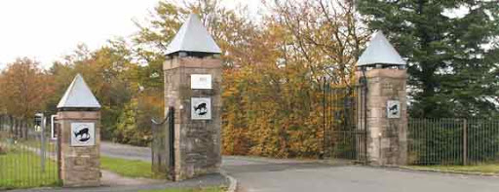
All buildings and land requested will be used in accordance with the charitable objectives of the company, please see Memorandum of Association, Article 4.
Palacerigg Community Trust (PCT) is run by the people of Cumbernauld for the people of Cumbernauld. It is a not for profit company with charitable aims. It has an open membership policy. Currently membership numbers stand at 25. We envisage with a membership drive through social media and engagement that membership will significantly increase.
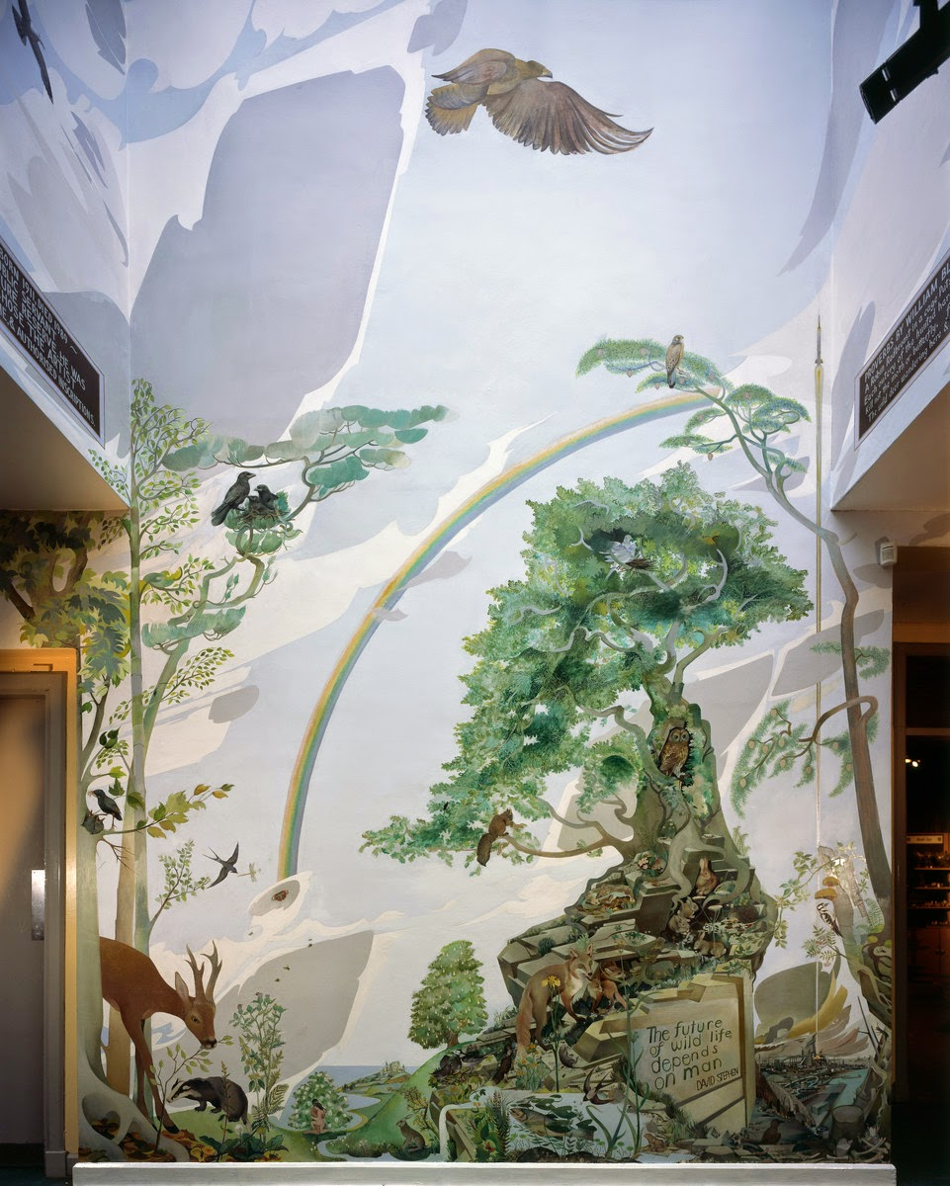
PCT will preserve the history of Palacerigg Country Park and its Visitor Centre, including protecting the culturally important mural by the late Alasdair Gray within the Foyer of the Visitor Centre, and the personal library of the late conservationist and previous director of the original animal collection, David Stephen.
PCT will provide an accessible area for community groups and events encouraging development of resilient community groups with ties to local people through partnership working. We will achieve this through extensive partnership working with anchor tenants, such as Palacerigg Community Farm and The Medicine Pony Tribe, both community interest companies, to allow the provision of therapeutic services and engaging activities based around animals and nature. Working alongside Watch us Grow, a group based at Palacerigg for decades, we will assist them in growing vegetables, which are then donated to a local group, Carbrain and Hillcrest Community Council which provides free meals to those in need within the Cumbernauld community - as well as this we will include Watch us grows service users within our activities as much as possible. Further to this we will work with national and local charities and educational groups, such as the SSPCA, Beloved Rabbit and Curious Creatures to educate the public in relation to the care required by various animals and the responsibilities associated with ownership. We will actively encourage public sector engagement from services such at NHS Lanarkshire, Police Scotland, Scottish Fire and Rescue Service, and the Scottish Ambulance Service.
At least one local business will be created or enhanced through the reopening of the Café on a leased basis. Creating jobs and training opportunities for local people, and bringing much needed visitor spend into the local economy.
PCT will re-instate and improve services lost through budget pressures, improving the local environment and amenities at Palacerigg Country Park, and will establish learning and therapeutic opportunities through contact with animals and nature. It will provide a meaningful day out incorporating learning through play to the local area and beyond.
Providing a safe space for all, with inclusion and diversity being actively encouraged.

Examples of groups that may wish to access these services include but are not limited to: -
Schools
Nurseries (Both private and local authority)
Social Work Departments
Toddler’s and other children’s groups
Brownie and Scout Troops
Watch us Grow
Community inclusion groups
Private childcare providers
Care givers
Parents and members of the general public
.

Partnership Working

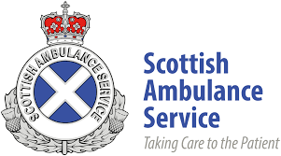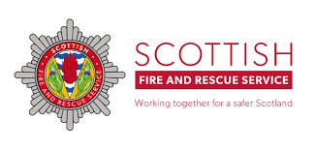
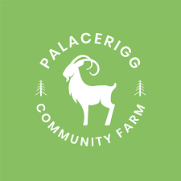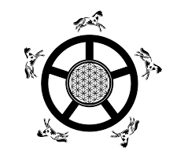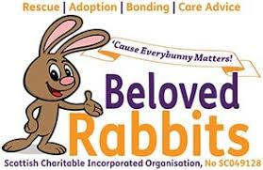
Why are Palacerigg Community Trust and the services it wishes to provide needed in Cumbernauld?

In its Programme for Government 2020/21, the Scottish Government states the aim to 'promote lifelong health and wellbeing' and to continue building a wellbeing economy in Scotland, where people and their wellbeing take centre stage in achieving economic success. Our work will help further this aim within the local area, where there is evidence of a pressing need. The Scottish Government's Mental Health Strategy 2017-2027 sets out Scotland's approach to mental health and summarises the national picture:
- People with life-long mental illness are likely to die 15-20 years earlier than average because of physical ill health.
- Poverty is the single biggest driver of mental poor health.
- Certain groups are more at risk of poor mental health - for example; people who have experienced trauma or adverse events during childhood; those experiencing social isolation / loneliness; or people struggling with substance use issues.
Analysis published on the Public Health Scotland website found that adults living in the most deprived neighbourhoods are around twice as likely to experience common mental health problems than average (22% versus 11%). There are many reasons for this, such as the negative impacts of child poverty, unemployment, or a lack of literacy / numeracy limiting access to services.
Data from the 2020 Scottish Index of Multiple Deprivation (SIMD) shows that 45.44% of datazones in North Lanarkshire fall within the 20% most deprived in Scotland, far above the national average. Health and Social Care North Lanarkshire's north area locality profile (September 2016) shows an average of 16.3% of people in north Lanarkshire as being 'employment deprived', with the figure being as high as 23.55% in the Cumbernauld Central area.
Across Scotland, 21% of Scottish Household Survey respondents reported feeling lonely at least some of the time over the past week, and just 20.1% agreed with the statement 'I can influence decisions affecting my local area'. The 2016 Scottish Household Survey found that 29.8% of respondents in North Lanarkshire were making one or more visits to the outdoors per week - far below the Scottish average of 48.5% (despite the fact that almost two thirds of North Lanarkshire residents reported living within a five-minute walk of green or blue space).
Time spent in the outdoors and with other people can positively impact mental wellbeing, and the continued presence of an enhanced visitor attraction at Palacerigg has real potential to improve local residents' mental health outcomes, and their involvement in the local community. As part of our proposed approach, the former Visitor Centre building would serve as an important civic space, where people can meet and feel involved in the running of an important community asset.

Benefits of the proposal
  - Please set out the benefits that you consider will arise if the request is agreed to.
This section should explain how the project will benefit your community, and others. Please refer to the guidance on how the relevant authority will consider the benefits of a request.
A CAT application supported by NLC will bring unrivalled benefit to the local, and wider community, far reaching and will evolve to fit changing needs by empowering local people to make decisions and placing the needs of the people at the heart of everything we do. Helping to make North Lanarkshire a better place to Live, Learn, Work, Invest and Visit, linking all we do to “The Plan for North Lanarkshire” (See appendix 14 - Palacerigg Community Trust’s Links to The Plan for North Lanarkshire).
PCT will create and sustain a community hub, where all individuals will be welcomed and respected. We will endeavour to create a sense of identity and worth allowing a robust community focused and community led project.
We will create an environment, where people feel safe and relaxed. Full involvement of the community will allow us to achieve outcomes that everyone can be proud of.
We are known to NLC having successfully set up the Palacerigg Community Farm (Palacerigg Animal Park C.I.C). That CIC will become the anchor tenant for this broader themed community company.
Any benefit that we generate will remain within Palacerigg , this will allow us to reinvest in our own project’s and make continuous year on year improvement to both service and infrastructure. Creating a lasting impact on the Country Park and the community it serves, promoting positive change and lasting development.
PCT will promote and improve social wellbeing and environmental wellbeing by getting people out into nature and benefiting from the scientifically proven health and welfare benefits, whilst providing education about responsible use of green space, and ways we can improve our natural habitat and surroundings. This in turn will assist in improving public health, for example as people take walks around the park improving physical and mental health. The work on infrastructure and community led projects will also help to provide much needed regeneration to an a sector that has disproportionately effected by budgetary constraints. Our providing of volunteer and employment opportunities, free and low cost services directed by the needs of the local people will reduce inequalities of outcome, resulting from socio-economic disadvantage.
Being a newly established group will allow us to fully involve the local community and assist us to drive this project forward, leading to meaningful and strategic growth rooted in the needs of local people. PCT will bring the community together in a shared enterprise of rebuilding and improving services within Palacerigg Country Park by developing multiple uses for both the buildings and land within the community asset transfer request, allowing us to generate income while creating a sustainable and developing local asset and effective partnership working.
PCT and the wider community see the mountains of potential that Palacerigg offers and relish the opportunity to improve all aspect of the country park, and in doing so the morale of the local area.
We appreciate that the council budget has been depleted year on year and as PCT, we are confident that we can manage and sustain a community hub providing quality services through local empowerment. We believe that management enabled through the Community Empowerment (Scotland) Act 2015 will become critical to the local people allowing for growth, development and prosperous future for the years to come.
NLC are well aware, having managed the country park and its previous animal collection, that it is not a financially viable business model to have a standalone, free to access animal collection and so we need to be able to be able to offer these additional services to ensure a successful outcome.
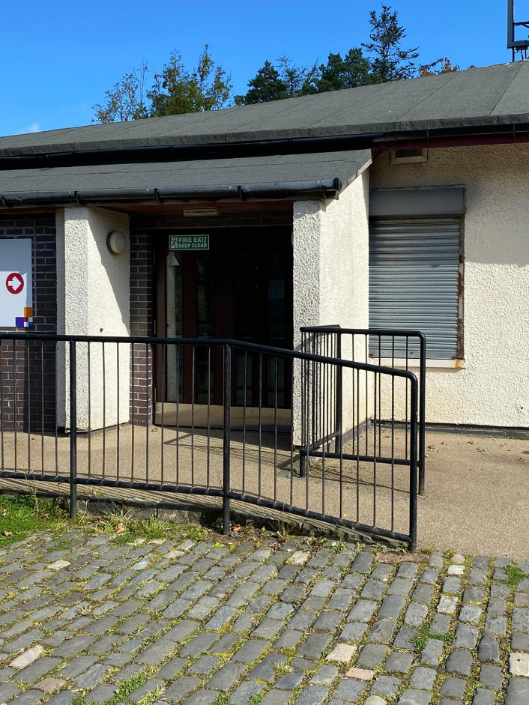
PCT will lease out the Café area within the former visitor centre, creating a new business opportunity which will provide jobs and training opportunities for local people. The pre-existing hatch on the side of the building makes the set-up ideal for both sit in and take away options.
PCT will reopen the outdoor toilet facilities at the former visitor centre, making a day out at Palacerigg Country Park more accessible for families with young children, the elderly and people with disabilities. This will also increase the amount of time spent within the country park by the average visitor.
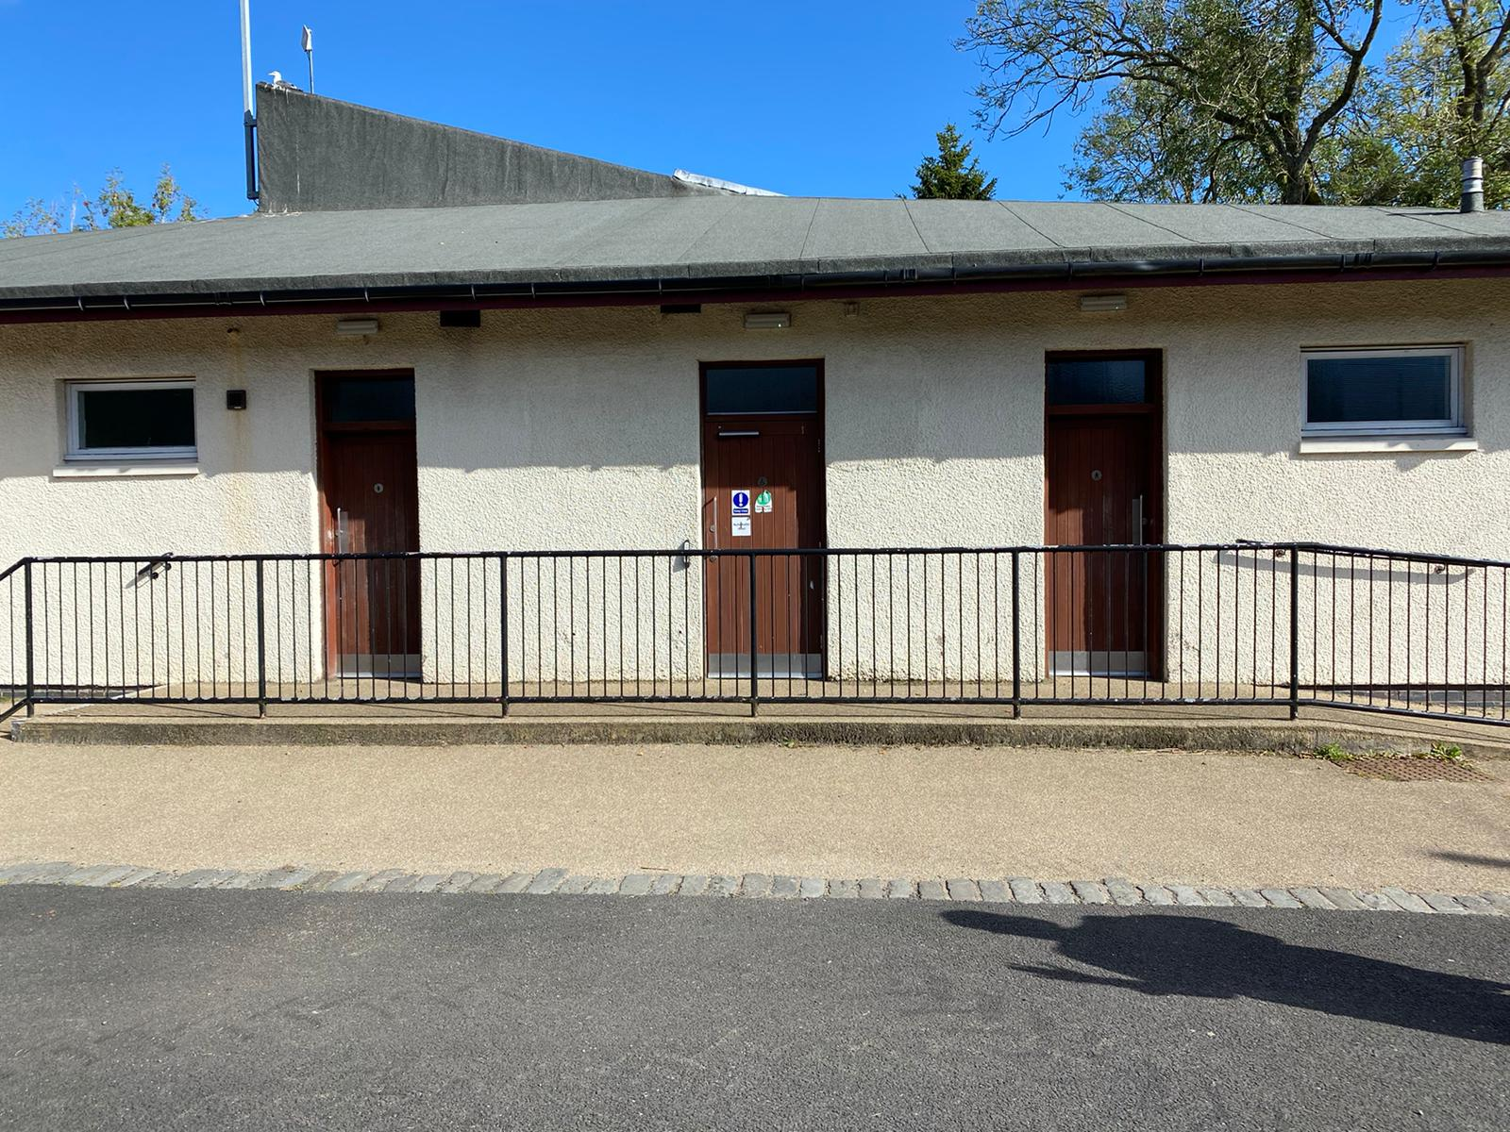
83% of the local community that engaged with NLC’s Masterplan for Palacerigg consultation process stated that they strongly disagreed with the removal of the animal collections.
Below are links to previous media articles highlighting the passion for Palacerigg that still exists within the local community.
https://www.google.co.uk/amp/s/www.cumbernauld-news.co.uk/news/environment/palacerigg-animals-have-been-rehomed-2040485%3famp

https://www.google.co.uk/amp/s/www.dailyrecord.co.uk/news/scottish-news/60000-treetop-walkway-chopped-down-22487981.amp

https://www.facebook.com/322514792064/posts/10157068261967065/?extid=PwDBCOKJryBv23K2&d=n

https://www.google.co.uk/amp/s/www.cumbernauld-news.co.uk/news/environment/protest-planned-save-animals-88835%3famp

https://www.google.co.uk/amp/s/www.scotsman.com/news/environment/hundreds-turned-out-palacerigg-protest-1421353%3famp

https://www.google.co.uk/amp/s/www.cumbernauld-news.co.uk/news/environment/beautiful-cumbernauld-mural-could-be-listed-save-it-posterity-2014326%3famp

https://m.facebook.com/cumbernauldcdt/posts/10157906481987065

https://m.facebook.com/cumbernauldcdt/posts/10157929989527065
Palacerigg Community Trust’s links to National Outcomes

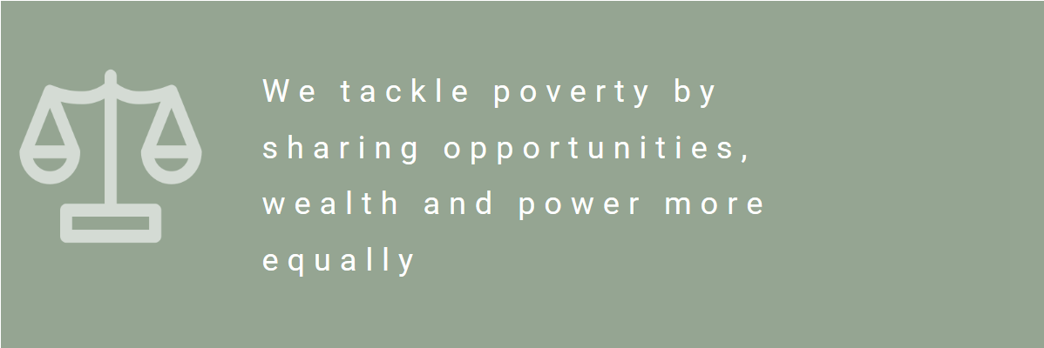

Poverty
We will provide access to important services that are either free or low cost – this will help to address inequalities and reduce financial pressure on low income households.

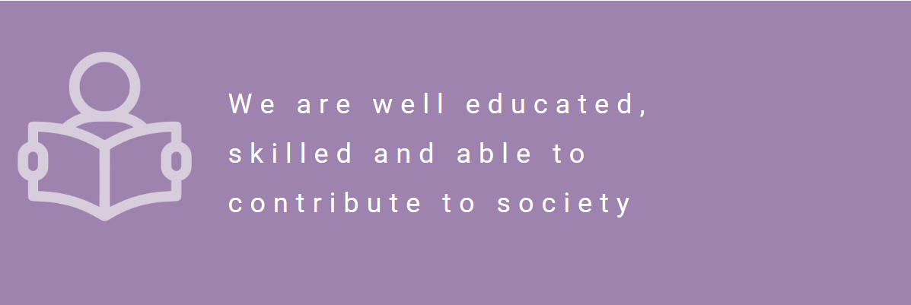

Education
With our partners, we will engage with local schools and nurseries to enhance pupils’ educational experience. The potential setting up of an outdoor nursery will offer quality early learning and childcare places to local children.

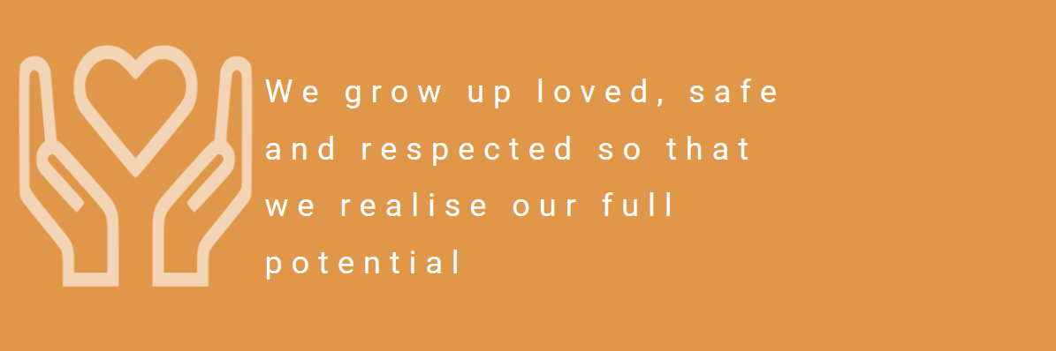

Children and Young People
We will provide stimulating activities and encourage children to engage positively with the natural environment and to play their part in caring for it.
We will provide the conditions in which all children can be healthy and active. We will provide children and young people with hope for the future and create opportunities for them to fulfil their dreams.

.

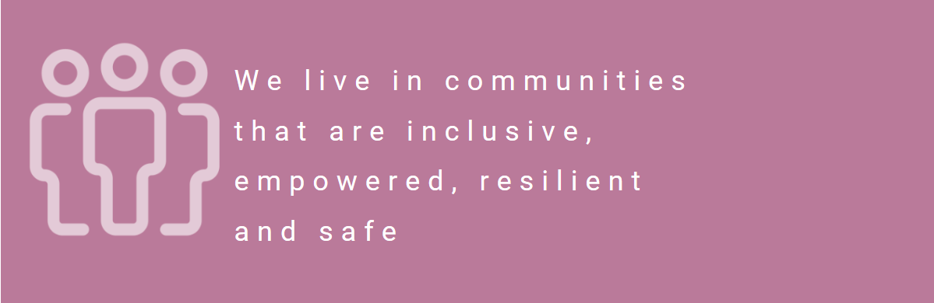

Communities
We believe that access to greenspace, nature and other leisure activities positively enhances our lives and health.
We will encourage people from all sectors of the community to volunteer, to take responsibility for our community and engage with decisions about it. Helping to build an empowered and resilient community.
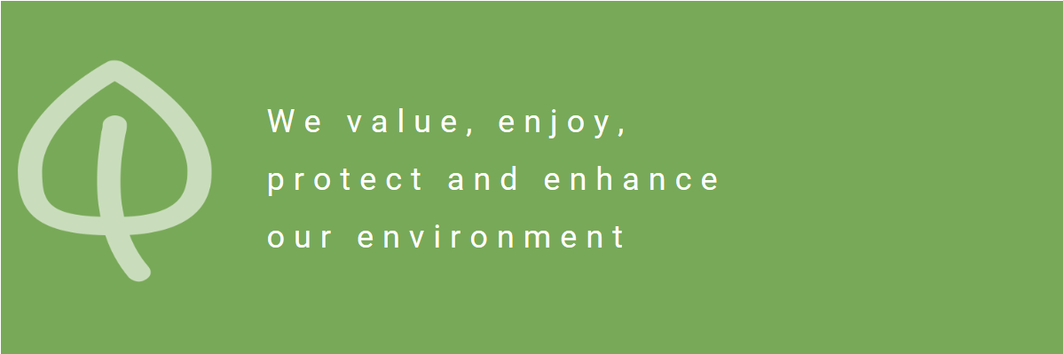

Environment
We will ensure all people within our community can engage with and benefit from nature and green space.
To be healthy and happy as a nation we must nurture and protect our local resources, environments and all who live in them.
We recognise that it is our duty to protect and enhance these assets, as they are essential to our economy, culture, way of life and the wellbeing of future generations.

Health
PCT will encourage people out into nature, keeping them active and improving health and wellbeing through outdoor activates and time in nature.
We will prioritise health and wellbeing and actively implement healthy public policy. Our approach is integrated, preventative and person centred, we are focused on resolving needs in order to achieve positive health, care and wellbeing outcomes.

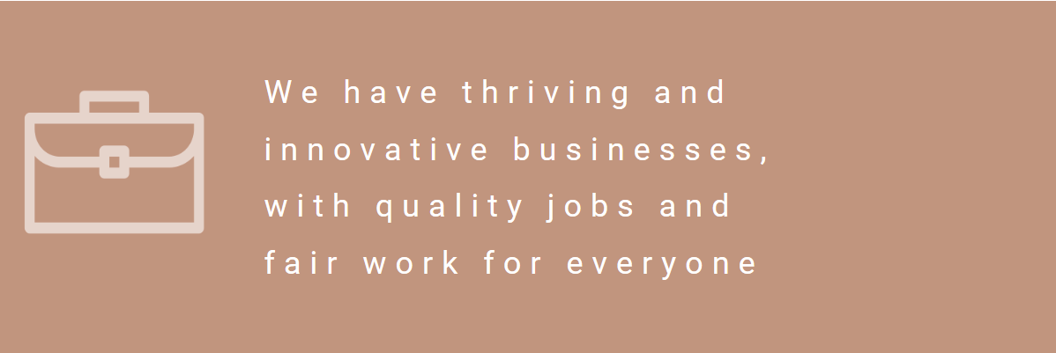
Inequality
We will provide services and space open to all, regardless for example of race, gender, sexual orientation, disability or socio-economic background. This will help to improve relations between different groups of people and reduce inequalities.
The majority of childcare burden in Scotland still falls to women – our provision of activities and learning for children will therefore be of particular benefit to women with childcare responsibilities.
We will endeavour to offer leadership opportunities to local women as part of the Community Trust.

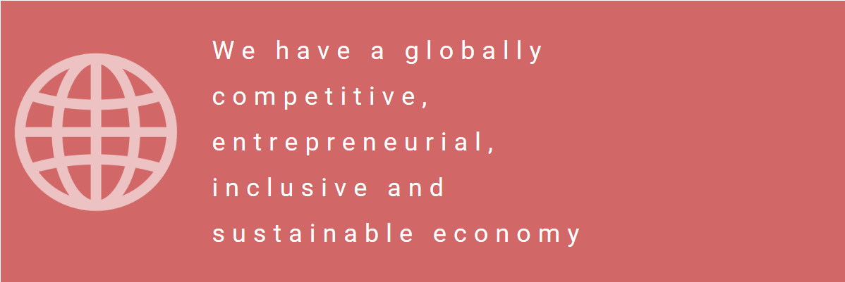
Decent Work and Economic Growth
The re-opening of the café, along with provision of space for local businesses and groups will help generate local jobs and bring visitor spend into the local economy.
Our volunteers will have the opportunity to gain important skills, which can transfer to the labour market and improve employability.

Summary of benefits provided by Palacerigg Community Trust

- Local authority budgets are being reduced therefore it is extremely difficult for them to offer community services. Many of these services are critical to the local community and PCT are confident that Palacerigg offers an appropriate venue for many services. PCT will offer services at a lower cost, either directly or through the promotion of other expertise locally. These services will contribute to our hub, offer volunteer and employment opportunities and support local people/businesses.

- The main building offers space to facilitate groups relating to health and well being such as adult and family fitness classes, yoga, meditation/mindfulness, to name a few. Many of these classes could also make use of the country park, which gives further benefit. There is also the possibility of offering more specialised 1:1 classes and treatments within the main building. The main building already has disabled access which is vital for PCT’s vison as we will welcome a wide range of groups to make use of the facilities, events and opportunities that will be available.

- In years gone by Palacerigg was well known for family and community events. PCT would reinstate these offering fun and enjoyment to all that attend. These events would be varied to include local markets, and seasonal events (Easter, Summer, Autumn and Christmas). The events will bring the local community together, promote positive relationships and inclusion, bring more people to Palacerigg and offer free and affordable opportunities. Events will generate income to support PCT by renting space to external groups, hiring tables, providing low cost activities and more, while building community spirit.

- We already have a good relationship with a local group Watch us Grow. There are many opportunities for PCT and Watch us Grow to work in partnership together including projects to grow vegetable and fruit which would then be given to local initiatives or families. Growing produce is a great way to educate and encourage families to consider how they could do this at home where possible. Many families in our area are impacted by poverty and are making use of the numerous food banks within Cumbernauld.

- PCT plan to create a wild meadow and viewing hides so that the local community can experience the wonderful wildlife this would support. This will include fruit trees/bushes. Again, this is a project Watch us Grow and other local groups can assist with, helping promote the natural environment/wildlife. Picking fresh fruit is a wonderful experience for children and families and although there are organisations that offer this, it is extremely expensive to participate in.

- Many of the activities that PCT will facilitate will make use of the extensive outdoor space. This will include children’s clubs, family days including bushcraft activities and actively encouraging the community to make use of the green space within and out with the country park independently.

- We would involve local schools for some projects and allow them to have some autonomy to input to the park. For example, creating a fairy trail. This could be a project where the pupils would determine how the trail is laid out, what signage is required, designing a map, etc. Involving young people promotes a sense of ownership and we envisage that this will deter vandalism but also create a sense of achievement and success. Many of these pupils will have younger family members that will enjoy the fairy trail but in years to come they too may become parents, and hopefully come along and enjoy Palacerigg.

- There is the potential for an outdoor nursery that would be a Community Interest Company (CIC) and this group would be make use of the main building out with key times therefore generating further income to the PCT. This would offer high quality early learning and childcare and allow parent to secure employment. Children experiencing the outdoors, nature and in this case, access to animals is widely promoted by the Scottish Government and the Care Inspectorate.

- Intergenerational interaction is so important for all involved. PCT will be promoting opportunities for this to happen. The community farm will naturally offer this as many grandparents will being their grandchildren to Palacerigg knowing this is a chance for enjoyable family time that all ages and abilities can enjoy and benefit from.

- There are outdoor toilets that are attached to the main building that PCT would reopen.

- There is a well-known mural that covers the wall in the foyer of the main building. PCT will ensure this is preserved and maintained, seeking guidance as to how to ensure this is done correctly.

- A local café offering a range of reasonably priced food and drinks. The café will support running costs but also encourage people to visit the country park more often and for longer. Many people may prefer to bring a picnic and there are picnic benches available.

- The coronavirus pandemic has impacted everyone. The stress and intensity of lockdown has made many people realise the benefits of being outdoors. Families that previously did not go outdoors now ventured out frequently. PCT will contribute to this continuing by offering many reasons form individuals, families, and groups to visit Palacerigg.

- PCT have considered how they will use the main building if social distancing is required. Due to the positioning of the exits it will be possible to operate a one-way system for events. This allows for the smooth running of events. Cleaning and social distancing would all be vigorously risk assessed and regularly reviewed.

- Visitors will come from further afield than Cumbernauld. This will encourage them to shop in Cumbernauld and make use of other services which will support economic growth in Cumbernauld and other nearby communities.

Restrictions on use of the land
  - If there are any restrictions on the use or development of the land, please explain how your project will comply with these.
Restrictions might include, amongst others, environmental designations such as a Site of Special Scientific Interest (SSI), heritage designations such as listed building status, controls on contaminated land or planning restrictions.
N/A

Negative consequences
  - What negative consequences (if any) may occur if your request is agreed to? How would you propose to minimise these?
You should consider any potential negative consequences for the local economy, environment, or any group of people, and explain how you could reduce these.
We have considered any potential risk and the risk management that we envisage would be implemented. Please see below;

Running Costs

Potential Risk; Running costs higher than anticipated.
Risk Management; Cash flow management and projection will be a priority and the first year in particular will give PCT the opportunity to ensure that costs are assessed and accurately factored in for all future projections.
Information from NLC Running costs are higher.
A phased rental payment from NLC would support us during the initial years.

Lower demand than expected

Potential Risk; Less uptake that projected
Risk management; This is unlikely to be the case as local greenspaces are in high demand and availability of high value, low cost days out in the local area is low.

Higher demand than can be managed

Potential risk; High demand
Risk Management; as per point above we anticipate a higher than normal demand for our services due to being free and reasonably priced where we must charge. We will have a controlled booking management system in place where numbered tickets will be issues. Risk assessments and health & safety risk assessments, one ways system and stewarding will be in place.

Lack of secured funding
Potential Risk; Less funding secured
Risk Management; A phased rental payment will be supportive
Longer term we anticipate that PCT will be in a position to cover all running costs and maintenance through rental income and activities/events/etc as proposed. This projected sustainability will be enticing to funders and reassurance that any funding secured would be used to enhance the community benefits. We will be in a position to operate with volunteers for what we have proposed until we are in a position to employ staff. We have had an overwhelming response from the public who would like to be involved. We also anticipate that funders would look at this project favourably.

Maintaining the board members required

Potenial Risk; Board of Directors resign, leaving less than required.
Risk Management; PCT has a committed board of directors however we visualise increasing the number of directors within the first year therefore the likelihood of going below the necessary amount will be minimal.

Weather

Potential Risk; Foot fall at Palacerigg drops due to weather.
Risk Management; By securing the visitor centre we would be able to offer both indoor and outdoor programme of activities and this will attract more people to visit regardless of weather. We have identified ways in which we can adapt services, such as birthday parties, to ensure we can continue to offer community benefits and generate income at the same time.

Transport

Potential Risk; Lack of transport to the park.
Risk Management; When the masterplan is released this may be a factor that has already been resolved. If further housing is built in Abronhill transport will be looked at by NLC. Possibility of a park and ride to a large, nearby, underutilised car park at Greenfaulds Station. Longer term we would look to secure funding for a minibus.

Duplication of services

Potential Risk; Other services duplicating what we offer.
Risk Managements; Cumbernauld is a largely populated area and there may be a duplication of some services. Palacerigg is a unique setting and therefore will attract people from various areas and due to the diversity of the PCTs vision this will encourage the community to make use of this fantastic resource. We will continue to monitor what is being offered within Cumbernauld and are committed to develop our partnership working.

Capacity to deliver
  - Please show how your organisation will be able to manage the project and achieve your objectives.
This could include the skills and experience of members of the organisation, any track record of previous projects, whether you intend to use professional advisers, etc.
In the initial stages PCT will be operating solely using volunteers. We have identified a large amount of skills, knowledge and experience within the board of directors and volunteers which will allow for a stable start to what we aim to achieve. Please see below a list of relevant skills and experiences;
Directors;
Owning a successful business for over 4 years, management of staff and volunteers, leadership, teamwork/team building interpersonal experience, training, coaching & mentoring, experience working with children, young people and families in a variety of settings/projects, experience of working with children and families with additional support needs and looked after children, effective communication skills, public speaking, planning & organising of large community events, Development and management of projects, charity based experience, partnership working both public and third sector, working at local and national government level, personal volunteer experience at Palacerigg Country Park, policy development, strong understanding and knowledge of confidentiality, health and safety, safeguarding, data protection (including GDPR & ICO), risk management, code of conduct & professional practice, crisis management, employment law and good practice, personal and professional experience of mental health issues & strategies, involvement in funding, knowledge & experience of consultation, evaluation & feedback methods (quantitative & qualitive) , professional & good work ethic, keen to lead by example & support the community success, creative skills, solution focussed approach, initiative, integrity, adaptability & flexible to change, degree level qualified and of course a desire to learn.
Volunteers;
charity experience, business/project owners, working with children & young people, marketing, branding, web development, social media, fundraising, funding application experience, children’s book author, artist, joinery, bookkeeping, videographer, previous board member experience and many more personal traits – some are listed about within the directors’ overview.
The board of directors will manage all aspects of the proposed plans and aim to secure funding to employ staff within the first year.
We trust that you will see above that there is a broad range of expertise and experience within the current individuals involved.
The priority will be to apply and secure funding for staff to facilitate groups, the management of the centres activities and supporting volunteers. We envisage that PCT will be able to offer further jobs in the future and continuous volunteer opportunities. This has been considered when establishing the business plan as it is important that we are transparent about what we can offer within the first year.
Community benefits will continue to increase as time goes on and the capacity to offer more services increases. As we will not be delivering everything ourselves this will ensure that the community will have a varied programme that will be of interest. This also will benefit PCT as we will generate income from the renting out of space.

- Level and nature of support
  - Please provide details of the level and nature of support for the request, from your community and, if relevant, from others.
This could include information on the proportion of your community who are involved with the request, how you have engaged with your community beyond the members of your organisation and what their response has been. You should also show how you have engaged with any other communities that may be affected by your proposals.
Over the last 20 months the community have evidenced their support towards Palacerigg and attended public meetings and events. Examples of this would be the peaceful protest that took place with over 200 people attending. Also, there was a public meeting in the village to discuss the removal of the animal collection. The community have an attachment to Palacerigg and want to see some of the memories people have recreated.
When we had a stall at the town centre many people spoke to us and shared fond memories of quality family time, with fun and engaging events and stated that Palacerigg Country Park was a place close to the community’s heart. We heard countless times how much of a shame it was that Palacerigg had lost its animal collections and how over many years’ services and as such their attendance had diminished.
North Lanarkshire Council (NLC) contracted a company to carry out a public consultation and create the Masterplan for the park and within this consultation there is evidence of the community needs/preferences. We are aware that 83% of the public strongly disagreed with the animals being taken away and this left the community feeling disheartened. Supporting the Community Farm will be part of the PCTs plan and will allow for an enjoyable family day out that everyone can enjoy regardless of financial status. If NLC support this application Palacerigg Country Park will become something special. With PCTs plans, partnership working and NLCs masterplan we will create something to be very proud of and this will attract further community and business support.
Palacerigg Community Farm have a Facebook page and the members of this group are keen to hear about the Country Park. We have informed people that we anticipate a large variety of events and opportunities and this has created excitement and hopefully over the coming years, will restore faith that Cumbernauld will be supported to offer services that local people (and further afield) will support, make use of and most importantly enjoy.
Further consultation and engagement are required, and we are committed to ensuring this is carried out.
Covid-19 has had an impact on what we have been able to do including attending a meeting with NLC to find out more about the masterplan and more detail about the consultation from late 2019.

- Funding
  - Please outline how you propose to fund the price or rent you are prepared to pay for the land, and your proposed use of the land.
You should show your calculations of the costs associated with the transfer of the land or building and your future use of it, including any redevelopment, ongoing maintenance and the costs of your activities. All proposed income and investment should be identified, including volunteering and donations. If you intend to apply for grants or loans you should demonstrate that your proposals are eligible for the relevant scheme, according to the guidance available for applicants.
PCT was established in 2020 with the sole the purpose of ensuring a genuine community focussed and community led project at Palacerigg Country Park. This project will develop year on year, therefore there is limited information that we can provide in terms of an established history in this area.
We have projected costs and income that we have calculated could be generated. It is for this reason that we are requesting an annual holiday for the rent as this will allow us time to identity and review all costs, both incoming and outgoing.
We are dedicated to securing funding and have continuous fundraising opportunities.
FUNDING AVAILABLE | AMOUNT FUNDED | DATE PCT WILL APPLY FOR
CAMPSIE TRUST | UP TO £50,000 | WHEN FUND REOPENS
NLC DISCRETIONARY FUND | UP TO £50,000 | OCTOBER 2020, THEREAFTER ANNUALLY
COMMUNITY GRANT NLC | UP TO £1000 | APPLY ONCE CAT SUBMITTED THEREAFTER ANNUALLY
ASDA FOUNDATION COMMUNITY GRANT | -- | CURRENTLY ON HOLD DUE TO COVIC-19
ASDA TRANSFORMING COMMUNITIES AND IMPROVING LIVES GRANT | -- | CURRENTLY ON HOLD DUE TO COVIC-19
ASDA – CHRISTMAS GIVING | £300 | APPLY ONCE CAT SUBMITTED THEREAFTER ANNUALLY
ASDA – GREEN TOKEN GIVING | UP TO £500 | APPLY ONCE CAT SUBMITTED THEREAFTER ANNUALLY
TESCO – BAGS OF HELP | £500-2000 | APPLY ONCE CAT SUBMITTED THEREAFTER ANNUALLY
AWARDS FOR ALL | £10,000 | APPLY ONCE CAT SUBMITTED THEREAFTER ANNUALLY
AVIVA COMMUNITY FUND | UP TO £50,000 | APPLY BY 13TH OCTOBER 2020, THEREAFTER ANNUALLY

Signature
Two office-bearers (board members, charity trustees or committee members) of the community transfer body must sign the form. They must provide their full names and home addresses for the purposes of prevention and detection of fraud.
This form and supporting documents will be made available online for any interested person to read and comment on. Personal information will be redacted before the form is made available.

We, the undersigned on behalf of the community transfer body as noted at section 1, make an asset transfer request as specified in this form.
We declare that the information provided in this form and any accompanying documents is accurate to the best of our knowledge.
Name : XXXXXXXXXXXXX
Address XXXXXXXXXXXXXXXXXXX
XXXXXXXXXXXXXX
XXXXXXXXXXXXXXXXX
Date XXXXXXXX
Position XXXXXXXX
Signature XXXXXXXXXX

Name XXXXXXXXXXXXXXX
Address XXXXXXXXXXXXXXX
XXXXXX
XXXXXXXX
Date XXXXXXXXXX
Position XXXXXXXXXXX
Signature XXXXXXXX
Checklist of accompanying documents
To check that nothing is missed, please list any documents which you are submitting to accompany this form.
Section 1 – you must attach your organisation’s constitution, articles of association or registered rules
Title of document attached:
Memorandum of Associations- Palacerigg Community Trust

Section 2 – any maps, drawings or description of the land requested
Documents attached:
- Maps of buildings and land requested - Appendix 1
- Map of Cumbernauld – Appendix 2
- Proposed internal layout of former Visitor Centre – Appendix 3
Section 3 – note of any terms and conditions that are to apply to the request
Documents attached:
Additional Terms and Condition – Appendix 4

Section 4 – about your proposals, their benefits, any restrictions on the land or potential negative consequences, and your organisation’s capacity to deliver.
Documents attached:
Palacerigg Community Trust - Business Plan
PCT – Links to NLC’s “Plan for North Lanarkshire” – Appendix 14

Section 5 – evidence of community support
Documents attached:
Emails of Community Support – Appendix 5
Summary of Support – Appendix 6
Letters of Support:-
- Watch us grow – Appendix 7
- Palacerigg Community Farm– Appendix 8
- The Medicine Pony Tribe– Appendix 9
- Curious Creatures– Appendix 10
- Wee Cycle Cumbernauld– Appendix 11
- Cumbernauld Law Practice – Appendix 12
- Beloved Rabbit – Appendix 13

Section 6 – funding
Documents attached:

