Palacerigg Community Trust
Business Plan
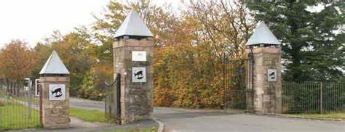

Company Information:
Name: Palacerigg Community Trust
Company Number: SC675892 (CLG with Charitable aims)
Registered Address: Palacerigg Visitor Centre, Palacerigg Country Park, Cumbernauld, G67 3HU
Email: palaceriggcommunitytrust@hotmail.com
Phone: XXXXXXXXXXXXXXXXXXXXXXXXXXXXXX
Board of Directors: XXXXXXXXXXXXXXXXXXXXXXXXXXXXXXXXX

Mission Statement:

“To provide valuable community services, built and governed by the community for the community.”

Contents

- Introduction Page 3

- Aims Page 4

- Vision Page 4

- Financial Considerations Page 5

- Financial Projections Page 6

- Rental Income Page 7-8

- Additional Income Proposals Page 9

- Tables of Financial Information Page 10

- Summary of Intended Use of Asset Page 11

- Maps Page 12

- Supplementary Information

History Page 13
Description of Activities and Benefits Page 14-15

- Links to NLC “Plan for North Lanarkshire” Page 16 -18

Introduction:
Formed in 2020, Palacerigg Community Trust (PCT) aims to protect the rich heritage of Palacerigg Country Park for the people of Cumbernauld and looks to rebuild a resilient community around the park and renew the passion of local people. As stated in our Mission Statement, our aim is to provide valuable community services, built and governed by the community for the community.
We aim to achieve this through a Community Asset Transfer agreement, to become leaseholders of land and buildings at Palacerigg Country Park, namely the former Visitor Centre and surrounding plot, blue storage shed, and long houses(x2) along with the Crush, Rotary and Meadow fields.
These facilities have previously been a fantastic asset to the people of Cumbernauld, North Lanarkshire and further afield and they can be again.
We plan to provide vital services to benefit health and wellbeing, advancement in education (including learning through play, outdoor learning, and agricultural education), relief from the effects of poverty and volunteering opportunities.
This will be achieved through affordable services for the community based at the former Visitor Centre, which will offer a welcoming, affordable, and inclusive space. A varied programme of activities and opportunities will ensure we maximise the community benefit. In addition to these services we will also include regular free community events, to ensure that all members of our community are given access to services, including those in low income households.
We will provide valuable opportunities to reduce social isolation, relief from the impact of poverty and encourage access to green corridors, all to increase the quality of life for the community and help build a happier and healthier future for all.

Aims:
Involve local people to: -
- Improve current services and facilities
- Enhance health and wellbeing
- Create new services voiced by the community
- Offer affordable and free services and opportunities
- Advance and encourage use of green space
- Promote social responsibility and resilient communities
- Create volunteer and employment opportunities
- Work with individuals and partnership organisations to establish a robust programme of activities.
Vision:
To bring the community together in a shared enterprise of rebuilding and improving services within the country park.
Being a newly established group will allow us to fully involve the local community and assist us to drive this project forward, leading to meaningful and strategic growth rooted in the needs of local people.
Create a welcoming community hub, available to all, regardless of protected characteristic or socioeconomic status.
Develop multiply uses for both the buildings and land within the Community Asset Transfer request which will help generate income while creating a sustainable and developing local asset in keeping with “The Plan for North Lanarkshire”, the Scottish Governments National Outcomes and the aims of North Lanarkshire Council’s Masterplan for Palacerigg, namely to encourage use of all areas within the country park through third sector partnership.
Palacerigg Community Trust, and members of the wider community of Cumbernauld, see the mountains of potential that Palacerigg offers and relish the opportunity to improve not only the physical structures and services but also the morale of the town as a whole.

Financial Considerations

PCT have carefully considered the current situation regarding Covid-19 and due to this are requesting a one year payment holiday and a reduced lease costs for year two and three leading to year four whereby the annual rent will increase to £7000 for all further years.

This is based on a 19-year lease (subject to negotiation and agreement of additional terms and conditions) of the following buildings and land: -

- Former Visitor Centre Building and surrounding plot of land
- Longhouses x2
- Blue Barn
- Meadow Field
- Crush Field and
- Rotary Field

For reference please see aerial maps on Page 12.

Please also read alongside informational table on Page 11, Summary of Intended Use of Asset.

Financial Projections
Palacerigg Community Trust intend to focus on having sufficient funds to cover all overheads and working towards robust forecast planning to ensure all profit further develops the community benefit to our area. Offering affordable activities and events will support both the financial costs of the Trust and enhance its community benefit.
Year 1; Restore & build community support
PCT projects that we will cover our costs and break even. We anticipate that this first year would allow us the opportunity to secure some funding and build a track record and evidence of our spend and management of funding. We will also run fundraising activities through the year. Any profit generated would be an additional benefit to the Trust.
Year 2; Develop
PCT expects to generate a small profit, approx. £1000. We are confident we will secure further funding within this year however revenue from the rental of the community space, fundraising and community events will cover overheads.
Year 3; Sustain and Grow
PCT projects that with increasing services and therefor increasing turnover we will generate in excess of £4000 operating profit. This will increase annually, as set up costs decrease, and the Trust becomes more established.
The above projections do not include the funding we endeavour to secure. We have based our costings on what we can generate ourselves leaving any funding an additional benefit and will allow us to employ staff and build on what we provide.
Year 4 & 5
Following the first three years PCT envisage that year 4 and 5 PCT will start to operate fully.

Rental Income
The following section sets out PCT’s plans generate income, maps of the area and plans of the former Visitor Centre are including within the supplementary information section of this document.

Rental of Meadow field; Palacerigg Community Farm.
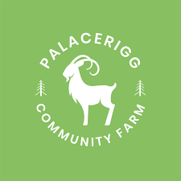
The first year reduction will support the Community Farm to develop as this will be one of the core organisations at Palacerigg Country Park. This not for profit group will bring a large amount of people to the park and in turn will support the PCT as these visitors will no doubt make use of the other activities that will be on offer. This will be a long-term lease.
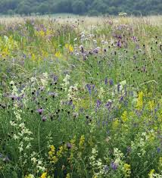
Rental of Crush field; Outdoor Play / Wild Meadow.
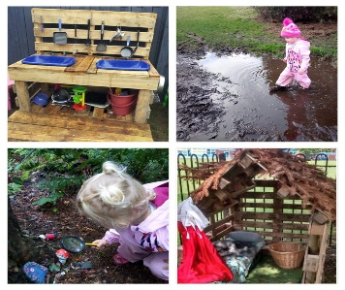
This field will be utilised by the PCT therefore will not generate rental income but will create revenue through the services it will offer. We envisage this space to be used for outdoor learning space for various activities including free play, bush craft, and the creation of a wild meadow field with beehives, creation of hedgerows, planting of fruit trees and wildlife viewing hides. Once established PCT will charge a small entry fee for the play space to cover running costs.

Rental of Rotary field; The Medicine Pony Tribe
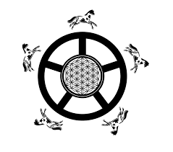
This field will be leased to The Medicine Pony Tribe, a local not for profit group for an equine wellness project.
They will graze a small herd of Mustangs here and run their own programme of activities whilst also assisting PCT with events.

Café lease
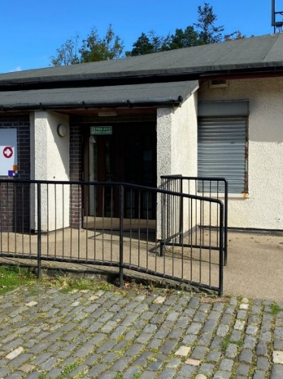
Café space within the former visitor centre will be leased to generate income for the Trust. This will allow for a new business to from and create employment or for an existing local business to expand.
PCT will reserve the right to utilise the Café area for fundraising activities outside the business hours of the lease holder to maximise the use of this space.

Rental of activity space
We will offer external organisations the opportunity to rent the activity space to enhance the community benefits.

Additional Income Proposals

Birthday parties
We will offer birthday parties to generate some income and ensure a special day for the child and their family and friends.
Gala days
Local Farmers/Craft Market style events, allowing small businesses and charities to benefit from the foot fall of the country park.
Halloween
Previously the Country Park offered Halloween themed events which we will recreate and facilitate during the month of October.
Summer & Easter Events
These events will mainly be free. As a nod to the legacy of the previous events which were extremely popular. Revenue will be generated by business, such as sweet stalls, bouncy castles and amusements paying a “pitch fee” and PCT running raffles, tombola, and competition tables, etc
Fundraising
We will hold several fundraising events and activities, including raffles, themed evenings, and will sell a children’s book range that explain the origins, aims and activities of the trust.
Other Opportunities
Anticipated rental from proposed outdoor nursery, children’s groups and upstairs space including yoga, children’s groups, adult groups, hobby groups, have not been included in the current financial projections. We will be actively promoting these opportunities therefore are certain rental income will increase.

Tables of Financial Information
Income | Year One | Year Two | Year Three | Year Four | Year Five
Grants | £20000 | £40000 | £50000 | £50000 | £50000
Donations | 3550 | £3000 | £6000 | £6000 | £3000
Meadow | £108 | £162 | £216 | £270 | £270
Crush | £270 | £450 | £630 | £810 | £810
Cafe | £3580 | £5360 | £8940 | £12500 | £12500
Activity | £1000 | £1800 | £2600 | £2800 | £2800
Birthday parties | £2400 | £4800 | £7500 | £9800 | £9800
Themed events | £1600 | £2650 | £3100 | £5780 | £5780
Gala/markets | £450 | £600 | £900 | £900 | £900
Christmas | £600 | £1200 | £1920 | £2800 | £2800
Face painting | £1250 | £2100 | £4800 | £4800 | £4800
Total | £34808 | £62122 | £86606 | £96460 | £96460

Running Costs
Outgoings | Year One | Year Two | Year Three | Year Four | Year Five
Rent | £0 | £3000 | £5000 | £7000 | £7000
Electric | £1400 | £1500 | £1700 | £1700 | £1700
Oil | £1600 | £1800 | £2000 | £2200 | £2200
Water | Exempt | Exempt | Exempt | Exempt | Exempt
Sewage (£2000) | Exempt | Exempt | Exempt | Exempt | Exempt
Insurance | £1800 | £1800 | £1800 | £1800 | £1800
Internet/Phone | £600 | £600 | £600 | £600 | £600
Misc. Start-up & maintenance | £4000 | £1000 | £1000 | £1000 | £1000
Activity Co-ordinator | £0 | £26000 | £26000 | £27000 | £27000
Cleaner | £11000 | £11000 | £13000 | £13000 | £14000
Receptionist/s | £13000 | £13000 | £26000 | £30000 | £30000
Accountant | £1200 | £1200 | £1200 | £1200 | £1200
Fundraising Officer | £0 | £0 | £3900 | £5500 | £5500
Solicitor Fees | £100 | £100 | £100 | £100 | £100
Total | £34700 | £61000 | £82300 | £91100 | £92100
Profit/Loss | £108 | £1122 | £4306 | £5360 | £4360

Summary of Intended Use of Asset

Asset | Current use | Planned Use | Notes
1. Former Visitor Centre and surrounding land around this building | Not in Use | Community Hub | See attached floorplan: in Supplementary Information
2. Blue Shed | Storage | Educational Area/Storage/ Rentable space | See aerial maps for location
3. Longhouses (x2) | Storage | Birthday Parties/ Crafting Workshops/ Rentable space | See aerial maps for location.  Planned use is in keeping with vision when originally installed.
4. Meadow Field | Not in Use | Palacerigg Community Farm  C.I.C  (Not for profit) | See aerial maps for location.  During public consultation, the public stated they wished animals returned to Palacerigg.
5. Crush Field | Not in Use | Outdoor Play/ Wild Meadow | See aerial maps for location.
6. Rotary Field | Not in Use | The Medicine Pony Tribe (Not for Profit) | See aerial maps for location.  Equine Wellness Programme

As demonstrated in the table above all the assets requested by PCT are not currently being used to benefit the community of Cumbernauld in any way, and as such, at present do not represent best value to NLC.

Maps
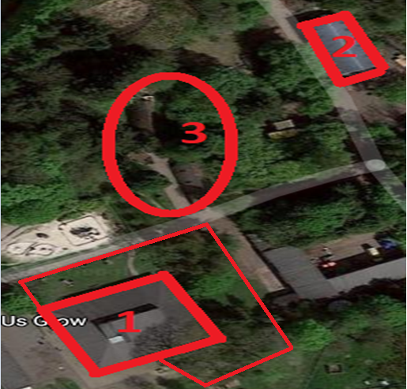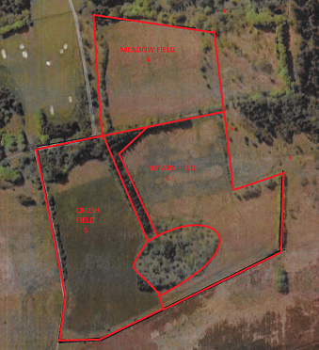

Supplementary Information
History
The brainchild of world-renowned local naturalist David Stephen (1911-1989), Palacerigg Country Park was opened by Cumbernauld Burgh Council in 1974. Set in nearly 700 acres of what was once an upland farm, the park became home to a hugely popular children's farm and a nationally important collection of north European wildlife (including wolves, lynx, and arctic foxes). A well-designed municipal golf course was also set within the landscape.
Since its inception in the 1970s, the park has been viewed as one of the local area's key assets and is closely tied in with Cumbernauld's identity and sense of self. An attraction over the decades were the hugely popular events held at Palacerigg, especially around Easter and Christmas time. These involved diverse activities for children such as treasure hunts, horse and cart rides, pond dipping, animal experiences, and visits to Santa's grotto (complete with real, live reindeer!)
The late Scottish artist Alasdair Gray painted an awe-inspiring mural on the walls of the park visitor centre in 1974, which can still be viewed in all its original splendour today.
As the park's founder and first Director, David Stephen brought his expertise to bear in developing a nature reserve on the surrounding land, with hundreds of thousands of native trees and shrubs being planted (many local adults fondly recall being involved in this planting work as schoolchildren). A large network of paths was laid out to allow park visitors to explore the new nature reserve, providing hugely valuable breathing space for local people. The fruits of this work are visible today, with roe deer, badgers, foxes, hares, and birds of prey all calling the park home.
It is no surprise that David Stephen was able to turn such a large, uncompromising tract of land into a first-class visitor attraction. A successful journalist and self-taught naturalist, he published numerous non-fiction books and newspaper articles on wildlife. His commitment to Palacerigg and the local community was unwavering and infectious. He died in 1989 aged 78, leaving Palacerigg as his legacy.
Before the founding of the country park, Palacerigg was an important working landscape. As well as farming, quarrying and fireclay mining were present in the late 19th and early 20th centuries. The Palacerigg labour colony was founded in 1905/6, giving unemployed Glaswegians the opportunity of work in return for food and maintenance for themselves and their families. The colony remained open until the Second World War.
With UK Government fiscal tightening over recent years, pressure on local authority budgets meant the range of animals on display at Palacerigg gradually dwindled. The council made the decision to close the animal park and visitor centre in 2019, citing competing budgetary pressures as the main reason. For many people in Cumbernauld, this represented the loss of a key piece of community infrastructure. A large-scale protest was held to save this popular visitor attraction, but in the end the difficult decision was taken by the local authority to remove the animals and close the park visitor centre. More than four decades after David Stephen founded it, the animal park was sadly no more.
With considerable support from the local community, efforts are now underway to ensure a future for the park's visitor centre and animal attraction. It is the hope of all involved that David Stephen's legacy may continue for many decades to come.
We have a history, but a much bigger future.
Description of activities and benefits PCT will bring to Palacerigg Country Park
Making space available to local groups and business to use (rental rates depending on type of use, applying commercial and charitable rates). Long term and short-term leasing i.e. café lease or one-off meeting booking.
Activities and Events run by the Trust, will bring benefit to the local community, and assist in covering costs incurred by the Trust (see Action Plan).
Renting out the Café area within the current Visitor Centre, will provide a much needed facility within the area, allowing people to spend more time within the park, encourage more people to the park and assist in covering costs incurred by the Trust.
Renting of the Meadow field to Palacerigg Community Farm, at a charitable rate, will allow us to support a much-needed local resource, allowing us to introduce partnership working. Palacerigg Community Farm is a trading name of Palacerigg Animal Park Community Interest Company, who were established in October 2019 to reinstate an animal park to Palacerigg, and have generated widespread community support, through social media, local events, and fundraising.
Reinstating previously successful events, including but not limited to upgrading the previously successful Santa’s Grotto event to a fully immersive winter wonderland event, Halloween events and night walks, Teddy Bears Picnics and Easter Eggstravaganza.
Regular crafting sessions within multi-purpose area of current Visitor Centre and longhouses.
Provision of Birthday Parties within multi-purpose area of current Visitor Centre and/or longhouses.
Regular education events run in co-operation with local businesses, services and charities for example, Police Scotland, Scottish Fire and Rescue, Scottish Ambulance Service, SSPCA, and local charities and community groups. These events would be age appropriate and consistent with the Trusts aims and purposes.
Information boards will sign post people to areas of natural beauty or significance along with areas of historical relevance around the park, whilst providing educational information in the form of diagrams, maps, and written information.
Health and fitness will be actively encouraged, from families having a walk around the many trails available to renting of areas with the Community Asset Transfer lease area to fitness groups and wellbeing groups, such as Slimming World, Mental Health and Addiction Groups.
The Trust endeavours to protect and maintain the mural within the current visitor centre foyer, painted by the late Alasdair Gray, which was ahead of its time in depicting the effect people are having on nature and the environment.
The Trust affirms to do all of the above whilst protecting and encouraging the return of indigenous wildlife, such as the red squirrel and pine marten, by actively improving areas and being socially and environmentally conscious of the impact of an activity on our surroundings.

PCT’s links to NLC “Plan for North Lanarkshire”
While setting out our plans for PCT we consulted North Lanarkshire Councils “Plan for North Lanarkshire, One Place- One Plan: A shared ambition for inclusive growth and prosperity for all – where North Lanarkshire is the place to be”. In doing so we found that many of the overarching principles within this document match the aims of the Trust. Below we will demonstrate how PCT will benefit North Lanarkshire through partnership working in line with its 5 priorities.

- Improve economic opportunities and outcomes.
- Support all children and young people to realise their full potential.
- Improve the health and wellbeing of our communities.
- Enhance participation, capacity, and empowerment across our communities.
- Improve North Lanarkshire’s resource base.
Priority 1: Improve economic opportunities and outcomes.
Create low cost rentable space for local groups, charities, and businesses, allowing for the establishing of new businesses in the area and growth of existing small business.
Building a supportive mini economy within the country park that will provide community benefit through services, employment, and wellbeing opportunities.
Creating services that will be developed and delivered by local people for the good of the community.
Creating a top class visitor attraction that will encourage people to visit North Lanarkshire and spend time and money within local businesses and on local services, the benefits of which will be felt beyond the country park and across the town of Cumbernauld.
Priority 2: Support all children and young people to realise their full potential.
Using multi-agency partnership working we will develop and deliver alongside our service users, meaningful and desirable learning opportunities tailored across age ranges, that are not widely available within North Lanarkshire, including outdoor play to learn, bush craft and agricultural education.
Allowing children and young people to have a voice in their own educational choices and experiences, whilst promoting independence, social responsibility, and inclusion.
This approach works to minimise the inequality and make opportunities available to those in the lowest income households.
Priority 3: Improve health and wellbeing of our community.
Support improved health and wellbeing of the local community by providing affordable space for local groups and clubs to meet in an appropriate facility.
Actively encourage the local community to spend time in nature, enjoying the scientifically proven benefits, including but not limited to reductions in stress, increased endorphins with the associated health benefits and improvement in mental and physical health.
Promote inclusion and work to prevent social isolation particularly within high risk groups, such as the older people within our community, people with disabilities as well as asylum seekers and refugees.
Support a return to “normal working” in the aftermath of the COVID-19 pandemic and assist those struggling with the long-term effects of the lockdown.
Priority 4: Enhance participation capacity and empowerment across our communities.
Improve and develop the environment and community spirit by listening to the voices of local people, ensuring we provide services that meet their needs in the local area.
Working with a community model to empower members to assist with all aspects of running of the Trust.
Enhance participation capacity by providing community facilities and services, utilising land and buildings currently serving no purpose to the public.
By maintaining the areas, we occupy to a high standard we will create a welcoming and safe place for anyone who wishes to visit. Palacerigg has many areas out with the Trusts proposed Community Asset Transfer, which over the years have become run down and overgrown, by encouraging social responsibility and increased community moral, we will work with local volunteers to improve these areas as well as our own (subject to NLC approval).
Priority 5: Improve North Lanarkshire’s resource base.
By providing services not available in the local area, we will provide a meaningful third sector service that compliments services already in place within North Lanarkshire.
By including the local community from the outset, we will create a resilient and self-sustaining Trust which supports a wide range of people, charities, local groups, and businesses.
Planning will ensure that we can adapt to new challenges, while have a base in the local community will ensure that we are always aware of what the community wants and requires.

