4: Viewpark Gardens Trust Business Plan - Executive Summary

Summary
Viewpark Gardens Trust

Mission Statement:
Viewpark Gardens Trust (VGT) was established in February 2020 with the primary aim to protect the historical Viewpark botanical gardens as a community resource through a Community Asset Transfer agreement, and to restore the gardens (and buildings within) to their former glory. The gardens are a key and valuable resource to the local community for a multitude of reasons, including but not limited to; recreation, health, education, and inclusivity. The gardens have been a community anchor site in the past and it is the goal of the VGT to bring the gardens to the heart of the community once again. This will be achieved through reviving the gardens, and then reintroducing and expanding on the community activities and events the gardens can facilitate.

Company Information:
Name: Viewpark Gardens Trust
Company number: 655832 (CLG with Charitable status imminent) Registered address: XXXXXXXXXXXXXXXXXXXXXXXXXXXXXXX
Email: viewparkgardens@gmail.com
Phone: XXXXXXXXXXX
Board of Directors:XXXXXXXXXXXXXXXXXXXXXXXXXXXXXXXXXXXXXXXXXXXX

Vision:
As a priority we will repair and restore the gardens to the point they are safe and inviting to open to once again be enjoyed by the public. We will then develop facilities to enable groups and individuals to use the gardens in various ways which will also generate income (as described in Community provisions section).
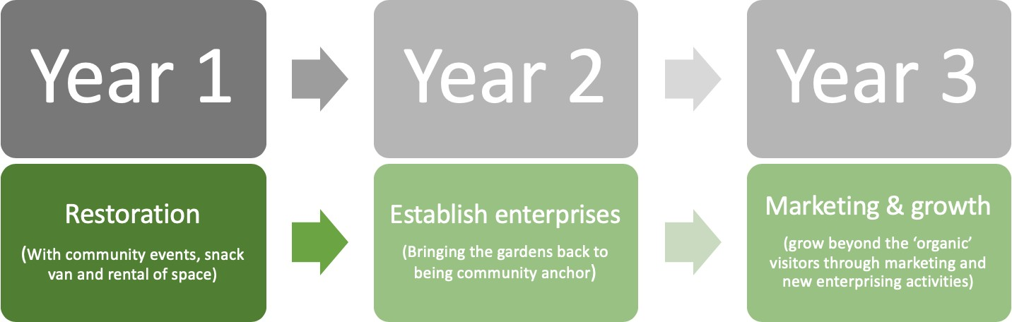
In regards to the Community Asset Transfer application to lease, and then own the Gardens we will point out that gardens are currently in a very poor state and require a large investment – estimated at over £300,000 – to restore the gardens. Therefore, as an ‘asset’ they are currently a liability to take on. However, VGT was established as we see beyond this and to the fantastic potential the Gardens have to become a community asset once more.

Financial projections (profit): from ALL activities. Note- profit is NOT the same as turnover as is forecast in the Finances section below.
Year one: Anticipate to simply break-even depending on grant awards. (due to initial costs of restoration, repair, and renovation offset by revenue) Year Two: Small operating profit (~£5000) – reinvested to service loans Year three: £5,000 - £10,000 operating profit.

The goal of the VGT places values over profit. Enterprising activities are run in order to match upkeep and overhead costs. VGT aim to be able to raise sufficient funds to offer the majority of community activities and events free at point of service. Any profits will be invested into the gardens and the local community.

Income providing community provisions
Outdoor space rental – renting various outdoor spaces to schools, fitness/yoga/recreation instructors, local groups etc. Service offered from year one, expanded years 2-5.
Estimated revenue: £1000 year one, £3000 per annum thereafter.
Coffee and Snack van(s) - Providing food and drink. Lack of similar offerings locally it is anticipated that the snack van will also attract new community members to the gardens. Van/Truck and some outdoor seating. Will eventually be replaced by permanent café upon renovation of buildings. Service offered from March 2021.
Estimated revenue: £2000 year one, £5000 per annum thereafter.
Wedding Photographs – The Viewpark gardens have often been chosen by local (and further afield) residents as the location for wedding photographs. Service will be introduced from March 2021 once suitably cleaned up the gardens and buildings.
Estimated revenue: £1000 year one, £3000 per annum thereafter.
Glasshouse rental – Exclusive bookings for the greenhouse (and parts of the Gardens) for events/ wedding ceremonies/ funeral/ conferences and workshops. Anticipated to begin within year 2.
Estimated revenue: approx. £8000 per annum.
Generated income projected at £20,000 per annum. Likely to be £10,000 in first year due to needing to build up the various income streams. These activities would be run through a separate wholly-owned trading subsidiary of VGT, with all profits going back to the core VGT charity.
Regular street food festival – ‘Street food’ vans invited at basic rate +5% of profits, together with music/events. Starting within year one, growing through years 2-5.
Estimated revenue: £1000 year one, £4000 per annum thereafter.
Regular events and festivals – Community events with fundraising opportunities. Hosting music, arts and crafts, workshops etc. Annual themed events such as Christmas grotto and fayre. Starting within year one.
Estimated revenue: £500 year one, £4000 per annum thereafter.
Local Farmers market – together with local arts and crafts businesses run monthly during Spring, Summer and Autumn months. Starting from March 2021.
Estimated revenue: £2000 per annum.

Finances
The table below outlines the projected costs and revenue the VGT anticipate upon taking responsibility of the Viewpark gardens. These are based upon our market research across similar community garden projects, the running costs of the Gardens as provided by NLC and a comprehensive study of the grants we are eligible to apply to. Recommend zooming to 200%to view figures clearly.
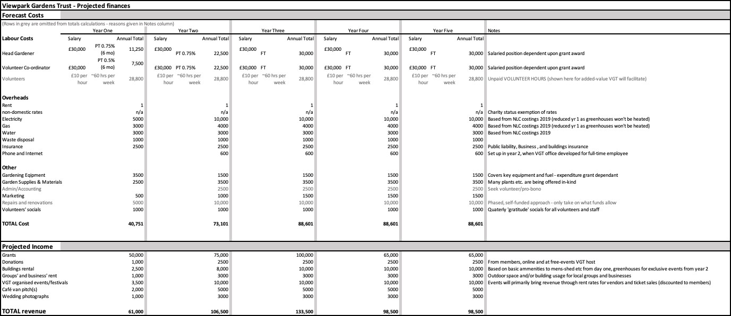

5: Supplementary Information

Charitable status
Our application for Charity status was submitted in Feb 2020. There have been some delays to the processing of our application due to COVID-19. However, it has now been escalated to the local area manager (XXXXXXXXXX) and we are told the charity status, and associated OSCR number is imminent.

We attach the confirmation email of our application. And will update our CAT application as soon as the charity number is granted.

History and usage of the Viewpark Gardens

Designed in 1840 by architect John Baird (primus) Viewpark house was built by William Robertson, a wealthy building contractor from Glasgow. The gardens at that time included a large greenhouse and separate vinery. During the excavation of the garden area, remains of the Roman road Watling Street were found along with two large burial urns dating to the Druidic period.
Mr Robertson died aged 63 in 1850. Two years later the house was then sold to Robert Addie, and Mr Addie would develop the gardens further. By the time of his death in 1870 Robert Addie and sons' collieries owned the nearby Rosehall and Viewpark pits. The Addie family vacated Viewpark house in 1904. Five years later the house would be used by the Social Committee of the Church of Scotland as a rescue home for women under a 10-year lease. In 1915 the house was offered by the Addie family to be used as temporary accommodation for Belgian refugees.
After the war part of the estate was acquired by Lanarkshire County Council for house. The mansion house itself passed through many hands and by 1940 had been

subdivided into flats for working class families before eventually being demolished in the early 50's.
During the 1950s, what is now known as Viewpark Gardens was operated as a market garden by the Baird family. The family would often give boxes of fruit and vegetables to local children free of charge. The three brick-based glasshouses standing today are the ones used by the Bairds. The large metal framed glasshouse was added at a later date by the council.
After the Bairds left the premises, the gardens were landscaped and developed for the use of the public. The glasshouses were re-designed to hold collections of tropical and subtropical plants, succulents and cacti. The rest of the grounds were landscaped to form a variety of themed gardens, including the Japanese garden with its miniature village. The main garden and its collections garden (located just outside the walled garden) boast a wide range of plants and trees, including two specimens of the endangered Monkey Puzzle tree. The gardens are also home to a heritage variety pear which, until recently, was unknown to exist in Scotland. With its stunning plants and water features the gardens has been a popular location for wedding photography.
Until ten years ago the local council, in its varying forms, hosted a large garden festival on the site. This was attended not only by the residents from the surrounding villages, but also from as far as England. With entertainment for the children, craft stalls and school competitions, the event also hosted experts from BBC Scotland's Beechgrove Garden as well as Clyde 1 radio station. Lasting for 1 week the festival was always well attended.

Groups having used the Gardens in the past
The following is an extensive but non-exhaustive list of groups having used the gardens:

- Highgate nursing home
- Laburnum nursery
- The scouts
- Girl Guides
- The Brownies
- Girls Brigade
- Boys Brigade
- Viewpark Parish Church
- St John Paul II (formally St. Gabriel’s and St. Columba’s primary schools)
- Tannochside primary (formally Tannochside and Burnhead primary schools)
- Tannochside nursery (formally Tannochside and Holzier nurseries)
- Viewpark play scheme
- Fallside Youth Project
- Thorniewood Walking Group
- Mossend Drama Club
- Eco Warrior Group Bellshill
- Junior Ecos
- Lanarkshire Amateur Photography
- Wedding photographers
- Uddingston pride- winning them awards in the Britain in Bloom and Beautiful Britain and Scotland competitions

Viewpark Gardens Trust Action plan for the Gardens.

This action plan is designed on the assumption that VGT can get the lease agreement, and access to the Gardens by 30th September 2020. Of course, this plan can be flexible to an earlier/later start date for the CAT lease. Restoration and repairs will be completed in a phased, self-funded approach.

Pre-lease agreement:
Community planning meetings, building membership and recruiting volunteers. Grant and funding applications.
Apply to the Community Learning Exchange fund for our directors to visit 2-3 similar walled gardens community projects to gain valuable insight.
Apply to the Accelerator Fund for support to develop the enterprising business plan. Bring all interested bodies and stakeholders together on site.
Website and social media development and marketing – to advertise upcoming events and recruit volunteers.

Month 1 (October2020):
Initial intensive ‘clean-up’ completed by volunteers co-ordinated by the VGT. This initial intensive effort will restore the gardens and buildings to a point they can be re- opened to the public (at limited times) and host events and established groups. It is anticipated this will require 160 volunteer hours per week throughout October 2020

Months 2-5 (Nov 2020-Feb 2021):
Basic upkeep maintained by volunteers – anticipated at 50-60 volunteer hours per week.
Negotiated access to community groups looking to use the space.
Gardens Re-opening event to tie in with Bonfire night (weekend 3rd & 4th Nov 2020), Christmas grotto (open limited hours from 5th -24th Dec) with community Christmas sing-alongs and a Christmas craft fayre.

Months 6-12 (March-Sept 2021):
Employment begins for head gardener and volunteer co-ordinator (subject to successful grant applications).
Coffee and food van(s) pitch established with coffee and food served on site. Community growing gardens and therapeutic gardening services offered.
Encourage usage by community groups (free of charge) and local businesses (at low-rates).
Upkeep and development of the gardens through volunteer schemes with anticipated 60-80 volunteer hours per week.
Gardens open to groups and public at full opening hours (anticipated to be M-F: 10:30-17:00 , Weekends: 10:30-18:00
Events to run include: Spring festival (weekend of re-opening to regular hours), monthly farmers (and local crafts) market, monthly/bi-monthly street food festival, easter egg-hunt and reinstate the Viewpark Flower Festival.
Procure the plants (from other botanical gardens across Scotland) and funding (through revenue and grants) to restore and re-open the greenhouses by March 2022).

Procure funding to develop indoor seating to enable the coffee and food vans to remain operational through the winter.

Year 2:
Continue activities as per year one. Of course, the usage of the gardens are somewhat seasonal, with many of the activities concentrated between March and September.
We anticipate being able to heat and open up the greenhouses for use from Sept 2021 allowing the therapeutic gardening to continue through the winter, as well a running at limited opening hours to both public and local groups using the gardens through winter months.
We anticipate the ability to host all the groups, activities and events outlined in the application from March 2022.

Years 3-5:
Continue activities as per year 2.
Marketing and publicity for the gardens to attract new visitors and users (beyond the organic usage).
Develop opportunities for new groups to use the gardens.
Grow the revenue of the gardens through product sales, growing use by local businesses etc.
Funding application to SLF etc. to enable purchase of gardens and development of some of the buildings towards long term vision of the Gardens under management by VGT.

Planned use of buildings within the Viewpark Gardens

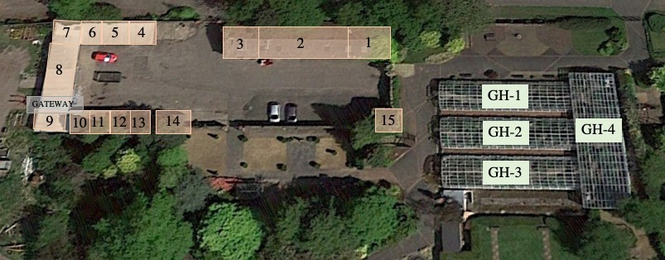
Scale of buildings are approximate representations

Building Space: 1 – Room 1
- – Stables
- – Bothy 1
- – Room 2
- – Room 3
- – Room 4
- – Room 5
- – Cages
- – Bothy 2
- – Toilet
11- Open storage
- – Room 6
- – Room 7
- – Porta-cabin
- – Tower
GH1 – Greenhouse 1 GH2 – Greenhouse 2 GH3 – Greenhouse 3 GH4 – Greenhouse 4

Building | Current use | Planned use | Notes
Room 1 | storage | storage | entrance via wooden door in front of building. Half wall separating it from the  stable on the inside
Stables | storage | Tidy up space, decorate and use as indoor seating for café/snack van.  Additional use as teaching and education facility, and bike  maintenance | needs a massive clear out (job for Winter 2020)
Bothy 1 | staff room | Rentable space for  groups
Room 2 | storage | With planning and funds – remodel rooms 2,3 and 4 into two larger rooms  to be rented by the  Bellshill mens shed | entrance via double doors on the side of building as you go in  the gate
Room 3 | storage/office |  | rooms 2,3, and 4 are  separated by

 |  | and/or the She shed and other community groups. These groups can then have use of the cages for storage | plasterboard so can  easily be remodeled
Room4 | cctv camera room |  | this room is tiny so it may be worth opening it up and joining it with  room 3
Room 5 | drying room | possible refurb as a  toilet facility | very small but has  heating
Cages | storage | Storage as used by VGT and local groups/businesses  renting space
Bothy 2 | staff room | VGT education space used for:  education, courses and workshop.  -SQA level qualifications, - vocational qualifications,  -community arts projects  - sign language courses  -youth clubs  -potential for center of excellence in horticultural qualifications | Used by the on-site gardeners before it was given over to restorative justice
Toilets | staff only | eventually remodeled | needs an overhaul. currently has 2 stalls and a row of urinals. not practical the way  they are
Open storage | currently has a metal store for the councils chemical weed killers  etc. | no change – used as storage by VGT
Room 6 | storage | VGT Office space/ or rental space. Eventually craft, produce and  memento shop. | currently has shelves in it and a stone floor, but easily renovated to be  used as planned.
Room 7 | storage | office/ rented space. possible craft/artist’s studio | same as room 6. These two rooms could be used as rentable art/craft studios if not needed for storage.  Currently lacks natural  light though
Portacabin | staff room | Secure office and ‘volunteers’ space (for storing belongings and  socialising) | Has TOILET and heating

Tower | nothing | At present this can’t be used due to damage. going forward, with the understanding that a grade C listing is imminent, we would look to turn this space into a mini interactive museum | two rooms over two floors. needs total renovation as the top floor room was used to house the doves and the floor/ceiling of the ground floor room is rotten.  neither room has been used in years
Greenhouses 1-3 | Houses cacti and tropical plants | Restore to former glory. This is possible due to contact with Edinburgh botanical gardens. Open  to public.
Greenhouse 4 | Houses tropical and subtropical collections | Restore using cuttings and expertise and support from our botanist Maxine and our contacts at the Royal Botanical gardens in Edinburgh.  This space can also be used as a teaching and education space. | Throughout the four glasshouses there will be information/history boards. These will potentially be interactive - depending on funding.
Once restored will be rented as ‘events’ space for; weddings, christenings, conference/meeting space, wine tasting,
prom celebrations etc.

Expanded description of the groups, activities, events and benefits the VGT will bring to the Viewpark Gardens

As highlighted in section 4.2 of the ATR form our plans for the Gardens include making the space available to local groups and businesses to use (rental rates depending on the usage), activities and events run by the Trust, all of which will bring many benefits to the surrounding community. Beyond those listed in section 4.2 are the following uses and benefits for which there was not the space to include in the ATR form:

Reviving the gardens and replacing the plants that have been lost. Links have already been formed with Botanical Gardens in other areas of Scotland, to assist in replacing the rare and tropical plants that were lost over winter.

Local schools and individuals will participate in classes and courses in various subjects of interest including gardening and horticulture, with the potential for work experience, apprenticeships and employment at a later stage.

The tearoom/coffee shop will provide a meeting place for local people, and will provide gluten-free, and vegan options. We are currently planning an outdoor area for food and beverages to endeavour to comply with social distancing and hygiene requirements.
As well as a social space, the proposed cafe will provide jobs for locals and the ability to train employees to achieve qualifications in disciplines such as health and safety and food hygiene.

The Group plans to reinstate the Viewpark Flower Festival. This would bring the community together in several ways. The horticulture element of the Festival would be implemented using displays and infographics pertaining to themes and factual horticulture information. The delivery of these would be age appropriate and inclusive with various options such as community arts events, school competitions and home growing classes. This will encourage people to take an interest in plants, crafts, and gardening.

Information boards in the Gardens will provide education on the history of the local area, the various rare plants housed in the gardens, and history of the Gardens themselves.

Health and fitness will be encouraged, as one of the group’s aims is to run outdoor fitness classes. Additionally, we will provide quiet and relaxing spaces in accordance with NHS guidelines on outdoor space for improving mental health, also known as ‘Green Exercise’.

Local artists, painters, poets, photographers and musicians will be encouraged to make full use of the gardens, both individually and within teaching groups.
Educationally this could easily be linked with curriculum requirements and would fill the gap in educational establishments (such as schools) who may struggle to provide contact music lessons etc. due to the coronavirus pandemic affecting ability to

deliver teacher facing classes.

Wildlife protection and conservation; an objective of the VGT is to encourage wildlife, particularly rare species such as kingfishers - which have been noted within the area. We believe there may be bats nesting within the garden areas - a bat survey has been proposed and designed, however a lack of access to the Gardens has resulted in a delay to carry out the survey. The pond area will be used to educate school groups. In the past the pond was periodically dredged and tidied by local youth groups led by one of our board members and overseen by the gardeners within the space.

Linkages to the NLC ‘Plan for North Lanarkshire’
In developing our plans for the Viewpark Gardens we consulted with the NLC “One Place-One Plan” plan for North Lanarkshire, and have aligned our vision for the Gardens to marry with objectives set out within the 5 Priorities outlined in the plan:

- Improve economic opportunities and outcomes.
- Support all children and young people to realise their full potential.
- Improve the health and wellbeing of our communities.
- Enhance participation, capacity and empowerment across our communities.
- Improve North Lanarkshire’s resource base.

This will be achieved as described below:

Priority 1 – Improve economic opportunities and outcomes.

Refocus our town centres and communities to be multi-functional connected places which maximise social, economic and environmental opportunities.
Achieved through education & community engagement. Allowing the people of Viewpark & surrounding to thrive. Providing ample environmental opportunities and encouraging/supporting local business and enterprise.

A place in NL that promotes the area as the place to live, learn, work, invest & visit.
Achieved by the Viewpark Gardens becoming a community hub – attracting a wide variety of people from NL and beyond. The Gardens will revitalise the mentality of the local community helping it to be seen as a promising place for living, learning, working and attracting investment.

Priority 2 – Support all children and young people to realise their full potential.

Raise the attainment and skills for learning, life & work.
The Viewpark gardens, under VGT, will be used to provide young people with the skills and experience required for life & work.

Children and young people will be included, supported and safe.
VGT in our vision for the Gardens set out an equal & inclusive environment. As such local children and young people will always be included, supported & safe.

Engaging children and families in early learning and childcare programmes. The Viewpark gardens can be used by many local programmes delivering early learning.

Engage with children, young people, parents, carers and families to help all children and young people reach their full potential.
At the Viewpark Gardens, VGT will provide essential life skills for young people. As well as job opportunities and training towards formal vocational qualifications,

Priority 3 – Improve health and wellbeing of our community

Increase opportunities for adults by understanding, identifying and addressing the causes of poverty and deprivations.
VGT will deliver education and support around finances, getting into work while helping households struggling with food insecurity by providing fresh, healthy produce and nutrition workshops.

Ensure residents are able to achieve, maintain and recover their independence through appropriate support at home and in their communities.
Viewpark gardens can, and will deliver many aspects of this community support

Encourage the health and wellbeing of people through a range of social, cultural and leisure activities.
The Viewpark gardens are a significant part of our cultural and leisure activities in Viewpark especially, but throughout the whole of the local area. The Gardens provide much needed outdoor space, and VGT will be facilitating the offerings of well-being, fitness, and social activities.

Priority 4 – Enhance participation capacity and empowerment across our communities.

Transform our natural environment to support wellbeing and inward investment and enhance it for current and future generations.
The Viewpark Gardens are an existing asset within North Lanarkshire, and will be utilised to support and improve wellbeing across deprived communities, especially the immediate surrounding areas. VGT will develop the existing facilities and offerings within the gardens attracting investment to the Gardens and perhaps also surrounding areas.

Ensure we keep our environment clean, safe & attractive.
The Viewpark Gardens are an attractive site within the locality, and it is the main priority of VGT to re-open this facility making it available to the community once again.

Improve engagement with communities and develop their capacity to help themselves.
The Viewpark Gardens site has capabilities to be a community engagement hub within Viewpark, especially to be utilised to improve the wellbeing of those in the community. Many of the activities we will facilitate are expected to help develop a growth mindset among the Viewpark community enabling this engagement and capacity.

Improve the involvement of communities in decisions.
The community of Viewpark & surrounding areas will have a strong say in the way the Gardens & buildings are used and adapted to benefit them in the most positive way possible. As set out in the ATR VGT will empower the community to maintain and use the Gardens. Run by locals, for locals.

Priority 5 – Improve North Lanarkshire’s resource base.

Build a workforce for the future capable of delivering on our priorities and shared ambition.
The Viewpark gardens could serve as a huge part of this. Particularly in the vocational training, work experience and jobs we will be able to offer. Demonstrating that the VGT CAT of the Viewpark gardens will be absolutely vital in the success of North Lanarkshire’s plan.

Review and design services around people, communities and shared resources.
The Viewpark gardens can serve as a resource for the wider community, offering a variety of services to improve the wellbeing of the local community

Ensure intelligent use of data and information to support fully evidence-based decision making and future planning.
The Viewpark gardens will serve as a part of the plan for North Lanarkshire. As can be seen, the vision VGT has for the Viewpark gardens mirrors the plan for North Lanarkshire in a magnitude of ways. We intend to be an exemplar group in community managed-projects and be consulted in future plans based on our success.

