COMMUNITY EMPOWERMENT (SCOTLAND) ACT 2015
ASSET TRANSFER REQUEST FORM

IMPORTANT NOTES:
This is a standard asset transfer request form which can be used to make a request to any relevant authority. Relevant authorities may also provide their own forms in their own style.
You do not need to use this form or a relevant authority’s form to make an asset transfer request, but using a form will help you to make sure you include all the required information.
You should read the asset transfer guidance provided by the Scottish Government before making a request. Relevant authorities may also provide additional guidance on their schemes.
You are strongly advised to contact the relevant authority and discuss your proposals with them before making an asset transfer request.
When completed, this form must be sent to the relevant authority which owns or leases the land your request relates to.

This is an asset transfer request made under Part 5 of the Community Empowerment (Scotland) Act 2015.
Section 1: Information about the community transfer body (CTB) making the request
1.1 Name of the CTB making the asset transfer request

Viewpark Gardens Trust
1.2 CTB address. This should be the registered address, if you have one.
xx xxxxxx xxxx
xxxxxxxx
xxxxxxxxxx
xxxxxx
xxx xxx
1.3 Contact details. Please provide the name and contact address to which correspondence in relation to this asset transfer request should be sent.
All correspondence should be directed to (email preferred):
xxxxx xxx
Email:
viewparkgardens@gmail.com

Telephone:
xxxxxxxxxxx

Address:
xxx xxxxxxx xxxx
xxxxxxxx
xxxxxxxxxx
xxxxxxx
xxx xxx

X We agree that correspondence in relation to this asset transfer request may be sent by email to the email address given above. (Please tick to indicate agreement)
You can ask the relevant authority to stop sending correspondence by email, or change the email address, by telling them at any time, as long as 5 working days’ notice is given.
1.4 Please mark an “X” in the relevant box to confirm the type of CTB and its official number, if it has one.
X | Company, and its company number is …………. | 655832
 | Scottish Charitable Incorporated Organisation (SCIO), and its charity number is ……………….. | Charitable status imminent* (see  supplementary info: section 5)
Community Benefit Society (BenCom), and its
registered number is ………………………………
 | Unincorporated organisation (no number)

Please attach a copy of the CTB’s constitution, articles of association or registered rules. Please refer to Appendices – Sections 1 (Articles of Association) and 2 (Constitution).
1.5 Has the organisation been individually designated as a community transfer body by the Scottish Ministers?
_{No} ☐

Yes ☐
Please give the title and date of the designation order:
1.6 Does the organisation fall within a class of bodies which has been designated as community transfer bodies by the Scottish Ministers?
_{No} ☐

Yes ☐
If yes what class of bodies does it fall within?

Section 2: Information about the land and rights requested
2.1 Please identify the land to which this asset transfer request relates.
You should provide a street address or grid reference and any name by which the land or building is known. If you have identified the land on the relevant authority’s register of land, please enter the details listed there.
It may be helpful to provide one or more maps or drawings to show the boundaries of the land requested. If you are requesting part of a piece of land, you must give a full description of the boundaries of the area to which your request relates. If you are requesting part of a building, please make clear what area you require. A drawing may be helpful.

Picture
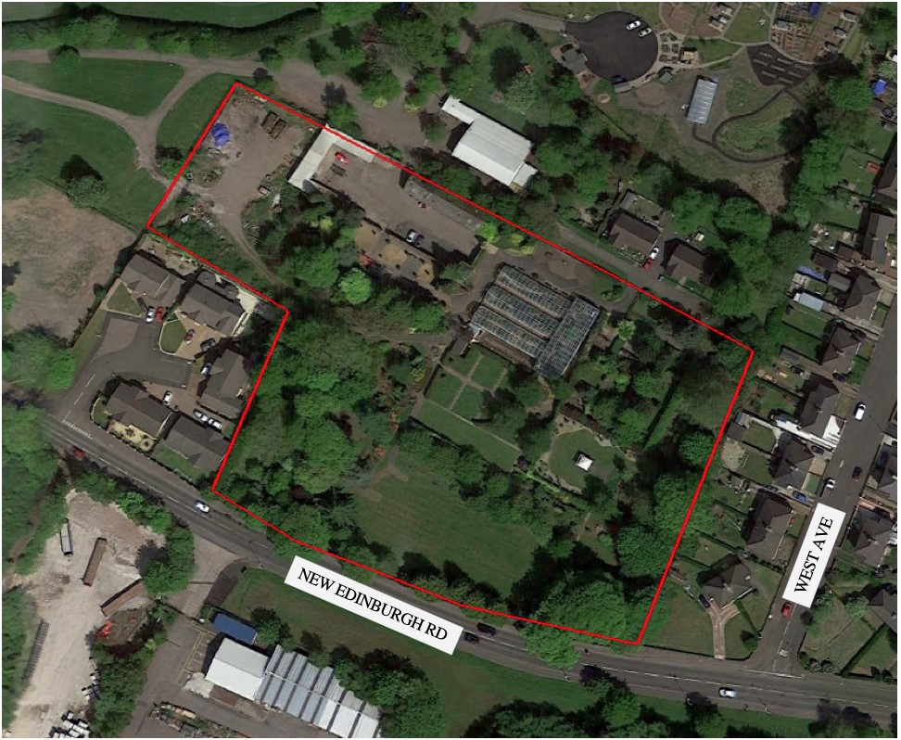
Viewpark Gardens

Baird’s Avenue

Viewpark

Uddingston

2.2 Please provide the UPRN (Unique Property Reference Number), if known.
If the property has a UPRN you will find it in the relevant authority’s register of land.
UPRN: n/a

Section 3: Type of request, payment and conditions
3.1 Please tick what type of request is being made:

X

X
3A
for ownership (under section 79(2)(a)) - go to section 3A
for lease (under section 79(2)(b)(i)) – go to section 3B
for other rights (section 79(2)(b)(ii)) - go to section 3C

– Request for ownership
What price are you prepared to pay for the land requested? :
Proposed price: £
Please attach a note setting out any other terms and conditions you wish to apply to the request.

3B – request for lease
What is the length of lease you are requesting?
5 years
How much rent are you prepared to pay? Please make clear whether this is per year or per month.
Proposed rent: £ 1 per annum.
Please attach a note setting out any other terms and conditions you wish to be included in the lease, or to apply to the request in any other way.

Additional terms and conditions we are requesting are set out in the appendices (section 3).

3C – request for other rights
What are the rights you are requesting?
A Key for the public toilets that lie out with the boundary of this lease request but for which other user groups on the site have a key.
Do you propose to make any payment for these rights?
Yes ☐

No ☐
If yes, how much are you prepared to pay? Please make clear what period this would cover, for example per week, per month, per day?
Proposed payment: £ per
Please attach a note setting out any other terms and conditions you wish to apply to the request.
An agreement for any cleaning and maintenance of the toilets to be negotiated between all users and NLC, particularly now that the toilets are unlikely to reopen as public toilets. It is uncertain at this point what the position of the public toilets will be going forward.

Section 4: Community Proposal
4.1 Please set out the reasons for making the request and how the land or building will be used.
This should explain the objectives of your project, why there is a need for it, any development or changes you plan to make to the land or building, and any activities that will take place there.
The Viewpark Gardens Trust (VGT) are a not-for-profit group with imminent charitable status formed by locals, for the benefit of the local community. This community asset transfer (CAT) is being requested to protect and preserve the Viewpark Gardens and develop a community provision that will be used by individuals and community groups (both established and new groups) alike. VGT will restore the gardens such that they can be opened back up to the public, providing a much-needed leisure facility within a deprived community; giving local individuals and families access to the large range of facilities and projects VGT will oversee. Upkeep and maintenance of the Gardens was costing NLC around £30,000 (plus labour) per annum. Transferring these responsibilities to the VGT will enable the Gardens to remain open to the community without such cost to NLC.
The Viewpark Gardens hold over 200 years of history and a collection of rare species, they have been a valuable asset to the local community for over 100yrs (further information of the history
and usage of gardens is provided in section 5.2 of the Appendices). The VGT appreciate the
upkeep that has been maintained by NLC to date, and understand the funds simply don’t exist for NLC to continue upkeep. However, we do not believe this should be cause for the community to lose the Gardens. The VGT have demonstrated community support and willingness to maintain and develop the Gardens.

Establishing a strong sense of identity and trust within the community, and reverting the Gardens back to being at the heart of the local community is a driving objective of the VGT. We intend to cohesively build this by providing services and benefits that are not otherwise available within the vicinity of the Gardens (full details provided in Appendices – section 5.5). Viewpark has a major deficit of community amenities and projects. Local people cannot often access clubs, spaces and outdoor events within the local area. Our visions for the gardens are designed in line with the NLC ‘Plan for North Lanarkshire’ – particularly the current challenges (how our plans fit are extensively laid out in section 5.6 of the Appendices).
Throughout this application we indicate some of the planned activities and facilities our Trust will provide and in doing so we highlight that we intend to do much more than simply re-open the Gardens to the public – we realise the fantastic potential the Gardens can offer as we develop into a community ‘hub’. Beyond simply providing access to the gardens for recreational activities, we also plan to develop organised activities and groups to help improve the general health of people within the local community. The Viewpark community, specifically those within the immediate surrounding areas of the Viewpark Gardens are in the top 5% of most deprived communities in North Lanarkshire - which itself is the 6th (out of 32) most deprived council in Scotland. Our Trust intends to empower the local community to drive the asset transfer in direct relation to the very specific needs and requirements of the immediate and surrounding areas. The following statistics outline the chronic issues many in the immediate vicinity to The Viewpark Gardens face with the most immediate housing estate being some of the most disadvantaged groups in the whole of North Lanarkshire:
- One in five Viewpark households are income deprived
- Almost 10% of Viewpark residents claim incapacity benefits
- Child poverty; approx. one in four children in Viewpark live in low-income households
- Life expectancy significantly below national average; by 5yrs for men & 8 years for women
- Viewpark (and surrounding areas) consistently has highest rates of anxiety, depression and psychosis in North Lanarkshire – and is significantly worse than the national average across the board for mental health related hospital admissions and prescriptions
These statics highlight the levels of deprivation and poor health within Viewpark. Scottish Index of Multiple Deprivation (SIMD) analysis and other indicators show that deprivation and poor health in Viewpark community has consistently worsened since 2016. To improve the current situation, it is critical that facilities, services and support are made available to the local community. This CAT will allow our Trust to deliver a wide range of solutions to the current problems within the area and we feel that it is of paramount importance for the relevant authorities to take into account the benefits, and added-value that will be realised from the proposals set out in this application. Furthermore, it is expected that the poor health and poverty within Viewpark will significantly worsen due to the Coronavirus pandemic. Ensuring access to the Viewpark Gardens will provide open, and outdoor space for community use which will be invaluable as we emerge from lockdown into ‘the new normal’.

All services and activities VGT provide will be undertaken with the guidance of fully qualified consultants and advisors, and adhere to risk assessments. The delivery of each project within the Viewpark Gardens will always be community focussed and community-led. A detailed action plan for how and when we will implement the various projects listed throughout this application is found in the supplementary information (section 5.3 of Appendices), as well as specific details of the planned usage of the buildings (section 5.4 of Appendices).

Benefits of the proposal
4.2 Please set out the benefits that you consider will arise if the request is agreed to.
This section should explain how the project will benefit your community, and others. Please refer to the guidance on how the relevant authority will consider the benefits of a request.
The benefits to the local community (and beyond) should this CAT application be supported by NLC are numerous and substantial. Primarily our Trust will enable the Gardens to be re-opened to the public through the safe-keeping, protection, and preservation of the Gardens which are such a valuable outdoor space with great potential to place itself at the heart of the community. We aim to provide a community “hub” for the local and wider community where individuals of all ages and various interest-groups can access our facilities and various projects easily. The need for a robust sense of community identity will be even more important moving forward out of lockdown due to the devastating effect of the Coronavirus pandemic on the economy, and both social and mental wellbeing.

As highlighted in section 4.1 (above) we have undertaken an in-depth assessment of what the immediate and future needs of the community are likely, and provide solutions in the provisions we will provide. These include (but are not limited to):

- Initiatives for mental health services and wellbeing such as: yoga and mindfulness classes, workshops, and retreats; “walk and talk” groups; space for therapists to work within and use the gardens as part of treatment; horticulture therapy.
- Public access to the gardens providing a much-needed outdoor space for walking And socially distanced meetings with friends (reducing the mental stress of isolation and loneliness) – the local area lacks such spaces.
- Encouraging the local community to improve their health through getting active – through welcoming local fitness instructors etc. and providing them a space to take outdoor (socially distanced) exercise classes.
- Outdoor education areas (and some undercover spaces) that can be easily accessed with the appropriate social distancing and hygiene requirements in place. This will include outdoor teaching and forest nursery areas for local schools and nurseries to access regularly.
- Regular community events such as farmers markets, local arts and crafts markets, reviving the annual Viewpark Flower Festival, fun run events, etc. In doing so we will promote social inclusion, integration and learning within the Viewpark community, as well as promoting and supporting local businesses.
- Seasonal community events such as a Christmas Fayre, Easter egg hunt, Halloween arts festival/pumpkin picking and carving etc.
- Building community spirit and resilience through projects and group activities such as: Community gardens, grow-your-own projects, garden therapy, community arts projects, environmental interest groups (similar to the Comrie conversations group), an Eco-Youth- Group, historical re-enactment groups, as well as access and use of the Gardens and buildings by local groups and the general public. Such projects and group activities also encourage learning opportunities and develop education within the community.
- Specialist areas and groups to meet the needs and ongoing requirements for a range of people. These will include Dementia patients, ASD adults and children, sensory gardens for deaf and/or blind visitors as well as facilities and easy access for disabled people and those who use wheelchairs or walking aids. Again, promoting social inclusion within the Viewpark community.
- Saving and/or replacing the rare plants which had been collected throughout the gardens over the years, and protecting rare species of wildlife (including bats and kingfishers) known to have inhabited the Gardens. In doing so we will educate those in the community about conservation and promote citizenship.
- Food security and poverty are prevalent issues facing many local households. We will be able to alleviate this through the community garden providing fresh, healthy, organic produce to those who most need it, while also educating in self-sufficiency and encouraging and supporting growing of produce elsewhere in the community (working in partnership with, and building on the success of schemes such as Grow73).
- In response to how the coronavirus has impacted the local and wider community the VGT would be looking to implement access to the gardens as soon as insurances were in place. The Gardens are currently closed to the public, depriving the local community of
a fantastic facility for walking and escaping the stresses of lockdown. We would be capable of providing a safe green environment whilst providing a space where people can easily socially distance.
12) With council budgets continually being squeezed, it is extremely difficult for local authorities to maintain community assets such as the Viewpark Gardens and it is clear that community management and ownership enabled through the ‘Community Empowerment Act (Scotland) 2015’ will become critical for continued running of many such assets. We believe the VGT can be exemplary in demonstrating how community groups can take on these projects successfully. Empowering, and working with other groups to do similar.

In addition to the evident benefits of the provisions outlined above, our Trust managing the Gardens will provide jobs and extensive volunteering opportunities for local individuals, and the ability to provide training towards formal qualifications in subjects ranging from horticulture to hospitality. There is also the potential for work experience, apprenticeship opportunities at a later stage. Through the events and our development of the Gardens into a community hub we will prioritise, encourage and support local businesses who share our values to improve our community in a sustainable manner.
As highlighted in point 8 (above) areas within the gardens will be designed to provide full inclusion of all visitors. This will mean that visitors with access challenges to other parks or projects will find a wide range of choices within Viewpark Gardens. It also includes the training of all directors and staff being trained in British Sign Language.

Restrictions on use of the land
4.3 If there are any restrictions on the use or development of the land, please explain how your project will comply with these.
Restrictions might include, amongst others, environmental designations such as a Site of Special Scientific Interest (SSI), heritage designations such as listed building status, controls on contaminated land or planning restrictions.
Tree preservation orders - we are aware of various trees within the Viewpark Gardens that will fall under the remit of protection. Due to the corona virus and the limitations we have been working with we have been unable to fully access the area with our qualified botanist to list these trees individually. We would be endeavouring to carry this survey out at the earliest convenience. The Viewpark Gardens Trust will fully safeguard the maintenance and care of all and any trees within the area proposed.
Listed buildings - There is a live and current application to North Lanarkshire Council from Historic Environment Scotland to list the Gatehouse as a Category C listed building. We had been expecting this to be complete by April however this has been delayed as a result of recent coronavirus issues. Our Trust applied for the listing and therefore would certainly uphold the regulations surrounding the listing of this important historic structure.

Negative consequences
4.4 What negative consequences (if any) may occur if your request is agreed to? How would you propose to minimise these?
You should consider any potential negative consequences for the local economy, environment, or any group of people, and explain how you could reduce these.
We have methodically and thoroughly assessed any potential negative impacts of our plans and do not believe that any of our plans for the Gardens will have negative consequences. In all areas we are only adding value:
Economy - the Gardens are not currently contributing to the local economy. VGT plans to bring a variety of activities which will add to the local economy and bring a number of employment opportunities.
Environment - Sustainability and saving a valuable natural resource are at the heart of VGT. Any planned additions/works to the gardens and buildings will undergo an environmental impact assessment (EIA). It is our Trust’s ethos (and part of our mission statement) to provide and employ the most environmentally friendly practices. Besides the physical environment, we envisage the VG’s becoming a community ‘hub’ and improving the social environment.

Groups of people - we have spoken with residents whose property is adjacent to VG’s to assess any unforeseen negative impacts. No residents we spoke to were in opposition to our plans, nor were any potential negative impacts raised. The area of interest we have identified takes into consideration the wants and needs of the various groups who lease the buildings in, and adjacent to the gardens, and does not displace any groups that used the gardens up until they were closed to the public. At all stages we will work with any group that wishes to support the aims of protecting and enhancing the Viewpark Gardens.

We of course appreciate that there may be negative impacts arising in the future, but we will maintain our approach to work with groups and individuals to reduce anything which may arise in the future. For now, however, the only negative consequence we can envisage for the local economy, environment and people would be for the gardens to fall into a state of complete disrepair, or for this hugely valuable space and local resource to be lost forever (due to development or similar).

Capacity to deliver
4.5 Please show how your organisation will be able to manage the project and achieve your objectives.
This could include the skills and experience of members of the organisation, any track record of previous projects, whether you intend to use professional advisers, etc.
The VGT board of directors will manage all aspects of the proposed plans for the Gardens. Our board has a wide range of expertise and expertise as outlined here:

Information redacted

Section 5: Level and nature of support
5.1 Please provide details of the level and nature of support for the request, from your community and, if relevant, from others.
This could include information on the proportion of your community who are involved with the request, how you have engaged with your community beyond the members of your organisation and what their response has been. You should also show how you have engaged with any other communities that may be affected by your proposals.
The local community are very supportive and appreciative of our plans and efforts to save the Gardens - which are highly valued by the local population. Members of the VGT had been involved and highly active in keeping the Gardens open, and (since they closed) the VGT have been active at all stages of the consultation process NLC have provided to support the transfer of the Gardens to community management. This includes attending the NLC consultation held 6-7th Feb 2020, and presenting at the Thorniewood community council meeting held 11th Feb 2020.
As part of our planning and preparation we shared a survey online, and spoke directly with residents in the membership area. A community information meeting was planned for 18th March 2020. It was expected to be well attended, however the lockdown due to Coronavirus meant this had to be cancelled.

Another activity to gauge community support which was curtailed due to Coronavirus was doordoor engagement of residents local to the gardens. Before this was curtailed we manged to cover West Ave and the new estate (5 houses) just off New Edinburgh road in their entirety. Of all the houses that were in and answered, only 2 household chose not join as members of the Trust.
There has been interest from a number of parties for various parts of the Gardens, demonstrating how valued they are. The group has been offered help in many different ways. Volunteers and experts alike are keen to work with us to restore and improve the gardens. From the response we have had from the local community thus far it is clear the anticipated volunteer hours required to implement our action plan (Appendices section 5.3 ) will easily be met.
The online community engagement survey received over 500 responses with 96% of those surveyed backing community ownership.

The group has 32 ordinary area members. These are full members who signed up during just one morning of canvassing. Due to coronavirus we have been unable to canvas further. We expect membership to be in the hundreds once we can safely do this again. We also have 11 associate members and 4 established group (affiliate) members. Ordinary members are those specifically living within the boundary near the gardens.
A petition was also started by the group to protest the closure of the gardens which has gained 2095 signatures: https://tinyurl.com/y87b9y6m
The Trust created a Facebook page in February 2020. Already this page has 896 likes and 931 followers. This is 100% organic support for the gardens since we have not run any active marketing campaigns on social media. https://www.facebook.com/viewparkgardens/

We have also began building partnerships with:
- Local groups who will benefit from using the Gardens – some have joined VGT as affiliate members.
- Sustainability and environmental organisations we can team up with and expand their current work.
- Local businesses with complimentary values and objectives who we can learn from and will potentially partner with (for example xxxxxxxx, xxxxxxx xxxxx xxx.)
- Other like-minded charities (e.g. xxxxxx, xxxxxxxxx xxxxxx, xxxxxxxxxxx xxxxxxxx etc.)

Section 6: Funding
6.1 Please outline how you propose to fund the price or rent you are prepared to pay for the land, and your proposed use of the land.
You should show your calculations of the costs associated with the transfer of the land or building and your future use of it, including any redevelopment, ongoing maintenance and the costs of your activities. All proposed income and investment should be identified, including volunteering and donations. If you intend to apply for grants or loans you should demonstrate that your proposals are eligible for the relevant scheme, according to the guidance available for applicants.
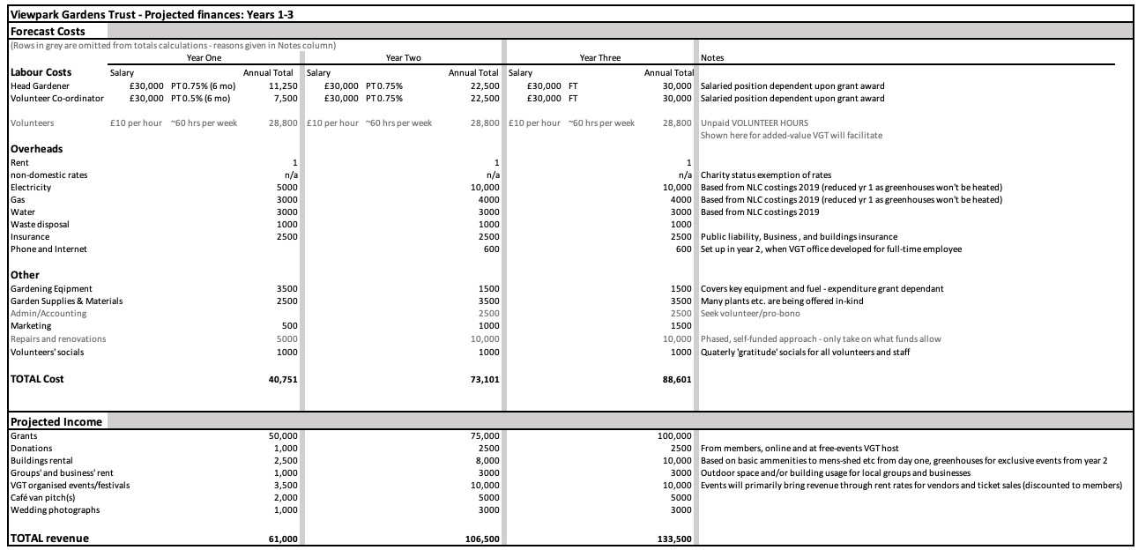VGT only established in February 2020 for the purpose of saving the Viewpark Gardens and taking on management of the Gardens through part 5 of the Community Empowerment Act (Scotland) 2015. As such we do not have an established history from which to show costings. Instead we outline below our projected costs and revenue based on the findings of our extensive market research which includes the running costs of the gardens through until Nov 2019 as provided by NLC, and similar projects to what we envision to deliver at the Viewpark Gardens (such as: Amisfield Walled Gardens, East Lothian; Castlebank park, Lanark; Granton Castle
Walled Garden, Edinburgh etc.)

Projected costs and revenue for years 1-3 (full 5 years can be found in section 4 of the Appendices):

VGT have multiple revenue avenues planned to raise funds for the gardens. A non-exhaustive list of these, and their projected revenue, are outlined in the Business plan – please refer to section 4
of the Appendices. We are happy to provide further details and evidence of the Trusts ability to
cover the management, maintenance and development costs.

In addition to income from enterprising activities within the Gardens, we are in the process of applying to numerous grants for which we are eligible. At this stage we are in a fantastic position that we are eligible for many grants – general and specialised - and should ALL applications be successful then we would receive almost double the projected expenditure for years 1-3.
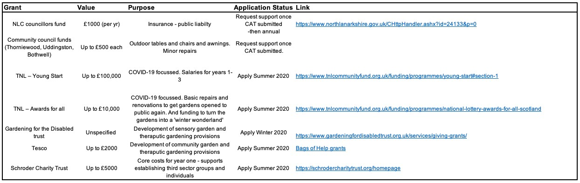
We have already entered initial conversations

with the Scottish Land Fund and National Lottery
Awards for All
–

both of whom have highlighted that the lease must be agreed before
we can
submit applications
–

though with great positivity for our case once VGT have procured
management of the Gardens.

T
he table below

outline
s

a

small selection of the funds we intend to apply to once we are in the
position (lease agreed) to
do so:

If

required we
are

also
in a position to be able to
take out business loans.

In terms of the asset transfer process we have budgeted for legal fees
, surveys of the current
buildings and an architect’s drawings for planning and costing renovati
on works
. As soon as a
validation date is agreed for this CAT application then our Trust
can

begin fundraising events.

Signature
Two office-bearers (board members, charity trustees or committee members) of the community transfer body must sign the form. They must provide their full names and home addresses for the purposes of prevention and detection of fraud.
We, the undersigned on behalf of the community transfer body as noted at section 1, make an asset transfer request as specified in this form.
We declare that the information provided in this form and any accompanying documents is accurate to the best of our knowledge.
Name: xxxx xxxx
Address: xxxx xxxx
Position: xxxxxxxx
Signature: xxxxxxxx
Date: 28/6/2020

Name: xxxx xxxx
Address: xxxx xxxx
Position: xxxxxxxx
Signature: xxxxxxxx
Date: 28/6/2020

This form and supporting documents will be made available online for any interested person to read and comment on. Personal information will be redacted before the form is made available.

Checklist of accompanying documents
To check that nothing is missed, please list any documents which you are submitting to accompany this form.

Section 1 – you must attach your organisation’s constitution, articles of association or registered rules
Title of document attached:
Appendix Section1 (Articles of association)
Appendix Section 2 (Constitution)

Section 2 – any maps, drawings or description of the land requested
Documents attached:
N/A – map provided in section 2.1 of application

Section 3 – note of any terms and conditions that are to apply to the request
Documents attached:
Appendix Section 3 (Additional terms and conditions)

Section 4 – about your proposals, their benefits, any restrictions on the land or potential negative consequences, and your organisation’s capacity to deliver.
Documents attached:
Appendix Section 5 (Supplementary information)

Section 5 – evidence of community support
Documents attached:
N/A – given the sensitive nature of our membership details we do not include further details at this stage. Further details and evidence can be requested if required.

Section 6 – funding
Documents attached:
Appendix Section 4 (Viewpark Gardens Trust Business plan - executive summary)

