Climate Plan

The council's brand and logo for climate change is Action on Climate Together 2030. 

Contents

The Plan 3

Our Changing Climate 3

Covid-19 3

Response to climate change 4

Carbon Footprint 4

North Lanarkshire 5

The council’s emissions 5

Climate Action to Date 5

Targets and Action Plan 7

Next Steps 9

# The Plan

The Plan for North Lanarkshire provides a shared ambition where North Lanarkshire is *the* place to Live, Learn, Work, Invest and Visit.

The Plan for North Lanarkshire sets out the council and its partners’ ambition for the area. It identifies a sustainable North Lanarkshire as a strategic priority with a focus on improving energy efficiency; reducing carbon dioxide emissions; improving the quality and energy efficiency of homes; contributing to meeting the climate change target.

The council has other policies and strategies that support positive action in terms of climate change:

* Environment Strategy
* Biodiversity Action Plan
* Core Paths Plan
* Open Space Strategy
* Active Travel Plan
* Single-Use Plastic Action Plan

The responsibility to act and prevent further climate change lies not solely with the council but with other organisations, businesses, and individuals too.

# Our Changing Climate

*Climate change is the term used for changes that occur in the earth’s climate that are linked to historic and current human activity.*

Greenhouse gases occur naturally however it is those resulting from human activity that have been scientifically proven to have caused an imbalance in natural systems resulting in climate change. As we continue our day-to-day activities, the level of greenhouse gases continues to increase in the atmosphere, increasing the likelihood of temperature rises.

Our summers will become hotter and drier. Our winters will be milder but wetter and have less chance of snow. The impact of these changes has already been seen:

* Travel disruption
* Emergency response situations
* Loss of power supply
* Landslides
* Flooding
* Increased risk of fires
* Disruption to service delivery

These changes are expected to lead to a loss of some of our native species (such as the Atlantic Puffin, Mountain Hare, Great Yellow Bumblebee and Bluebell) and habitats in Scotland. A report from the World Wildlife Fund in 2020 suggests that we will see an increase in non-native species. We can also expect to see an increase in emerging diseases that have originated from animals that affect humans (SARS, MERS, Ebola, COVID-19).

## Covid-19

COVID-19 was declared a pandemic on 11 March 2020 by the World Health Organisation (WHO). By the 16th March the first of a series of rules were introduced which became a nationwide ’lockdown’ by the 26th March. Emissions across the globe reduced for a time as people used their cars less and office buildings and some businesses remained closed. The global footprint is the measure of all the world’s greenhouse gases caused by human activity. As COVID rules became more relaxed, emissions increased, and this resulted in a 6% increase in the global footprint.

## Response to climate change

The United Nations is the international lead on Climate Change. It has a set of 17 goals that nations such as Scotland can use to help develop their own government policies. These are known as the Sustainable Development Goals.

Figure 1 United Nations Sustainable Development Goals

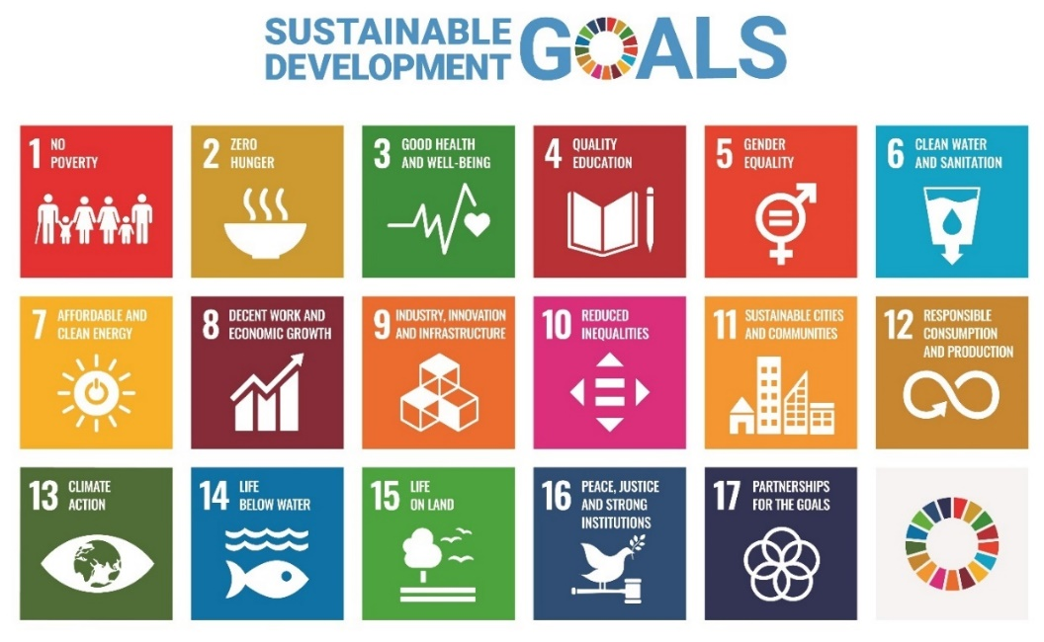

Source 1 United Nations, Dept of Economic and Social Affairs

In 2015 the United Nations met in in Paris and agreed to do their best to prevent future temperature increases by reducing greenhouse gas emissions. This meeting was known as cop21. The document they signed is known as the Paris Agreement.

In 2021 the nations will meet again in Glasgow for COP26. This is an important meeting as the aim is for all the nations to agree the final detail of the agreement made in Paris.

In Scotland the Climate Change (Scotland) Act 2009 sets the nations targets. It ensures all local authorities have a duty to help deliver these targets by acting sustainably and making sure that we are prepared for changes in our climate.

There are several other Scottish Government policies (such as a focus on renewable energy - wind, wave and solar) that are designed to help reduce emissions as well as trying to make sure no-one is unfairly affected by any of the proposed changes. An example of this is the phasing out of new petrol and diesel cars. This will encourage people to move to other forms of transport. For example, electric vehicles or public transport.

# Carbon Footprint

The council declared a climate emergency in June 2019. It agreed to achieve net zero greenhouse gas emissions in North Lanarkshire by 2030. net zero means that all emissions are reduced as close to zero as possible. nature-based solutions and technology are used to remove the emissions that remain. this will be a challenge for all to achieve.

The number of emissions created is also known as a carbon footprint. By committing to net zero the council will work closely with its staff, local businesses, and local communities to reduce the carbon footprint of North Lanarkshire. The council are hosting climate events in the run up to COP26 that will engage with staff, partners, business, and our school children. The main theme of these events is that climate change is all our responsibility and so we all must act now to make a difference.

The council signed the Edinburgh Biodiversity Declaration in June 2021. This recognises the role of the council in promoting and protecting its local animal and plant life as well as habitats (woodland, greenspaces, peatlands, water ways etc).

## North Lanarkshire

In North Lanarkshire most towns have access to a good rail network. People that live in North Lanarkshire are however more likely to travel by road than train. Businesses are also more likely to transport their goods and supplies by road. This creates a lot of greenhouse gas emissions. These emissions as well as those created from using our homes, offices, schools etc make up over 80% of the carbon footprint of North Lanarkshire.

By making use of public transport including the rail network these emissions can be lowered. Improving the energy efficiency of our buildings will also help to lower emissions as we will need to use less energy to keep them warm and comfortable. The council is responsible for improving the energy efficiency of its own housing and must achieve the Energy Efficiency Standard for Social Housing by 2032. There is advice and assistance available to homeowners from Home Energy Scotland:

* energy advice
* help to change energy supplier
* energy carers help for vulnerable
* referral to *Warmer Homes Scotland* for those that are eligible

Warmer Homes Scotland provide an energy efficiency improvement service to eligible households. Following an energy survey, the scheme will deliver energy efficiency improvements. The scheme provides help to those that are in most need, targeting those who cannot afford or find it difficult to heat their homes.

## The council’s emissions

Since 2015/16 the council has managed to reduce its emissions by a third. It will continue to try to reduce all its emissions aiming for net zero by 2030. Its biggest challenge will be to reduce the emissions caused by heating and operating its buildings. And thereafter, it will need to consider what it can do about the remaining emissions. The council’s Greenspace Team will continue to protect and improve blue (waterways) and green spaces as these can help tackle emissions. Derelict land will continue to be brought back into use. Some sites have already been used to create allotments in towns and land at the former Ravenscraig Steel Mill has been used to create a park.

## Climate Action to Date

The council continues to target emission reductions whether this is through communication, behavioural change, or direct action. The following highlights a few of the past and current activities.

Table 1 Climate Action Delivered

| Action | Purpose |
| --- | --- |
| Action on Climate Together 2021(ACT2021) Climate Events | Engage with stakeholders:   * staff, partners, and contractors * local businesses * school children and staff   on climate change. Speakers to provide factual information on climate change, relating it to their own experience and to that of the audience. Feedback from events to shape the council’s future climate action and communication |
| Learning for Sustainability (Curriculum for Excellence) | Younger learners explore issues affecting their school and local community and as they progress, how these issues become relevant in wider national and international context. |
| School Tree Planting Scheme | To recognise the climate challenges, we are all faced with, supported by the Greenspace Team, trees will be planted by ASN and primary school pupils in specific areas in North Lanarkshire. |
| Earth Hour Competition | To highlight their understanding of climate change, school children were asked to submit artwork and poems on any aspect of climate change. Two videos have been made highlighting some of the work submitted. |
| Town Visions | Low-carbon development and sustainability will be at the heart of each town. The visions will also look to limit emissions associated with local travel. These will be informed by feedback from local communities. |
| Local Heat & Energy Efficiency Strategy Pilot | To test an approach to creating a Local Heat and Energy Efficiency Strategy (LHEES). The Scottish Government requires each local authority to have their LHEES in place by 2023. LHEES will help to reduce emissions created by heating buildings, have a local focus, and help those that cannot afford to heat their homes to a comfortable level. |
| Clyde Valley Residual Waste Project | Waste is diverted from landfill and is treated to produce low-carbon electricity. This will lower the number of emissions associated with waste in North Lanarkshire. |
| Recycling Services | Encourage households to reduce their waste that goes to landfill by using a system of bins to recycle. Recycling centres provide a further opportunity to recycle waste. |
| Street Lighting | Replace all council street lighting with LED bulbs to lower the amount of energy needed to operate the system. This will reduce the number of emissions generated by street lighting. |
| Ravenscraig Park | Use a former derelict site of the steelworks to provide open space, outdoor play facilities and a wildflower meadow. |
| Energy Efficiency in Social Housing | All council and housing association landlords are required to improve the energy efficiency of their housing stock. Improving the energy efficiency will reduce the amount of heat required to keep homes warm and comfortable. This will help reduce energy emissions and help those who cannot afford to heat their homes. |
| Project PACE | Install new public electric vehicle chargers at 20 sites in North Lanarkshire in partnership with the Scottish Government, Transport Scotland, and SP Energy Networks. |
| Strathclyde Park and Park Power | A masterplan has been developed following a public consultation exercise. The use of renewable energy from water and solar are being considered as part of these plans. |
| Dumbreck and Garrell Project | Working with the Scottish Environmental Protection Agency (SEPA) and funded by both the Water Environment Fund and council, the project will restore the natural river channel, providing improved paths and improved protection from flooding. The project provides opportunities for health and wellbeing benefits, and cultural and natural heritage conservation and education. |
| Climate Ready Clyde Regional Adaptation Strategy | The council has contributed over the past three years to the development of a Regional Adaptation Strategy and Action Plan. The plan will help make sure that the Glasgow City Region, which includes North Lanarkshire is prepared for the impacts of climate change. |
| Driving Best Practice  And  The council’s fleet | Participating in the Energy Savings Trusts ‘Fuel Good Driver Training’ to reduce the amount of fuel used by the council’s fleet. The council have 64 electric vehicles. They will replace a further 61 in 2025 and 269 by 20.0 with electric ones. |
| Efficient and Cleaner Operations (ECO) Stars, Fleet Recognition Scheme | Assist businesses and organisations who are making changes to their fleet (buses, coaches, and goods vehicles) in order to improve their efficiency and emissions by reducing fuel consumption. |
| Active Travel Strategy | Recently completed, the strategy sets out our approach to active travel policy in our area for the next 10 years. The aim of the strategy is to provide a safe, attractive, and good quality network for people to walk, wheel or cycle. |

## Targets and Action Plan

Achieving the ambitious 2030 target will rely on other sectors such as business, transport and energy taking deliberate action to reduce and offset their emissions. The graph shows how challenging it will be for the council to lower their own emissions.

Figure 2 Historic and Proposed Emissions

The following is a breakdown of the annual carbon budgets the council is proposing to set itself to help limit its emissions.

Figure 3 Proposed Carbon Budgets within the council (tonnes of carbon dioxide equivalent)

| Annual Reduction Targets | Buildings | Transport | Waste | Annual Target Reduction | Reduction from baseline year (2015/16) |
| --- | --- | --- | --- | --- | --- |
| 2020/21 | 44,854 | 6,067 | 19,226 | 6,965 | 46,927 |
| 2021/22 | 38,843 | 6,042 | 19,226 | 6,035 | 52,962 |
| 2022/23 | 33,639 | 6,018 | 19,226 | 5,229 | 58,192 |
| 2023/24 | 29,131 | 5,994 | 19,226 | 4,532 | 62,724 |
| 2024/25 | 25,228 | 5,969 | 7,919 | 15,235 | 77,959 |
| 2025/26 | 21,847 | 5,748 | 7,919 | 3,601 | 81,560 |
| 2026/27 | 18,920 | 5,528 | 7,919 | 3,148 | 84,708 |
| 2027/28 | 16,384 | 5,307 | 7,919 | 2,756 | 87,464 |
| 2028/29 | 14,189 | 5,086 | 7,919 | 2,416 | 89,881 |
| 2029/30 | 12,288 | 4,865 | 7,919 | 2,122 | 92,003 |

This climate plan is a work in progress. The council is looking to engage with other organisations, business and industry and individuals to help identify and agree actions that can be taken to reduce the North Lanarkshire footprint. There are solutions available that the council and others in North Lanarkshire may want to consider:

* Change staff job descriptions to include a responsibility to limiting climate change
* Create a ‘Climate Friendly’ accreditation scheme for North Lanarkshire business
* The use of district heating and cooling systems to reduce emissions. The use of non-gas alternatives would enhance emission reductions.
* Extend the use of heat pumps to provide heating or cooling.
* The use of site-based renewables for electricity generation and heat; heat from sewage; rainwater recovery.
* All new build to be carbon neutral or net positive carbon beyond 2025
* Use energy storage (batteries) to store energy from renewables and create microgrids
* Reduce the need for travel e.g., online meetings, working from home
* Encourage car-pooling and car clubs within organisations
* Promote the use of public transport
* Explore the use of more climate friendly materials and technology
* Develop a large-scale renewable site such as an energy park or solar meadow
* Work closely with the business and industry sector on climate change action to deliver a net zero for North Lanarkshire.

## Next Steps

This plan will be further developed following the consultation exercise. It will include an action plan which has been developed from all the feedback received from the public, elected members, organisations, business, and industry. We will continue to look for opportunities to expand the list of actions through engagement in further surveys and our social media communications.

**Please note this is a summarised version of the plan. Click the link if you wish to access the full** [Draft Climate Plan](https://www.northlanarkshire.gov.uk/your-community/working-communities/consultations/live-consultations/climate-plan-act2030-take-survey).