How to apply for a job

All our jobs are on www.myjobscotland website.
You will need to register with myjobscotland and set up your account. To do this you will need internet access and an email account.

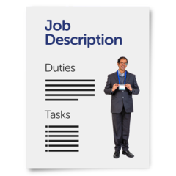  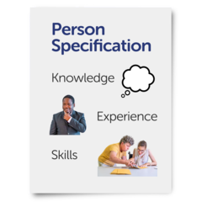 | Advert and Job Description  When you see a job you think you might want, you will see:  - The Job Advert  - A job description / employee specification

The advert will:

- Give you a short explanation of the tasks of the job.
- Tell you what you would be expected to do.
- Tell you the pay, hours and days you will have to work
- Tell you where the job is

This will help you to decide if you want to apply.

The job description/employee specification will go into more detail about the job. It will include:
- The tasks and responsibilities of the job
- The skills you need to do the job

The employee specification will be in 2 parts.

- Part 1: Essential criteria - the things you must be able to do or be qualified for
- Part 2: Desirable criteria – things that would be helpful to do the job

If you do not have the desirable criteria you can still apply for the job.

