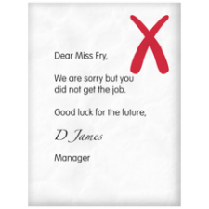 | Interview Outcomes  If you do not get the job you will get a formal email from myjobscotland.  If you want feedback, contact the  People Help Desk on:  01698 403 151.  They will ask the Hiring Manager to contact you. This gives you a chance to hear what went well and what you need to work on.
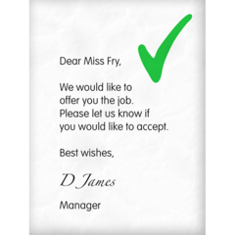 | If you are getting the job you will get a formal email from myjobscotland. This is called:  The Preferred Candidate Notification  This means we are offering you the job.
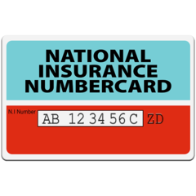  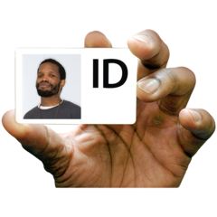 | Before you can start there are some things we need to do. These are called pre- employment checks.  These can include:  - Your bank details (for your wages)  - HMRC checklist (for your tax and national insurance)  - Criminal Conviction form (to let us know if you have any previous convictions) * This does not always mean you will not be offered the job*  - Health questionnaire (to help us support any needs you have so you can do the job)  - Disclosure – PVG (this is a check that is needed for certain jobs such as care)  - References (we will write to your referees, including your most recent employer)  - Additional information (this is proof of your identity and qualifications)
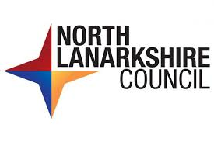 | When we get all the information needed, we will contact you with a start date.  We will then tell you:  The time  - Date  - Where to report  - Who to report to  Welcome to North Lanarkshire Council

