Jobs

All our jobs are advertised on www.myjobscotland website.

There are different kinds of jobs. These include:
- Education and Families
- Enterprise and Communities
- Health and Social Care
- Chief Executives Office

For example, you could work in a school as a support assistant, work in catering or cleaning.

You might decide you want to work in one of our offices.

 | All of our jobs are important. We work together to deliver services to everyone who lives here.
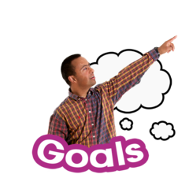 | We need people who want to work and share our goals.  We are a Disability Confident Leader.  This means people will always get an interview if:  - They have a disability  - They have some of the skills needed for the job

We also support people who have been in the Armed Forces (veterans) and their families.

Veterans will always get an interview if:
- They have been in the armed forces
- If they have some of the skills needed for the job

We offer good wages, holiday time and a pension scheme. We offer other good benefits including our www.workwellNL programme.
This supports our colleagues to look after their health, money and mental health.

