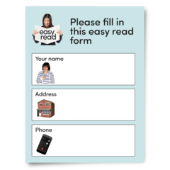 | Ready to Apply?  When you apply there are some things we need to know. These things will be in your application form.
These things will help us to get to know and understand:
- Why you are the best person for the job
- If your skills match the ones in the job description
- To see some examples of work you have done before

These will help us decide if you will be asked to come for an interview.

You will also need to tell us your:
Name
Address
Telephone number
Qualifications
Training you have had

Always check your application before you send it. You could get someone who knows you to check it too.
This helps make sure you told us all the things you are good at.

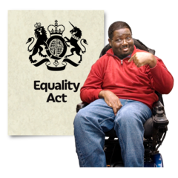 | Equality and Diversity  You will be asked to complete an equality and diversity form.  This is to make sure we treat everyone equally.
Submitting the form
When you submit your application, you will get a receipt sent to your email address.
This comes from myjobscotland

Selection
All jobs advertised have a closing date. After this date no applications will be accepted.
After the closing date the Hiring Manager
(person looking for a worker) will:

- Look at all the applications
- Decide who meets the criteria
- Decide who will be invited for an interview

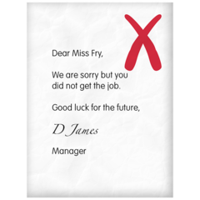  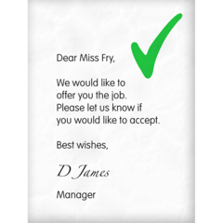 | If you are not getting invited, you will get an email from myjobscotland. The process will stop here.  If you are being invited, you will get an email inviting you to the next part of the process.
North Lanarkshire council interview in different ways:
- An Interview
- Assessment Centre
- Work related task (something practical)

The invitation will tell you what to expect at your interview.

- A face to face or an online meeting
- Where to come to (if face to face)
- A time and date for the interview
- How many people will interview you

It will ask you to tell us what you need to support you at interview. For example, a job coach to come with you.

