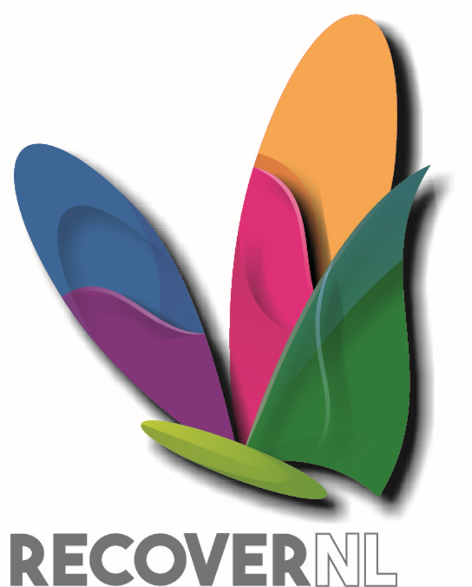
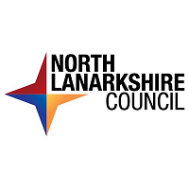

Recover NL (Environmental Fund)
2022 - 2023
Guidance for Applicants

Please read this guidance thoroughly before applying to the Recover NL Environmental Fund using the application form provided.
Overview of application process
- Recover NL (Environmental Fund) for 2022 – 2023 is now open. Organisations and groups who are constituted and have their own bank account are eligible to apply.

- Applications may still be accepted from unconstituted groups and/or groups without their own bank account. If this applies to you - please email our grants team on RecoverNLEnvironmentalFund@northlan.gov.uk with your groups name and telephone number and someone will call you to discuss the options with you.

- To apply organisations / groups must fully complete and return the official application form and submit along with the required supporting documents. This includes a signed copy of your constitution or official governance document (with two signatures) and a copy of your bank statement.

- Organisations / Groups who applied last year can apply again this year. You must intend to undertake more activities during the funding period or to deliver a new project.

- It is important to answer all sections of the application form, as officers will use your answers to assess your application and to allocate a score.

- Your score will be used to determine if your application is successful and will be used to decide the level of funding to be awarded.

- Even if your application is successful, it is important to know that the grant award may be lower than what was requested. Lower scoring applications and the volume of applications may mean award levels need to be reduced.

- This year, there is no deadlines for submission. The funding programme will remain open throughout the year, as long as funding remains available.

- Please check our website to ensure that the funding programme is still open.

- All applications and supporting documents should be emailed to:
RecoverNLEnvironmentalFund@northlan.gov.uk

- On receipt of your application, you will receive an acknowledgement email from us.

- Applications will be logged and issued to officers for assessment.

- Applications will be assessed as soon as possible, and this will involve officers from North Lanarkshire Council and Voluntary Action North Lanarkshire.

- Decision notices will be issued within 4 weeks of assessments being completed. However, it could take longer if the volume of applications is high.

- This year, funding has been allocated to each community board area and this is based on population size and deprivation statistics. Since, funding is limited, early applications are encouraged.

The funding allocations are as follows:

Community Board | Allocation
Airdrie | £24,997
Bellshill | £18,480
Coatbridge | £21,052
Cumbernauld | £22,049
Kilsyth | £5,403
Motherwell | £24,195
Northern Corridor | £10,912
Shotts | £6,855
Wishaw | £16,057
Total Allocation | £150,000

What organisations will be funded?
Applications can be submitted by constituted community groups or voluntary organisations, operating within North Lanarkshire that can demonstrate effective and ongoing activities at the point of application, especially if those activities relate to community led environmental work such as litter picks, community clean-up events and other types of small-scale environmental projects.

Specifically, you are eligible to apply if you are classed as a: -
- Registered charity
- Scottish Charitable Incorporated Organisation (SCIO)
- Unincorporated club or association
- Company limited by guarantee (with charitable or community objectives)
- Community Interest Company

Organisations should have a bank account in the name of the organisation/group with at least two cheque signatories, who are unrelated by birth, marriage, or household address.

What can be funded?

This fund is specifically to purchase relevant equipment and materials such as tools, PPE equipment, bin bags, litter pickers etc. Equipment for personal use such will not be funded.

How much can organisations apply for?

Single Organisations/Groups can apply for up to £2,000. However, joint applications for projects/activities being delivered by two or more organisations is acceptable. If you submit a joint application, you can request up to £3,000 in total.

Completing the application form
Complete all 7 sections of the application. Each section is clearly numbered as follows:
Section 1: Organisation / Group details
Section 2: Main Contact details
Section 3: Contact details for secondary contact
Section 4: Joint Applications
Section 5: About your organisation / group
Section 6: About your application
Section 7: Signature
Underneath each section heading is several straightforward questions, these are lettered A, B, C and so on and listed in grey shaded boxes on the left-hand side.
It is important to answer all questions, as the answers provided will be considered and scored by officers as part of the assessment process.
Section notes:
Section 1: Organisation / Group details
Basic organisational / group information is requested, including: - the name of your organisation, the type of organisation you are and the community board area(s) you operate in.
Section 2: Main Contact details
Provide us with the requested details of your main contact. This will be the person, who we will communicate with. The main contact should be familiar with the funding application and be able to provide us with further information or clarification should we need it.
Section 3: Contact details for secondary contact
The secondary contact will only be contacted, should we be unable to reach the named main contact. It would be helpful for this person to be familiar with your application.
Section 4: Joint Applications
If you are submitting a joint application involving two or more organisations, you will need to provide us with details for the other partner organisation(s). You will also be asked to confirm that you have permission of the other partners to submit a joint application. If you answer, no – then we will not be able to proceed with the joint application.
Please note, an officer will contact all listed partner organisations to confirm their involvement. It is important to make your partners aware of this.

Section 5 & 6 are the most important sections for the assessment process – as previously mentioned, please provide an answer for all questions.
Section 5: About your organisation / group
To aid the assessment process, it is important for us to learn more about your organisation. Specifically, tell us about the work you do and/or activities you provide; let us know which communities/ neighbourhoods you predominately serve; any partners you work with, and numerical information about any employees, group members and volunteers.
Section 6: About your application
This section provides you with an opportunity to detail what you require the funding for; how you will use the materials and equipment; the difference the project will make to the environment within your community, plus any other relevant details.
When you are deciding what equipment and materials to request funding for, please think about the following points upfront as it may help you determine if other factors may need to be considered for effective and safe delivery of your project and activities.
- Where do you plan to store the equipment and resources? (This should not be in your home)
- Who will have access to and use of the equipment and materials? Will you need a booking out procedure?
- Is there any health and safety requirements that you need to think about? For example, risk assessments, safe handling of equipment, manual handling, other training etc.
- Will you be insuring the equipment?
- Have you considered equipment maintenance, for example how will this be done and who by?
Section 7: Signature
The main contact should sign the application to confirm the accuracy of the information contained within the form.
If further advise is required, please email us on: RecoverNLEnvironmentalFund@northlan.gov.uk

Monitoring and evaluation
Organisations who accept funding awards will be required to participate in our grant monitoring processes. This will include, completing relevant returns to meet our reporting obligations. As well as the submission of a final expenditure proforma, all receipts must be retained and submitted as part of the monitoring process.
Organisation may also be asked to contribute to evaluation work such as case studies and the completion of outcome / impact statements.

Use of Data
The data you supply to us will be held and processed under the terms of the UKGDPR and the Data Protection Act 2018. The information you provide will be held electronically. It will only be used to enable a decision to be made about whether a grant to your group or organisation may be approved. We might give copies of all or some of this information to individuals and organisations we consult with when assessing applications, administering the programme, monitoring grants, and evaluating funding processes and impacts. We might use data you provide for research purposes. We recognise the need to maintain the confidentiality of vulnerable groups. Individual recipients of the grants/programmes will not be identified but the organisations in receipt of funding may be.
Further Information
If you require any further information, please contact North Lanarkshire Council by email on:
RecoverNLEnvironmentalFund@northlan.gov.uk

