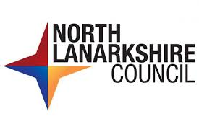

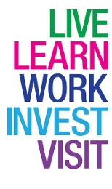**Working with North Lanarkshire**

**Council**

|  |  |
| --- | --- |
| **North Lanarkshire Council logo**Community life | **Introduction**  For people living in North Lanarkshire, we want it to be a good place to:   * Live * Learn * Work * Invest * Visit |
| Cash Hand PoundsTeamwork 1 | We want everyone to have better chances to earn money.  We want all children to do as well as they can. |
| GP Information | We want to get better at making sure all our community has better health and get well looked after. |
| You | We want to get better at working with the community and other organisations.  To do this we need you. |