Hate Crime

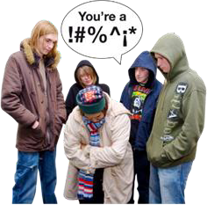

Copyright images © Photosymbols. Prepared by Disability Equality Scotland

What is hate crime and how can I report it?
Hate crime is when someone is bullied or harassed because they have a protected characteristic or someone thinks they have a protected characteristic.
Being harassed means being picked on.
Characteristics describe us as people.
A characteristic is how you see yourself or a group that you feel part of.
A protected characteristic is one that is covered by the law.
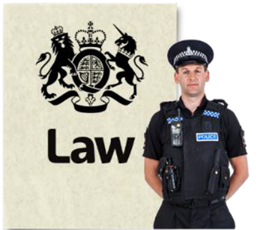 | You are covered by hate crime law if you are targeted because of your:  - disability  - race - this means how we describe our background  People from an ethnic group might have the same language, culture or religion.

- religion

- sexual orientation
Sexual orientation means what kinds of people you love or have sexual or romantic feelings about.

- or transgender identity
This means you do not identify as the sex on your birth certificate.
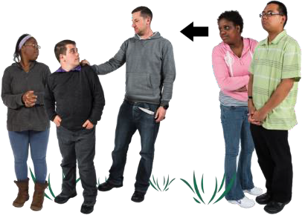 | We want you to report hate crime:  - if it happens to you  - or if you see or hear it happening to someone else
Hate crimes can include:

- hitting you

- calling you names

- damaging your home or your things

- threatening you

- robbery

- online abuse
Police Scotland and hate crime
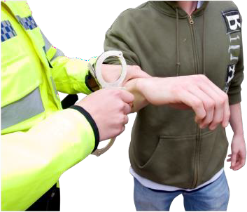 | Police Scotland takes hate crime very seriously.  We will work to do everything we can to arrest the person or people who have broken the law.

Everyone in Scotland is protected by law from hate crime.
This includes:
- people who live in Scotland including asylum seekers or refugees
- people who are here to work
- people who are visiting Scotland

An asylum seeker or a refugee is a person who has fled their home country because of war or other things harming them or their family.
They come to another country for protection.
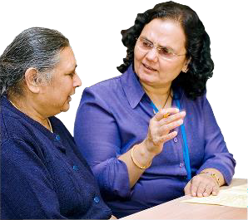 | If English is not your first language, we will get assistance for you from an interpreter which includes a British Sign Language interpreter.  This is to help you give us your report in your first language.

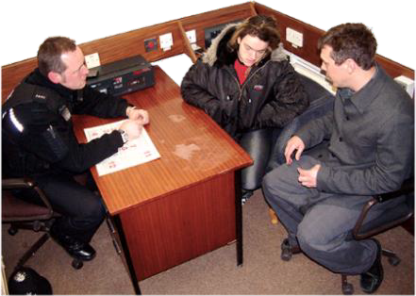 | We want you to feel safe and comfortable when speaking to us.  If we can, we will arrange to speak with you at a place you feel comfortable.  You can also have a support person present.
Reporting a hate crime
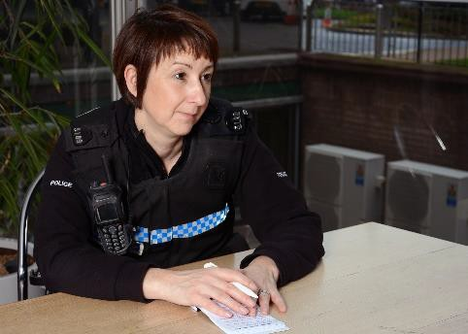 | When you report a hate crime:  - we will listen to you, give you support and your report will be investigated
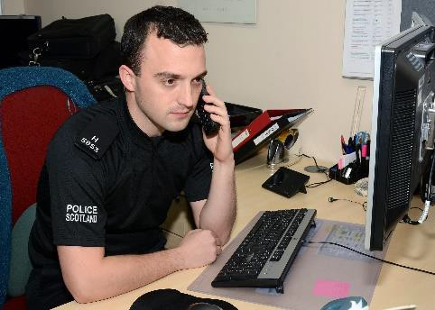 | - you will be contacted by a police officer either:  - by phone  - in person  - or in the way you want them to get in touch
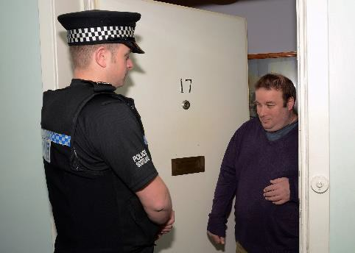 | - Police Scotland will work to find out more about what has happened  They will let you know what is happening.

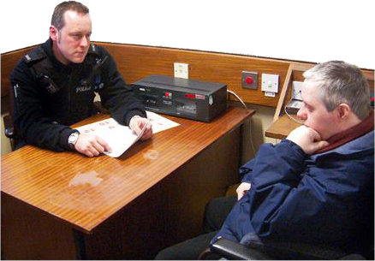  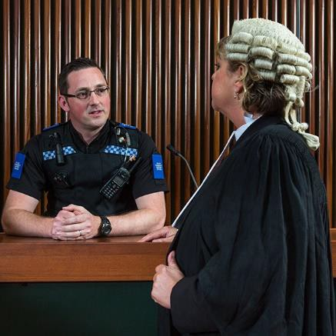 | - if Police Scotland has enough evidence, the person responsible will be charged with the offence and reported to The Crown Office and Procurator Fiscal Service  The Crown Office and Procurator Fiscal Service gets reports about crimes from the police and other reporting organisations.  It then decides what action to take, including whether to prosecute someone.  Prosecute means to officially accuse someone of committing a crime in a law court.
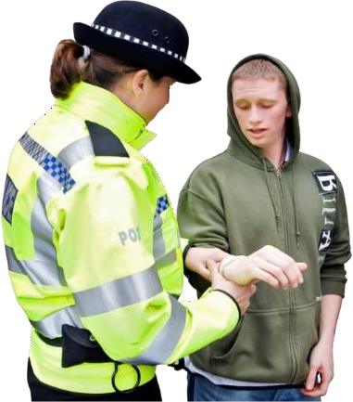 | Evidence means information that could be provided to a court to see if someone is guilty or not guilty of a crime.  An offence is when a person commits a crime.  This means they do something that is against the law.

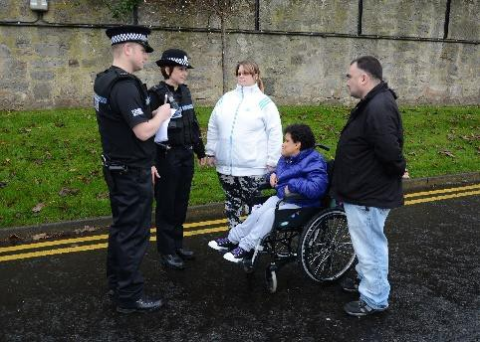 | - If there is not enough evidence we will still record your report as a hate incident and offer you support  It is important to still report hate incidents that are not a crime.  This helps us to know what is happening in Scotland.
 | - when your case is with the Crown Office & Procurator Fiscal service we will keep you up to date with what is happening
You can contact Police Scotland and report hate crime in these ways:
- by phoning 999 if it is an emergency or if you are in danger

- by phoning 101 if it is not an emergency

- in person at any police station

- by completing a hate crime reporting form

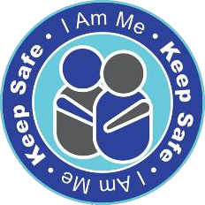 | - at a Third Party Reporting Centre  Staff at a Third Party Reporting Centre will contact the Police for you.  - by texting 999  You must register for this service. Text the word 'register' to 999.  You will get a reply and you should then follow the instructions you are sent.  - using Contact Scotland-BSL  - using the Keep Safe Scotland App
 | There is a British Sign Language video about Hate Crime here.

Getting support when reporting hate crime
Sometimes victims and witnesses of hate crime do not feel comfortable reporting it to the police.
They may feel more comfortable reporting it to someone they know well.
They may want support when they report.
Police Scotland works with different organisations to make sure everyone can report hate crime.
Some organisations are Third Party Reporting Centres.
Staff in these centres have been trained to support people who want to report hate crime to the police.
They can make the report for you.

Copyright images © Photosymbols. Prepared by Disability Equality Scotland

