Strategic Commissioning Plan 2023-26

Health & Social Care North Lanarkshire

Contents

- Introduction | 3
- Strategic Context | 4
- Developing the Plan | 7
- Strategic Needs Analysis | 9
- What We’ve Heard | 12
- Our Priorities & Ambitions 2023 - 2026 | 15
- Enabling The Plan | 18
- Measuring Performance | 21

Introduction

Welcome to our Strategic Commissioning Plan for Health & Social Care North Lanarkshire. This plan will cover the period 2023-26 and will cover the final period of our long term Strategic Plan 2016-2026. In developing this plan we have built on the work established in our previous Strategic Commissioning Plan 2020-23, and through engagement and collaboration with local people, service users, members of staff and other key stakeholders this plan sets out our ambitions for improving the health and wellbeing of North Lanarkshire’s population.

This plan sets out how community health, social care and social work functions delegated to the Integration Joint Board by North Lanarkshire Council and NHS Lanarkshire will be planned and delivered over the medium term.

Despite the significant challenges we have all faced since March 2020, we have made significant achievement and progress in the last three years. This plan gives an overview of some of these achievements and how they have helped to shape our priorities for the next three years. We have set out these priorities for further consultation with you to ensure we are focusing on the right things. We will develop a more detailed implementation plan to support our priorities in the coming months.

We continue to experience the long-term and lasting impact of the COVID19 pandemic, working with people to ensure they can access the support and treatment they require following a sustained period of disruption and restriction. We recognise the strength and resilience of our communities, workforce and partners as we move forward with our plans for recovery and renewal.

The next three years will undoubtedly present further challenges and uncertainty as we continue our recovery from the pandemic-related disruptions, and also in how we prepare for the establishment of a National Care Service. However, it is clear that we have strong foundations to build upon, working with service users, patients, carers, families and partner organisations to improve the health and wellbeing of North Lanarkshire residents.

Strategic Context
While North Lanarkshire’s Integration Joint Board has overall responsibility for planning health and social care services within the area, we have to consider the range of other national and local strategies, plans and policies to ensure our plan is consistent and aligned with the priorities of North Lanarkshire Council, NHS Lanarkshire, other community planning partners, and national priorities.
National policies, legislation, strategies and plans

Public Bodies (Scotland) Act 2014
Carers (Scotland) Act 2016
Community Empowerment (Scotland) Act 2015
Equalities (Scotland) Act 2010
Fairer Scotland Duty
National Care Service
Scotland’s Digital Health and Care Strategy
Scotland’s Public Health Priorities
Primary Care Improvement Programme

Local Strategies & Plans

The Plan for North Lanarkshire
Our Health Together
Lanarkshire Mental Health & Wellbeing Strategy
Local Housing Strategy 2021-26
Tackling Poverty Strategy
Equality Strategies (NHSL and NLC)
Children’s Services Plan
Community Solutions Strategic Commissioning Plan
North Lanarkshire Alcohol & Drugs Partnership Strategy
Community Justice Partnership Improvement Plan
Carers Strategy

The strategic planning landscape is complex, as outlined in the diagram above. However, through our Strategic Commissioning Plan we are seeking to provide a clarity of direction for the partnership, while ensuring the appropriate linkages are made and due attention is given to our other planning commitments.

We have put in place a number of strategies and plans which will be taken forward during the lifetime of this overarching Strategic Commissioning Plan:

We are fully committed to working in partnership with our statutory partners and the third and independent sectors. We will continue to work within the community planning structure within North Lanarkshire, recognising that through The Plan for North Lanarkshire, the Health & Social Care Partnership makes a vital contribution to realising the vision of making North Lanarkshire the place to Live, Learn, Work, Invest and Visit. We are also closely engaged in the development of the new, emergent strategy for NHS Lanarkshire, Our Health Together. This new strategy will seek to ensure maximum impact across our whole health and care system with due consideration afforded to recovering services and building resilience and dovetails neatly with the priorities set out in this plan.

In working to deliver our priorities, the partnership will support both North Lanarkshire Council and NHS Lanarkshire role as Anchor Organisations. That is, using their resources and influence to effect change to the social, economic and environmental conditions that determine the health and wellbeing of local people. Anchor Organisations are defined by the Joseph Roundtree Foundation as:
“…big and locally rooted organisations including the NHS, local authorities, colleges and universities, and private businesses with local HQs. Because they employ many people, spend substantial amounts of money, own and manage land and assets and often deliver crucial services, they have a considerable impact on local communities and economies. Further, they are historically rooted in the physical area, intrinsically connected to the local community and are pivotal to wellbeing.”

Crucially, all of our delivery and implementation will be local and our plans are also closely aligned with the new Local Outcome Improvement Plans for each of the eight Community Board areas. Our overall structure for delivery remains with six localities, with three each aligned to a sector (North East and North West), which allows for closer relationship with the two acute hospitals located within North Lanarkshire. The diagram below outlines how our teams and relationships are structured, also including the hosting relationship with South Lanarkshire, and where we deliver services on an area-wide basis.

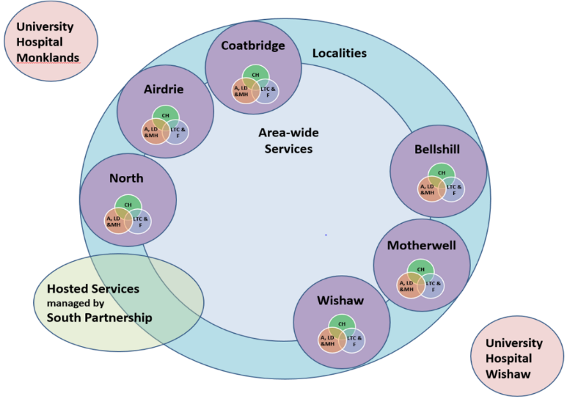

The outcomes that pull all of the strategic and planning strands together are reflected in an agreed set of nine national Health and Wellbeing Outcomes which the Health & Social Care Partnership has a duty to deliver. These are:

Outcome 1
People are able to look after and improve their own health and wellbeing and live in good health for longer.

Outcome 2
People, including those with disabilities or long-term conditions, or who are frail, are able to live, as far as reasonably practicable, independently and at home or in a homely setting in their community.

Outcome 3
People who use health and social care services have positive experiences of those services and have their dignity respected.

Outcome 4
Health and social care services are centred on helping to maintain or improve the quality of life of people who use those services.

Outcome 5
Health and social care services contribute to reducing health inequalities.

Outcome 6
People who provide unpaid care are supported to look after their own health and wellbeing, including to reduce any negative impact of their caring role on their own health and wellbeing.

Outcome 7
People using health and social care services are safe from harm.

Outcome 8
People who work in health and social care services feel engaged with the work they do and are supported to continuously improve the information, support, care and treatment they provide.

Outcome 9
Resources are used effectively and efficiently in the provision of health and social care services.

Developing the Plan

We value the input and contribution from all our stakeholders in all the work we do. In developing the Strategic Commissioning Plan 2023-26 we have been committed to ensuring we engage as widely and as meaningfully as possible across and within our communities, workforce and partner organisations.

During 2022, the relaxation of many COVID-19 restrictions offered us the opportunity to have many more in-person events than we had originally anticipated. Through a variety of workshops and local events we have been able to engage with a range of stakeholders through physical, face-to-face meetings. Our ability to use technology to supplement these events and meetings with online workshops has allowed us to offer a wide range of engagement opportunities.

To support the development of this plan we engaged with a range of stakeholder groups, including people who use our services, carers of people who use our services, local residents, people who work in health and social care, local community groups and organisations, local elected members, and people who work for partner organisations and other service providers.

In each of the events that took place we reviewed the achievements and challenges of the past three years and used a range of information and intelligence to guide our conversations into the opportunities and challenges facing the partnership in the future.

The following provides an overview of the types of events and discussions which have taken place over the preceding 3-4 months.

Strategic Planning Group
Our Strategic Planning Group has the overall responsibility for producing, monitoring and reviewing our Strategic Commissioning Plan. The Group is chaired by our Chief Officer and has a wide-ranging membership, including representation from: senior leaders and managers within the partnership, service user and carer representatives, VANL, and a range of other partner organisations. Consultation and engagement with the group took place via an online workshop and the group will meet again in December 2022 to review the draft plan.

Sector and Locality Engagement
Our North-East and North-West sectors brought their locality teams and local stakeholders together across two in-person engagement events: one in Cumbernauld New Town Hall and one in Dalziel Park, Motherwell. These events allowed for a large attendance from each of the six localities, with dedicated inputs and workshop sessions on the development of this plan.

Staff Roadshows
Two staff roadshow sessions were dedicated to engagement on the development of future priorities and reviewing current achievements and challenges. These took place online allowing for a wide range of staff from across a large number of disciplines and services to take part.

Community Boards – Strategic Engagement
A Strategic Engagement event took place with members from each of the eight Community Boards in North Lanarkshire with a range of questions and discussion topics focusing on many local issues and priorities.

Operational Leads
We engaged with senior leaders and managers across our delivery areas, including:

- Adult Health Services
- Specialist Children’s Health Services
- Addiction, Learning Disability & Mental Health Services

These sessions provided an opportunity for more tailored discussions and engagement in relation to the specific delivery areas.

This version of our plan is a consultative draft which allows us to seek further and final views before we publish our final version in March 2023. Therefore, between December 2022 and February 2023 we will undertake a final consultation on the draft plan.

Timeline of Engagement & Consultation
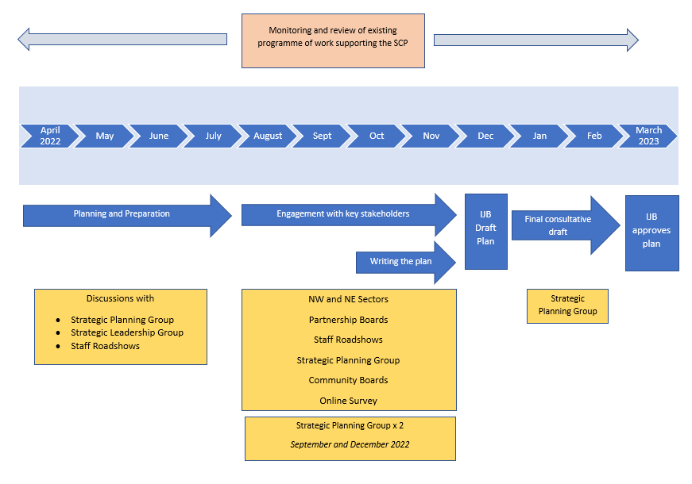
Strategic Needs Analysis

A comprehensive needs analysis has been developed with expert support from the Local Intelligence Support Team (Public Health Scotland). The draft analysis is attached as appendix 2 and will be further developed in the early part of 2023, with final publication alongside the SCP in March 2023.

Key messages from this detailed work include the following:

Population change
By mid-2043, it is projected that the overall population of North Lanarkshire will be very slightly lower than current levels (-0.9%), while the overall Scottish population is projected to increase by 2.5%. It projected that by 2043, in North Lanarkshire:

- those aged 0-15 to shrink by 14.8%  - those aged 75 and over to increase by 71.4%  - working age population to shrink by 4%  - pensionable age population to increase by 26% by 2043 | 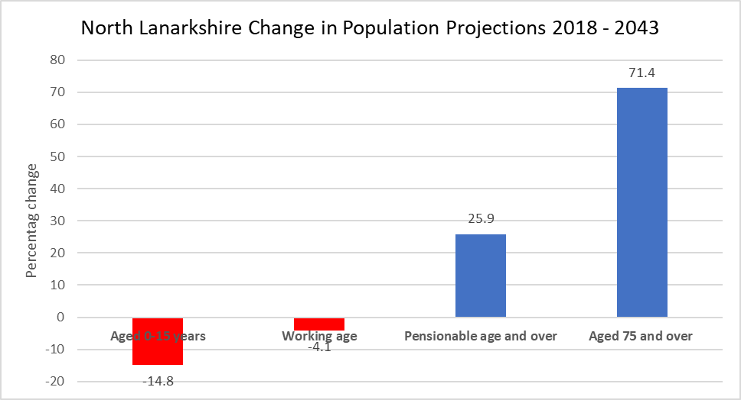

In relation to the forecasted increase in an ageing population, people will be living longer and as a result it is anticipated this will result in an increase in the number of people with long term conditions, and an increase in the number of older people with multiple conditions. As these changes are in addition to current, long standing public health issues such as obesity, physical inactivity, smoking, alcohol and substance misuse – it is expected these changes associated with an ageing population will increase demand for Health and Social care services.

The next 20 years will see an ageing population, a continuing shift in the pattern of disease towards long-term conditions, and growing numbers of older people with multiple conditions and complex needs and the impact of this on them and their immediate carers. There will be an increasing number of older family carers and older people within our workforce - many of whom will have their own health needs. The overall impact will be a steadily increasing demand for health and social care.

On the one hand, we must ensure that we are able to manage and mitigate the levels of demand from an ageing population on our health and care services. First and foremost, extending the number of years that our population spends living in good health is vital. If people in Scotland live longer, but not healthier lives, then more people will spend a greater proportion of their lives in some kind of ill-health. An outcome of this would be increasing demand on health and care services for a longer period of time across the lifespan.

Life expectancy
Life expectancy and healthy life expectancy trends in Scotland have not improved since around 2012, and this is also this case for North Lanarkshire. These life expectancy trends indicate the urgency of addressing their underlying causes – the social and economic circumstances such as poverty, housing, and education that together influence health throughout the life.

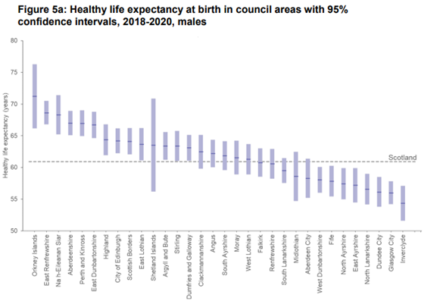 | 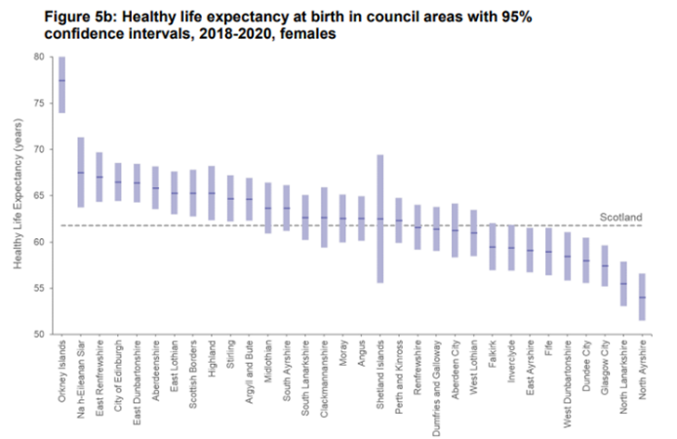

Poverty and deprivation
North Lanarkshire has a higher proportion of its population living in the 20% most deprived datazones compared to the Scottish position – 33% of North Lanarkshire’s population live in the 20% most deprived datazones compared with 19% of Scotland’s population living in the 20% most deprived datazones. This has increased since the 2016 SIMD.

Across North Lanarkshire, 50,897 (15%) people are income deprived, the Scottish average is 12%. Of this 50,897 income deprived population –
- 28,234 live in the 20% most deprived datazones and 21,655 live in the 15% most deprived datazones
- therefore, 22,663 income deprived people live outside the 20% most deprived datazones
- and 29,242 income deprived people live outside the 15% most deprived datazones

There are 24,796 working age people in North Lanarkshire experiencing employment deprivation. This is 11% of the working age population. In Scotland this is 9%.
- 13,415 people are employment deprived in the 20% most deprived datazones and 11,205 people are employment deprived in the 15% most deprived datazones,
- This means 11,381 employment deprived people live outside the 20% most deprived datazones
The number of people experiencing income and/or employment deprivation in North Lanarkshire has fallen since the 2016 SIMD.

Drugs death rate
The drug related death rate for North Lanarkshire is slightly higher than the Scottish average for the most recent figures (2017-21).

Alcohol related deaths
The age-standardised death rates for alcohol-specific deaths in North Lanarkshire are higher than the Scottish average and fourth highest in Scotland.

The age-standardised death rates for alcohol-specific deaths in the most deprived 20% of areas in Scotland has been consistently higher than the rest. The death rate in the most deprived areas is 4.3 times the rate in the least deprived areas in 2020 (41 deaths per 100,000 compared to 10). Since 2001 the death rate in the most deprived areas has remained the highest of all five SIMD quintiles although the gap has narrowed slightly.

Locality Profiles
We have developed profiles for each of our six localities – these are still in draft form and will be published in full in March 2023.

What We’ve Heard

The conversations which took place across the range of engagement activities highlighted in section above generated a richness of views, experience and intelligence from a range of individuals and stakeholders. Much of engagement focused on reviewing where we thought things were working well and where we felt there were ongoing challenges, or indeed, anticipated challenges in the future.

The achievements and challenges highlighted below are a distillation of these conversations and represent some of the common themes which emerged in our engagement activities.

Achievements

Resilience within the system – staff, carers, service users
A common thread through all our engagement activity was the recognition of the efforts and resilience of members of staff from across the health and social care sector, volunteers, carers, service users and family members in dealing with the many challenges of the C-19 pandemic.

Focus on staff health, wellbeing and connectedness
Training, practical and psychological supports have been developed for staff wellbeing across the Health and Social Care partnership over the past two to three years. These initiatives are now aligned and incorporated within the major strategic workplans of both North Lanarkshire Council, NHSL and Health and Social Care Partnership NL which will inform and shape the way we work going forward, engaging with staff, embedding good practice in our ways of working and improving our methods of supporting staff in the longer term.

Use of technology – within a variety of settings
The use of technology has expanded considerably over the past three years, and the experience of the C-19 restrictions resulted in the acceleration of our plans to use technology more in relation to online appointments and consultations, technology-enabled care and also as a key element of our communication and day-to-day management.

Mental Health Renewal and Recovery
The recovery and renewal of our mental health services continues to progress and the importance of linking these efforts with our new priorities was reflected in engagement discussions and feedback.

Care Academy
The Health and Social Care Academy, based within the Coltness High School campus went live in August 2018, providing curriculum opportunities linked to the health and social care sector. These are targeted at young people in the senior phase of learning from the nine secondary schools in North Lanarkshire’s south locality.

It is focused on assisting pupils to gain qualifications as well as work related learning experiences which will help them in gaining employment and assist in meeting the workforce requirements of this sector. The main areas are health and social care, general nursing and allied health professions.

Community Solutions - community capacity building
Community Solutions is the community led, health and social care investment programme operating across North Lanarkshire focused on building communities where people can have full, independent lives. The programme, which has been in place since 2013, is a partnership between HSCNL, Voluntary Action North Lanarkshire (VANL), and the community and voluntary sector of North Lanarkshire. Its latest Strategy and Investment Plan 2022-25 was agreed in March 2022, setting out investment plans within the programme to strengthen community capacity and resilience and deliver person-centred, community-based support and services to priority groups.

Enhanced Capacity & Resilience
In February 2022, the Integration Joint Board approved a £20m business case, utilising both recurring and non-recurring resources to transform the whole health and social care system and build capacity and resilience within it. Building on the wider approach to recovery and renewal across the sector, investment has started to be made in supports and approaches which:
- Maximise capacity through new staffing, resources and services;
- Ensure staff wellbeing;
- Ensure system flow by improving planned discharge from hospital and increasing access to care in a range of community settings;
- Improve outcomes through collective investment in people, systems, services and supports which deliver the right care in the right setting.

Challenges

Increasing demand for services, with increasingly complex needs and limited capacity for response
With an ageing population, the projected growth in demand for health and social care services over the next 15-20 years is considerable. However, there was also a common view from those who engaged in our discussions that demand for services and support is increasing now and in the short-term and that individuals’ needs are becoming increasingly complex.

Cost of living crisis and widening inequalities
Given current challenges in relation to the cost of living crisis, the wider issues of poverty and income deprivation were highly prevalent in the discussions and engagement activity that took place. There are significant and persistent inequalities in outcomes across the North Lanarkshire population that have a significant impact on people’s life opportunities and life chances. There is strong evidence to suggest the experience of the C-19 pandemic has widened some inequalities with some sectors of society disproportionately affected by the disruption and restrictions. The current cost of living crisis will also disproportionately affect those with lower incomes.
Staff recruitment and retention
The wider health and social care sector has experienced challenges related to the recruitment and retention of staff for some time, with the recent experiences of COVID-19 and the United Kingdom leaving the European Union placing further pressure on challenging situation. There is a need to invest in the workforce through training and development, and clear career pathways allied to ensuring we make employment within the sector as attractive as possible. Through a values-based approach we should be offering flexible and positive working environments with an embedded culture of staff wellbeing.
National Care Service
The Scottish Government has committed to establishing a functioning National Care Service (NCS) by the end of the parliamentary term in 2026. The aims of the service are centred around early interventions that prevent or delay the development of care needs and reduce care needs that already exist; and the proposed service aspires to design services collaboratively with the people to whom they are provided and their carers’. These aims are reasonable and consistent with the priorities set out in this plan. However, social work and social care staff may transfer to a new organisation as part of the proposals but this is unclear at this point. Over the next 2-3 years, proposed changes will have a direct impact on colleagues working in health and social care and there will be a significant work to prepare for the implementation of the NCS.
Our Priorities and Ambitions for 2023 – 2026

The long term vision for the Health and Social Care partnership which was set out in the original Strategic Plan 2016-2026 remains relevant and will continue as the over-arching vision of this plan. The vision set out in 2016 was that the people of North Lanarkshire will achieve their full potential through:

- Living safe, healthy and independent lives in their communities.
- Receiving the information, support and care they need, efficiently and effectively, at the right time, in the right place and in the right way.
- Ensuring North Lanarkshire is the best place in Scotland to grow up

In 2020, we identified six key ambitions that helped to prioritise our areas for action:

- Do the right thing first time
- Provide a range of community services to support people to live well in connected communities
- Focus on what matters to people (outcomes)
- Be at the forefront of technical and sustainable solutions
- Promote prevention and early intervention
- Ensure North Lanarkshire is the best place to work, volunteer and care

Following our engagement with stakeholders, taking into account the experience of the past three years and the current and future challenges facing the partnership, it has been agreed to revise our ambitions to the following:
- Do the right thing first time
- Increased focus on prevention, early intervention and tackling inequalities by working with communities and people
- Develop and support a workforce for the future
- Improve mental health and wellbeing
- Support people through a whole family approach

Do the right thing first time
Overarching the whole system is the work to ensure that when people make contact with our services that the response is quick and effective, with a focus on helping people to help themselves first. The continued development of First Point of Contact incorporating good conversations across the Health and Social Care Partnership (HSCP) and embedding the approach with a whole system focus remains a priority and will ultimately support getting it right first time.

Increased focus on prevention, early intervention and tackling inequalities by working with communities and people

The population and needs analysis within this Plan highlights the need to do things differently, to understand the demographic challenges facing North Lanarkshire and to harness the opportunities of people living healthier lives for longer. Changing the way we deliver services and support people includes acknowledging that in some cases the way we do things attracts higher costs because we focus more on managing crises and late interventions. We need to focus more on prevention, early intervention and empowering people to live fulfilling lives.

By providing ‘upstream’ support at an early stage, we can reduce the demand on intensive health and care service and re-invest in more community focused support services. However, we recognise that early and effective support is not always best provided through health and social care services. Through working with our partners in the Third Sector, we can identify, support and develop local community-based programmes, run by voluntary and independent organisations that focus on the health and care needs of local communities.

Work will take place to support and empower people to continue to live healthy, meaningful and more personally satisfying lives as active members of their community for as long as possible. To do this will show ambition and be innovative to develop and try new ways of providing services that haven’t been done before, even that is difficult and sometimes more risky than the easy option.

We value and recognise the vital role local people and communities play and through our Engagement and Participation structures we will continue to ensure we provide a voice for local people, service users, patients and carers and ensure we listen to their needs and aspirations. Our strategic planning arrangements don’t stop with publication of a plan, and so engagement and participation from local people will extend into the delivery of our partnership priorities.

Develop and support a workforce for the future
The increase in ageing population of North Lanarkshire is broadly mirrored within the workforce of the health and social care sector, therefore it is important for us to be cognisant of this and ensure mechanisms are put in place to allow flexibility and support to both our ageing workforce, and our workforce throughout each career level from entry level to ensure their physical and mental health is nurtured.

There are also continuing challenges with regards to resourcing, attracting, recruiting and retaining staff. There is an increasing need to support a ‘pipeline’ of workers coming into the profession, for example through highlighting the sector in schools, through other opportunities in developing the young workforce, through wider employability routes, or from career changers.

Whole system planning requires further development to better understand the needs and demands of communities including their public health challenges, the types of roles needed to support different Health and Social Care needs, and the availability of different types of workers over time and geographically, as well as the relationships and influences between all parts of the system.

Improve mental health and wellbeing
We know, through our service information and through speaking to our local communities, that mental health concerns are increasing in the population. This means potentially a greater demand for mental health services and community supports. There is a need for a refreshed and reinvigorated approach to mental health improvement and the delivery of the Lanarkshire Mental Health & Wellb
eing Strategy, continuing to focus on the four core areas:
- Good mental health for all
- Improving access to mental health supports and services
- Children and young people’s mental health and wellbeing
- Specialist mental health services

Supporting people through a whole family approach
Our aspiration is to support adults and children of all ages with the tools to set, plan for and achieve their goals together. This puts wellbeing at the heart of our approach and considers the situation that adults and children live in, who they live with and family relationships. This may include helping an adult and their family to think about what may happen in the future, and plan for those possible changes, when the adult needs more care or if a carer becomes unwell; supporting carers of all ages within their caring role and as equal partners in care; supporting families where substance use and other challenges exist. This means in practice understanding each person as an individual, as well as recognising the part they play in their family and community. The approach builds on everyone’s strengths and develops their resilience.

Clearly, these priorities are interlinked and we expect them to influence and shape each other as we progress our implementation.

Implementation Plan
Under each priority area we will develop an agreed set of shorter and medium term goals (Programme of Work) that we plan to address between 2023 and 2026. The Programme of Work will set out in detail the programmes that will be progressed over the next three years. We will update these on an annual basis to ensure that we stay on track and, at the same time, be able to respond to any new or emerging issues that we need to address. We will closely monitor our progress and continue to seek out feedback from service users, carers, and families on the impact we are making.

Enabling Our Plan

Medium Term Financial Plan

A medium term financial plan will sit alongside the Strategic Commissioning Plan for the period 2023-26. The financial outlook for the public sector is extremely challenging and so it is essential that our strategic ambitions are set against the financial resources we anticipate will be available.

The IJB financial strategy must ensure sustainability for the current and future years whilst recognising the current significant challenges for both partners. Efficient, effective and affordable services fit for the future will need to be developed as part of the integration and transformational change activities.

The IJB Medium to Long Term Financial Plan was prepared in March 2020 and underpins strong financial planning and management, the achievement of best value and the allocation of resources to support sustainable models of service delivery from a whole system perspective, ensuring our limited resources are targeted to achieve our outcomes. This plan however was prepared before the impact of the emergency response to the Covid-19 pandemic was known. As part of the recovery plan to the Covid-19 pandemic, the IJB Medium to Long Term Financial Plan is being reviewed to reflect the operational and financial challenges.

The IJB Chief Finance Officer will continue to consult with both partners about the options available to address all 2022/2023 recurring and non-recurring health and social care cost pressures. Cost reduction options will be explored however this is not expected to release sufficient funding to meet the total increase in all health and social care cost pressures going forward. Reliance will therefore require to be placed on non-recurring funding and reserves.

Our joint focus with all our partners and stakeholders will continue to be ensuring that all resources in scope are maximised, health and social care services are remobilised and a whole system approach across North Lanarkshire is adopted which is sustainable and operates efficiently and effectively.

Market Facilitation Plan

The Plan outlines our approach, sets out our commitment to working in partnership and outlines how we will communicate key messages, enabling a basis for early engagement and consultation with the market on how best to respond to supporting social care and support need. Engagement will take place through existing communication channels and provider forums, with the aim of developing a joint action plan to support the delivery of the Market Facilitation Plan, which will also reflect the Strategic Plan objectives. We need providers to consider these key messages if they wish to be best placed to respond to future market requirements.

Developing a Market Facilitation Plan is an evolving process and we will involve all our partner organisations on an on-going basis to help make sure that the changes we wish to make can be delivered and sustained.

Workforce Plan
Our workforce planning arrangements are integrated with the Lanarkshire Health and Social Care Integrated Workforce Plan 2022-25 and the Workforce for the Future Strategy. Through our combined efforts with NHS Lanarkshire and North Lanarkshire Council we are seeking to build a flexible, resilient and skilled workforce for the future across the health and social care sector and we will continue to expand and develop the Care Academy model that has already proved successful.

Housing Contribution Statement – TO FOLLOW
an overarching strategic statement of how the Integration Authority intends to work with housing services, whether delegated to it or not, to deliver its outcomes.

- role of the local housing sector in the governance arrangements for the integration of health & social care;
- Provide a short overview of the shared evidence base and key issues identified in relation to housing needs and the link to health and social care;
- Set out the shared outcomes and service priorities linking the Strategic Commissioning Plan and Local Housing Strategy;
- Set out the current and future resources and investment required to meet these shared outcomes and priorities, and identify where these will be funded from the integrated budget and where they will be funded by other (housing) resources;

Engagement and Participation Strategy
Health and Social Care North Lanarkshire (HSCNL) has a firm commitment to ensuring ongoing meaningful involvement with the communities it serves. This engagement and participation strategy sets out how we will achieve this. This will ensure we have the right systems and supports in place to enable effective engagement between stakeholders and HSCNL and the strategy and approach is a key supporting pillar of the overall Strategic Commissioning Plan.

Transformation Plan
This Strategic Commissioning Plan seeks to address the need to act now and have a lasting and sustainable impact and build resilience in the whole system supporting people and communities in North Lanarkshire. Investment across the sector must strengthen services and supports in creating additional capacity across our health and care system as well as targeting our efforts to transform and redesign to ensure people can access the right support from the right person at the right time.

Recognising that more of the same will not sustain robust services and supports into the future, a Strategic Commissioning Plan Programme Board (SCP PB) has been established to ensure a whole system approach is adopted to support transformational change which capitalises on the availability and use of all of our resources and will drive forward the transformation agenda emanating from this plan.
A key element of our Transformation Plan will be an Organisational Development Strategy focusing on our leadership values, culture and behaviours. We will look to build on our strengths to develop a compassionate leadership model which encourages and sustains behaviours of understanding, empathising and helping create inclusive, effective and collective cultures within our teams.

We will also further develop our programme management approach to the delivery and implementation of this plan and its programme of work, with identified training and development resources available to leaders and managers to effectively deliver a shared transformation and improvement agenda.

Support, Care & Clinical Governance – quality and standards of care and support
A Support, Care & Clinical Governance framework is in place for integrated services, built upon the national clinical and care governance framework. The framework encompasses the following

- Professional regulation, workload and workforce development;
- Information assurance;
- Service user experience and safety and quality of integrated service delivery and personal outcomes;
- Person-centre care;
- Management of clinical risks; and
- Learning from adverse event

Measuring our Performance
The Health and Social Care Partnership has long been committed to a whole system approach, recognising the co-dependencies that exist across the entire health and social care system. Ensuring we have a performance framework that reflects the whole system requires continued engagement with partners and stakeholders from across the whole system, including but not limited to: HSCP services, Acute services, NLC services, third sector, carers, people with lived experience, etc.

We have robust performance monitoring processes in place which allow us to assess how well we are delivering health and care services to the people of North Lanarkshire. As part of our annual performance reporting arrangements, we are required to demonstrate how we perform against the nine national health and wellbeing outcomes. These are:

- People are able to look after and improve their own health and wellbeing and live in good health for longer.
- People, including those with disabilities or long-term conditions, or who are frail, are able to live, as far as reasonably practicable, independently and at home or in a homely setting in their community.
- People who use health and social care services have positive experiences of those services, and have their dignity respected.
- Health and social care services are centred on helping to maintain or improve the quality of life of people who use those services.
- Health and social care services contribute to reducing health inequalities.
- People who provide unpaid care are supported to look after their own health and wellbeing, including to reduce any negative impact of their caring role on their own health and well-being.
- People who use health and social care services are safe from harm.
- People who work in health and social care services feel engaged with the work they do and are supported to continuously improve the information, support, care and treatment they provide.
- Resources are used effectively and efficiently in the provision of health and social care services.

These nine national health and wellbeing outcomes are underpinned by 23 performance measures which are reported through our Annual Performance Reports. In addition to the reporting on the 23 national indicators, we also publish information a further suite of six indicators set out by the Scottish Governments Ministerial Strategic Group for Health and Community Care.

Appendix 1
List of engagement events and activities

Date | Forum | Type of engagement
7 June 2022 | Strategic Planning Group | Online event, via MS Teams
9 June 2022 | Locality Planning Group Chairs event | In person event
4 August 2022 | Staff Roadshow | Online event, via MS Teams
31 August 2022 | North East Sector – Motherwell, Bellshill and Wishaw Localities (staff, stakeholders, elected members and carer/service user representatives) | In person event
7 September 2022 | North West Sector – North, Coatbridge and Airdrie Localities (staff, stakeholders, elected members and carer/service user representatives) | In person event
13 September 2022 | Strategic Planning Group | Online event, via MS Teams
29 September 2022 | Community Board Strategic Engagement Event | Online event, via MS Teams
30 September 2022 | Session with Public Partnership Forum North | In person event
7 October 2022 | Adult Health Services Event | In person event
7 October 2022 | Specialist Children’s Health Services Event | In person event
20 October 2022 | Session with Access Panel | In person meeting
27 October 2022 | Staff Roadshow | Online event, via MS Teams
2 November 2022 | IJB Liaison Session | Online event, via MS Teams

