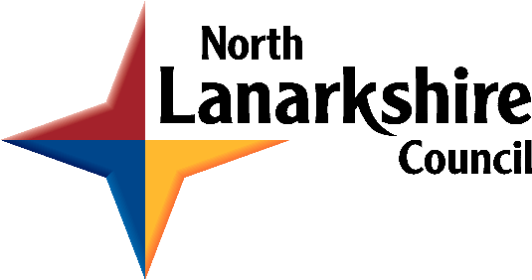
NORTH LANARKSHIRE LICENSING BOARD

INCOME AND EXPENDITURE REPORT 2022/2023

The North Lanarkshire Licensing Board is required under section 9B of the Licensing (Scotland) Act 2005 to publish an annual financial report within three months of the end of the relevant financial year.

This report has been prepared using financial data taken on 31 March 2023.

The financial statement is as follows:

Income | £ |  | Expenditure | £
Income (licensing fees) (1) | £388,963 |  | Staff costs (2) | £232,167
Total | £388,963 |  | Transport | £48
 |  |  | Supplies | £8,467
 |  |  | Overheads (3) | £43,801
 |  |  | Departmental recharges | £105,934
 |  |  | Total | £390,418
 |  |  | Difference between income and expenditure surplus/deficit | (-£1,495)

Notes:
- Denotes income from applications and annual fees received under the Licensing (Scotland) Act 2005
- Denotes salary, superannuation, national insurance and pension costs associated with the Licensing Standards Officers, Clerk and other legal services staff responsible for administration support under paragraph eight of Schedule 1 to the Licensing (Scotland) Act 2005.
- Denotes the portion of central administrative costs allocated to the Licensing Board budget.

