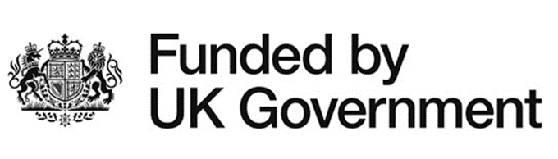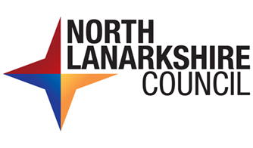

UK Government Shared Prosperity Fund
North Lanarkshire Council
Privacy Statement

North Lanarkshire Council is a local authority established under the Local Government etc. (Scotland) Act 1994. Its head office is located at Civic Centre, Windmillhill Street, Motherwell, ML1 1AB, United Kingdom.

The UKSPF is a government funded programme and North Lanarkshire Council are expected to capture and hold information about the projects that receive funding to help us assess how well the programme is doing and what impact(s) the projects are having on our local communities.

You can contact our Data Protection Officer, by post at this address or by email: DataProtection@northlan.gov.uk.

Personal information that we will collect and use

We require to process personal data relating to the individuals who are submitting the grant applications on behalf of an organisation. We will only obtain and use the necessary information for the delivery of the UKSPF challenge funds projects. We are not permitted to collect information that we do not need or will not use.

The following personal information will be processed to manage the Shared Prosperity Fund Grants applications –

- Full name of representative for the organisation
- Contact details including email and telephone number

The purposes we use your personal information for and what we do with it

You are giving us your personal information to allow us to assess your eligibility, progression and results/outcomes for programmes funded through the UK Shared Prosperity Fund (UKSPF). We will also use the information provided to support evaluation of the Challenge Funds delivered through the UKPSF. The Data Controller for this programme is North Lanarkshire Council and as such, they will maintain all paper copies of paperwork – Application Form, Assessment, monitoring evidence, etc. All electronic data is stored on the Council’s Sharepoint system maintained by North Lanarkshire Council.

North Lanarkshire Council will process grant funding applications for the purposes of grants for:

- Supporting volunteer development
- Supporting locally based community activities and initiatives
- Improving digital infrastructure in community facilities/buildings
- Development of the tourism sector

Your information will be used:

- To comply with UK Government funder rules and regulations,
- To allow us to manage and process applications for UKSPF challenge funds
- To allow us to conduct necessary background checks to prevent fraud
- To allow us to monitor outcomes in relation to your project,
- To contact you in regard to your application
- To monitor compliance with equal opportunities legislation
- To allow us to report project updates to the UK Government’s Department for Levelling Up, Housing and Communities (DLUHC)
- To carry out evaluation of the approaches used to deliver the UKSPF Programme

Legal basis for using your information

Under the UK General Data Protection Regulation (UK GDPR) our lawful basis for processing the personal data is Public Task – Article 6 (e) states that processing will be compliant when ‘processing is necessary for the performance of a task carried out in the public interest or in the exercise of official authority vested in the controller.’

Who do we share your information with?

We are legally obliged to safeguard public funds so are required to verify & check your details internally for fraud prevention. We may share this information with other public bodies (& receive information from these other bodies) for fraud checking purposes.

We are also legally obliged to share certain data with other public bodies, such as HMRC and will do so where the law requires this. We will also generally comply with requests for specific information from other regulatory and law enforcement bodies where this is necessary and appropriate. Your information is also analysed internally to help us improve our services.

This data sharing is in accordance with our Privacy Policy and covered in our full privacy statement on our website.

The information you provide on your application form will be shared within North Lanarkshire Council and Funders as appropriate.

How long do we keep your information for?
We only keep your personal information for the minimum period amount of time necessary. The period is set out by the funding requirements and also based on the business need.

We maintain a records retention and disposal schedule which sets out how long we hold different types of information for. You can view this on our website or you can request a hard copy from the contact address stated above.

Information which we need to retain for purposes of UK Government audit requirements will be retained in accordance with the rules set out in the Council Retention Schedule. Currently the minimum retention date is to 31 March 2030 for the UKSPF programme.

Your rights under data protection law

Under the Data Protection Act 2018 and the UK GDPR you have the following rights:

Access to your information
You have the right to request a copy of the personal information that we hold about you.

Right to request rectification or deletion of your personal data
We want to make sure that your personal information is accurate, complete, and up to date. Therefore, you may ask us to correct any personal information about you that you believe does not meet these standards

You have the right to ask us to delete personal information about you where -
- you think that we no longer need to hold the information for the purposes for which it was originally obtained,
- you have a genuine objection to our use of your personal information - see Objecting to how we may use your information below,
- our use of your personal information is contrary to law or our other legal obligations.

Right to object to the processing of your personal data
You have the right at any time to tell us to stop using your personal information for direct marketing purposes.

Restricting how we may use your information
In some cases, you may ask us to restrict how we use your personal information. This right might apply, for example, where we are checking the accuracy of personal information that we hold about you or we are assessing the objection you have made to our use of your information.

This right might also apply if we no longer have a basis for using your personal information but you don't want us to delete the data. Where this right is realistically applied will mean that we may only use the relevant personal information with your consent, for legal claims or where there are other public interest grounds to do so.

Please contact us as stated above if you wish to exercise any of these rights.

Complaints
We aim to directly resolve all complaints about how we handle personal information. If your complaint is about how we have handled your personal information, you can contact the Council's Data Protection Officer by Email - DataProtection@northlan.gov.uk.

You have the right to make a complaint at any time to the Information Commisioner’s Officer, the UK Data Protection Regulator. Complaints may be submitted to the Information Commissioner at:

Information Commissioners Office – Scotland
Queen Elizabeth House
Sibbald Walk
Edinburgh
EH8 8FT

Telephone: 0303 123 1115

Email: scotland@ico.org.uk

Please note if your complaint is not about a data protection matter or concerns the handling of personal information, please contact us using the complaints procedures in place.

