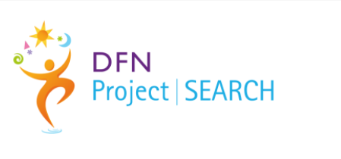

University Hospitals Monklands & Wishaw

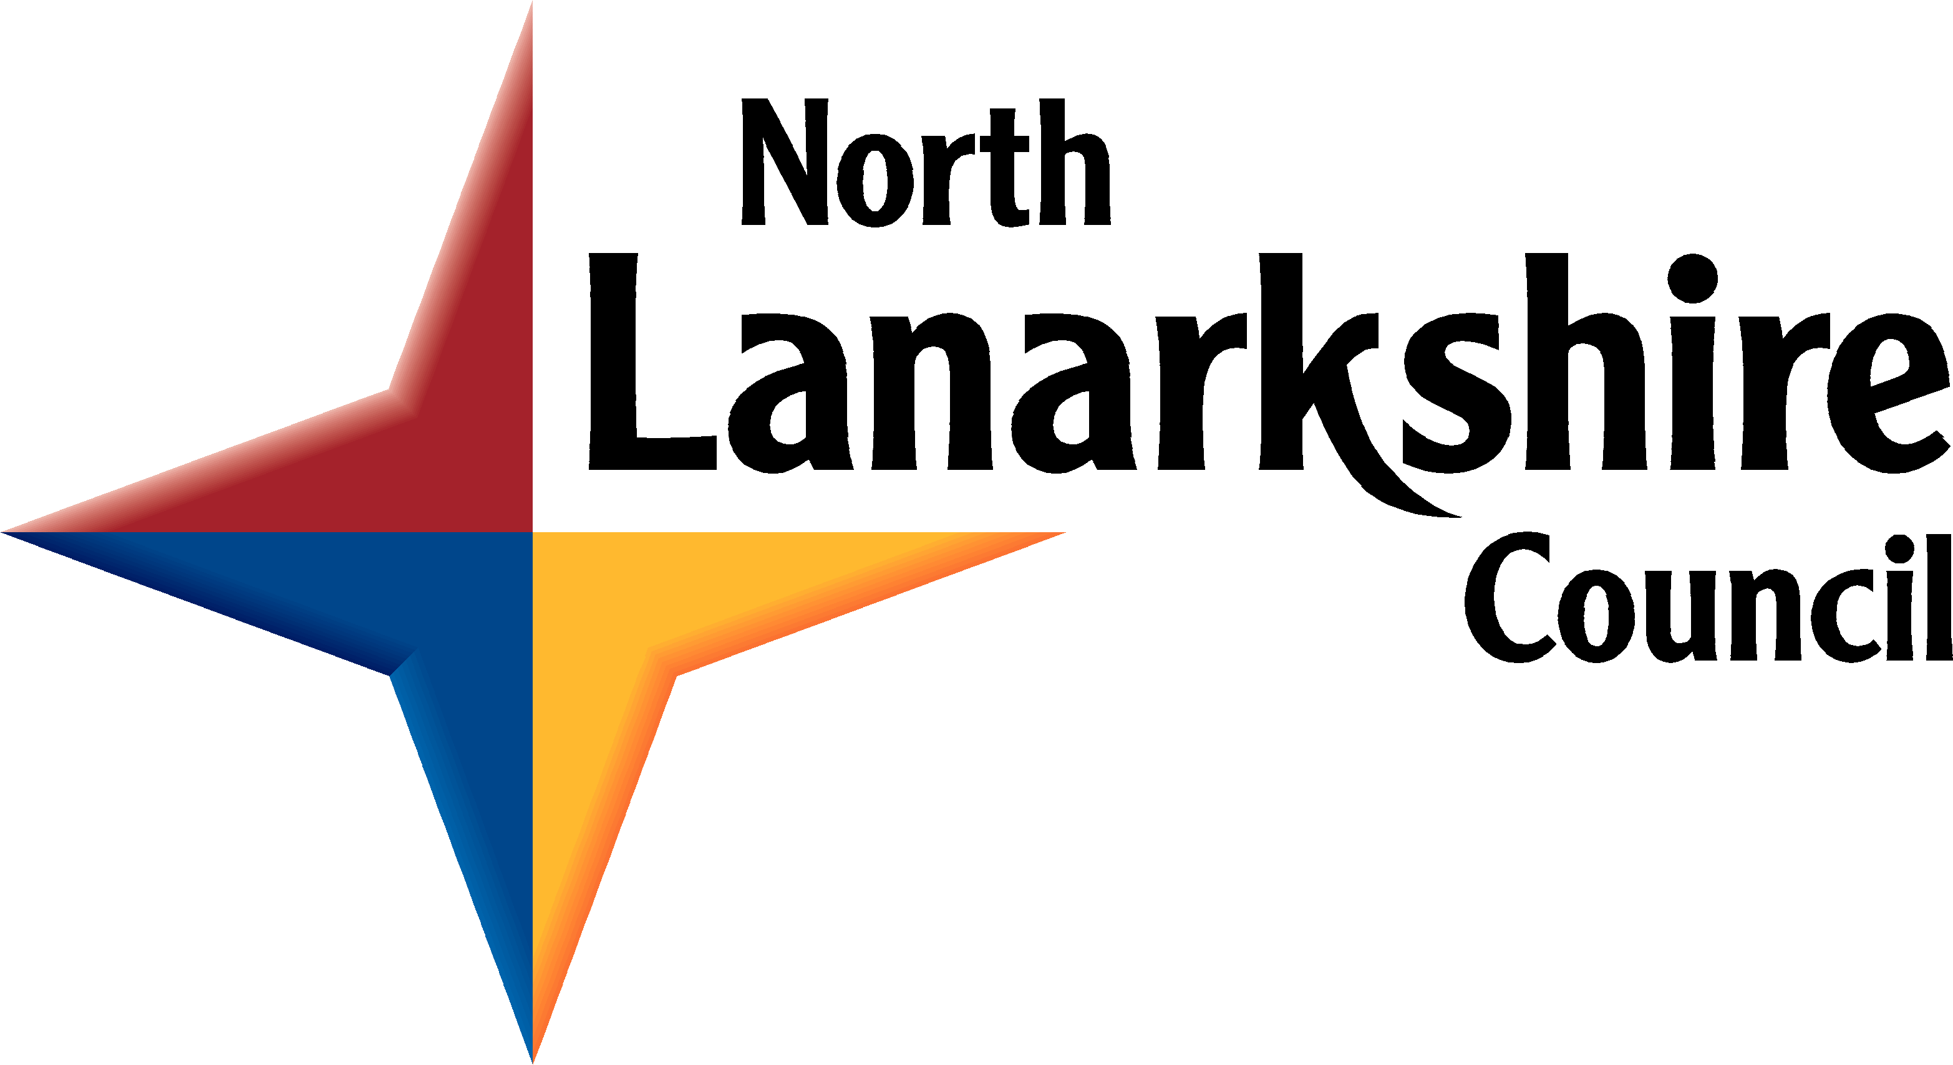  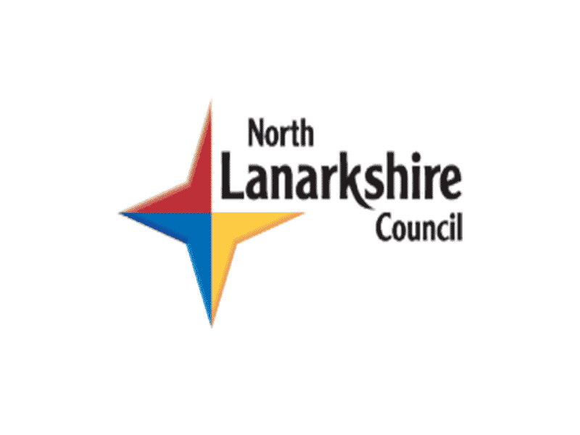 | 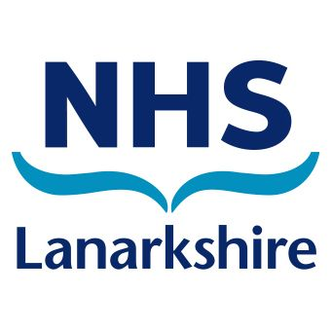 |  |  | 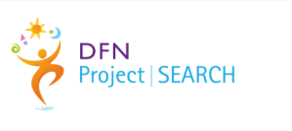

   | DFN Project search is a 9-month training course for young adults who have a learning disability or autism who want to learn all about work
 | We run two courses, one in University Hospital Wishaw and the other in University Hospital Monklands
 | You will learn lots of different things in the training room including how to  - write a CV  - what is important in work  - how to keep fit and healthy for work
 | You will complete 2 or 3 work placements each lasting about 11 weeks, where you will develop new skills and learn how to complete different tasks in a job
 | The project starts in August each year and finishes in June the following year
 | You attend Monday to Thursday from 9.00am to 4.00pm and (9.00am – 12.30pm on a Friday  There will be regular breaks
 | You do not get paid, but you may be able to get a bursary from the college. You can also apply if you are on Universal Credit
 | You will get the same holidays as New College Lanarkshire students
 | DFN Project search is a partnership run by-  - NHS Lanarkshire  - New College Lanarkshire  - North Lanarkshire Council – Supported Employment
 | Lots of people will help you on the project, you will get all the help you need from the lecturer, job coach and hospital staff
 | To apply, you must –  - Live in North Lanarkshire  - Be aged between 18 to 29 years old  - Be able to travel independently to the hospital  - Be willing to work 16 hours or more a week
 | You can apply by going to New College Lanarkshire website  www.nclanarkshire.ac.uk  - click on courses  - click on Employability Programmes  - click on DFN Project SEARCH
 | If you have any questions, feel free to contact Supported Employment on 01698 274500 or email SupportedEmployment2@northlan.gov.uk

