Open Space Strategy
  - Green and Open Space
  - Public Opinion Survey Report

Date: 22 August 2023
Authored by: Moira McKenna Dell
Senior Project Officer (Planning)
Strategy and Policy
Enterprise and Communities
North Lanarkshire Council
Contact: mckennam@northlan.gov.uk

Contents
Executive Summary 2
Background and objectives 3
Survey method 4
Survey results 4
Open Space Survey 1: 5
Open Space Survey 2 35
Appendix 1 37
Open Space Survey 1 Questions: 37
Open Space Survey 2 Questions: 42
Appendix 2 43
Open Space Survey 1 – ‘not listed above’ responses 43
Open Space Survey 2 – ‘not listed above’ responses 48

Executive Summary
As part of the process of developing an Open Space Strategy, the council sought feedback from our communities in relation to green and open space in North Lanarkshire via online surveys.
The surveys sought feedback on the perceptions of green and open space in North Lanarkshire and invited people to identify sites in the area that were important to them using an interactive map.
Statistics and findings:
- A total of 1185 responses were received on people’s perception of green and open space (Open Space Survey 1)
- A total of 465 spaces were identified as being important to our communities (Open Space Survey 2)
- 88.11% of participants visited open space once a week or more.
- 73.76% had a 10-minute walk or less to their nearest green or open space. The majority (53%) could walk to their nearest green or open space within 5 minutes.
- 89.7% of participants strongly agreed with the statement ‘Visiting green spaces makes me feel better’.
- 53.84% of participants were very satisfied or quite satisfied with the quality of their local greenspace. 13.92% were neither satisfied nor dissatisfied.
- 69.96% of participants responded ‘yes’ or ‘maybe’ that they would be interested in volunteering in future.
- The main factors that would influence if people used green and open space more or less often were:
- Litter
- Antisocial behaviour or vandalism
- Maintained paths for walking, wheeling and cycling
- Levels of cleanliness

Background and objectives
The Planning (Scotland) Act 2019 introduced new statutory duties upon councils to prepare and publish an Open Space Strategy (OSS) and to assess the sufficiency of play opportunities for children in their area.
An open space strategy must contain:
(a) an audit of existing open space provision
(b) an assessment of current and future requirements
(c) any other matter which the planning authority consider appropriate
North Lanarkshire Council is in the process of developing our ambitious Open Space Strategy (OSS) that will set out a strategic framework of North Lanarkshire’s policies and proposals for the development, maintenance, and use of green infrastructure, including open spaces and green networks.
Our aim is to work with partners, stakeholders and communities to maintain a diverse range of well-maintained, connected green, open and civic spaces across North Lanarkshire.
We wanted to hear from as many people as possible to give a balanced overview of everyone’s interests and allow us to make best use of the limited resources available. To do so, as part of the stakeholder engagement forming part of the Open Space Strategy study, we carried out two public opinion surveys on green and open space.
- Open Space Survey 1 asked for general views, including perception of the quality and accessibility of our green and open spaces.
- Open Space Survey 2 gave an opportunity for people to tell us more about specific spaces which are important to them where they live.
These surveys were conducted for 12 weeks from 17 April to 10 July 2023 and were designed to allow us to gain an understanding on the use and perceptions of green and open spaces, and to understand what spaces were important to people.
The data collected will be used to inform our Open Space Strategy as well as assisting with future policy, planning, and management of open spaces.

Survey method
Having decided to use online surveys to get the greatest reach, and giving people to option to contact us where they needed assistance, we decided to use ArcGIS Survey123 for data gathering.
In addition to allowing us to create, share and analyse questions, this system provided the solution to gathering map-based location data needed to help us identify spaces in North Lanarkshire that were important to people.
Open Space Survey 1 was a questionnaire. The format consisted of 17 questions with some having the option for people to comment and tell us more where their answer was not listed in the options.
Open Space Survey 2 was a map-based question that allowed people to pinpoint on a map a specific site that was important to them, and to let us know what they used that space for.
For both open space surveys, all multiple select answer options were randomised to remove the potential for answer option order bias.
The open space surveys were made available on the council website and promoted via the council’s various social media channels including Facebook, Twitter (currently rebranding to X) and Govdelivery. Posters were printed with a QR code linking to the surveys and distributed round key locations in country parks and handed by the Open Space Rangers.

Survey results
The total number of responses for each survey is as follows:
- Survey 1 asking for general views, including perception of the quality and accessibility of our green and open spaces: 1185 responses.
- Survey 2 giving an opportunity for people to tell us more about specific spaces which are important to them where they live: 465 responses.
This report contains charts and tables. Where response percentages do not sum to 100%, this may be due to computer rounding or multiple answers.
Where questions had multiple response options, participants were invited to select as many that applied to them.
Not every participant responded to every question.

Open Space Survey 1:
Participants were asked to tell us some basic information about themselves, including age, gender and ethnicity. Asking these ‘about you’ questions can help us understand the needs, perceptions, satisfaction, behaviour and lifestyle of different members of the community.

About the participants
Q1. Of the 1,185 participants, the highest number of responses were from people who live in North Lanarkshire (72.32%).
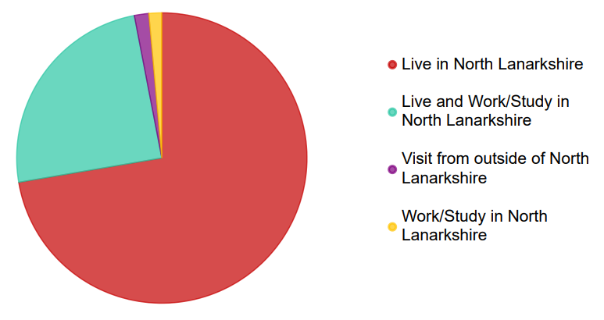
Answers | Count | Percentage
Live in North Lanarkshire | 857 | 72.32%
Live and work/study in North Lanarkshire | 292 | 24.64%
Visit from outside of North Lanarkshire | 19 | 1.6%
Work/study in North Lanarkshire | 17 | 1.43%

Q2. Age of participants
A broad age range of participants completed the survey with the 41 – 50 and the 51 – 60 age group accounting for the majority of the responses (27.17% and 26.58% respectively).

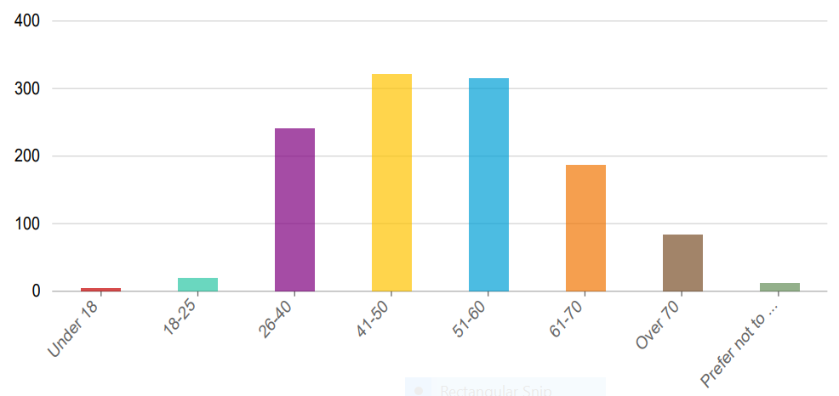

Answers | Count | Percentage
Under 18 | 5 | 0.42%
18 - 25 | 19 | 1.6%
26 - 40 | 241 | 20.34%
41 - 50 | 322 | 27.17%
51 - 60 | 315 | 26.58%
61 - 70 | 187 | 15.78%
Over 70 | 84 | 7.09%
Prefer not to say | 12 | 1.01%

Q3. Gender of participants
The majority of the participants were female (68.95%)
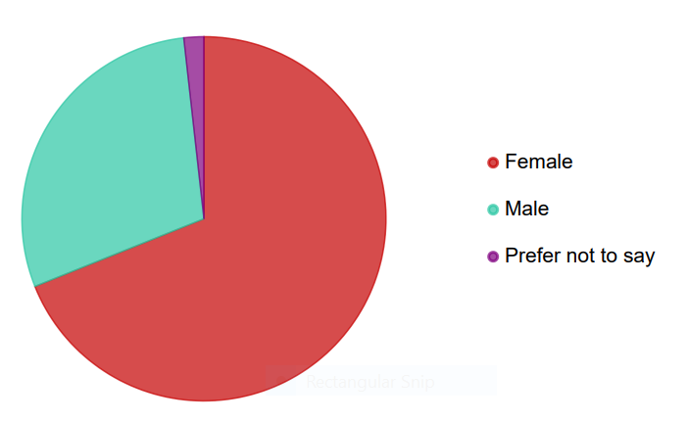
Answers | Count | Percentage
Female | 817 | 68.95%
Male | 347 | 29.28%
Prefer not to say | 21 | 1.77%

Q4. Ethnicity of participants
The majority of participants identified as being White: Scottish, other British, Irish, Polish, Gypsy/Traveller or other white (96.12%).

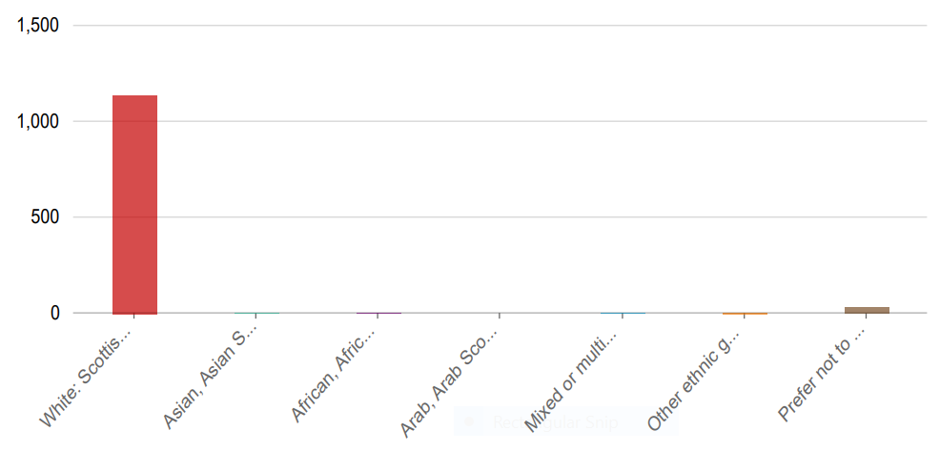
Answers | Count | Percentage
White: Scottish, other British, Irish, Polish, Gypsy/Traveller or other white | 1,139 | 96.12%
Asian, Asian Scottish/British or other Asian | 3 | 0.25%
African, African Scottish/British or other African | 2 | 0.17%
Arab, Arab Scottish/British or other Arab | 0 | 0%
Mixed or multiple ethnic group: White and Black Caribbean, White and Black African, White and Asian, any other mixed background | 4 | 0.34%
Other ethnic group | 5 | 0.42%
Prefer not to say | 32 | 2.7%

Q5. How participants describe themselves
Those in full time employment and part time employment account for 66.58% of participants (52.15% and 14.43% respectively).

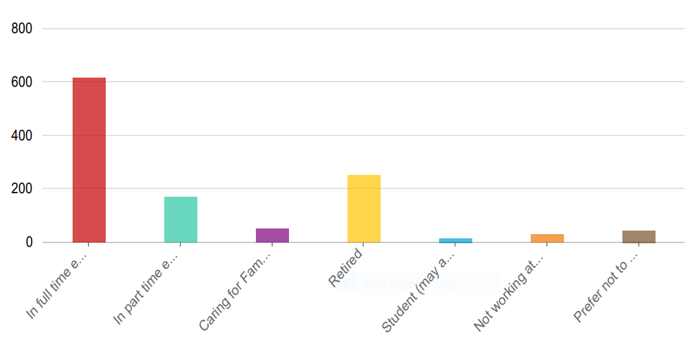

Answers | Count | Percentage
In full time employment | 618 | 52.15%
In part time employment | 171 | 14.43%
Caring for Family | 52 | 4.39%
Retired | 252 | 21.27%
Student (may also be working too) | 16 | 1.35%
Not working at the moment | 31 | 2.62%
Prefer not to say | 45 | 3.8%

Q6. Participants were asked if they were disabled. Most people responding to the survey were not disabled, however 9.2% of participants responded that they were disabled with 3.88% preferred not to say.
Of the 75 participants that elected to tell us more about their disability, the majority used the word ‘mobility’ when describing their disability.

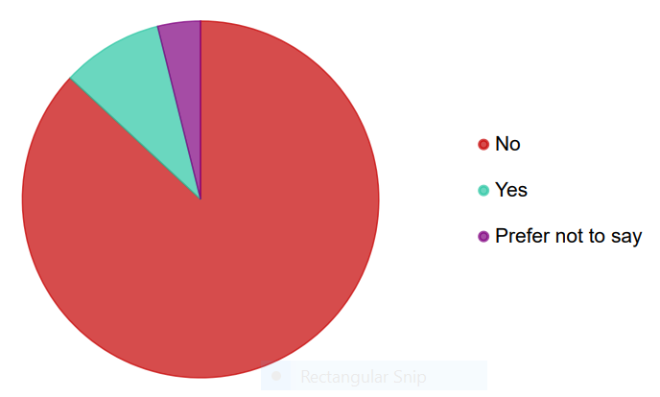
Answers | Count | Percentage
No | 1,030 | 86.92%
Yes | 109 | 9.2%
Prefer not to say | 46 | 3.88%

  - 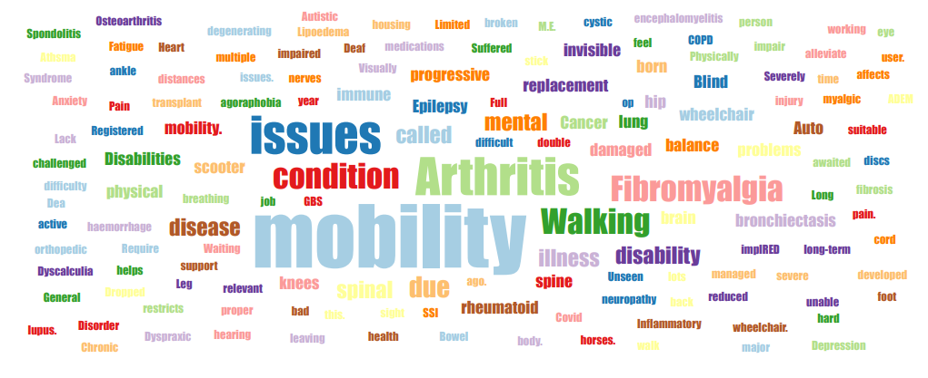
Word cloud created using participants description of their disability.
Q7. Participants were asked to provide their postcode. ML6, followed by ML1 were the most referenced postcodes.

Word cloud created using participants postcodes.

About North Lanarkshire's green and open spaces
Participants were asked what type of spaces they used, how they got there and their perception of green and open spaces in North Lanarkshire.
Participants were also asked what would make them more or less likely to use green and open spaces in North Lanarkshire and if given the opportunity, whether they would consider volunteering.

Q8. Participants were asked which types of green and open spaces they visited most often.
The most popular responses were:
- Woodland: 74.09%
- Local park: 69.54%
- General greenspace - grassed areas for informal activities (such as playing, running about, picnicking, dog walking): 63.38%
- Natural or semi natural greenspace: 60.34%

Of the ‘not listed above’ responses, not everyone told us more. Where they did, the most common themes were canals and riverbanks.
All ‘not listed above’ responses can be viewed in Appendix 2.

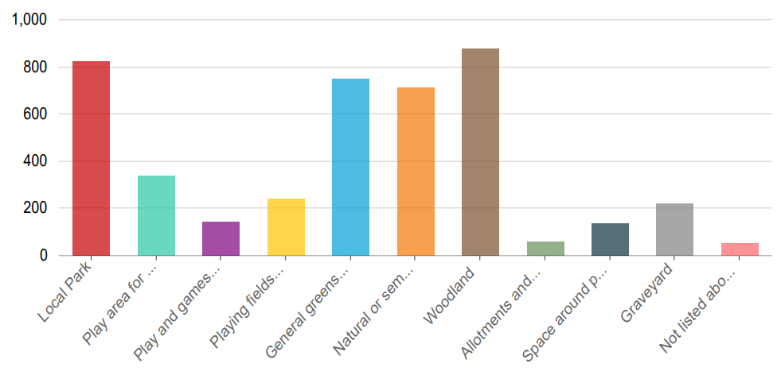

Answers | Count | Percentage
Local Park | 824 | 69.54%
Play area for young children | 339 | 28.61%
Play and games areas for older children/teenagers | 143 | 12.07%
Playing fields | 242 | 20.42%
General greenspace - grassed areas for informal activities (such as playing, running about, picnicking, dog walking) | 751 | 63.38%
Natural or semi natural greenspace | 715 | 60.34%
Woodland | 878 | 74.09%
Allotments and community growing space | 58 | 4.89%
Space around public buildings | 135 | 11.38%
Graveyard | 222 | 18.73%
Not listed above (please specify) | 51 | 4.3%

Q9. Participants were asked on average how aften they had visited green space and open spaces in North Lanarkshire in the last 12 months. The most popular answer given was several times a week (37.72%).
Overall, 88.11% of participants visited open space once a week or more.

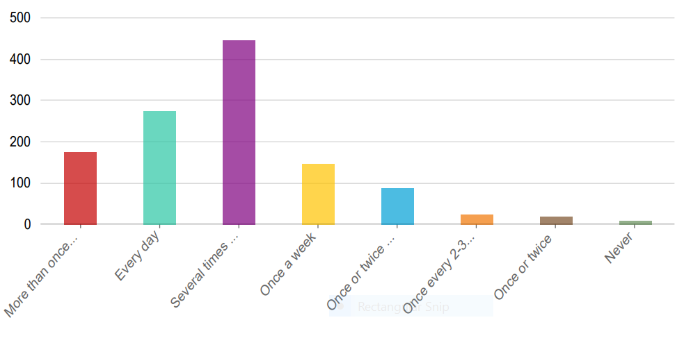

Answers | Count | Percentage
More than once per day | 175 | 14.77%
Every day | 275 | 23.21%
Several times a week | 447 | 37.72%
Once a week | 147 | 12.41%
Once or twice a month | 88 | 7.43%
Once every 2-3 months | 24 | 2.03%
Once or twice | 20 | 1.69%
Never | 9 | 0.76%

Q10. Participants were asked how they normally travel to green space areas in North Lanarkshire. The majority of people walk, wheel or cycle (66.5%). This was followed by car (32.49%).
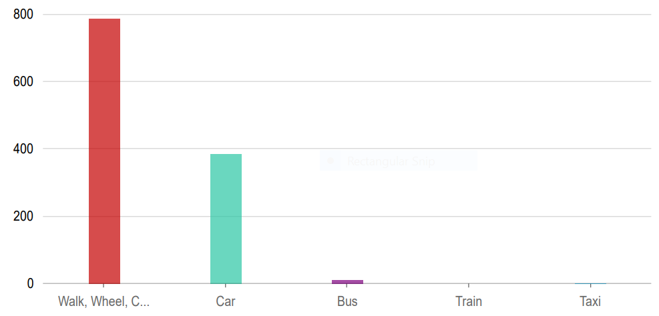

Answers | Count | Percentage
Walk, Wheel, Cycle | 788 | 66.5%
Car | 385 | 32.49%
Bus | 11 | 0.93%
Train | 0 | 0%
Taxi | 1 | 0.08%

Q11. Participants were asked how far away from their home, or place of work/study their nearest greenspace was in North Lanarkshire.
- For participants who live or live and work/study in North Lanarkshire, the majority (53%) had a 5 minute walk or less to their nearest green or open space. (1,146 answers).
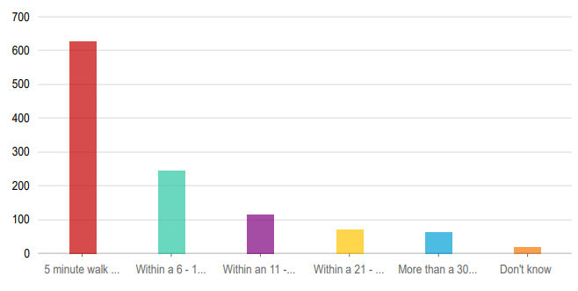

Answers | Count | Percentage
5 minute walk or less | 628 | 53%
Within a 6 - 10 minute walk | 246 | 20.76%
Within an 11 - 20 minute walk | 116 | 9.76%
Within a 21 - 30 minute walk | 71 | 5.99%
More than a 30 minute walk | 65 | 5.49%
Don’t know | 20 | 1.68%

- For participants who work/study in North Lanarkshire, the majority had a 5 minute walk or less to their nearest green or open space. (17 answered)
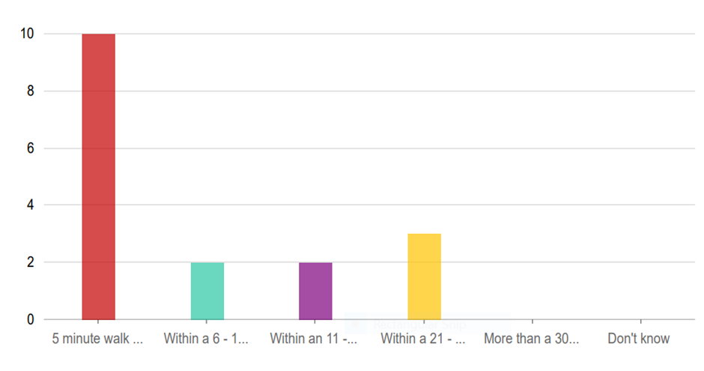

Answers | Count | Percentage
5 minute walk or less | 10 | 0.84%
Within a 6 - 10 minute walk | 2 | 0.17%
Within an 11 - 20 minute walk | 2 | 0.17%
Within a 21 - 30 minute walk | 3 | 0.25%
More than a 30 minute walk | 0 | 0%
Don’t know | 0 | 0%

- For participants who visit from outside North Lanarkshire, the majority had more than a 30 minute walk to get to their nearest green or open space in North Lanarkshire. (19 answered)
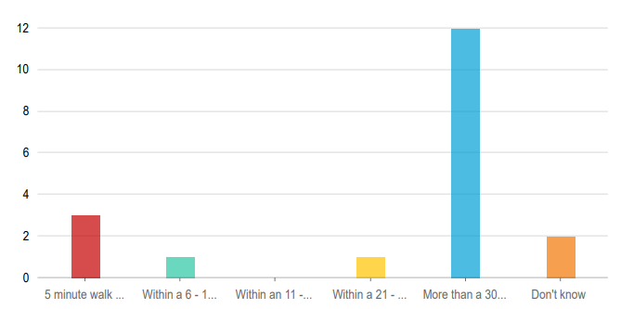
Answers | Count | Percentage
5 minute walk or less | 3 | 0.25%
Within a 6 - 10 minute walk | 1 | 0.08%
Within an 11 - 20 minute walk | 0 | 0%
Within a 21 - 30 minute walk | 1 | 0.08%
More than a 30 minute walk | 12 | 1.01%
Don’t know | 2 | 0.17%

Q12. Participants were asked if they agree or disagree with the following statement: ‘Visiting green spaces makes me feel better’.
The majority agreed strongly (89.7%)
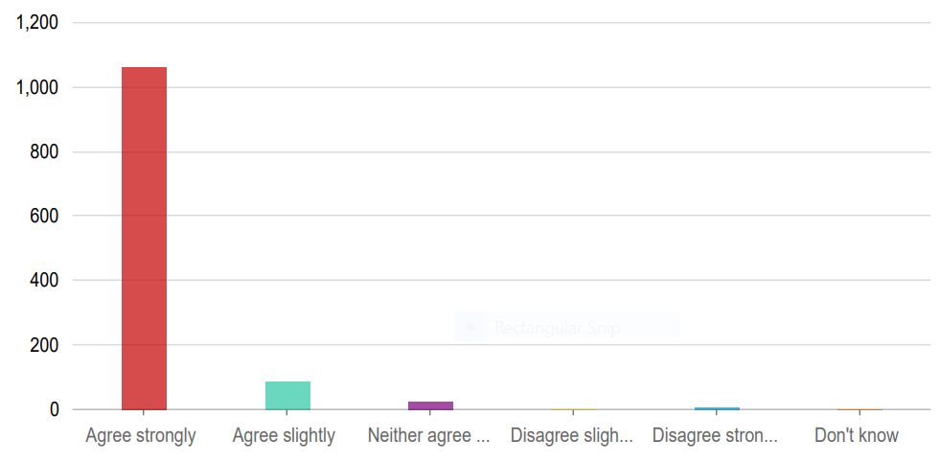

Answers | Count | Percentage
Agree strongly | 1,063 | 89.7%
Agree slightly | 89 | 7.51%
Neither agree nor disagree | 24 | 2.03%
Disagree slightly | 1 | 0.08%
Disagree strongly | 7 | 0.59%
Don’t know | 1 | 0.08%

Q13. Participants were asked how satisfied they were with the quality of their local greenspace overall.
The majority of participants were very satisfied or quite satisfied with the quality of their local greenspace (53.84%). The most popular response was quite satisfied (39.49%)

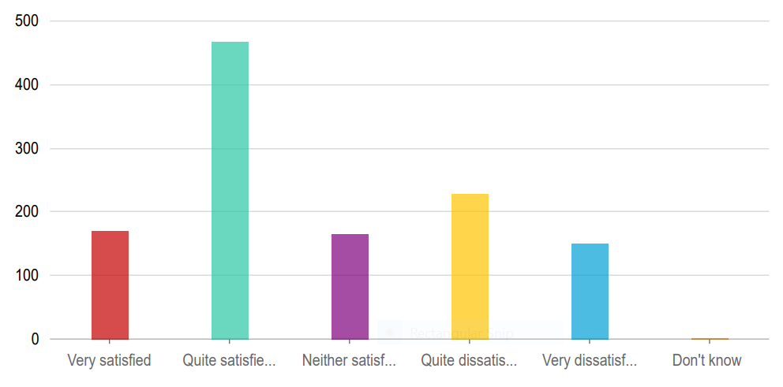

Answers | Count | Percentage
Very satisfied | 170 | 14.35%
Quite satisfied | 468 | 39.49%
Neither satisfied nor dissatisfied | 165 | 13.92%
Quite satisfied | 229 | 19.32%
Very satisfied | 151 | 12.74%
Don’t know | 2 | 0.17%

Q14a. Participants were asked how much they agreed or disagreed that their nearest greenspace was somewhere they could relax and unwind.
The majority of participants agreed strongly or agreed slightly that their nearest greenspace was somewhere they could relax and unwind (78.57%). The most popular response was agree strongly (47.43%)
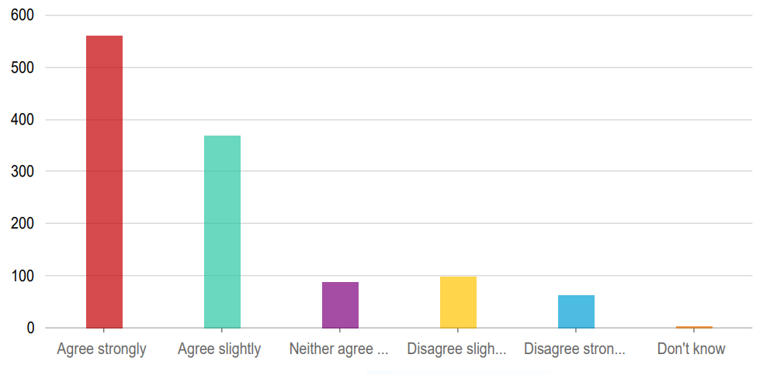

Answers | Count | Percentage
Agree strongly | 562 | 47.43%
Agree slightly | 368 | 31.14%
Neither agree nor disagree | 89 | 7.51%
Disagree slightly | 99 | 8.35%
Disagree strongly | 63 | 5.32%
Don’t know | 3 | 0.25%

14b. Participants were asked how much they agreed or disagreed that their nearest greenspace was a safe place to visit.
The majority of participants agreed strongly or agreed slightly that their nearest greenspace was a safe place to visit (66.41%). The most popular response was agree slightly (39.32%).

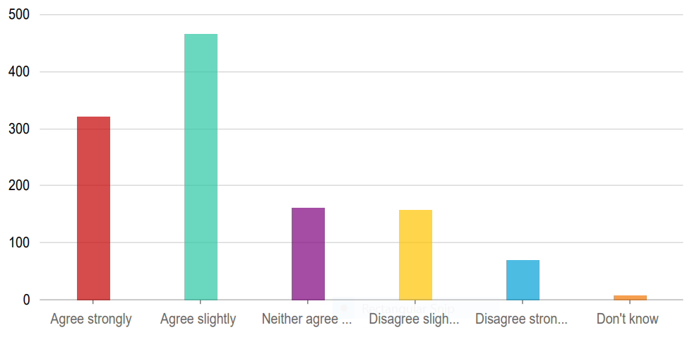
Answers | Count | Percentage
Agree strongly | 321 | 27.09%
Agree slightly | 466 | 39.32%
Neither agree nor disagree | 162 | 13.67%
Disagree slightly | 158 | 13.33%
Disagree strongly | 70 | 5.91%
Don’t know | 8 | 0.68%

14c. Participants were asked how much they agreed or disagreed that their nearest greenspace was somewhere that encourages physical activity – such as walking, cycling, sports and play.
The majority of participants agreed strongly or agreed slightly that their nearest greenspace was somewhere that encourages physical activity – such as walking, cycling, sports and play. (77.73%). The most popular response was agree strongly (47.43%).

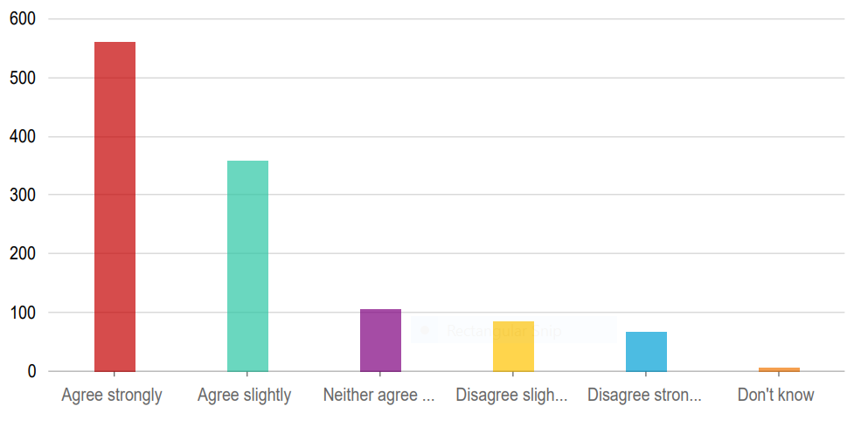
Answers | Count | Percentage
Agree strongly | 562 | 47.43%
Agree slightly | 359 | 30.3%
Neither agree nor disagree | 106 | 8.95%
Disagree slightly | 85 | 7.17%
Disagree strongly | 67 | 5.65%
Don’t know | 6 | 0.51%

14d. Participants were asked how much they agreed or disagreed that their nearest greenspace was an attractive place.
The majority of participants agreed strongly or agreed slightly that their nearest greenspace was an attractive place. (65.49%). The most popular response was agree slightly (34.77%).

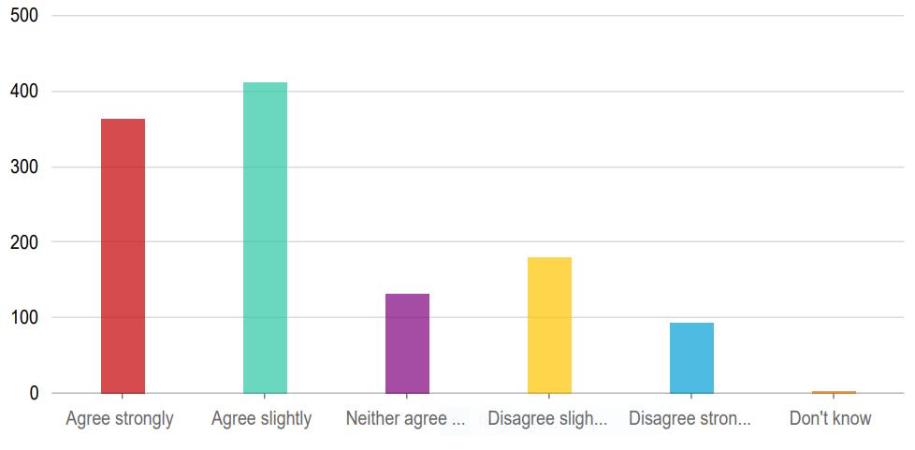

Answers | Count | Percentage
Agree strongly | 364 | 30.72%
Agree slightly | 412 | 34.77%
Neither agree nor disagree | 132 | 11.14%
Disagree slightly | 180 | 15.19%
Disagree strongly | 94 | 7.93%
Don’t know | 3 | 0.25%

14e. Participants were asked how much they agreed or disagreed that their nearest greenspace was a good place for young people to play.
The majority of participants agreed strongly or agreed slightly that their nearest greenspace was a good place for young people to play (53.42%). The most popular response was agree slightly (31.14%).

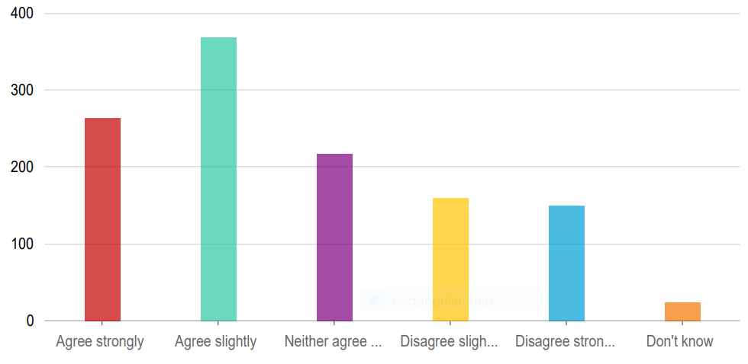

Answers | Count | Percentage
Agree strongly | 264 | 22.28%
Agree slightly | 369 | 31.14%
Neither agree nor disagree | 218 | 18.4%
Disagree slightly | 160 | 13.5%
Disagree strongly | 150 | 12.66%
Don’t know | 24 | 2.03%

14f. Participants were asked how much they agreed or disagreed that their nearest greenspace allowed them to explore nature.
The majority of participants agreed strongly or agreed slightly that their nearest greenspace allowed them to explore nature (76.12%). The most popular response was agree strongly (44.98%).
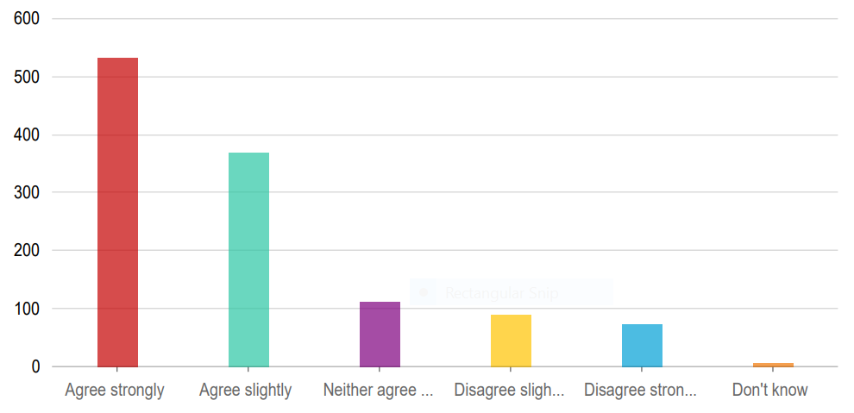

Answers | Count | Percentage
Agree strongly | 533 | 44.98%
Agree slightly | 368 | 31.14%
Neither agree nor disagree | 113 | 9.54%
Disagree slightly | 90 | 7.59%
Disagree strongly | 73 | 6.16%
Don’t know | 7 | 0.59%

14g. Participants were asked how much they agreed or disagreed that their nearest greenspace is easy to get to.
The majority of participants agreed strongly or agreed slightly that their nearest greenspace was a good place for young people to play (83.88%). The most popular response was agree strongly (54.43%).

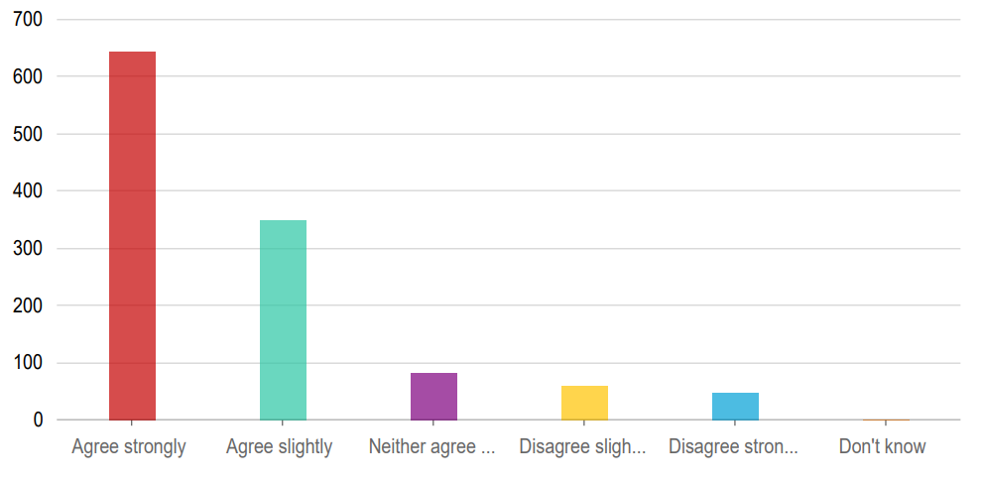

Answers | Count | Percentage
Agree strongly | 645 | 54.43%
Agree slightly | 349 | 29.45%
Neither agree nor disagree | 83 | 7%
Disagree slightly | 59 | 4.98%
Disagree strongly | 48 | 4.05%
Don’t know | 1 | 0.08%

14h. Participants were asked how much they agreed or disagreed that their nearest greenspace was easy to get around.
The majority of participants agreed strongly or agreed slightly that their nearest greenspace was easy to get around (82.11%). The most popular response was agree strongly (45.06%).

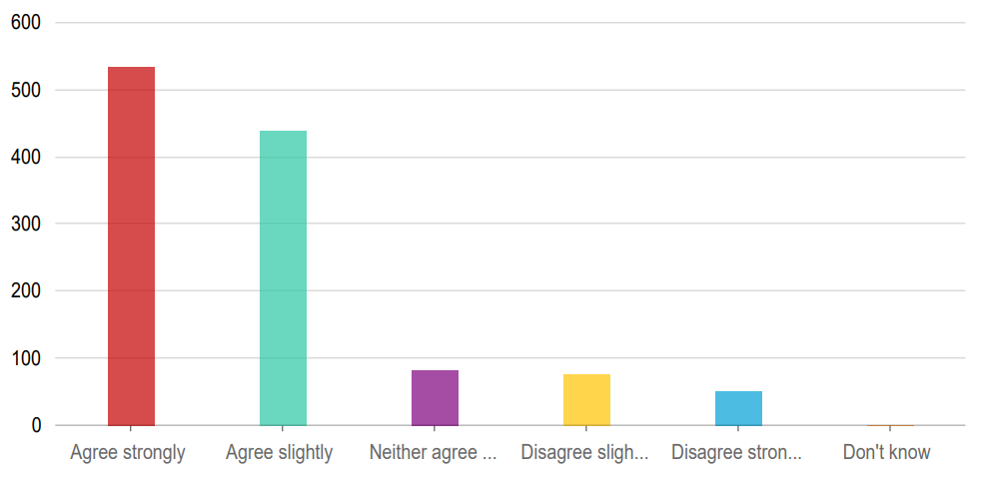

Answers | Count | Percentage
Agree strongly | 534 | 45.06%
Agree slightly | 439 | 37.05%
Neither agree nor disagree | 83 | 7%
Disagree slightly | 76 | 6.41%
Disagree strongly | 52 | 4.39%
Don’t know | 1 | 0.08%

14i. Participants were asked how much they agreed or disagreed that their nearest greenspace benefits their health and wellbeing.
The majority of participants agreed strongly or agreed slightly that their nearest greenspace benefits their health and wellbeing (91.48%). The most popular response was agree strongly (71.56%).
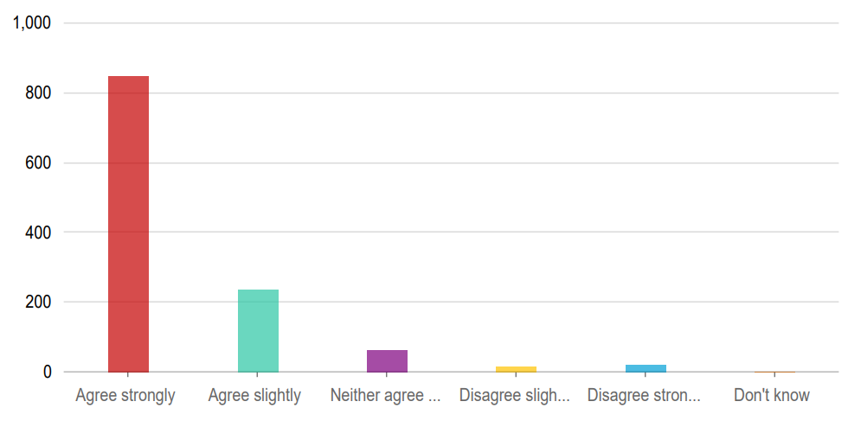

Answers | Count | Percentage
Agree strongly | 848 | 71.56%
Agree slightly | 236 | 19.92%
Neither agree nor disagree | 62 | 5.23%
Disagree slightly | 15 | 1.27%
Disagree strongly | 22 | 1.86%
Don’t know | 2 | 0.17%

14j. How much participants agreed or disagreed that their nearest greenspace is welcoming.
The majority of participants agreed strongly or agreed slightly that their nearest greenspace was welcoming (63.8%). The most popular response was agree slightly (33.5%).

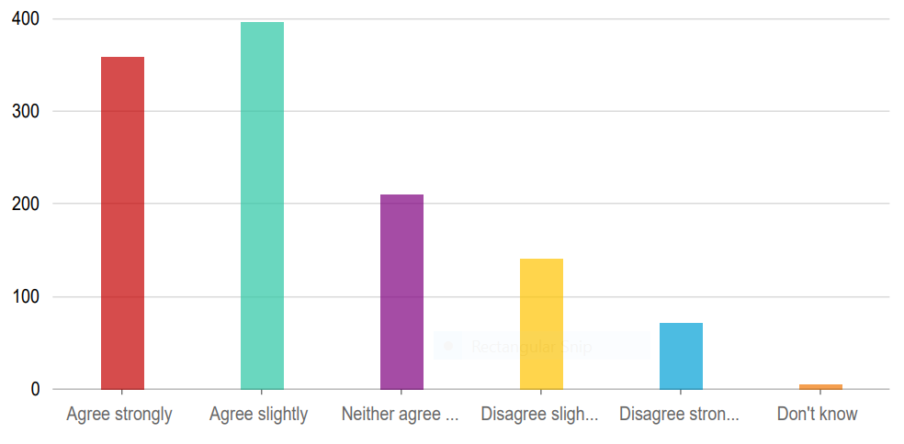

Answers | Count | Percentage
Agree strongly | 359 | 30.3%
Agree slightly | 397 | 33.5%
Neither agree nor disagree | 211 | 17.81%
Disagree slightly | 141 | 11.9%
Disagree strongly | 72 | 6.08%
Don’t know | 5 | 0.42%

14k. How much participants agreed or disagreed that their nearest greenspace makes the area they live in / work or study in a better place to be.
The majority of participants agreed strongly or agreed slightly that their nearest greenspace makes the area they live in / work or study in a better place to be (78.14%).
The most popular response was agree strongly (54.68%).

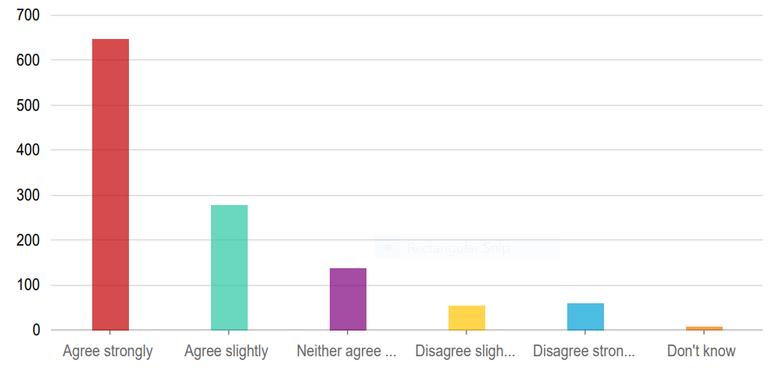

Answers | Count | Percentage
Agree strongly | 648 | 54.68%
Agree slightly | 278 | 23.46%
Neither agree nor disagree | 138 | 11.65%
Disagree slightly | 54 | 4.56%
Disagree strongly | 60 | 5.06%
Don’t know | 7 | 0.58%

Q15. Participants were asked what, if anything, would encourage them to use or visit North Lanarkshire’s greenspace or open spaces more often. They were asked to select all answers that applied.
A broad range of responses were given. The most popular responses were:
- Low levels of litter (72.57%)
- No signs of antisocial behaviour or vandalism (72.41%)
- Well maintained paths for walking, wheeling and cycling (68.02%)
- High levels of cleanliness and free from dog fouling (66.58%)
Of the ‘not listed above’ responses, not everyone told us more. Where they did, the most common themes were accessibility (Lights, Pavements, Lowered Kerbs) and more bins.
All ‘not listed above’ responses can be viewed in Appendix 2.

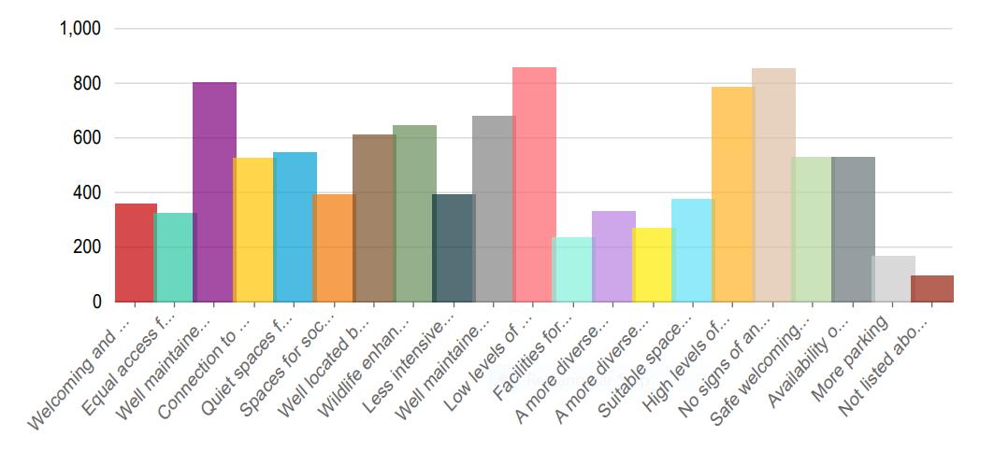
Answers | Count | Percentage
Welcoming and well-located entrances | 362 | 30.55%
Equal access for all with no barriers (such as steps, poor signage or lack of disabled persons parking space) | 327 | 27.59%
Well maintained paths for walking, wheeling and cycling | 806 | 68.02%
Connection to other spaces (such as paths and active travel routes for walking, wheeling or cycling and/or public transport) | 530 | 44.73%
Quiet spaces for destressing, relaxing and unwinding | 551 | 46.5%
Spaces for socialising with family and friends | 395 | 33.33%
Well located benches, picnic tables or shelters | 613 | 51.73%
Wildlife enhancements (such as tree and wildflower planting, long grass, wetlands and shrubs) | 648 | 54.68%
Less intensively maintained natural spaces where you can feel closer to nature (see birds and wildlife) | 397 | 33.5%
Well maintained spaces | 648 | 57.72%
Low levels of litter | 860 | 72.57%
Facilities for sports and recreation | 237 | 20%
A more diverse range of play spaces and recreational opportunities for children | 335 | 28.27%
A more diverse range of outdoor activities recreational opportunities for teenagers and young people (for example skateparks, multi-use games areas) | 271 | 22.87%
Suitable spaces for elderly and disabled people | 378 | 31.9%
High levels of cleanliness and free from dog fouling | 789 | 66.58%
No signs of antisocial behaviour or vandalism | 858 | 72.41%
Safe welcoming spaces with natural surveillance, clear sight lines and appropriate lighting | 533 | 44.98%
Availability of public toilets | 534 | 45.06%
More parking | 171 | 14.43%
Not listed above (please specify) | 99 | 8.53%

Q16. Participants were asked what, if anything, would make them less likely to use or visit North Lanarkshire’s greenspace or open spaces. They were asked to select all answers that applied.
A broad range of responses were given, the most popular responses were:
- Antisocial behaviour or vandalism (80.76%)
- High levels of litter (78.14%)
- Low levels of cleanliness and clear evidence of dog fouling (69.37%)
- Poorly maintained spaces (58.57)
- Poorly maintained paths for walking, wheeling and cycling (57.06%)

Of the ‘not listed above’ responses, not everyone told us more. Where they did, the most common theme was regarding dogs (off lead, fouling, lack of litter bins, lack of walking areas/parks, signage).
All ‘not listed above’ responses can be viewed in Appendix 2.

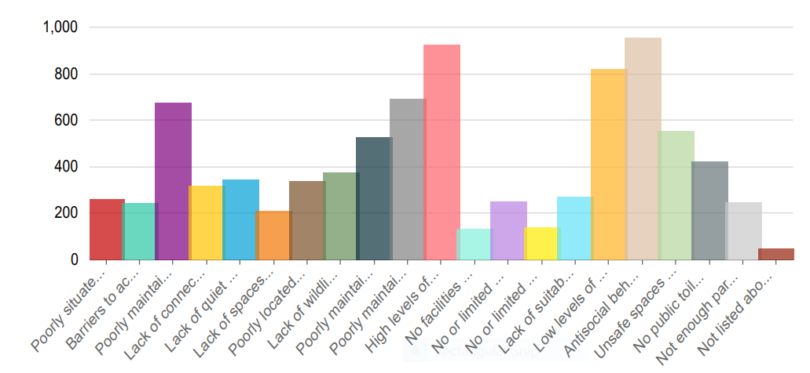

Answers | Count | Percentage
Poorly situated entrances | 260 | 21.94%
Barriers to access (such as steps, poor signage or lack of disabled persons parking space) | 246 | 20.76%
Poorly maintained paths for walking, wheeling and cycling | 676 | 57.06%
Lack of connection to other spaces (such as paths and active travel routes for walking, wheeling or cycling and/or public transport) | 320 | 27%
Lack of quiet spaces for destressing, relaxing and unwinding | 346 | 29.2%
Lack of spaces for socialising with family and friends | 211 | 17.81%
Poorly located benches, picnic tables or shelters | 338 | 28.52%
Lack of wildlife enhancements (such as tree and wildflower planting, long grass, wetlands and shrubs) | 375 | 31.65%
Poorly maintained natural spaces with poor links to nature | 528 | 44.56%
Poorly maintained spaces | 694 | 58.57%
High levels of litter | 926 | 78.14%
No facilities for sports and recreation | 134 | 11.31%
No or limited play spaces and recreational opportunities for children | 252 | 21.27%
No or limited outdoor activities recreational opportunities for teenagers and young people (for example skateparks, multi-use games areas) | 140 | 11.81%
Lack of suitable spaces for elderly and disabled people | 270 | 22.78%
Low levels of cleanliness and clear evidence of dog fouling | 822 | 69.37%
Antisocial behaviour or vandalism | 957 | 80.76%
Unsafe spaces with no natural surveillance, clear sight lines and appropriate lighting | 555 | 46.84%
No public toilets | 423 | 35.7%
Not enough parking | 248 | 20.93%
Not listed above (please specify) | 49 | 4.14%

Q17. Participants were asked if given the opportunity, would they be interested in volunteering in green and open space areas?
Contact details were not collated as this question was designed to gauge interest and plan future volunteering opportunities.
The majority of people (69.96%) indicated yes (36.88%) or maybe (33.08%) that they would be interested in volunteering in future.

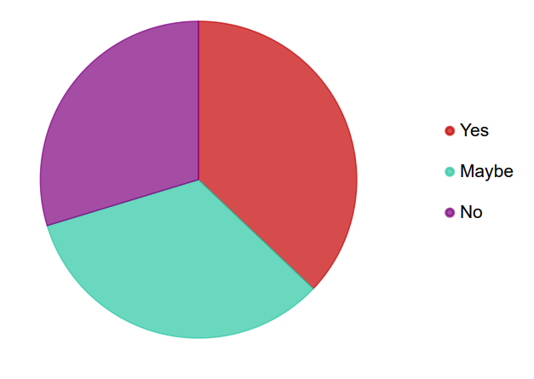
Answers | Count | Percentage
Yes | 437 | 36.88%
Maybe | 392 | 33.08%
No | 350 | 29.54%

Open Space Survey 2

Participants were asked to pinpoint on a map a space that was important to them and tell us why they visit that space.
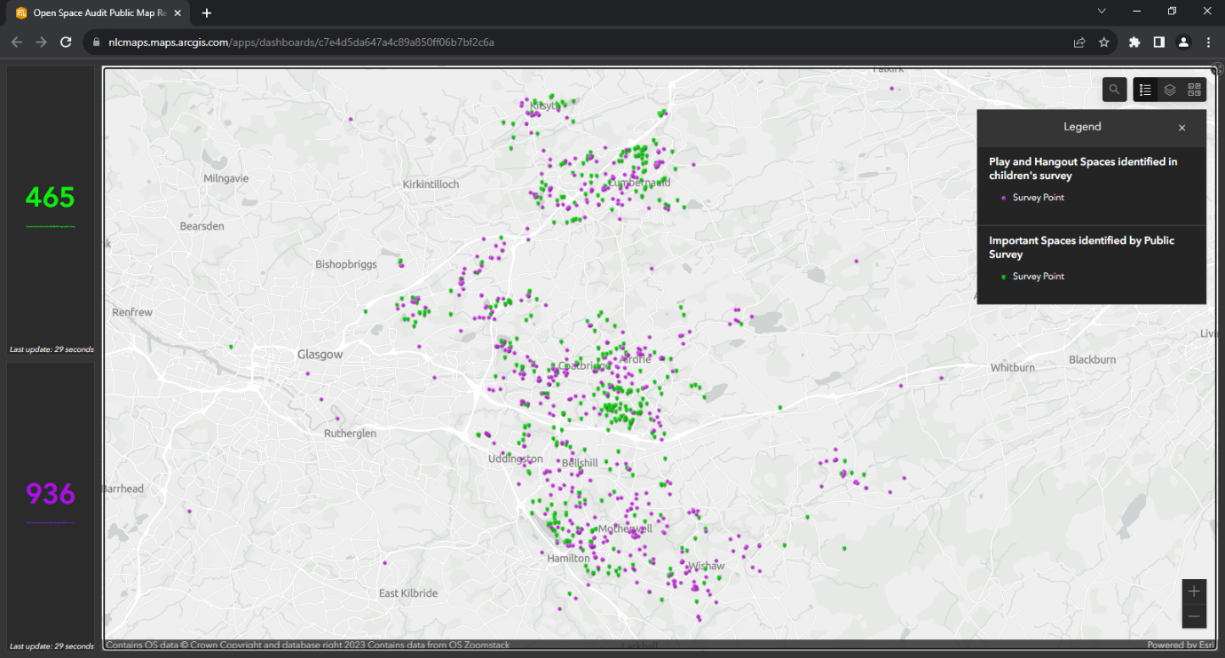

Q1. Why participants visit the space.

Participants were asked to select all answers that applied to the specific space they considered important to them. The majority of participants who identified spaces as being important to them cited the following reasons for visiting these spaces:
- For mental and physical health (80.65%)
- To destress, relax and unwind (78.91%)
- To feel closer to nature (enjoy the surroundings, see birds and wildlife) (71.4%)

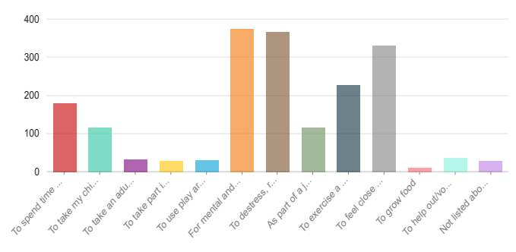
Answers | Count | Percentage
To spend time with family or friends | 180 | 38.71%
To take my child to an outdoor space | 117 | 25.16%
To take an adult in my care to an outdoor place | 33 | 7.1%
To take part in organsied sport/hobby | 28 | 6.02%
To use play areas or to hang out with friends | 31 | 6.67%
For mental and physical health | 375 | 80.65%
To destress, relax and unwind | 366 | 78.71%
As part of a journey to somewhere else (for example walking, wheeling or cycling) | 116 | 24.95%
To exercise a pet | 228 | 49.03%
To feel close to nature (enjoy the surroundings, see birds and wildlife) | 332 | 71.4%
To grow food | 10 | 2.15%
To help out/volunteer | 37 | 7.96%
Not listed above (please specify) | 29 | 6.24%

Appendix 1

Open Space Survey 1 Questions:
About you
Q1. Do you live, work / study or visit North Lanarkshire? Please tick the option that best applies to you.
- Live in North Lanarkshire
- Live and work / study in North Lanarkshire
- Work / Study in North Lanarkshire
- Visit from outside of North Lanarkshire
If you work or study in North Lanarkshire, please think about the spaces close to your work or place of study when answering.
If you visit from outside North Lanarkshire, please think about the spaces in North Lanarkshire that you visit when answering.

Q2. What is your age?
- Under 18
- 18 - 25
- 26 - 40
- 41 - 50
- 51 – 60
- 61-70
- Over 70
- Prefer not to say

Q3. Which one of the following best describes your sex/gender
- Female
- Male
- Prefer not to say

Q4. Which of these groups do you belong to?
- White: Scottish, other British, Irish, Polish, Gypsy/Traveller or other white
- Asian, Asian Scottish/British or other Asian
- African, African Scottish/British or other African
- Arab, Arab Scottish/British or other Arab
- Mixed or multiple ethnic group: White and Black Caribbean, White and Black African, White and Asian, any other mixed background
- Other ethnic group
- Prefer not to say

Q5. Which of these best describes you?
- In full time employment
- In part time employment
- Caring for Family
- Retired
- Student (may also be working too)
- Not working at the moment
- Prefer not to say

Q6. Are you disabled? Y/N/Prefer not to say
If Y - Would you like to let us know more about your disability? (Please write in.)

Q7. Please tell us your postcode: (for example ML1 1AB)

Q8. What types of space do you visit most often? Please tick all that apply.
- Local park
- Play area for young children
- Play and games areas for older children/teenagers
- Playing fields
- General greenspace - grassed areas for informal activities (such as playing, running about, picnicking, dog walking)
- Natural or semi natural greenspace
- Woodland
- Allotments and community growing space
- Space around public buildings
- Graveyard
- Not listed above (please specify)

Q9. In the last 12 months, how often on average have you visited green space areas in North Lanarkshire?
- More than once per day
- Every day
- Several times a week
- Once a week
- Once or twice a month
- Once every 2-3 months
- Once or twice
- Never

Q10. How do you normally travel to green space areas in North Lanarkshire?
- Walk, Wheel, Cycle
- Car
- Bus
- Train
- Taxi

Q11. How far away from your home (or place of work/study in North Lanarkshire) is your nearest greenspace area?
- 5 minute walk or less
- Within a 6 - 10 minute walk
- Within an 11 - 20 minute walk
- Within a 21 - 30 minute walk
- More than a 30 minute walk
- Don't know

Q12. How much to you agree or disagree with the following statement: ‘Visiting green spaces makes me feel better’.
- Agree strongly
- Agree slightly
- Neither agree nor disagree
- Disagree slightly
- Disagree strongly
- Don’t know

Q13. Overall, how satisfied are you with the quality of your local greenspace?
- Very satisfied
- Quite satisfied
- Neither satisfied nor dissatisfied
- Quite dissatisfied
- Very dissatisfied
- Don’t know

Q14. How much do you agree or disagree with the following statements relating to your nearest greenspace?
- Agree strongly
- Agree slightly
- Neither agree nor disagree
- Disagree slightly
- Disagree strongly
- Don’t know
My local greenspace…
- Is somewhere I can relax and unwind
- Is a safe place to visit
- Encourages physical activity – such as walking, cycling, sports and play
- Is an attractive place
- Is a good place for young people to play
- Allows me to explore nature
- Is easy to get to
- Is easy to get around
- Benefits my health and wellbeing
- Is welcoming
- Makes the area I live in / work or study in a better place to be

Q15. What, if anything, would encourage you to use or visit North Lanarkshire’s greenspace or open spaces more often? Please tick all that apply.
- Welcoming and well-located entrances
- Equal access for all with no barriers (such as steps, poor signage or lack of disabled persons parking space)
- Well maintained paths for walking, wheeling and cycling
- Connection to other spaces (such as paths and active travel routes for walking, wheeling or cycling and/or public transport)
- Quiet spaces for destressing, relaxing and unwinding
- Spaces for socialising with family and friends
- Well located benches, picnic tables or shelters
- Wildlife enhancements (such as tree and wildflower planting, long grass, wetlands and shrubs)
- Less intensively maintained natural spaces where you can feel closer to nature (see birds and wildlife)
- Well maintained spaces
- Low levels of litter
- Facilities for sports and recreation
- A more diverse range of play spaces and recreational opportunities for children
- A more diverse range of outdoor activities recreational opportunities for teenagers and young people (for example skateparks, multi-use games areas)
- Suitable spaces for elderly and disabled people
- High levels of cleanliness and free from dog fouling
- No signs of antisocial behaviour or vandalism
- Safe welcoming spaces with natural surveillance, clear sight lines and appropriate lighting
- Availability of public toilets
- More parking
- Not listed above (please specify)

Q16. What, if anything, would make you less likely to use or visit North Lanarkshire’s greenspace or open spaces? Please tick all that apply.
- Poorly situated entrances
- Barriers to access (such as steps, poor signage or lack of disabled persons parking space)
- Poorly maintained paths for walking, wheeling and cycling.
- Lack of connection to other spaces (such as paths and active travel routes for walking, wheeling or cycling and/or public transport)
- Lack of quiet spaces for destressing, relaxing and unwinding
- Lack of spaces for socialising with family and friends
- Poorly located benches, picnic tables or shelters
- Lack of wildlife enhancements (such as tree and wildflower planting, long grass, wetlands and shrubs)
- Poorly maintained natural spaces with poor links to nature
- Poorly maintained spaces
- High levels of litter
- No facilities for sports and recreation
- No or limited play spaces and recreational opportunities for children
- No or limited outdoor activities recreational opportunities for teenagers and young people (for example skateparks, multi-use games areas)
- Lack of suitable spaces for elderly and disabled people
- Low levels of cleanliness and clear evidence of dog fouling
- Antisocial behaviour or vandalism
- Unsafe spaces with no natural surveillance, clear sight lines or appropriate lighting
- No public toilets
- Not enough parking
- Not listed above (please specify)

Q17. If given the opportunity, would you be interested in volunteering in green and open space areas? (This could be for example clean ups, community planting or volunteering through friends of groups. We will not contact you about volunteering, but this will help us gauge interest and plan volunteering opportunities in the future.) Yes / No / Maybe

Open Space Survey 2 Questions:
Tell us what spaces are important to you.
We are carrying out an audit of North Lanarkshire to identify all green and open spaces.
Please tell us what spaces in North Lanarkshire are important to you.
To mark the space that is important to you on the map*
- Click on the area and a blue marker should appear confirming that area is selected.
- You can use search bar on map to zoom into exact postcode, street or town.
- If filling this in on a computer, hold Ctrl and scroll on mouse to zoom in and out of map, or the + and - buttons on map itself.
- On mobile devices use two fingers together to move around the map.
- You can take the survey again if you would like to tell us about another space.
* (SURVEY SHOWS MAP)
Why do you visit this site? Please select your top three reasons you use, visit or enjoy this space/site
- To spend time with family or friends
- To take my child to an outdoor space
- To take an adult in my care to an outdoor place
- To take part in organised sport/hobby
- To use play areas or to hang out with friends
- For mental and physical health
- To destress, relax and unwind
- As part of a journey to somewhere else (for example walking, wheeling or cycling)
- To exercise a pet
- To feel closer to nature (enjoy the surroundings, see birds and wildlife)
- To grow food
- To help out / volunteer
- Not listed above (please specify)

Appendix 2

Open Space Survey 1 – ‘not listed above’ responses

The following are verbatim responses given via our open space survey.
Of the ‘not listed above’ responses, not everyone told us more.
Q8. Not listed above responses:
- loch
- Attractions and historic areas
- Bowling green
- Strathclyde Park
- Broadwood loch
- The small field in Annathill was rented without consultation to a junior football team. We see 15-25 cars double parking on the days they use our only remaining amenity. The field was recently vandalised by a rival club
- Broadwood loch
- Canal
- Canal
- Canal
- Canal
- Canals and lochs
- Canals and river banks
- Core paths
- Country Park
- Cycle paths. Footpaths.
- cycle routes including through parks and avoiding roads where possible
- Exploring Calderbank at Monkland Canal
- Football parks
- Garden
- Golf course
- Golf course
- Golf courses
- Golf courses, especially during lockdown, were a wonderful facility for walking in a safe environment with lots of wildlife. It is a pity they are not so accessible now to the public.
- Green areas with historic interest
- I have no intergenerational park to visit in my area with children that’s accessible to all with activities for all so I have to drive to Coatbridge/Airdrie for Green space that is safe and accessible
- Walking paths
- Nature Parks, Waterways, designated trails and walkways
- I'm rarely well enough to visit these beautiful areas due to often being bed bound, if I had a home with outside space this would help as I feel isolated in my upstairs flat
- Local field
- Local fields, and nearby loch
- Local golf course
- Lochs and water areas
- Monklands canal and surrounding area
- Natural forests and trails outside North Lanarkshire.
- None at the mo really. None inviting or make me wanna go
- North Calder Heritage Trail
- Nowhere to go
- Palacerigg Golf Course and Park.
- Rawyards Dog Park
- Spare Bit Of Ground That Is Grass....Has Become A Nightmare By Local Teenagers Etc Breaking Bottle Etc..... Setting A Light, This Needs Taken Away.....&Turned Into A Car Park.....Its Become A Stinking Mess Also With Dog Poo..... Vandalism t
- Sustrans paths. Community parks like Brownsburn. Community Garden as in Calderbank Community Garden at Woodhall Ave. Heritage paths like along the North Calder. Paths in Woodhall Faskine and Palacecraig. Airdrie.
- Tracks for walking and cycling
- Viewpark Gardens before you let in go to ruin - hope to return when it's in community hands
- Walk everyday round Broadwood loch.
- Walking the canal towpath and faskine calderbank
- Woodhall, Faskine and Palacecraig area

Q15. Not listed above

- More signage regarding dogs in Childrens play areas
- Dogs to be kept on leads unless in a specific area away from main attractions/routes
- Better Control of dogs
- No dogs allowed
- More styles to get over fences. Keep old trees.
- Less parking or car parking/access away from the greenspace. Eg the room that cars are afforded in Strathclyde park is over generous and encourages more vehicle fumes/noise pollution in the greenspace I'm trying to enjoy.
- I prefer not to see parts of Rockburn Park sold without consultation. An absolute disgrace.
- Removal of the security type fencing that sits adjacent to much of the fottpath network in Cumbernauld. It make the paths feel claustrophobic and penned in.
- Safe to visit on my own at any time
- Dog friendly areas
- More lowered kerbs for mobility scooters and wheelchairs
- Non local gov areas
- Existing footpaths are in a terrible condition. Maintenance workers vehicles don't stay on paths and churn up grass. Too much open space left to go wild. Nowhere to sit.
- Dog Parks and dog specific walking areas
- Places where there is not road noise. Strathclyde park is nice, but it sounds like a central reservation some times. Why is there not an acoustic barrier along the motorway? There are lovely spaces such as Dunsyston Forestry Block planned for destruct
- Please maintain and preserve the green and natural spaces in and around Shotts
- Dog free or at least a warden supervising behaviour of dog owners. Used to visit local parks and country park but too many dogs running off lead or on extending lead. No pleasure in walking in parks unless you have a dog.
- Public transport assistance to non car families
- Traffic calming and wildlife protection
- Stop through traffic again in Strathclyde Park and enforce the speed limits.
- Make accessible. There are no pavements to Strathclyde Park. The hill down the A725 has no barrier. The road up the hill into the housing scheme at the golf course; no pavement. People fly down there in cars doing 50mph+. It’s dangerous walking with a ba
- little or no traffic
- Why is there so much road going around Strathclyde Park? There is no other park that I can think of that prioritises cars. It's ridiculous. Can't walk the dog for cars parking in places they shouldnt, or motor bikes knocking you over on the paths.
- Roads should be closed to cars mainly Strathclyde park
- More bins, to be emptied frequently - so littering can be avoided
- Just to pick up on the litter issue- the littering in NLC and my area is horrendous- it doesn't matter what the area is like if NLC doesn't start to value it 'we value what matters, what matters we value'!

Q16. Not listed above

- Accessibility. Like when Strathclyde park was closed for through traffic reducing access to the graveyard from Motherwell forcing people into the motorway or diverting through a dangerous road full of dangerous parking in Bellshill.
- All the above the town is an eyesore.
- All the sbove
- Bird poo at Strathclyde park, it’s filthy
- Building on part f the green space.
- Cyclists on footpaths that are narrow, dogs off lead
- Dog poo and gangs are a big problem
- Dogs being allowed off their lead
- Dogs roaming with owners not taking responsibility or concern for other park users
- Dogs running around
- Dogs unleashed
- Drinking and drugs. NEDS
- Free space with no local gov input or control ie use our own paths and not be dictated to what path etc we should use. Also no housing that erects fencing around our open spaces
- Greenspace taken over or giving way to car infrastructure eg strathclyde park roads running at both sides.
- I'm pretty sure turning Rockburn Park into a car park for the local industrial estate would make me less likely to visit it.
- Inclusion of parking at every opportunity, not all spaces should be accessible by car.
- Lack if variety...if you go there and you've seen it all, why go back
- Lack of baby change facilities
- Lack of dog litter bins
- Lack of dog only areas
- Lack of lowered kerbs
- Less selling off of green spaces for building, as has happened here in Annathill. I’ve had to bury 3 badgers, innumerable birds and two hares killed by heave traffic and destruction of there habitats.
- Local gov control
- Majority of space given to grow wild.
- More bins. Large number of small bins replaced by a smaller number of large bins that don’t get emptied enough. No bins for miles through the woods in Drumpellier Park
- No Dog Parks or specific dog walking areas
- No signs 5o let people know which is a dog park and which is a children's play park in the green spaces.
- No-one wants to go to a scrubby bit of grass that has no natural feeling that dog walkers use to evacuate their animals bowels before they, if you are lucky, scrape it around with a plastic bag before hanging it in a tree...
- Not appropriate lighting. As a woman I do not feel safe walking/running in NLC
- Please protect and preserve the green and natural spaces in and around Shotts
- Poor lighting and lonely overgrown paths making people feel vulnerable or unsafe walking alone
- Poorly supervised dogs
- Public transport assistance to non car families
- Speeding continually on main access road
- Speeding vehicles and through traffic including traffic noise. It reduces the wildlife birds on partucular
- The children’s play parks badly need upgraded. The small swingpark at Strathclyde Park is so well used. It desperately requires a makeover.
- The removal of the green space to build houses
- There are barely any bins available in local parks and woodland so dog walkers bag thier poop and throw it into trees ect. ,I do not have a dog but whenever I have litter I can never find a bin .
- There is nothing for kids to do barely a park now and especially for pre teens/teens no wonder they get in trouble being so board and hardly a woods now with choopping all the trees down to make room for developments and woods that are left are littered
- to much traffic
- Too many cars and too many car parks.
- Too many cars on roads that should be closed
- Too much glass shards - like currently everywhere I go when trying to go into a public green space!
- Transport links not available for those without a private vehicle
- Unsafe
- What idiot thought it was a good idea to add in the speed bumps to Strathclyde Park. This is a huge barrier for anyone with mobility issues and going over these causes pain.

Open Space Survey 2 – ‘not listed above’ responses

The following are verbatim responses given via our open space survey.
Of the ‘not listed above’ responses, not everyone told us more.
Q1. Why do you visit this site responses considered in the context of the site identified.
- I run there
- I run there
- Natural loch but wildlife such as deer fox, hedgehogs etc lost from area due to vast house estate building
- I have lived and walked and brought up my children and now my grandson 46 years in this clay road scheme now they are taking it all away to build a euro rail track300 yds from my back door.
- EXERCISE
- Stepps greenbelt is under threat from housing developers and the Scottish Government DPEA reporters. STOP house building on greenbelt and use derelict and brownfield sites for hosuing.
- This is the place I live. Cumbernauld was built as a interconnected network of green spaces. All of them need to be maintained at a level far above the current levels. Walking or cycling around Cumbernauld should feel like a journey through a park.
- It’s important to me because potentially it could be home to an incinerator which will harm the surrounding area
- Participate in Cumbernauld Living Landscapes activities
- The area at Roughrigg / Dunsyston is one of the few places that a public access woodland area without constant road noise. Forestry commission/scot water have made the areas accessible and they are lovely however NLC is planning to DESTROY this area.
- The area including Richard Johnston but more the surrounding areas between Kirklees Allotments and the globe cemetery are a lovely space. Please do not destroy this area by putting houses on it!
- Foraging.
- Kids used to play football here but now an absolute mess ash park is overgrown and used as drinking area or by youths on quad bikes and motorcycled
- To take my grandchildren outside. looking for an activity outside.
- For Daily exercise ... I walk about one and a half hours each morning and meet other people doing the same, so it's social as well.
- I live here
- Somewhere for kids to legally use quad bikes etc!!! Luckily we know a farmer who lets us use a bit of land. There should be places for children to do these things!
- I'm most of the time too ill to get out to enjoy the beautiful outdoors, I live in an upstairs flat with causes isolation, I would love a home with some outdoor space to help me relax
- I live next to this busy car park
- This car park at farm st is a source of fumes and traffic emissions into my garden. This wasn’t taken into account when the council removed all the trees in the area. The tree replacement programme is totally inadequate to absorb damaging fumes.
- I live here
- Ridiculous that we are now asked about green and open space provision when all this existed naturally before NLC promoted its destruction for housing. Shortsighted, shameful and greedy.
- It’s the nearest green space to me but there is nothing for adults, e.g. an outdoor gym. The play equipment is for children only.
- For the view and the wildlife eg. deer, foxes, birds of prey, badgers, hares, rabbits...
- Birth place
- Able to use mobility scooter
- To save the historic monuments/wildlife/wildflowers/rare birds/insects and threatened creatures
- Visit family grave
- To run

