Play Sufficiency Assessment
  - Play Space
  - Public Opinion Survey Report

Date: 22 August 2023
Authored by: Moira McKenna Dell
Senior Project Officer (Planning)
Strategy and Policy
Enterprise and Communities
North Lanarkshire Council
Contact: mckennam@northlan.gov.uk

Contents
Executive Summary 2
Background and objectives 3
Survey method 4
Survey results 5
Play Survey 1: 5
Play Survey 2: 25
Appendix 1 43
Play Survey 1 Questions: 43
Play Survey 2 Questions: 46

Executive Summary
As part of the process of developing a Play Sufficiency Assessment, the council sought feedback from parents and carers, and children and young people in relation to play in North Lanarkshire via online surveys.
The surveys sought feedback on the perceptions of play spaces in North Lanarkshire and invited children and young people to identify their favourite play space in the area using an interactive map.

Statistics and findings:
Play survey 1 (parents and carers)
- A total of 1,663 responses were received on peoples perception of play space.
- 74.44% of participants were responsible for children on the 5-11 age category.
- 42.93% said their child(ren) go outside to play or hang out with friends several times a week.
- 72.16% of participants said their child(ren) get to where they play by walking, wheeling, cycling, scooting, skateboarding or blading.
- 71.38% had a 10 minute walk or less to where their child(ren) play.
- 44.14% of participants were either quite dissatisfied or very dissatisfied that their child(ren) have access to outdoor play outside of school hours. The most popular response was quite satisfied (26.88%).
- 72.5% of participants agreed strongly or agreed slightly that their local play space was easy to get to by walking or cycling
- The main issues highlighted when asked what participants didn’t like about their child(ren)’s play space were:
- Litter
- Dog poo in the play space
- Equipment that is broken or has missing has parts
- Dangerous litter, for example glass or needles

Play survey 2 (children and young people)
- A total of 931 responses were received from children and young people of their perception of play space.
- 68.77% of children and young people responding were in the 5-11 age group
- 31.94% of children and young people responded that they went to play or hang out in public play spaces a few times a week.
- 54.59% of children and young people responded that there was outdoor public play/hang out space near to where they live that they could walk or cycle to on their own or with friends (without an adult).
- 931 responses when we asked children and young people identified their favourite play space on a map-based survey.
- 68.91% usually get to their favourite play or hang out space by walking, wheeling, cycling, scooting, skateboarding or blading.
- When asked to think about what could make their favourite play or hang out space easier and safer to walk, wheel, cycle, scooting, skateboard or blade to, the most popular responses were:
- Safer, more crossing points (traffic lights, zebra)
- More/Safer/Improve/Repair Pathway
- Closer Areas
- More/Better/Fix Equipment
- Better Lighting
- Maintained Better (Rubbish/Ground/Equipment/Glass/Mud/Grass)
- When asked to think about a space they didn’t like and why, the most popular responses were:
- Litter
- Dog poo in the play space
- Dangerous litter, for example glass or needles
- Equipment that is broken or has missing has parts

Background and objectives
The Planning (Scotland) Act 2019 introduced new statutory duties upon councils to prepare and publish an Open Space Strategy (OSS) and to assess the sufficiency of play opportunities for children in their area.
A Play Sufficiency Assessment (PSA) must:
- Be a written report, incorporating maps
- Show by means of a map, the location of formal play spaces within North Lanarkshire
- Include statements about the overall
- quality
- quantity
- accessibility
of formal play spaces and informal play spaces in North Lanarkshire
- Be published electronically
North Lanarkshire Council is in the process of developing our Play Sufficiency Assessment (PSA) to evaluate outdoor play opportunities and experiences for children and young people in North Lanarkshire.

Our aim is to work with partners, stakeholders and communities to support children’s right to play and to create environments where children and young people can freely play across North Lanarkshire.

We wanted to hear from as many people as possible and to ensure that the voices of children and young people were heard to give a balanced overview of everyone’s interests and allow us to make best use of the limited resources available.

To do so, as part of the stakeholder engagement forming part of the Play Sufficiency Assessment study, we carried out two public opinion surveys on play in North Lanarkshire.

- Play Survey 1 aimed at parents and carers asked for general views, including perception of the quality, quantity and accessibility of play spaces.
- Play Survey 2 gave an opportunity for children of all ages to tell us more about play spaces which are important to them where they live and to highlight specific play spaces that were important to them.
For some children, because of their age or circumstance, completing this survey would be challenging. Where this was the case, we asked that adults help groups of children and young people they worked with to respond to questions about their experiences of play, relaxation, and leisure in their local areas.

These surveys were conducted for 12 weeks from 17 April to 10 July 2023 and were designed to allow us to gain an understanding on the suitability of spaces for children going out to play and hang out, and to understand what spaces were important to children and young people.

The data collected will be used to find ways of protecting and improving the opportunities, time and space available for playing or hanging out.

Survey method
Having decided to use online surveys to get the greatest reach, and giving people to option to contact us where they needed assistance, we decided to use ArcGIS Survey123 for data gathering.

In addition to allowing us to create, share and analyse questions, this system provided the solution to gathering map-based location data needed to help us identify play spaces in North Lanarkshire that were important to children and young people.
Play Survey 1 was a questionnaire. The format consisted of 15 questions with some having the option for people to comment and tell us more where their answer was not listed in the options.

Play Survey 2 was a combination of questionnaire with a map-based question that allowed children and young people, or an adult responding on their behalf, to pinpoint on a map a specific play space that was important to them, and to let us know what they used that space for.

For both surveys, all multiple select answer options were randomised to remove the potential for answer option order bias.

Play survey 1 was made available on the council website and promoted via the council’s various social media channels including Facebook, Twitter (currently rebranding to X) and Govdelivery. Play survey 2 was distributed via Education & Families school text system.

Survey results
The total number of responses for each survey is as follows:

Play Survey 1 asking for parents and carers thoughts on the suitability of space in their area for children going out to play and hang out: 1,663 responses.

Play Survey 2 allowed all children and young people of all ages to tell us what they think of where they live, play and hang out and to tell us where their favourite space is: 931 responses.

This report contains charts and tables. Where response percentages do not sum to 100%, this may be due to computer rounding or multiple answers.

Where questions had multiple response options, participants were invited to select as many that applied to them.

Not every participant responded to every question.

Play Survey 1:
Participants were asked to tell us some basic information about themselves, including age and gender. Asking these ‘about you’ questions can help us understand the needs, perceptions, satisfaction, behaviour and lifestyle of different members of the community.

About the participants
Q1. Of the 1,663 participants, the highest number of responses were from parents or carers (86.05%).

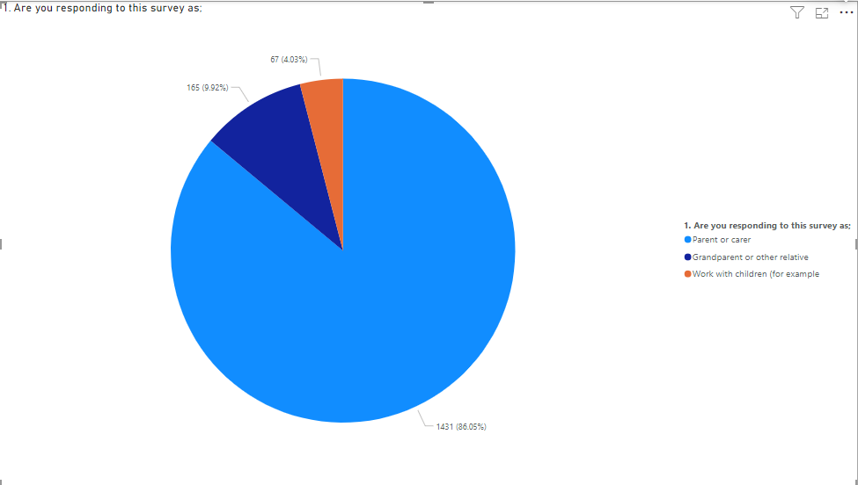

Answers | Count | Percentage
Parent or carer | 1,431 | 86.05%
Grandparent or other relatives | 165 | 9.92%
Work with children (for example, childminder) | 67 | 4.03%

Q2. Age of children participants were responsible for.
Participants were responsible for a child or children with a range of ages.
The majority of participants were responsible for a child or children in the 5-11 age category (74.44%).

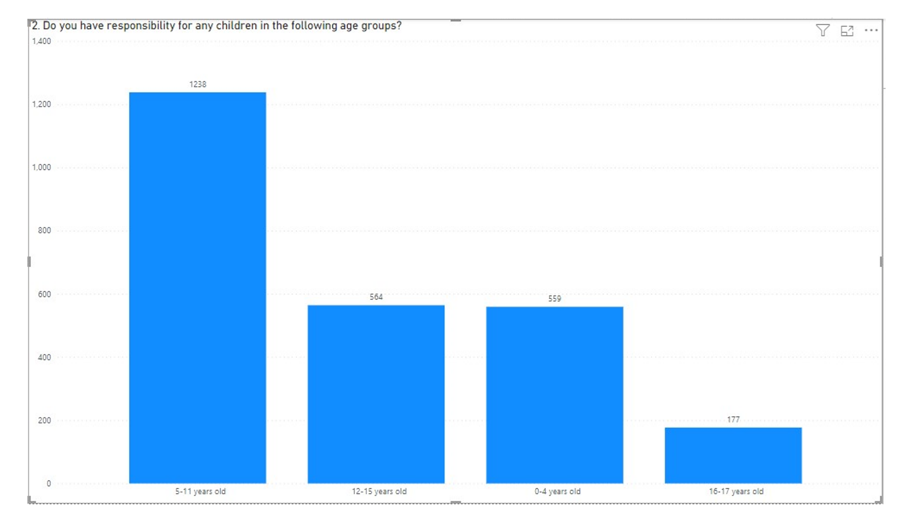

Answers | Count | Percentage
0-4 | 559 | 22.03%
5-11 | 1,238 | 48.78%
12-15 | 564 | 22.20%
16-17 | 177 | 6.97&

3. Gender of participants children.
The most popular response was girl(s) and boy(s) (42.69%).

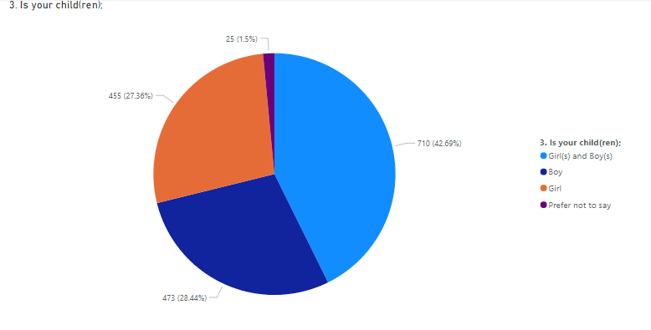
Answers | Count | Percentage
Girl(s) and Boy(s) | 710 | 42.69%
Boy | 473 | 28.44%
Girl | 455 | 27.36%
Prefer not to say | 25 | 1.5%

4. How participants describe themselves
Those in full time employment and part time employment account for 74.09% of participants (47.93% and 26.16% respectively).
The most popular response was that participants were in full time employment (47.93%)
(Note: This closely reflects the Office of National Statistics latest figures for North Lanarkshire that indicate 69.9% of people are in employment)
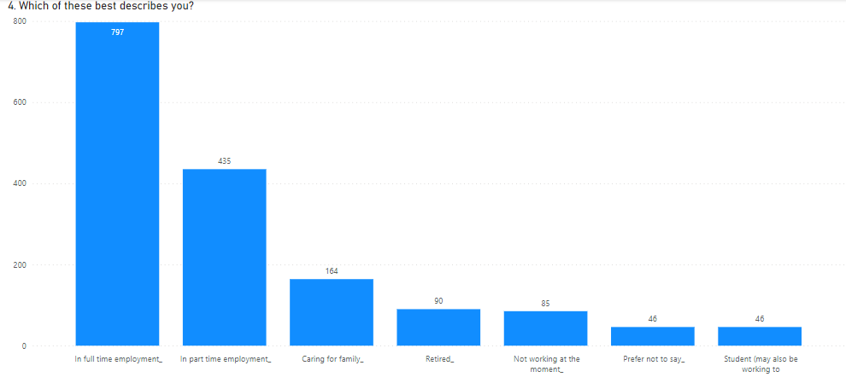

Answers | Count | Percentage
In full time employment | 797 | 47.93%
In part time employment | 435 | 26.16%
Caring for family | 164 | 9.86%
Retired | 90 | 5.41%
Student (may also be working too) | 46 | 2.77%
Not working at the moment | 85 | 5.11%
Prefer not to say | 46 | 2.77%

Q5. Participants were asked if they were disabled. Most people responding to the survey were not disabled, however 7.16% of participants responded that they were disabled with 3.19% preferred not to say.
Of the 81 participants that elected to tell us more about their disability, the majority used the word ‘mobility’ when describing their disability.

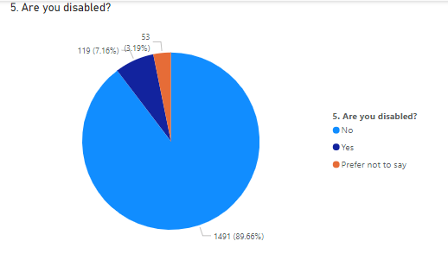

Answers | Count | Percentage
No | 1,491 | 89.66%
Yes | 119 | 7.16%
Prefer not to say | 53 | 3.19%

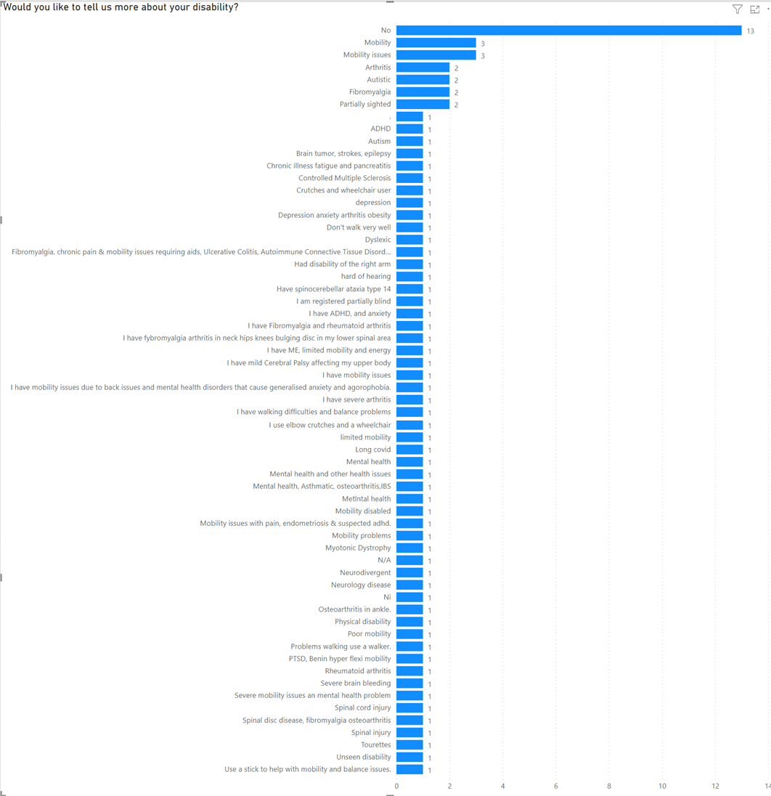
Q6. Participants were asked if their child or any of their children disabled. Most people responding to the survey said their child or children were not disabled, however 11.67% of participants responded that their child or children were disabled with 2.77% preferred not to say.
Of the 46 participants that elected to tell us more about their child or childrens disability, the majority used the word ‘autism’ when describing the disability.
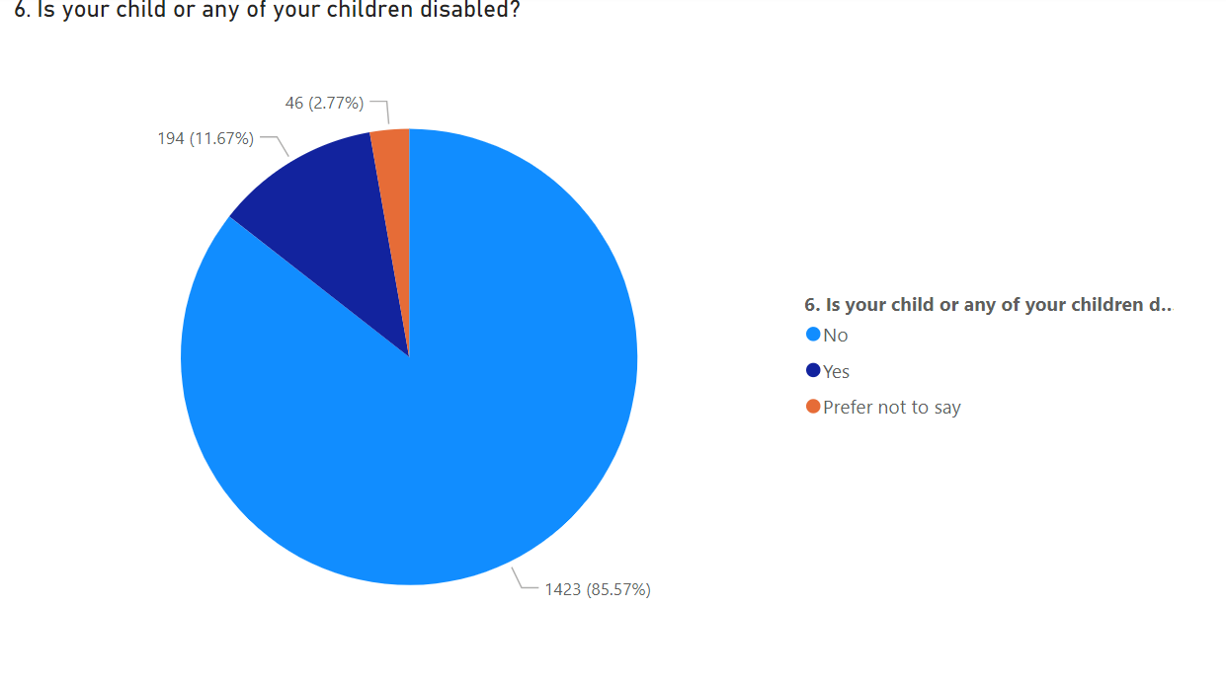

Answers | Count | Percentage
No | 1,423 | 85.57%
Yes | 194 | 11.67%
Prefer not to say | 46 | 2.77%

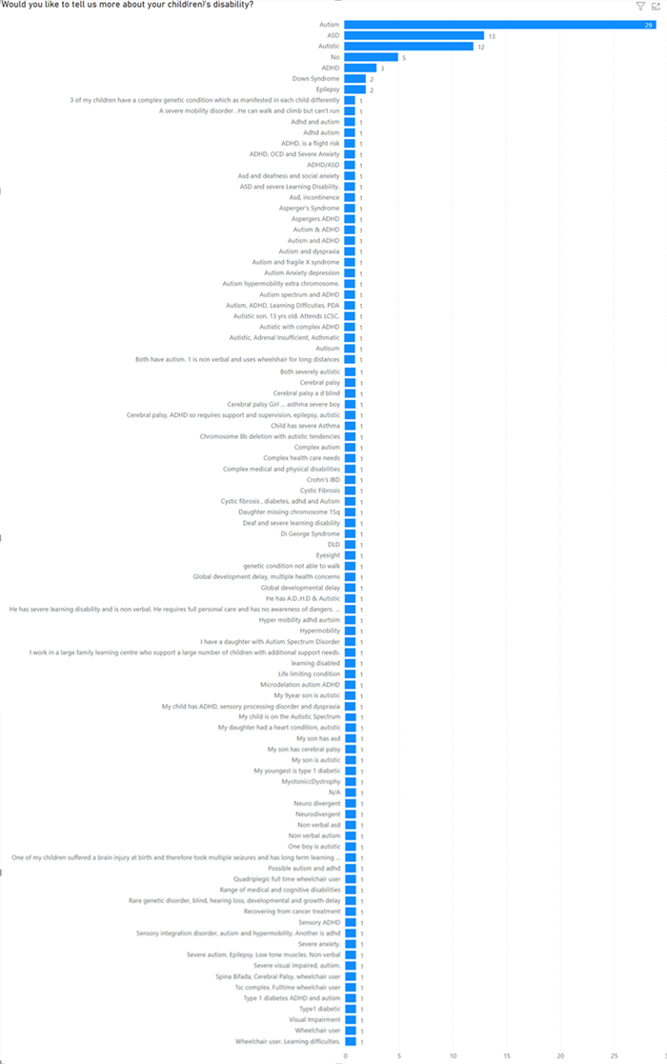
Answers from when participants were asked if they would like to tell us more about their disability.

Q7. Participants were asked to provide their postcode. ML1, followed by ML6 were the most referenced postcodes.
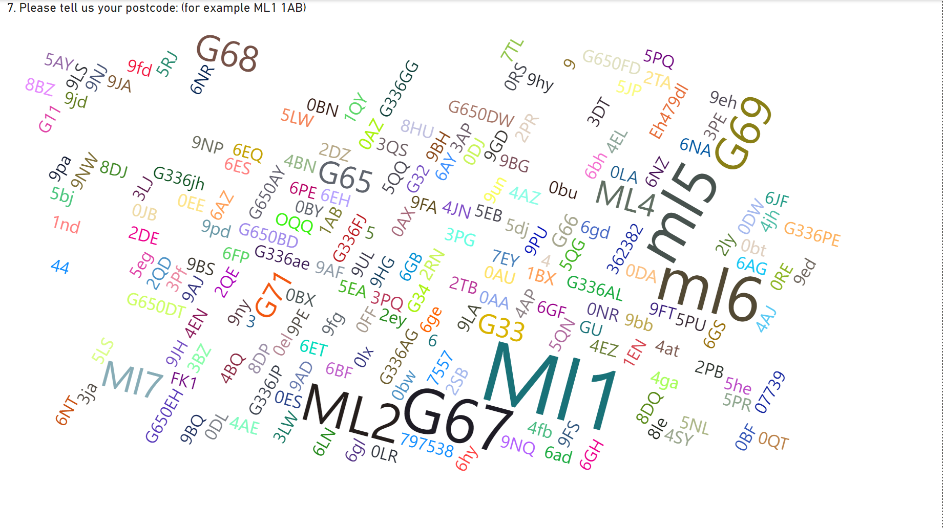
Word cloud created using participants postcodes.

About play
Participants were asked about their local play spaces in North Lanarkshire, how they got there and their perception of these play spaces.

Q8. Participants were asked how often their child(ren) go outside to play or hang out with friends.
The most popular response was several times a week (42.93%)

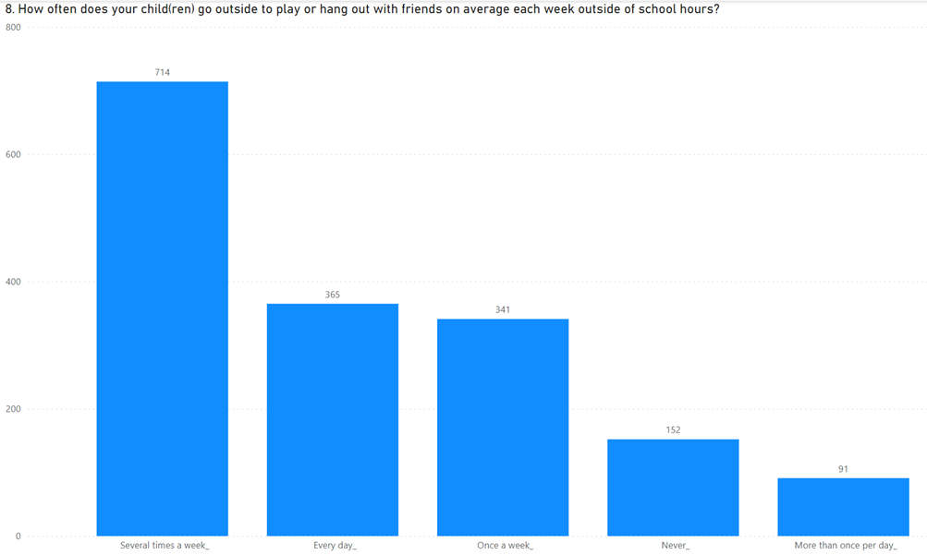

Answers | Count | Percentage
More than once per day | 91 | 5.47%
Every day | 365 | 21.95%
Several times a week | 714 | 42.93%
Once a week | 341 | 20.51%
Never | 152 | 9.14%

Q9. Participants were asked how their child(ren) get to the place or places they play in.
The majority of respondents said their child(ren) most popular response was Walk, wheel, cycle, scooting, skateboarding, blading (72.16%)
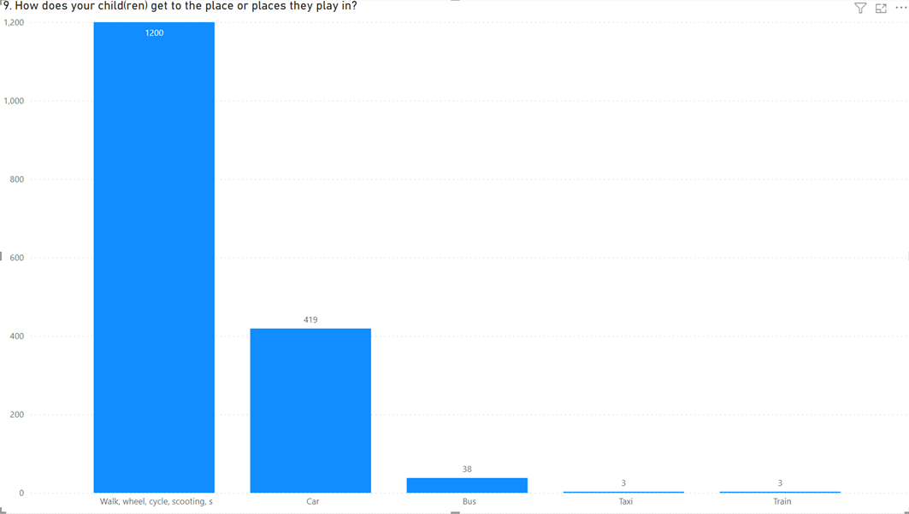

Answers | Count | Percentage
Walk, wheel, cycle, scooting, skateboarding, blading | 1,200 | 72.16%
Car | 419 | 25.2%
Bus | 38 | 2.29%
Train | 3 | 0.18%
Taxi | 3 | 0.18%

Q10. Participants were asked how far away from home their nearest play space was.
The majority of respondents said their nearest play space was within a 10 minute walk (71.38%). Of those within a 10 minute walk or less, the most popular response was 5 minute walk or less (46.36%)

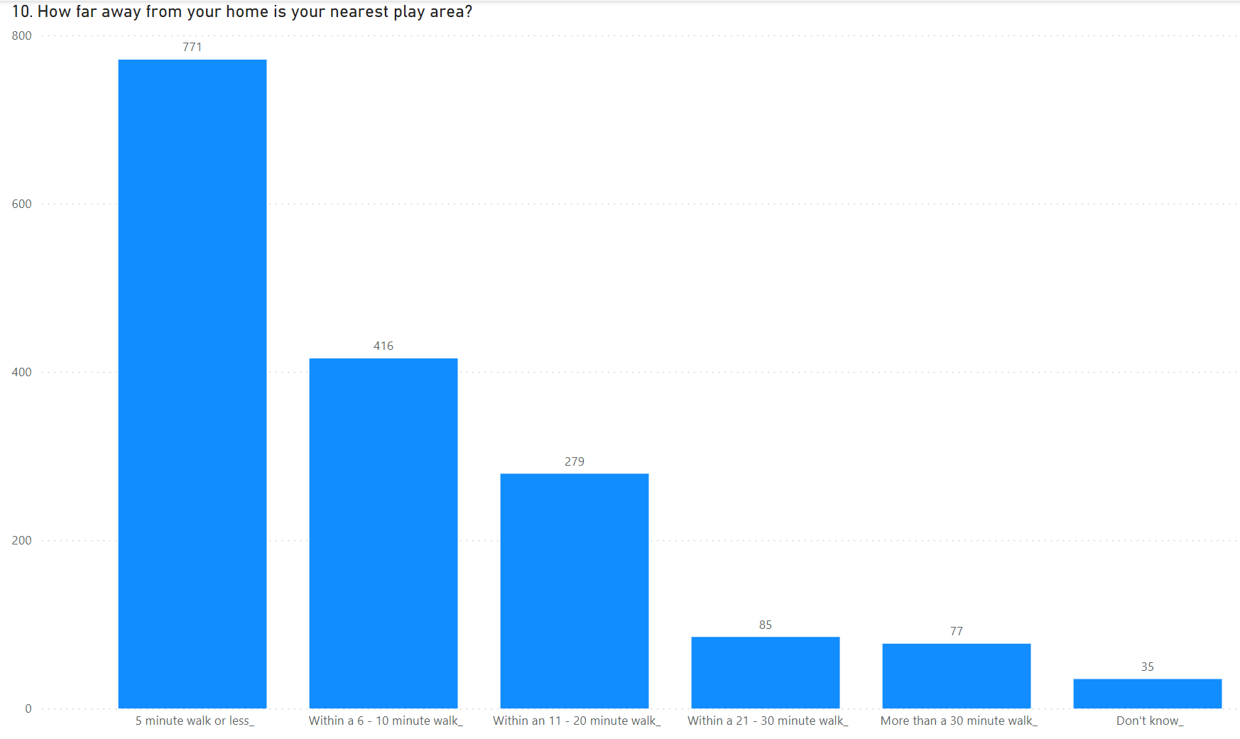

Answers | Count | Percentage
5 minute walk or less | 771 | 46.36%
Within a 6–10 minute walk | 416 | 25.02%
Within an 11-20 minute walk | 279 | 16.78%
Within a 21-30minute walk | 85 | 5.11%
More than a 30 minute walk | 77 | 4.63%
Don’t know | 35 | 2.1%

Q11. Participants were asked how satisfied they were that their child(ren) have access to outdoor play outside of school hours.
The most popular response was quite satisfied (26.88%), the next most popular response was quite dissatisfied (23.57%)
Overall, more people were either quite dissatisfied or very dissatisfied (44.14%) than were quite satisfied or very satisfied (37.82%)

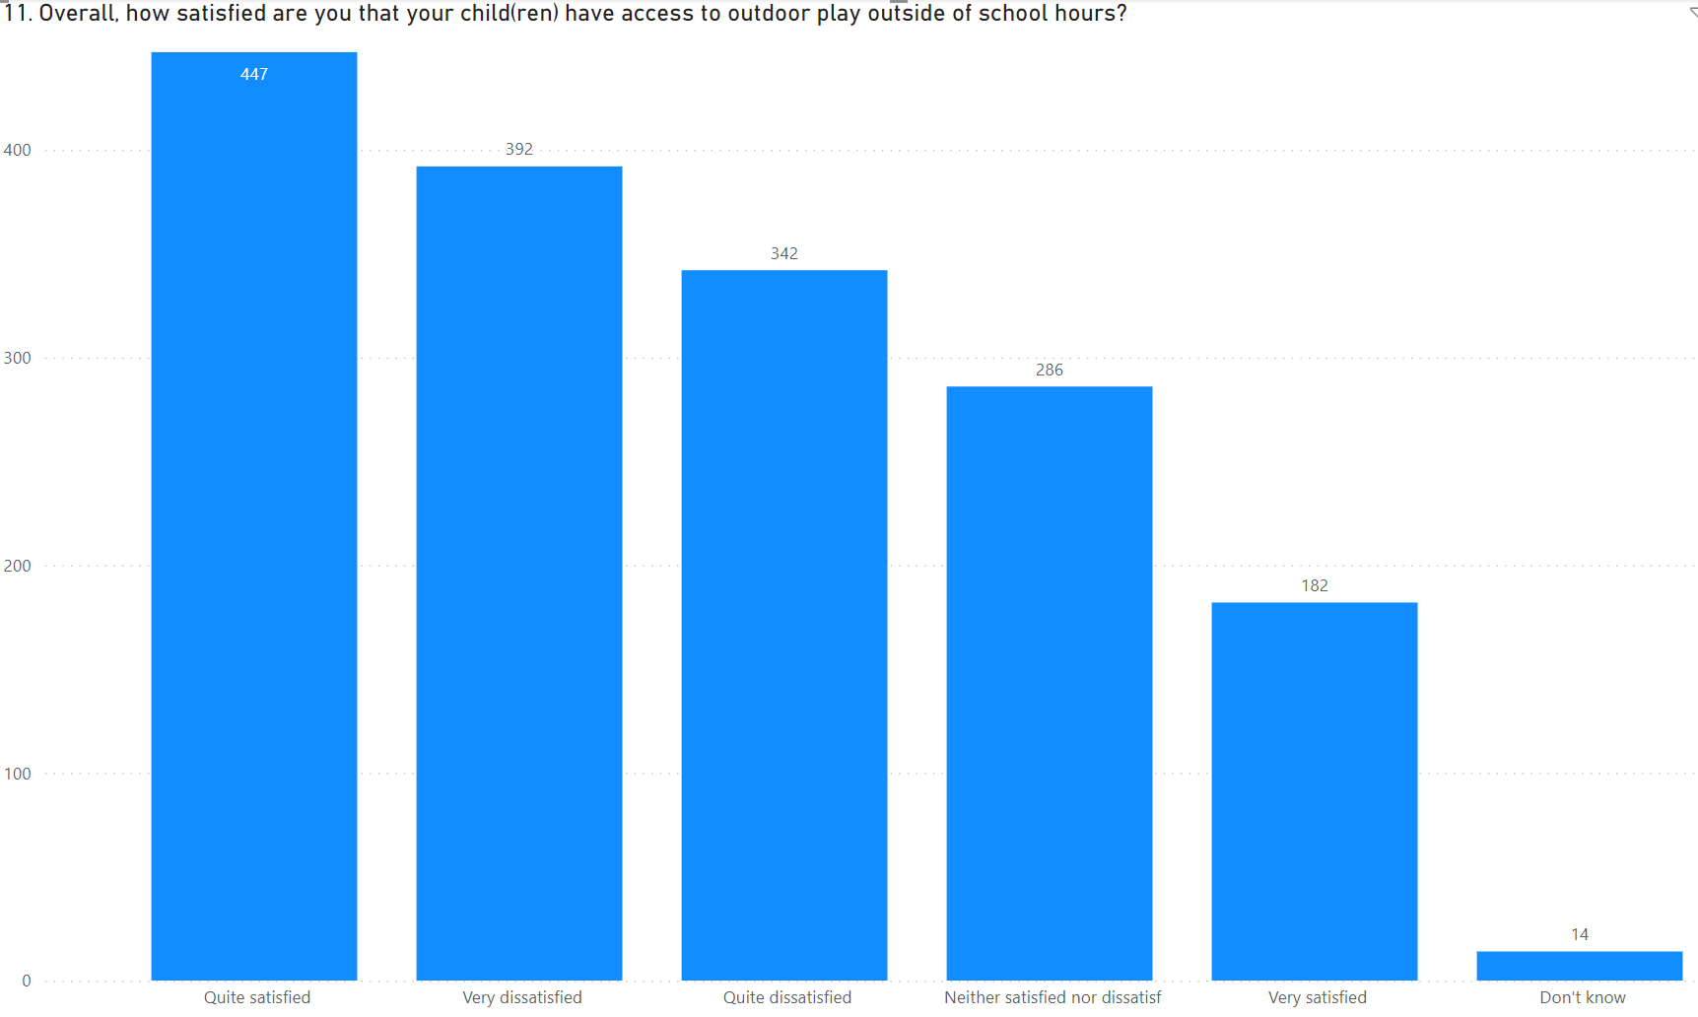

Answers | Count | Percentage
Very satisfied | 182 | 10.94%
Quite satisfied | 447 | 26.88%
Neither satisfied nor dissatisfied | 286 | 17.2%
Quite dissatisfied | 342 | 20.57%
Very dissatisfied | 392 | 23.57%
Don’t know | 14 | 0.84%

Q12a. Participants were asked how much they agreed or disagreed that their local play space was easy to get to by walking or cycling.
The majority of participants agreed strongly or agreed slightly that their local play space was easy to get to by walking or cycling (72.52%). The most popular response was agree strongly (46.84%)

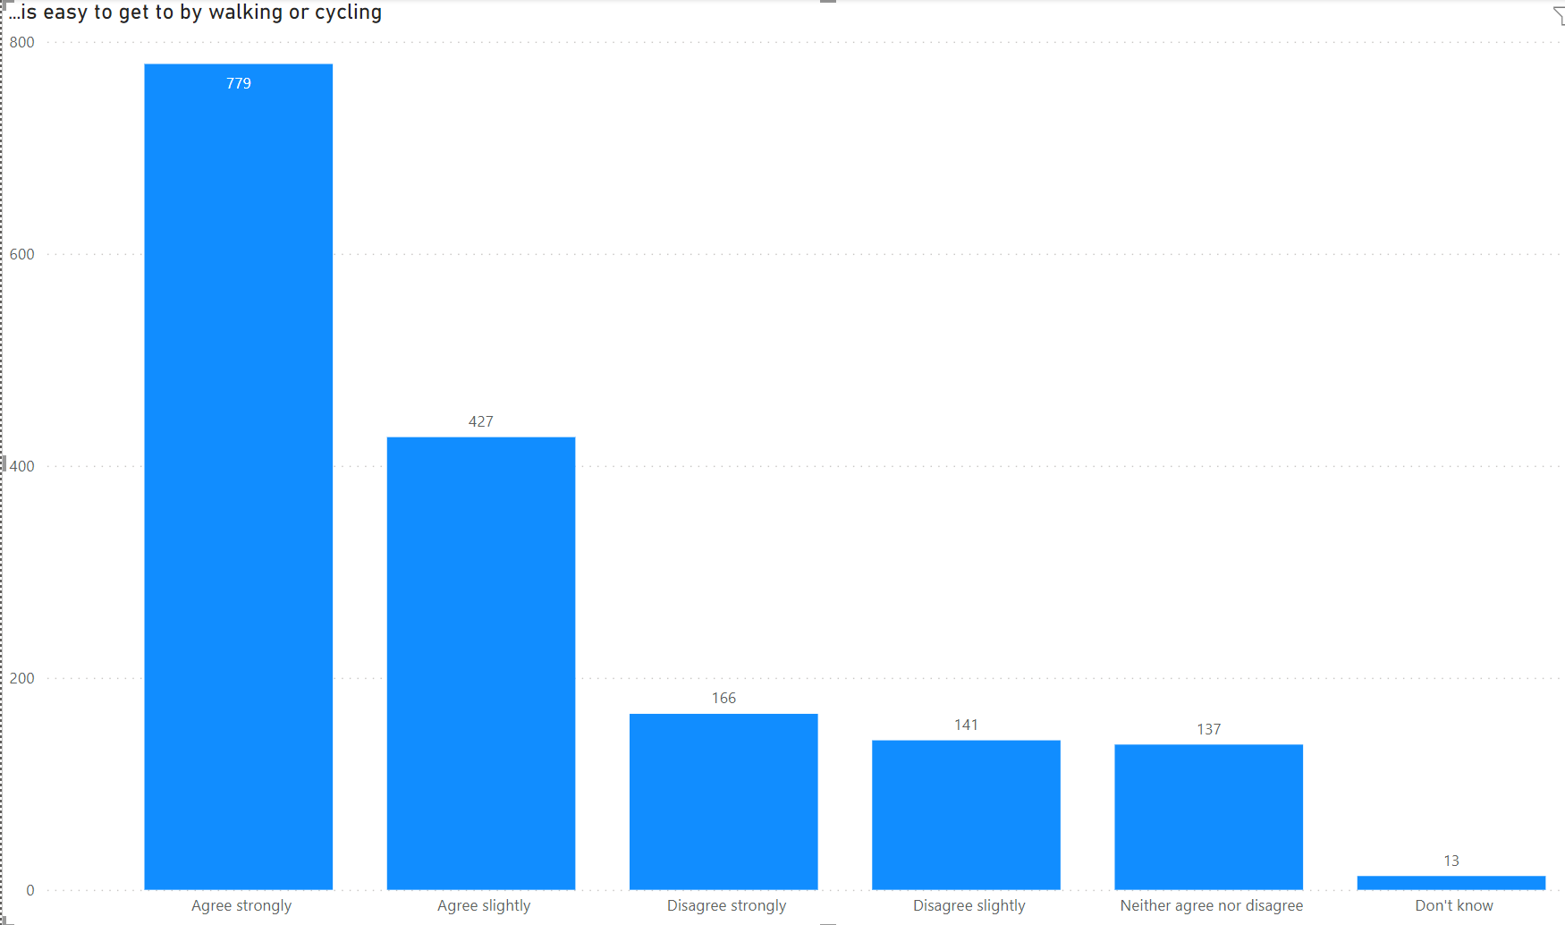

Answers | Count | Percentage
Agree strongly | 779 | 46.84%
Agree slightly | 427 | 25.68%
Neither agree nor disagree | 137 | 8.24%
Disagree slightly | 141 | 8.48%
Disagree strongly | 166 | 9.98%
Don’t know | 13 | 0.78%

Q12b. Participants were asked how much they agreed or disagreed that their local play space felt welcoming and safe.
The most popular response was disagree strongly (26.16%)
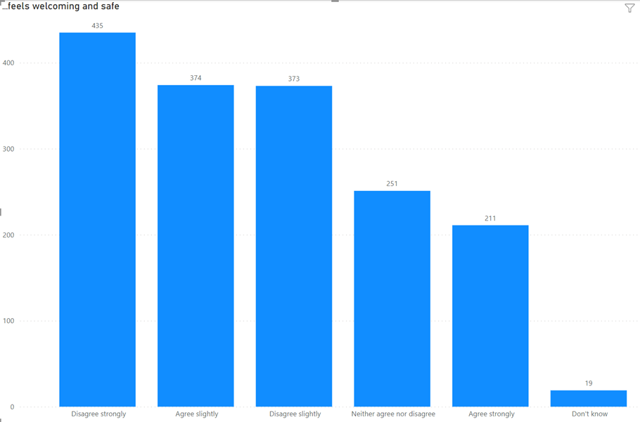

Answers | Count | Percentage
Agree strongly | 211 | 12.69%
Agree slightly | 374 | 22.49%
Neither agree nor disagree | 251 | 15.09%
Disagree slightly | 373 | 22.43%
Disagree strongly | 435 | 26.16%
Don’t know | 19 | 1.14%

Q12c. Participants were asked how much they agreed or disagreed that their local play space has natural things to play on or with, for example trees, logs, rocks.
The most popular response was disagree strongly (49.13%)
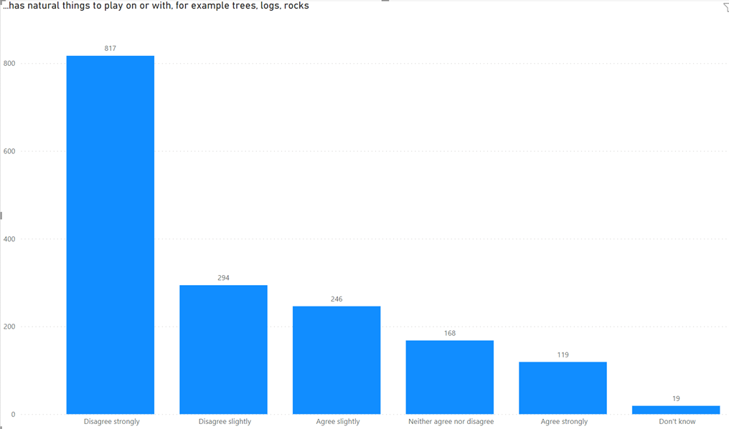

Answers | Count | Percentage
Agree strongly | 119 | 7.16%
Agree slightly | 246 | 14.79%
Neither agree nor disagree | 168 | 10.1%
Disagree slightly | 294 | 17.68%
Disagree strongly | 817 | 49.13%
Don’t know | 19 | 1.14%

Q12d. Participants were asked how much they agreed or disagreed that their local play space has natural things has things to move around and play with in different ways
The most popular response was disagree strongly (36.44%)

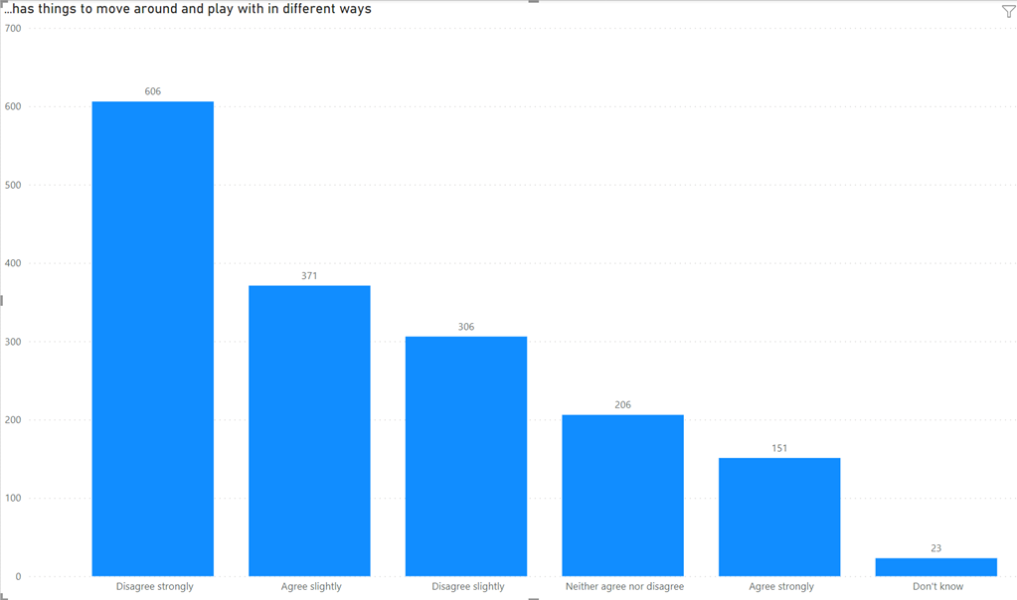

Answers | Count | Percentage
Agree strongly | 151 | 9.08%
Agree slightly | 371 | 22.31%
Neither agree nor disagree | 206 | 12.39%
Disagree slightly | 306 | 18.40%
Disagree strongly | 606 | 36.44%
Don’t know | 23 | 1.38%

Q12e. Participants were asked how much they agreed or disagreed that their local play space has fixed equipment to play on.
The majority of participants agreed strongly or agreed slightly that their local play space has fixed equipment to play on (74.99%).

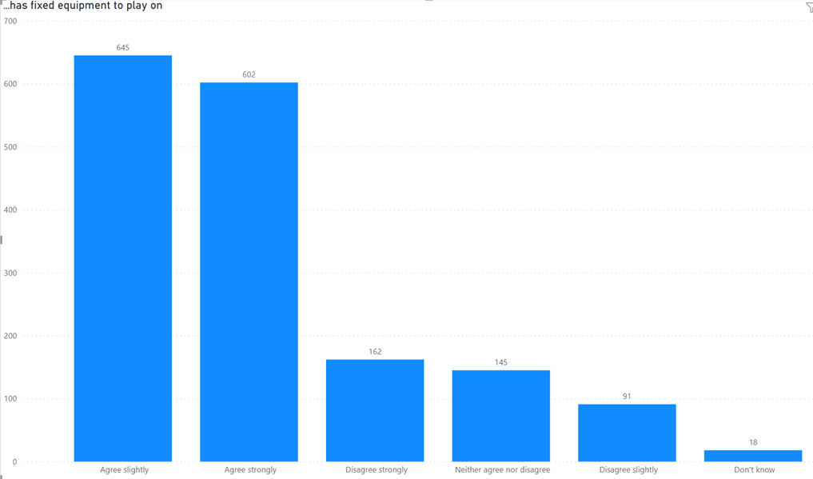

Answers | Count | Percentage
Agree strongly | 602 | 36.2%
Agree slightly | 645 | 38.79%
Neither agree nor disagree | 145 | 8.72%
Disagree slightly | 91 | 5.47%
Disagree strongly | 162 | 9.74%
Don’t know | 18 | 1.08%

Q13. Participants were asked which is their child(ren)s favourite places to play or hang out outside of school hours. Participants could select multiple answers.
The most popular responses were:
- Your garden or friends garden: 14.85%
- Play parks: swings, slides, climbing frames, seesaws: 13.00%
- A local park or grassy area: 12.91%

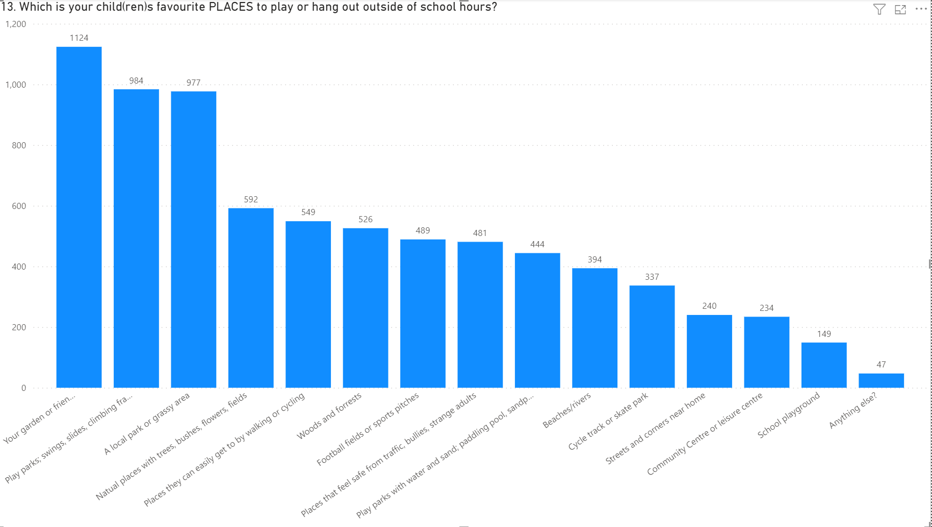

Answers | Count | Percentage
Your garden or friends’ garden | 1,124 | 14.85%
School playground | 149 | 1.97%
Streets and corners near home | 240 | 3.17%
Places that feel safe from traffic, bullies, strange adults | 481 | 6.36%
A local park or gassy area | 977 | 12.91%
Places they can get easily by walking or cycling | 549 | 7.26%
Natural places with trees, bushes, flowers fields. | 592 | 7.82%
Play parks with water and sand; paddling pool, sandpit, fountains | 444 | 5.87%
Play parks: swings, slides, climbing frames, seesaws | 984 | 13.00%
Cycle track or skate park | 337 | 4.45%
Football fields or sports pitches | 489 | 6.46%
Community centre or leisure centre | 234 | 3.09%
Woods and forests | 526 | 6.95%
Beaches/rivers | 394 | 5.21%
Anything else? | 47 | 0.62%

Q14. Participants were asked what would make their child(ren)s play or hang out space outside of school hours, better.
The most popular responses were:
- If it was cleaner: 11.18%
- Equipment like slides, swings and roundabouts: 10.48%
- Adventurous equipment like zip wires and high ropes: 10.47%
- Good quality clean toilets: 9.77%
- Sports equipment like football pitches, tennis courts or basketball hoops: 9.67%

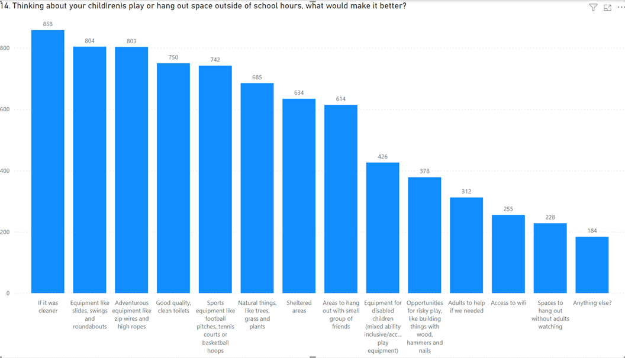

Answers | Count | Percentage
Equipment like slides, swings and roundabouts | 804 | 10.48%
Adventurous equipment like zip wires and high ropes | 803 | 10.47%
Opportunities for risky play, like building things with wood, hammers and nails | 378 | 4.93%
Natural things, like trees, grass and plants | 685 | 8.93%
Sports equipment like football pitches, tennis courts or basketball hoops | 742 | 9.67%
Areas to hang out with small groups of friends | 614 | 8.00%
Sheltered areas | 634 | 8.26%
Access to Wifi | 255 | 3.32%
Good quality, clean toilets | 750 | 9.77%
Adults to help if we needed | 312 | 4.07%
Equipment for disabled children (mixed ability inclusive / accessible play equipment) | 426 | 5.55%
Spaces to hang without adults watching | 228 | 2.97%
If it was cleaner | 858 | 11.18%
Anything else? | 184 | 11.06%

Q15. Participants were asked why they didn’t like their child(ren)s play or hang out space outside of school hours.
The most popular responses were:
- There is sometimes litter lying around, for example paper, or cigarette butts: 14.54%
- There is sometimes dog poo in the play space: 12.67%
- Sometimes some of the equipment is broken or missing has parts: 12.19%
- There is sometimes dangerous litter lying around, for example glass or needles: 11.95%
- There are sometimes older children there make my child(ren) feel scared: 11.62%

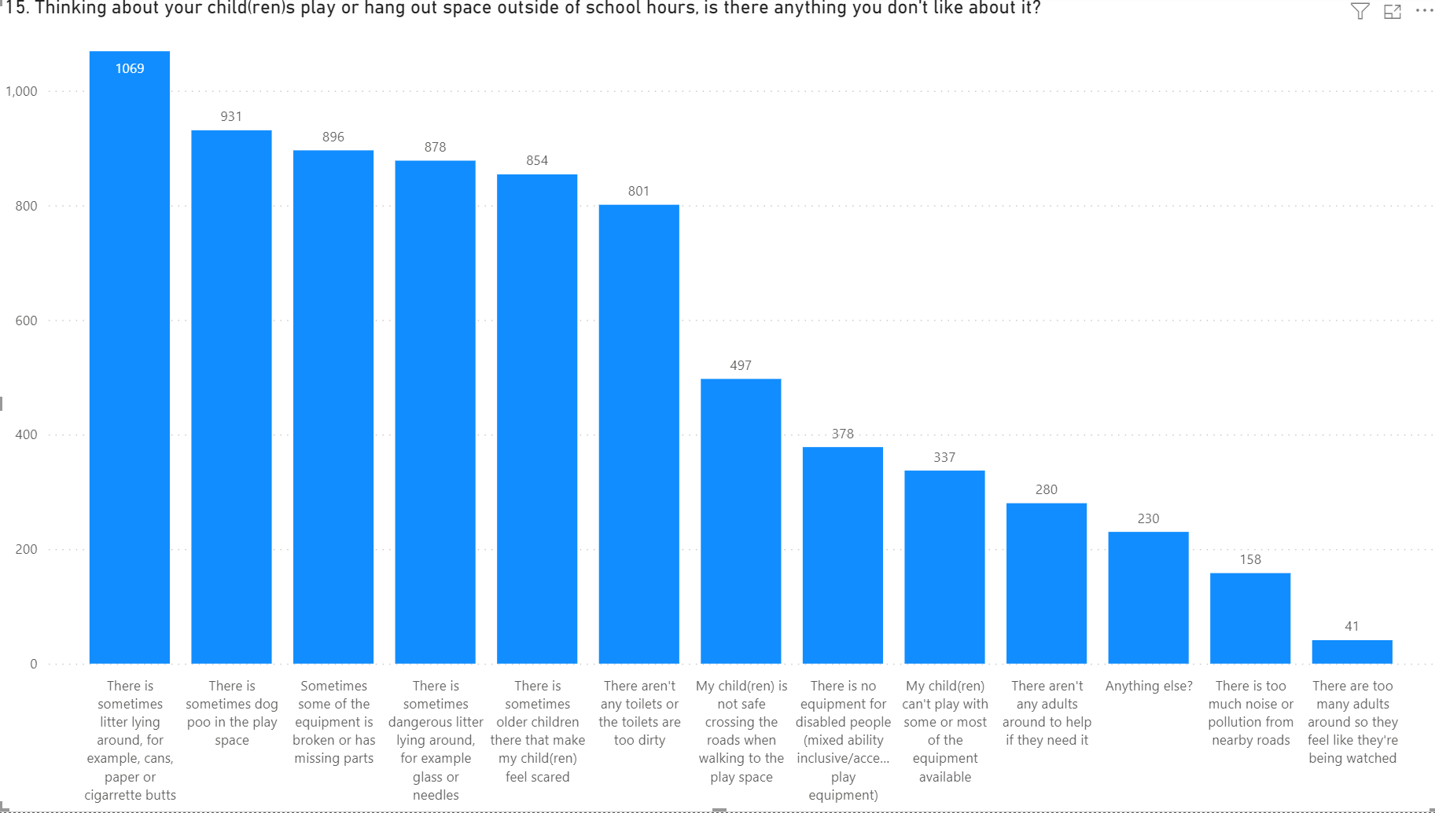

Answers | Count | Percentage
There is sometimes dog poo in the play space | 931 | 12.67%
There is sometimes litter lying around, for example paper, or cigarette butts | 1,069 | 14.54%
There is sometimes dangerous litter lying around, for example glass or needles | 878 | 11.95%
Sometimes some of the equipment is broken or missing has parts | 896 | 12.19%
There is too much noise or pollution from nearby roads | 158 | 2.15%
My child(ren) is not safe crossing the road when walking to the play space | 497 | 6.76%
There are sometimes older children there make my child(ren) feel scared | 854 | 11.62%
There aren’t any adults around to help if they need it | 280 | 3.81%
There are too many adults around, so they feel like they are being watched | 41 | 0.56%
There aren’t any toilets, or the toilets are dirty | 801 | 10.90%
My child(ren) can’t play with some or most of the equipment available | 337 | 4.59%
There is no equipment for disabled children (mixed ability inclusive/ accessible play equipment) | 378 | 5.14%
Anything else? | 230 | 3.13%

Play Survey 2:
Participants were asked to tell us some basic information about themselves, including age, gender and nearest town. Asking these ‘about you’ questions can help us understand the needs, perceptions, satisfaction, behaviour and lifestyle of children and young people in the community.

About the participants

Q1. Of the 931 responses, the highest number of responses were from children or young people responding on their own (94.98%)

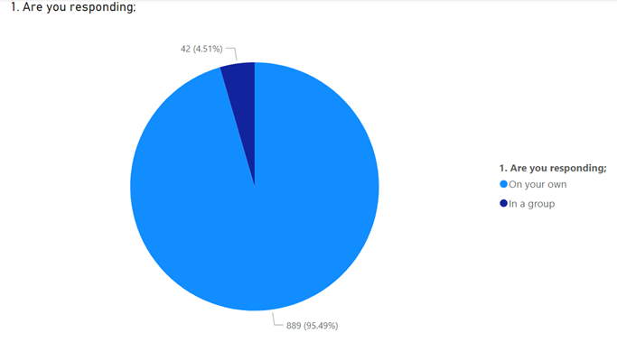

Answers | Count | Percentage
On your own | 889 | 95.49%
In a group | 42* | 4.51%
*191 children were represented by 42 group response

From this point, all answers to the questions are combined from the individual and group responses, giving all responses from all children no matter if they responded individually or as part of a group.

Q2. Gender of participants.
The gender ratio for girl / boy of children and young people participating was broadly similar with 1.21% preferring not to say.
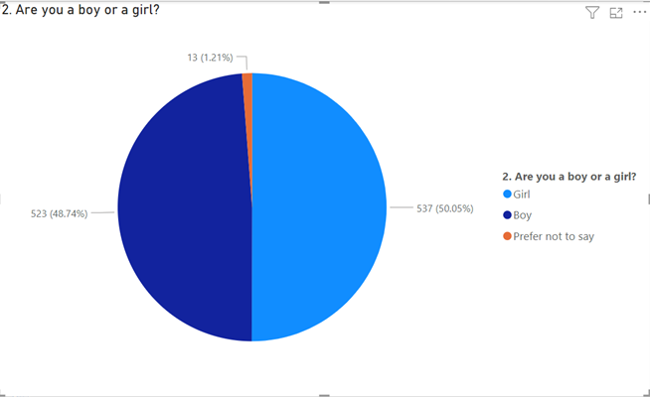

Answers | Count | Percentage
Girl | 537 | 50.05%
Boy | 523 | 48.74%
Prefer not to say | 13 | 1.21%

Q3. Age of participants
For individual responses, the majority of participants were in the 5 - 11 age group.
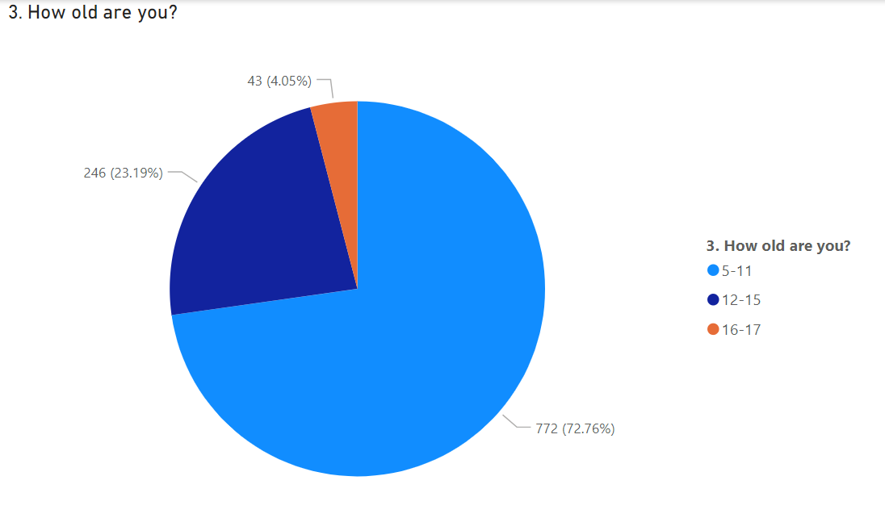

Answers | Count | Percentage
5-11 | 772 | 72.76%
12-15 | 246 | 23.19%
16-17 | 43 | 4.05%

Q4. Participants were asked if they were disabled. Most children and young people responding to the survey were not disabled, however 8.99% of participants responded that they were disabled with 2.13% preferred not to say.
Of the 80 participants that elected to tell us more about their disability, the majority used the word ‘autism’ when describing their disability.

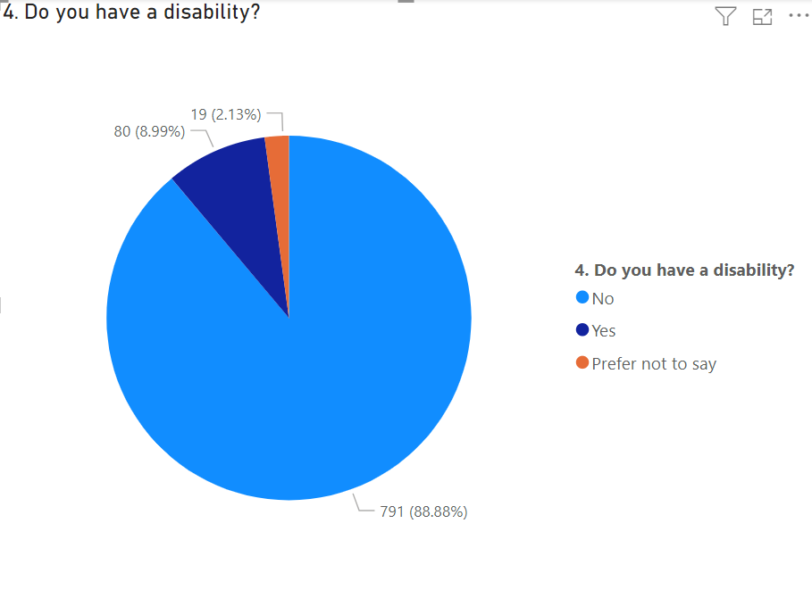

Answers | Count | Percentage
No | 791 | 88.88%
Yes | 80 | 8.99%
Prefer not to say | 19 | 2.13%

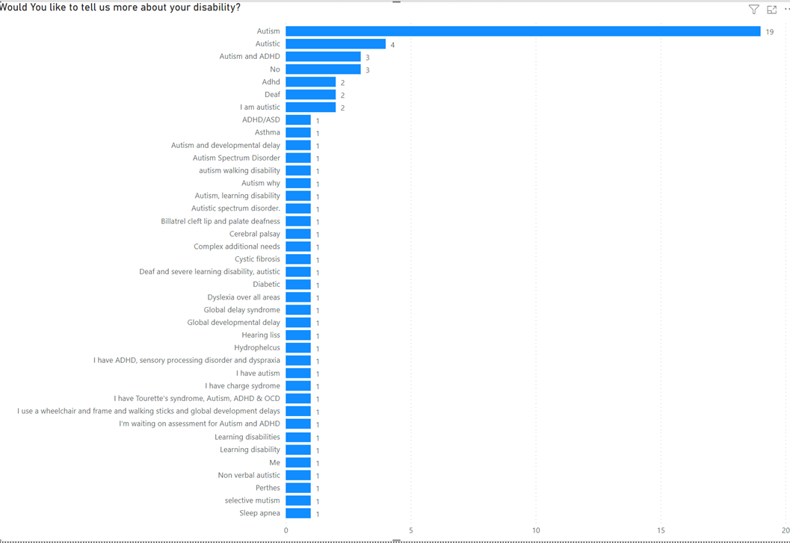

Q5. Children and young people were asked what school they went to. We captured all responses in the table on Appendix 2.

Q6. Participants were asked to tell us their nearest town.
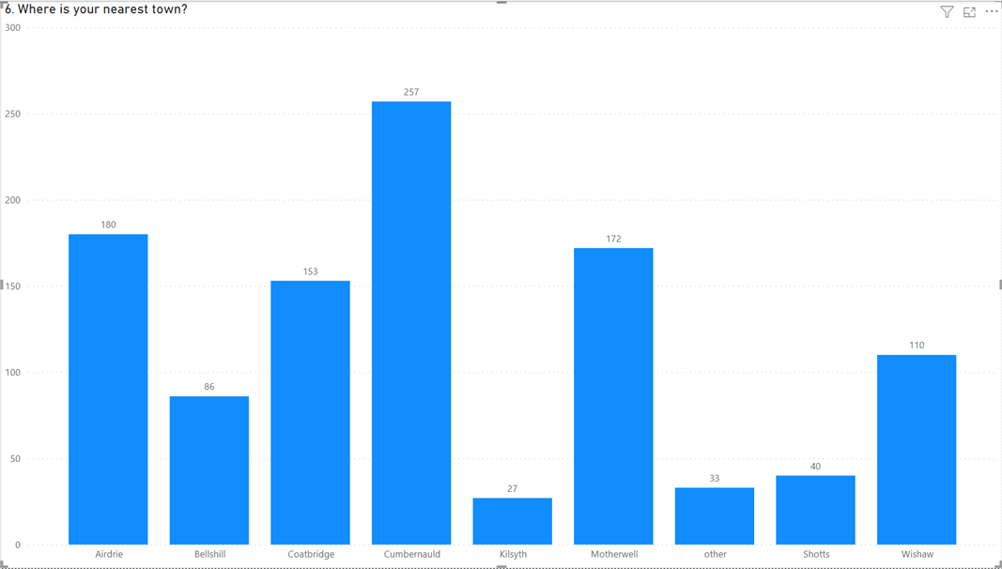

Answers | Count | Percentage
Airdrie | 180 | 17.01%
Bellshill | 86 | 8.13%
Coatbridge | 153 | 14.46%
Cumbernauld | 257 | 24.29%
Kilsyth | 27 | 2.55%
Motherwell | 172 | 16.26%
Shotts | 40 | 3.78%
Wishaw | 110 | 10.40%
Not listed above (Please Specify) | 33 | 3.12%

The list of answers given when ‘not listed above’ was answered are below.
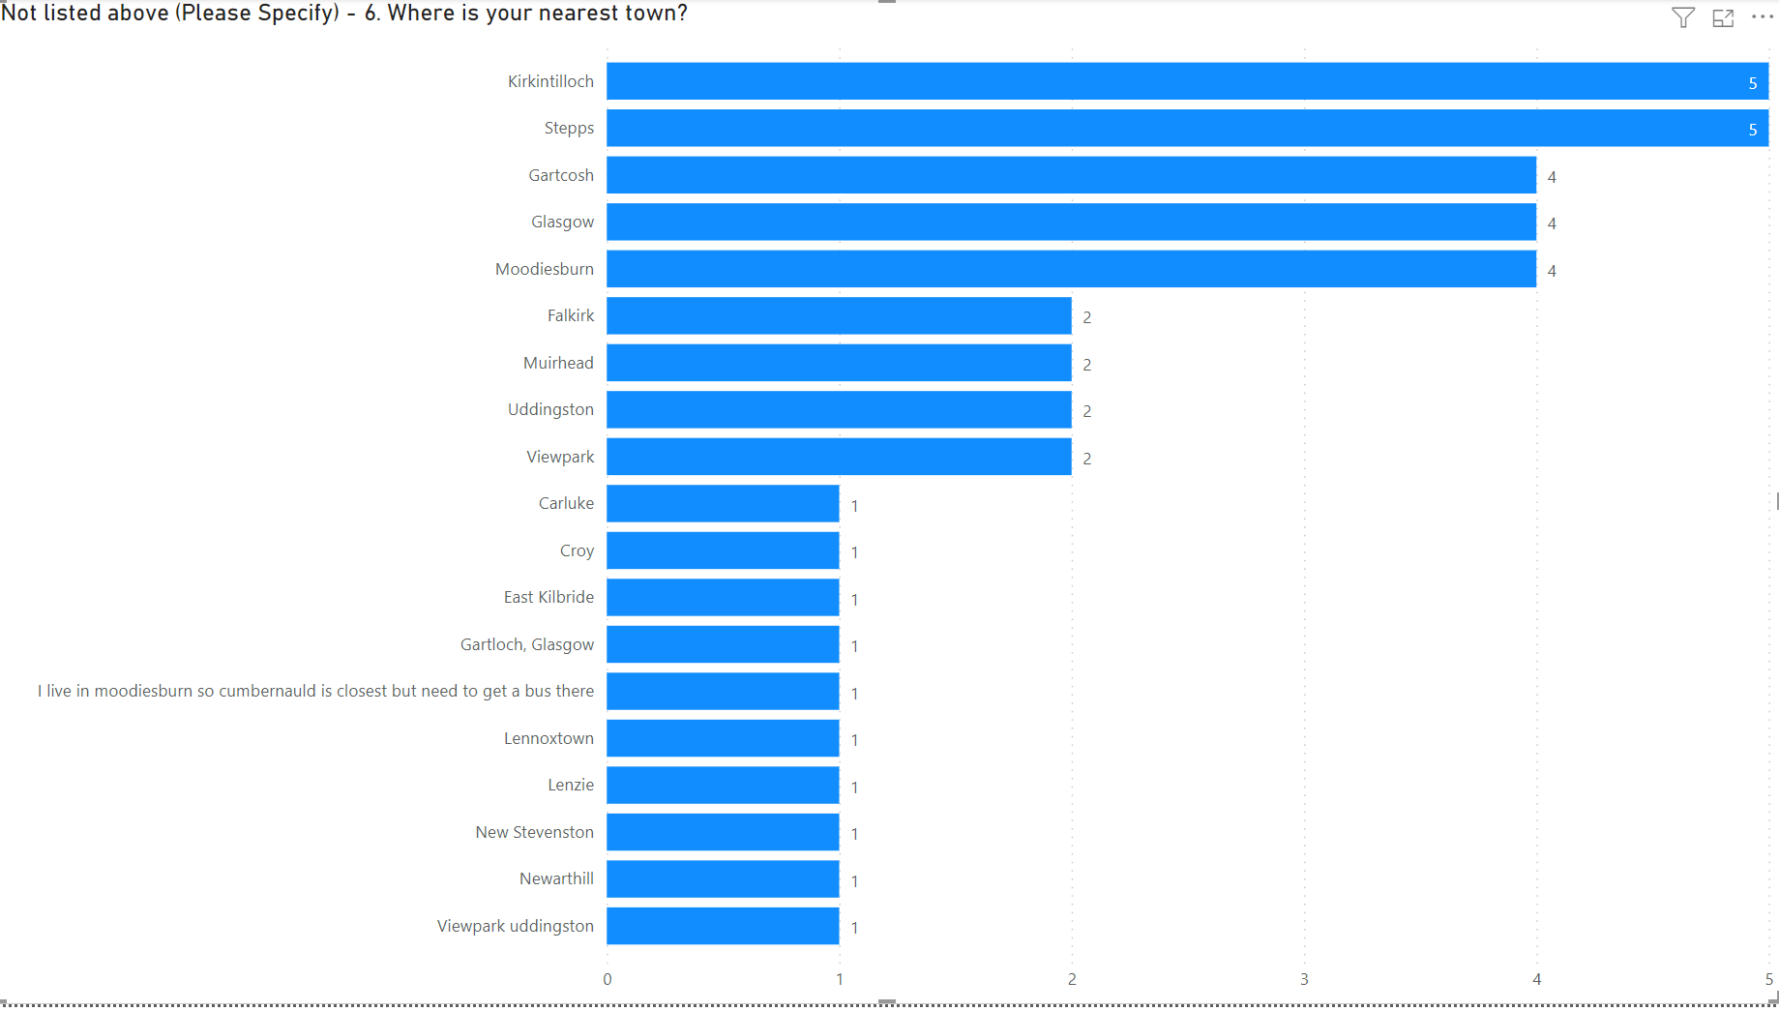

About playing out in local areas
Children and young people were asked about how often they play and whether there was somewhere close to where they live that they could play.

Q7a. Children and young people were asked how often they went to play or hang out in public play spaces.
The most popular answer was a few times a week (33.43%)

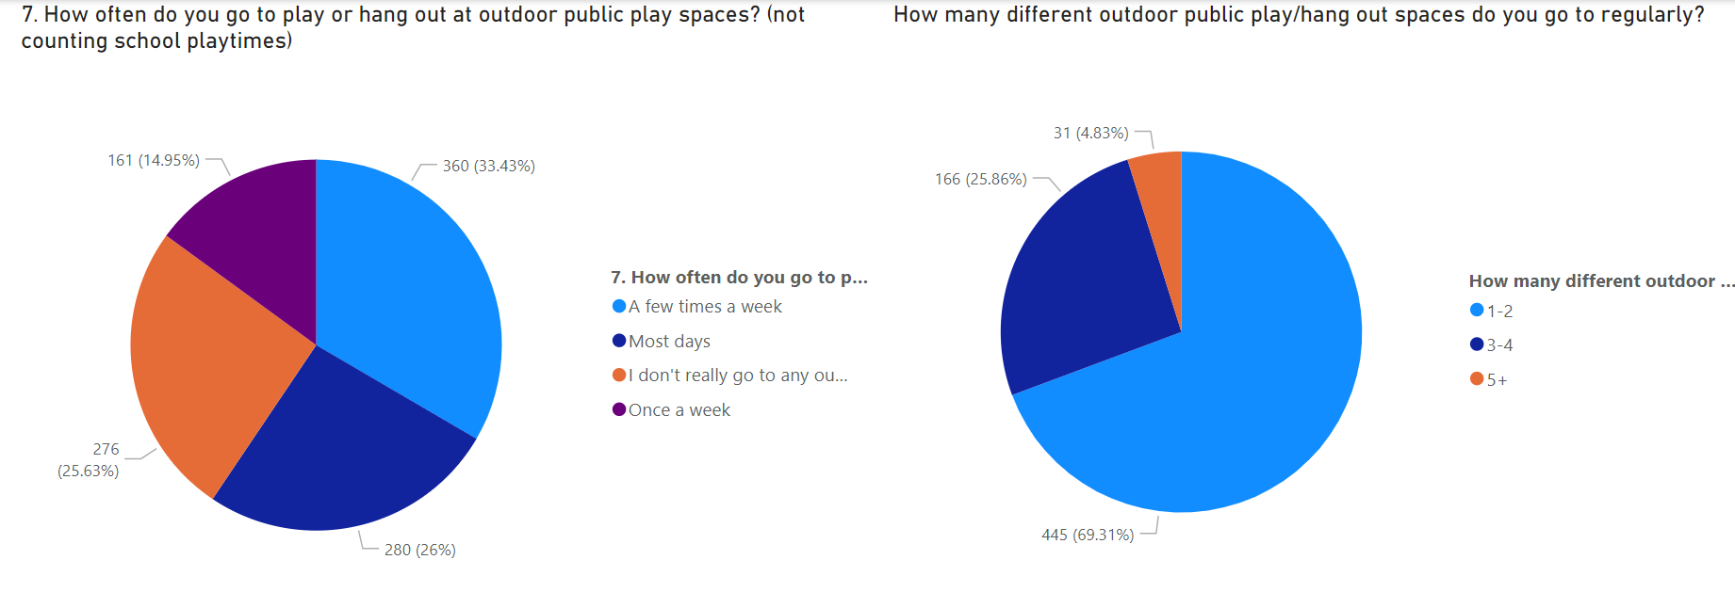

Answers | Count | Percentage
A few times a week | 360 | 33.43%
I don’t really go to any outdoor play/hang out spaces | 276 | 25.63%
Most days | 280 | 26.00%
Once a week | 161 | 14.95%

Where response was that participants play or hang out at outdoor public play spaces, they were then asked how many different outdoor public play / hang out spaces they went to regularly.
The most popular response was 1 – 2.

Answers | Count | Percentage
1-2 | 445 | 69.31%
3-4 | 166 | 25.86%
5+ | 31 | 4.83%

Q8. Children and young people were asked if there was an outdoor public play/hang out space near to where they live that they can walk or cycle to on their own or with friends (without an adult).
The majority of children and young people said yes (54.59%)

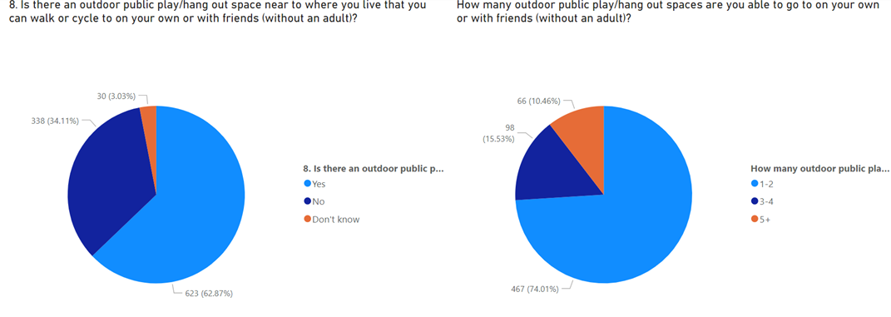

Answers | Count | Percentage
Yes | 623 | 62.87%
No | 338 | 34.11%
Don’t know | 30 | 3.03%

For group responses: Of the children and young people responding through a group, the most popular response was yes.

Where those responded yes, they were then asked how many public play/hang out spaces they were able to go to on your own or with friends (without an adult).
The most popular response was 1 – 2.

Answers | Count | Percentage
1-2 | 467 | 74.01%
3-4 | 98 | 15.53%
5+ | 66 | 10.46%

Tell us about your favourite play or hang out space
Children and young people were asked to tell us where their favourite play space was in North Lanarkshire, how they got there and how they played there.

Q9 – MAP BASED QUESTION

Q10. Children and young people were asked how they usually get to the play / hang out space. The majority usually walk, wheel, cycle, scooting, skateboarding, blading (74.77%)
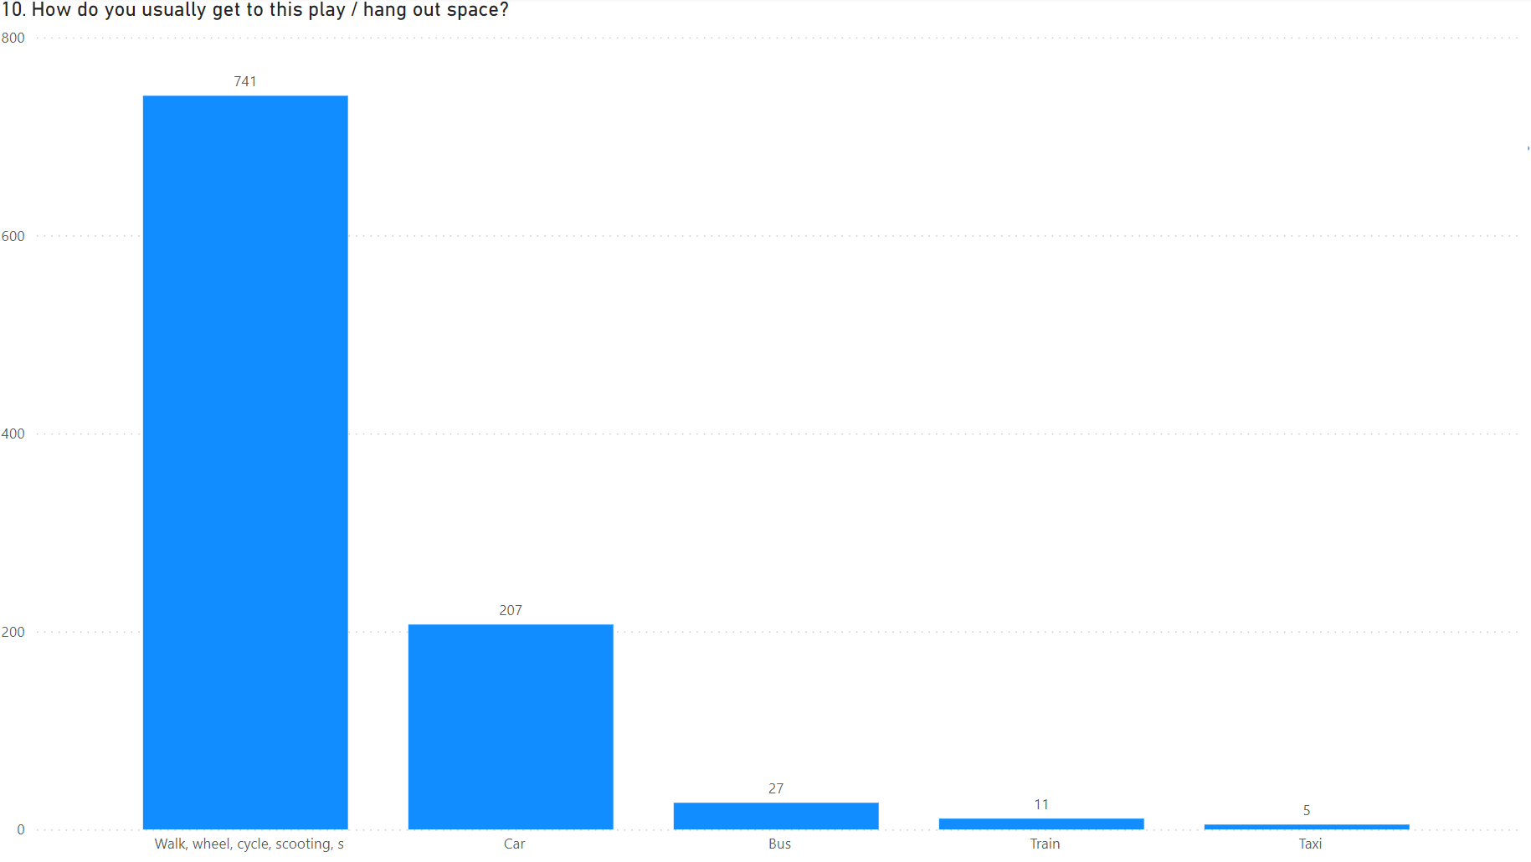

Answers | Count | Percentage
Walk, wheel, cycle, scooting, skateboarding, blading | 741 | 74.77%
Car | 207 | 20.89%
Bus | 27 | 2.72%
Train | 11 | 1.11%
Taxi | 5 | 0.50%

Q11. Children and young people were asked if the play space they identified had natural things to play on or with, for example, trees, logs, rocks.
The majority said no (55.68%)

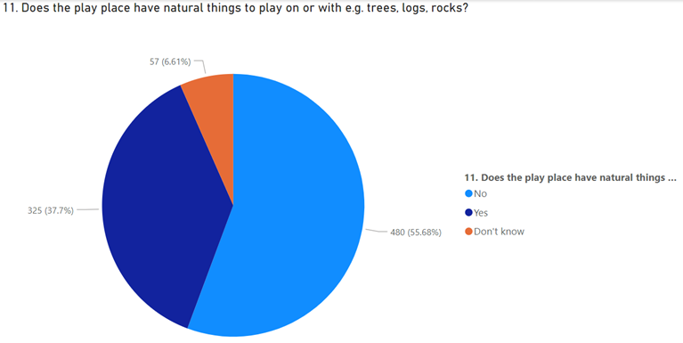

Answers | Count | Percentage
No | 480 | 55.68%
Yes | 325 | 37.70%
Don’t know | 57 | 6.61%

Q12. Children and young people were asked if there are things to move around and play with in different ways in the play space.
The most popular answer was no (53.94%)

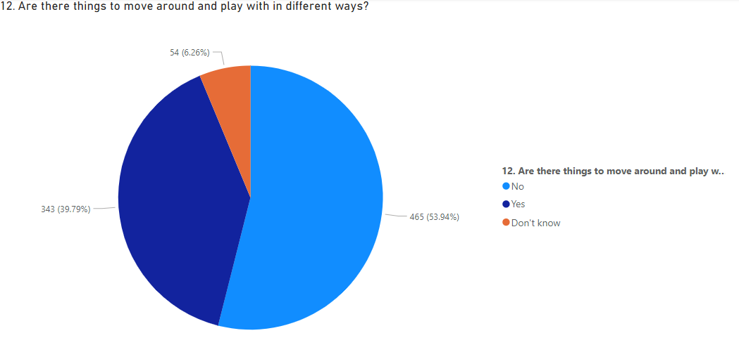

Answers | Count | Percentage
No | 465 | 53.94%
Yes | 343 | 36.65%
Don’t know | 54 | 6.26%

Q13. Children and young people were asked if there is fixed equipment to play on in the play space.
The majority said yes (71.37%)
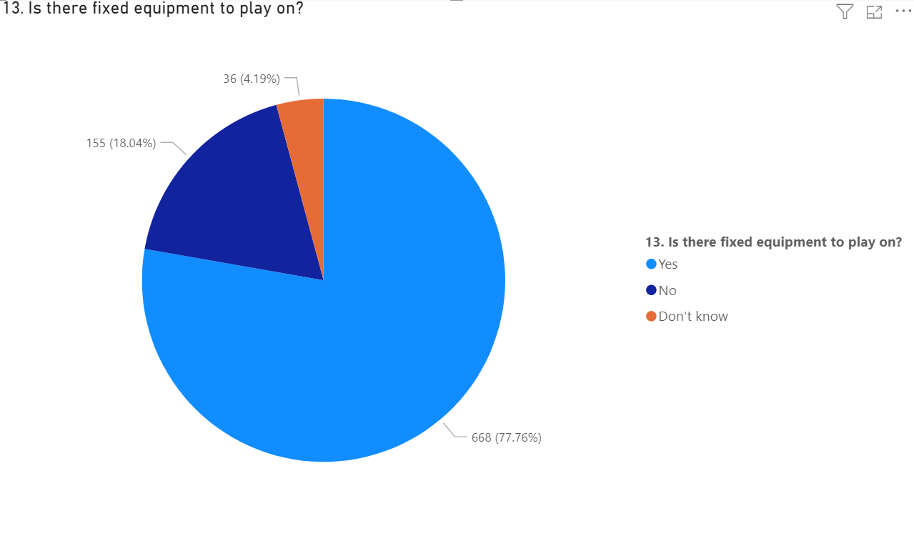

Answers | Count | Percentage
Yes | 668 | 77.76%
No | 155 | 18.04%
Don’t know | 36 | 4.19%

Q14. Children and young people were asked what we could change to make it easier and safer to walk, wheel, cycle, scooting, skateboard or blade to this space.
We captured all responses through the word cloud below.
The most popular responses included:
- Safer, more crossing points (traffic lights, zebra)
- More/Safer/Improve/Repair Pathway
- Closer Areas
- More/Better/Fix Equipment
- Better Lighting
- Maintained Better (Rubbish/Ground/Equipment/Glass/Mud/Grass)
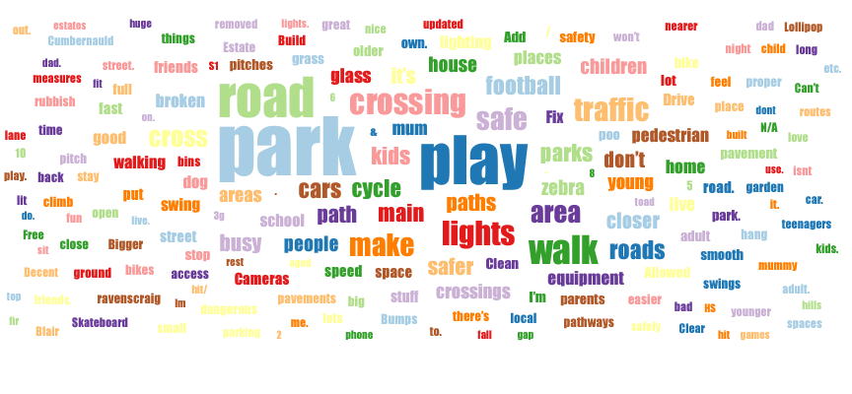
Word cloud created using participants responses as to what we could change to make it easier and safer to walk, wheel, cycle, scooting, skateboard or blade to their favourite play or hang out space.

Q15. Children and young people were asked what would make this space better.
The most popular responses were:
- Adventurous equipment like zip wires and high ropes: 51.92%
- Sheltered areas: 43.7%
- Sports equipment like football pitches, tennis courts or basketball hoops: 38.03%
- Good quality, clean toilets: 38.03%
- Areas to hang out with small groups of friends: 35.26%

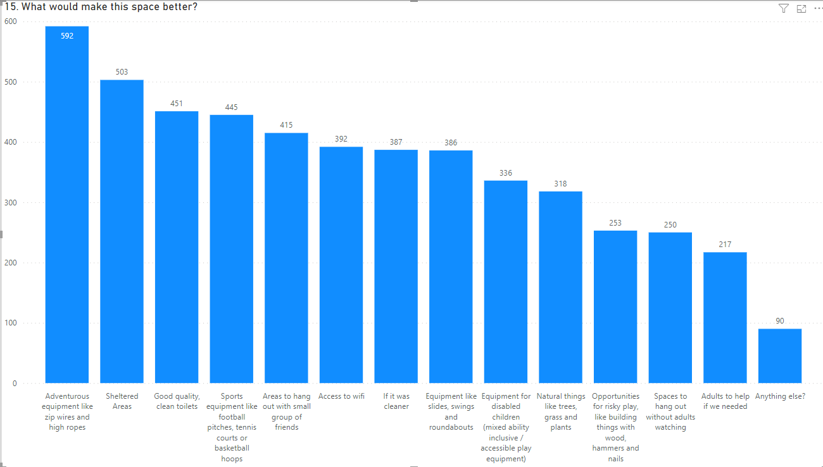

Answers | Count | Percentage
Equipment like slides, swings and roundabouts | 386 | 7.67%
Adventurous equipment like zip wires and high ropes | 592 | 11.76%
Opportunities for risky play, like building things with wood, hammers and nails | 253 | 5.02%
Natural things, like trees, grass and plants | 318 | 6.32%
Sports equipment like football pitches, tennis courts or basketball hoops | 445 | 8.84%
Areas to hang out with small groups of friends | 415 | 8.24%
Sheltered areas | 503 | 9.99%
Access to Wifi | 392 | 7.79%
Good quality, clean toilets | 451 | 8.96%
Adults to help if we needed | 217 | 4.31%
Equipment for disabled children (mixed ability inclusive / accessible play equipment) | 336 | 6.67%
Spaces to hang out without adults watching | 250 | 4.97%
If it was cleaner | 387 | 7.69%
Anything else? | 90 | 1.79%

Tell us about a space that you don’t like
Children and young people were asked to tell us why they didn’t like a play space in North Lanarkshire.

Q16. Children and young people were asked to tell us about a space that they didn’t like and why they didn’t like it.
The most popular responses were:
- There is sometimes litter lying around, for example, cans, paper, or cigarette butts: 64.53%
- There is sometimes dog poo in the play space: 56.2%
- There is sometimes dangerous litter lying around, for example glass or needles: 47.76%
- Sometimes some of the equipment is broken or missing has parts: 45.19%
- There are sometimes older children there that make me feel scared: 44.87%
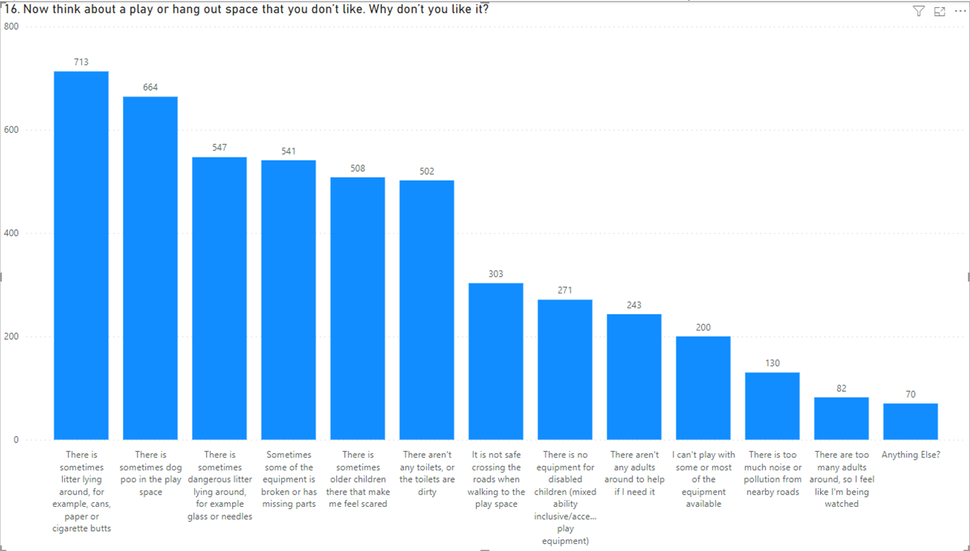

Answers | Count | Percentage
There is sometimes dog poo in the play space | 664 | 13.91%
There is sometimes litter lying around, for example, cans, paper, or cigarette butts | 713 | 14.94%
There is sometimes dangerous litter lying around, for example glass or needles | 547 | 11.46%
Sometimes some of the equipment is broken or missing has parts | 541 | 11.33%
There is too much noise or pollution from nearby roads | 130 | 2.72%
It is not safe crossing the roads when walking to the play space | 303 | 6.35%
There are sometimes older children there that make me feel scared | 508 | 10.64%
There aren’t any adults around to help if I need it | 243 | 5.09%
There are too many adults around, so I like I’m being watch ed | 82 | 1.72%
There aren’t any toilets, or the toilets are dirty | 502 | 10.52%
I can’t play with some or most of the equipment available | 200 | 4.19%
There is no equipment for disabled children (mixed ability inclusive / accessible play equipment) | 193 | 20.62%
Anything else? | 63 | 6.73%

Appendix 1

Play Survey 1 Questions:
About you
Q1. Are you responding to this survey as:
- Parent or carer
- Grandparent or other relative
- Work with children (for example, childminder)
When responding to the survey ‘your child(ren)’ will be the child(ren) you are responding about.
Q2. Do you have responsibility for any children in the following age groups?”
- 0-4
- 5-11
- 12-15
- 16-17
Q3. Is your child(ren):
- Girl
- Boy
- Prefer not to say

Q4. Which of these bests describe you?
- In full time employment
- In part time employment
- Caring for family
- Retired
- Student (may also be working too)
- Not working at the moment
- Prefer not to say
Q5. Are you disabled?
- Yes
- No
- Prefer not to say
If Y - Would you like to let us know more about your disability? (Please write in.)
Q6. Is your child or any of your children disabled?
- Yes
- No
- Prefer not to say
If Y - Would you like to let us know more about your child(ren)s disability? (Please write in.)
Q7. Please tell us your postcode: (for example ML1 1AB)
Q8. How often does your child(ren) go outside to play or hang out with friends on average each week outside of school hours?
- More than once per day
- Every day
- Several times a week
- Once a week
- Never
Q9. How does your child(ren) get to the place or places they play in?
- Walk, wheel, cycle, scooting, skateboarding, blading
- Car
- Bus
- Train
- Taxi
Q10. How far away from your home is your nearest play area?
- 5 minute walk or less
- Within a 6 - 10 minute walk
- Within an 11 - 20 minute walk
- Within a 21 - 30 minute walk
- More than a 30 minute walk
- Don't know
Q11. Overall, how satisfied are you that your child(ren) have access to outdoor play outside of school hours?
Highly satisfied - Highly dissatisfied – scale to be added
Q12. How much do you agree or disagree with the following statements relating to your nearest play space?
- Agree strongly
- Agree slightly
- Neither Agree Nor
- Disagree slightly
- Disagree strongly
- Don’t know
My local play space…
- Is easy to get to by walking or cycling
- Feels welcoming and safe
- Has natural things to play on or with, for example trees, logs, rocks
- Has things to move around and play with in different ways
- Has is fixed equipment to play on
Q13. Which is your child(ren)s favourite PLACES to play or hang out outside of school hours? Please tick all that apply.
- Your garden or friends’ gardens
- School playground
- Streets and corners near home
- Places that feel safe from traffic, bullies, strange adults
- A local park or grassy area
- Places they can get to easily by walking or cycling
- Natural places with trees, bushes, flowers, fields
- Play parks with water and sand: paddling pool, sandpit, fountains.
- Play parks: swings, slides, climbing frames, seesaws
- Cycle track or skate park
- Football fields or sports pitches
- Community centre or leisure centre
- Woods and forests
- Beaches/rivers
- Anything else?
Q14. Thinking about your child(ren)s play or hang out space outside of school hours, what would make it better? Please tick all that apply.
- Equipment like slides, swings and roundabouts
- Adventurous equipment like zip wires and high ropes
- Opportunities for risky play, like building things with wood, hammers and nails
- Natural things, like trees, grass and plants
- Sports equipment like football pitches, tennis courts or basketball hoops
- Areas to hang out with small groups of friends
- Sheltered areas
- Access to Wifi
- Good quality, clean toilets
- Adults to help if we needed
- Equipment for disabled children (mixed ability inclusive / accessible play equipment)
- Spaces to hang out without adults watching
- If it was cleaner
- Anything else? (answers given when this option was selected are on Appendix 2)
Q15. Thinking about your child(ren)s play or hang out space outside of school hours, why don’t you like it? Please tick all that apply.
- There is sometimes dog poo in the play space
- There is sometimes litter lying around, for example, cans, paper, or cigarette butts
- There is sometimes dangerous litter lying around, for example glass or needles
- Sometimes some of the equipment is broken or has parts missing
- There is too much noise or pollution from nearby roads
- My child(ren) is not safe crossing the roads when walking to the play space
- There are sometimes older children there that make my child(ren) feel scared
- There aren’t any adults around to help if they need it
- There are too many adults around, so they feel like they are being watched
- There aren’t any toilets, or the toilets are dirty
- My child(ren) can’t play with some or most of the equipment available
- There is no equipment for disabled children (mixed ability inclusive / accessible play equipment)
- Anything else? (answers given when this option was selected are on Appendix 2)

Play Survey 2 Questions:
Tell us about you
- Are you responding on your own or as part of a group.
- On your own
- In a group
- Are you a boy or a girl? Tick one
- Boy
- Girl
- Prefer not to say
2a. How many boys are in the group?
2b. How many girls are in the group?
2c. How many in the group prefer not to say?

- How old are you?
- 5-11
- 12-15
- 16-17
3a. How many in the group are aged 5-11?
3b. How many in the group are aged 12-15?
3c. How many in the group are aged 16-17?

- Do you have a disability?
- Yes
- No
- Prefer not to say
4a. How many in the group have a disability?
If Y - Would you like to let us know more about your disability? (Please write in.)

- Which school or nursery do you go to?

- Where is your nearest town?

Tell us what you think by answering these questions about playing out in your local area.
- How often do you go to play or hang out at outdoor public play spaces? (not counting school playtimes) Tick one
- Most days
- A few times a week
- Once a week
I don’t really go to any outdoor play/hang out spaces
(Branch question as if answered 7 ‘don’t really go’ then doesn’t apply) How many different outdoor public play/hang out spaces do you go to regularly?
- 1-2
- 3-4
- 5+

- Is there an outdoor public play/hang out space near to where you live that you can walk or cycle to on your own or with friends (without an adult)?
- Yes
- No
- Don’t know
Branch if Y -How many outdoor public play/hang out spaces are you able to go to on your own or with friends (without an adult)?

Tell us about your favourite play or hang out space

- MAP BASED QUESTION: Can you show us on this map where your favourite play or hang out space is? (please add user instructions as per OSS)

- How do you usually get to this play / hang out space?
- Walk, wheel, cycle, scooting, skateboarding, blading
- Car
- Bus
- Train
- Taxi

- Does the play place have natural things to play on or with e.g. trees, logs, rocks
- Yes
- No
- Don’t know

- Are there things to move around and play with in different ways
- Y
- N
- Don’t know

- There is fixed equipment to play on?
- Yes
- No
- Don’t know

- What could we change to make it easier and safer to walk, wheel, cycle, scooting, skateboard or blade to this space? Comment box (answers given are on Appendix 2)

- What would make this space better? Please tick all that apply.
- Equipment like slides, swings and roundabouts
- Adventurous equipment like zip wires and high ropes
- Opportunities for risky play, like building things with wood, hammers and nails
- Natural things, like trees, grass and plants
- Sports equipment like football pitches, tennis courts or basketball hoops
- Areas to hang out with small groups of friends
- Sheltered areas
- Access to Wifi
- Good quality, clean toilets
- Adults to help if we needed
- Equipment for disabled children (mixed ability inclusive / accessible play equipment)
- Spaces to hang out without adults watching
- If it was cleaner
- Anything else? (answers given when this option was selected are on Appendix 2)

Tell us about a space that you don’t like

- Now think about a play or hang out space that you don’t like. Why don’t you like it? Please tick all that apply.
- There is sometimes dog poo in the play space
- There is sometimes litter lying around, for example, cans, paper, or cigarette butts
- There is sometimes dangerous litter lying around, for example glass or needles
- Sometimes some of the equipment is broken or missing has parts
- There is too much noise or pollution from nearby roads
- It is not safe crossing the roads when walking to the play space
- There are sometimes older children there that make me feel scared
- There aren’t any adults around to help if I need it
- There are too many adults around, so I like I’m being watched
- There aren’t any toilets, or the toilets are dirty
- I can’t play with some or most of the equipment available
- There is no equipment for disabled children (mixed ability inclusive / accessible play equipment)
- Anything else? (answers given when this option was selected are on Appendix 2)

Appendix 2

Play Survey 1 Question 13 – Which is your child(ren)’s favourite places to play or hang out outside of school hours? – All responses to ‘Anything Else?’

The following are verbatim responses given via our play survey.

Of the ‘not listed above’ responses, not everyone told us more.

Anything else? - 13. Which is your child(ren)s favourite PLACES to play or hang out outside of school hours?
Macdonalds as there is limited places for 16-17 year olds
A safe place, we have no playground facilities.
At home
At home because the council took away the local areas basket ball court etc and the nearest chute area is full of broken glass and needles
Athletics track
Basketball arena
Bedroom on computer
Bellhaven but it’s ALWAYS full of dogs off leads last July/august we were there & a dog of the lead came up and jumped on and scratched my friends little boy. There’s a water but at the park with no water during summer! It should be maintained
Bus to football pitch approx 5 miles away
Costa coffee, Guides
Craigieburn community garden is our back door,my children and their friends plant flowers fruit and vegetables for everyone in the street,the kids litter pick and I personally had to pick up 28poos!. Theres no other safe places near us
Cumbernauld Shopping Centre
Dance studio and Cheer Gym
Go walks round village
Graveyard as the football park, changing rooms, tennis courts and Glen are gone.
Home can b impulsive
Homes
Horse riding
I have to take my grandson to Braidhurst high school.. Astro football park 5 min walk from me but kids are playing football in the street and are in danger from cars as NLC will not give local kids access to the daisy park astro pitch.
In Auchinloch due to new housing there are loads of kids and no facilities. The village really needs some sports fields and other things to keep them entertained. They can’t be expected to walk to the nearest pitches in Stepps.
Langloan Running Track
local allotment
Local outoor platy area in whinhall allotments called muddy boots for under 5s
Martial art class LOVESit .
More outdoor gym my daughter loves the one I. king George park but I do not feel this is a safe place for her.
MUGA at high school
My youngest does not like to go outdoors to play or hang out
Nature trails
One stays in the house out of school, the other has to go down the main street as all 'play' areas are for younger children not teenagers.
Out of area activity
Outside small local shops
places to play ball games where dog owners do not use the space to allow their dogs to run off-lead. Dog-free spaces to run, roll etc
Places where the whole family can do things like Dunbeth Park it covers all age groups with its equipment, football parks, gym, seats and pathway
Places without dog mess
She doesn’t play outside but goes to horse riding stables
Somewhere that's not full of needles, rubbish and broken play equipment
Sports clubs etc
Supermarkets
Tesco
The running tracks - of which are none in Airdrie and langloan no longer has toilets
There’s nowhere appropriate that my children can be unaccompanied
We have to travel to safer places that have enclosed spaces and safe areas
We live in Auchinloch. Other than a toddlers play park there is nothing for kids. Some sports fields would be very welcome.
We tend to travel to parks outwith our area eg. Glasgow and East Kilbride as they are better kept and have more to do.

Play Survey 1 Question 14 – Thinking about your child(ren)s play or hand out space outside of school hours, what would make it better? – All responses to ‘Anything Else?’
The following are verbatim responses given via our play survey.

Of the ‘not listed above’ responses, not everyone told us more.

Anything else? - 14. Thinking about your child(ren)s play or hang out space outside of school hours, what would make it better?
A bin in park or nearby. No dogs mess in park. Park is continuously used as a dog park and council won’t even put a sign up to say no dogs allowed.
A crossing to get to it. My child was almost killed yesterday trying to cross the road to get to the park but NLC have said the speeding is not severe enough to merit a crossing. So my children can't use Birkenshaw Park for fear of death.
A decent walking, cycling, riding path from approximately 100 Community Road to Bothwellhaugh Road/
A good bin
A grass area.
A maintained area of grass
A proper training track - there is enough football pitches
A sports centre with a full sized handball court to cater for the many school kids that play in Cumbernauld
A warden or park patrol officer someone of authority regularly checking the parks over particularly the one at Maree drive as it’s being vandalised.
A youth zone for teens
Accepting staff in cafes
Access to the local football pitches when out of hours
Age aappropriate especially for little ones1-3 years , always broken grass lying around. Maybe look at making separate play parks for little ones
Age appropriate equipment.
Age appropriate play things
All responses here are relating to a private play garden and space within my area which I pay for in terms of factor fees, as such these responses are not in relation to NLC delivered/ maintained/ offered resources.
All year round ground surface to help them be safe and be able to use all year round. Not having parks with just grass or more than it being a muck while all year round. Also it being fenced in
Alot of parks etc near us are full of older children hanging around drinking and my kids don't feel save there so would rather stay indoors
An area where dogs are not allowed. I have one child who is scared of dogs due to several intimidating experiences. My other child with Autism attracts unwanted negative attention from dogs.
Areas that are maintained and not a risk to life as is the current local play place
As said before intergenerational park for everyone to use.
away from speeding cars, less broken glass, less alcoholic drink dregs about the place.
Being closer to home would be better.
Bench
Bench sheltered area
Benches for adults to sit on
Better drainage so not muddy
Better equipment for younger children (toddlers), the play space has two slides and nothing else
Better equipment in local park, it is old and rusty, hardly anything there for them to do. It’s a shame.
Better lighting
Better policing of the ‘young team’.Also better control of the vandalism and piles of litter we have to wade through after the high school children have visited the places at lunch time.
Better signage so people know where the dog parks are and where the kids parks are.
Bike pump track
Bike tracks, bmx or pump track
Bluebell Playpark Stepps requires maintenance - cleaning, painting and repairs toi equipment
Changing places toilets
Child parks which adults can allow them to use on their own as most small kids are unable to get on ones that don’t have a proper stair access to the slides etc
children between ages 12-17 have nothing to do outside that is actually fun for them without adults or money so they just get bored and hang about street corners and drink and you see so much of it i feel there should be somewhere they could go
Chryston has terrible pavements for cycling loads of roads to cross that are not safe the cycle track was taking away
Clean and safe
Climbing and parkour equipment
Closer to home so safer for them to walk to
Closer to home! There is a large grassy area on the Calder road that's wasted space. Could have a fabulous play park or something similar to bellshill academy play area
Cycle paths, bike tracks
Damaged equipment fixed, litter free dog foul free, no broken glass on the
Disabled parking to make accessible & fenced for security purposes
Equipment for younger children
Equipment that 2 year olds can climb and go down a shoot without falling through ropes etc.
Expanded and refurbished play area. I think that NLCs flagship park could accommodate a really good play area like Calderglen or Rouken Glen that has a number of items that are accessible to children with disabilities. I think a nice cafe beside it.
Fences and gates on areas for safe play. Even flooring for push chairs etc toilets
Food court, or snack space
Free from dogs dirt and needs to be well lit for winter, no lighting at present
Having play areas would be nice
Ideally a play area in our own estate so kids dont need to go to other plsy parks that they need to cross roads to get to
If it was bigger and more.of it. Really overcrowded
If it was clean, safe and in a safer location where cars and older groups of teenagers are hanging around leaving things.
If it was drier underfoot. The park often becomes bog like after it rains
If it was nearer to our home. There I'd one park in the whole of condorrat about a 20min or more uphill walk. There's open green space which could be utilised better as play parks.
If it was safe from large groups of teenagers
If it wasn't used as a drinking area in the evening and left like a dump.
If the equipment and surface area was fit for purpose and usable me all year round
If the local gym was cheaper!
If there was a play space closer that she could go to with her friends.
Improved drainage in play area of park at Auchjnstarry.
Indoor hang out spaces with cheap cafe
Indoor track
Interactive equipment and places to inspire imagination. Not muddy or waterlogged places.
It's worth noting that the play park my child uses is ran by our factor and we pay for the service. There are no council owned and maintained play parks within easy walking distance for my child.
Just more areas for kids hardly a park and ones that are left are run down broken baby parks then for older ones there's nothing to do
Just somewhere they can play safely we have nothing in Gartcosh. My children have to walk to glenboig park.
Lack of maintenance such as grass cutting on small football field.
Less grown up children shouting and swearing
Local all-weather football pitches aren't readily accessible out of school hours, which is disgraceful. These should be open to let kids play and not get into trouble due to having nothing to do.
Local playpark are maintained by factors and they have minimal play equipment and need some TLc. To go to a decent park, we drive.
Local youth groups especially in winter
More access to things like water fountains etc
More maintenance
More rubbish bins, more seating areas.
More seating for adults/kids
More skateparks in North Lanarkshire.
More things that toddlers and pre school children are most likely able to play and explore with!
My son have no sense of danger. Very important if our play area has a safety gate so can play freely but there is no gate at all
natural Dens
New equipment
New running track, toilet facilities and changing area.
Newmains should have a children’s youth club if some sort, help get some kids off the street
NLC could leave some natural green spaces instead of building on them all. We used to have a playground and a wildflower meadow on our estate, they've both gone and the only play park in the village is across a busy road.
NLC have not provided any areas for children to play in Gartcosh. The facilities above are provided by housebuilders and are very much a token minimal effort.
No council play parks in my area
NO Dog poo in the football park
No dogs. The local park is not safe or accessible to all children due to the dogs, especially the ones not on leads.
No vandalism. No rubbish. No glass
older children do not use younger children rides swings
Open the daisy park astro park and let the kids play football on it.
Opportunities to learn more/new things neither taught at home nor at school, within a safe environment like a community centre facility.
Our area in crowwood has nothing but empty muddy space the equipment was removed several years ago and never replaced
Our local park is a dump! Made a dog pen at Souterhouse park but couldn’t put a football pitch in for the kids!
Our local park is just grass with a football pitch, a park a little further away has a few play things for younger smaller kids
Our play area at Rosehall Road, was dismantled at the start of the pandemic. It has been left in a very poor state and children in this area have nowhere safe to play
Our play area has been taken away and I don’t know why. My children then grandchildren played there most days after school
Park at school needs done up/funding to fix/do up park.
Parks ti be replaced after they've been removed instead of leaving kids without somewhere to play!
Paths to access not flooded, broken or muddy due to flooding.
Pedestrian crossing close to local park. Bike/scooter track. Stones/trees to climb etc. Toilet.
phone line to call to report vandalism and excessive littering
Places for parents to sit when kids play. Benches near playgrounds and access to toilet so you can enjoy stayvrstgen than rush to home or use bushes. Better maintained parks and more bins closer to or in the areas of play. Often bins are overflowing.
Places that children can go on their own. Safe to play.
Places that don't involve kids having to cross a busy road to get to
Play area closer that doesn’t involve crossing a busy road, the closet park to us is in Waterloo across a very busy road
Play equipment that isn't rusty and needing painted
Play park nearer our home.
Play parks to be equipped for Scottish weather. The Duchess Park was recently upgraded but due to only have the park having the rubber floor it means children can’t really play when raining due to the soggy muddy ground.
Playpark ...No broken glass/rubbish and equipment in better condition
Playparks that aren't close to busy roads
Please cut the grass. It is your responsibility!
Public transport to get to them
Purpose, like a scavenger hunt with things to find, or fitness challenges.
Right of walk ways free of drink and drugs.
Rip out the whole unused swingpark, redeploy somewhere with small children and replace with a bmx park - some mounds of dirt and a cheap track would get a lot of use whereas I never see any children in our poorly designed park.
Road crossings to allow independent access
Safe
Safe access to play/activity areas such as paths protected from traffic.
Safe environment
Safe road crossing points and better streetlighting on Alexander street and Beltane Park
Safe spaces away from bullies, needles and alcohol
Safe spaces that are well kept and not damaged or marked as a result of graffiti.
Safe spaces they can walk to themselves.
Safe walking/cycling route from our home. Dog-free spaces for ball games, running etc
Safe Walkways and cycków paths
Safely maintained
Safer access to reach the play park
Safer from children who continuously cause problems and harm to the other children
Safer roads, speed bumps, crossings
Safety away from teens adults drinking, smoking, smashed glass and drugs
Safety measures on Balloch Road
Scotland is a wet country and grass as a base in playparks just doesn’t work.
Seating
Seating areas like benches to eat. Alot more equipment and tidying up of tufts grass etc. Toilets as far from anywhere.
security and education information on safety
Security cameras where older children might not be tempted to set fire and destroy kids equipment
Skate parks or bike riding area
Some kind of security to stop it being constantly graffitti-ed and burnt down
Someone in attendance like a park keeper
Sometimes this facility is closed/locked or it is being used by teams so not accessible for children 24/7. Sir Matt Busy football pitches or similar available morning until night.
Somewhere a bit closer as he can't go without an adult
Somewhere that’s not sodden and can’t be bothered see in wet weather as the one in the public park is so often to sodden to play in!
Somewhere the parents knew it was safe. We are all aware of abductions, sexual assault, paedophile rings, alcohol and drugs. I would want to know that my child was safe. And I never feel that if she ever goes out in Bellshill
Space for adults to sit in parks whilst kids play. Very important in parks beside schools as benches fill up very quickly at pick up time.
Stopping older teens & adults from taking over the play areas in evenings & weekends, whilst under the influence of drink or drugs.
Sufficient enough gates
Table tennis. At least 2 coaches football and other games that require training
Teenagers can feel excluded, there are very few play areas which target that group of children and they are often moved on from playparks etc.
That the area is accessible all year. Most play parks are water logged in winter. Bins bit empty and lots of litter.
The area to be well maintained and free from litter. Our local park is in poorly maintained.
The equipment at the park fixed or replaced when broken
The grass area in front of Birch Road used to be a great area for kids to play and run around in. The council decided to plant wild flowers in this area now it’s overgrown and a mess and a real loss to the local kids and community who could use this space
The park I'm chapelhall behind the school is unsafe for children to play in. The full park is full of broken glass and vandalised equipment. The full park is horrible and run down. Definitely not fit for purpose.
The park in George St has been refurbished amazingly but the grass becomes very wet and muddy. Maybe better to have rubber matting?
The parks aren't kept clean/tidy, the grass areas aren't maintained and are generally uninviting.
The play area in mount Ellen can be used rarely due to it being wet and mud
The play park next to us was started but never got any equipment I.e swings etc, it just got left. Now it's over grown with grass and weeds. The kids actually went up to try and pull out the weeds and tidy it up just the other week.
The space we have isn't big enough for all those who wish to use it.
The traffic around that are is very busy. Speeding cars are a real issue in my street.
There are many children within my estate, Monklands Estate Airdrie, with very little to do. There is a large are within the estate that would be fantastic for all children. Safe play equipment or a football/basketball area could be included.
There is no place close to where I live
There is no play area near there was a swing park but got 95% of it took away because of damage and lack of maintenance
There is not a play area within gartlea - would be a huge bonus as there is over 50 kids here that have nothing to do
There is nothing in Holytown that would encourage children to go out and play - there are council run/club managed football spaces but NLC must remember football is of zero interest to a lot of people regardless of how much money NLC spend on football.
There is only one park in Auchinloch and nowhere for ball games to be played. The park is 10 minute walk from our house at the other end of village and so I have to accompany my eldest because of the distance.
This badly needs looked at in Auchinloch. No facilities for kids older than toddlers.
Upgraded cycle parks - the one in Airdrie requires repair.
Use Dunbeth park (old playpark area) as a parkour or skateboard site. Ground has lay desolate for several years now unused. .
Water
Water features/ground fountains/logs/wheels
Water/sand facilities in Belhaven park or even just the splash park bit to be filled during the summer also the park is filled with dogs off the lead
Well maintained
Wheelchair accessible areas and play areas
Without teenagers hanging about

Play Survey 1 Question 15 – Thinking about your child(ren)’s play or hang out space outside of school hours, is there anything you don’t like about it? – All responses to ‘Anything Else?’
The following are verbatim responses given via our play survey.

Of the ‘not listed above’ responses, not everyone told us more.

Anything else? - 15. Thinking about your child(ren)s play or hang out space outside of school hours, is there anything you don't like about it?
A cafe? Chatelherault being a good example. An indoor educational area to learn and play. A cafe. But set in a country park. So have the play park nearby and also acres of forest and trees and fields.
A flat grassed area for ball games.
A safe area for older children to play outdoor sports closer to home
A severe lack of childrens play parks nearby
All equipment is dated from the 70stitallt run down seriously needs updated
Also the near by swing park for the children has been burnt down and now cant go to the swing park they like and the other one is 20minutes and always full with older kids also and can’t get playing
Antisocial behaviour is evident, such as vandalism or groups using the parks as places to meet or drink alcohol
As above- this is not an NLC space so unfair to include possible as part of this consultation reponse. if I was responding in relation to the nearest play park which is councilled own - my response would be there is none. The old one was removed
As mentioned above, there is no age appropriate spaces for teenagers to be outside.
Auchinloch has nothing for kids older than toddler age. Some sports fields, tennis or basketball would be great. There are lots of kids as a result of new housing and no facility.
Broken glass all over the basket ball court
Busy roads on way to parks. Although they are responsible it is still a concern
Calder Park was great but it is continually being damaged and ruined. Very disappointing for the kids
Can only play football when cubs are not on and when very high gates are open. If teens do not want to hang around streets there is very little space for them
Children in this are need to have a safe area to play ,whete they can join friends and encourage physical development
Council did nothing to understand ages of kids in the village. It’s designed for pre school children - there are none.The council worker next door to the park is the only person who had a say! She has no children. Is that not an abuse of position!!
Cumbernauld play parks are below standards of other play parks . We always have to travel out with Cumbernauld to go to a good play park, that can accommodate large groups of children.
Detest nothing in Shotts, that they need to go to Wishaw on a bus
Disinterest by local adults in small football field made for local children
Disused vaping equipment is often lying around
Dog walkers are a nuisance. Think park belongs to them. Dogs off leash and defacting. Behavious is unacceptable. Ther should be signs do dogs off leash and no dog fouling. Beahvious of ownwers is unacceptable.
Dogs in the park
Dogs off leads
Don’t have anything age suitable
Equipment is for toddlers and boy age appropriate beyond 5
Equipment is for very young children
Equipment is not clean
Equipment is old and outdated and sparse
Equipment needs renewed. Mole holes in grass.
Football pitch availability, access can be quite limiting due to clubs and games
Football pitch is closed
Football pitches are closed and my son and his friends climb high fences to get in, This is dangerous and unfair on the children who want to play football.
gate at local play area has been faulty for over year now therefore dogs can enter where they shouldnt be
Gates not sufficient enough for child as flight risk
Graffiti
Graffiti with bad language written
Grass areas aren't maintained. Went to Centenary Park in Airdrie at weekend and everywhere was filthy, the equipment is needing maintained or painted to be inviting for children. Having grass areas is pointless it always becomes muddy and hard to play.
Grass becomes wet and muddy
Grass is too long and makes it difficult to access equipment
Grass is too long!
Ground covering is not suitable for use all year round
His area is over grown and not suitable for children to play, they often get told by local residents to move on from this area.
Human excrement sometimes on the play facilities, vandalism, equipment set on fire
I can't allow my children out by themselves as I don't feel they are safe & I can't walk/cycle to local swingparks etc due to my disability. Theres a small swingpark directly behind my house which which is dreadful
I don't like my son walking through the industrial estate, crossing the road or going through the underpass to get access. This is one of the routes he also takes to school.
I feel it would be safer if it was fenced due to it being in my street where there are roads surrounding it. With my child being autistic and having a lower sense of danger/higher unpredictability this would make it better.
I feel my daughter is to old for the play park near us ideally there should be some sort of courts like tennis or basketball
In the particular swingpoark where I live, the equipment is better suited to younger children which suits me youngest but it could do with some more stuff for my 9 and 11 year olds.
It has been vandalised (destroyed by fire), lack of bins and respect by the older children
It is too far from our home for my child to travel safely without an adult.
it needs a cycle track or muga for the kids to have something to do
It needs stuff for different ages of children and be better looked after by council and the community
It requires something for older kids
It would be good if our local parks were better equipped with toilets etc also more seating picnic areas
It’s in a small location close to residents, close to road, dogs etc. Other areas in the village would be more appropriate
It’s not a well lit area (Auchinloch) and is a bit away from anything else so feels a bit isolated esp when big kids are around
It’s too far away for my child to go to play with her friends. There are busy roads to cross. Older neighbours complain if they play in the street. Not fun for children in my local area
It's for younger kids and they'll soon grow out of it. Then there will be nothing for my kids to do
Its in the heritage park which closes at 4.
Its not the best lit area as the day gets darker.
It's very overcrowded, would benefit from covering a much larger enclosed area with nearby seating for adults
Judged going to swing park cos they're older. Seen as a nuisance or that they're doing something wrong when not & just want somewhere to go. Have ended up converting space in my garden so they don't get bothered or blamed for something that wasn't them
Lack of play space in the first place there are very limited places for children to go especially teens
Langloan running track is needing renewed, there are no toilet or changing facilities. Children train there are Scottish and National champions at athletics and deserve the appropriate facilities to progress in their love of sport
Large rocks not suitable for child’s playground
Little owned council play areas nearby forcing us to use areas where people have parks through there factors and they can be against people living outside their estate using the parks
Local park is disgusting
Lots of graffiti
Lots of vulgar graffiti
More for older children would be good all the parks are younger kids really
More small kick about areas with the baseball nets & the football goals & more bins about & even getting school kids to litter pick there schools & surroundings & teach parents to use a bin
Muddy ground is a real issue
My child has no sense of danger so play spaces having a fence round is peace of mind for me
My child leaves cumbernauld to go to kilsyth in order to play on a football pitch as there is nothing like this in cumbernauld
My daughter completed this form and forgot to say she wished there were bike/scooter parking racks/stations at the park (Burngreen and Lochan Road) - I agree that this is a great idea as the girls have nowhere to out their bikes.
My daughter does not use play areas
My eldest child doesn't find the equipment particularly engaging. The play park needs updating. Our village is severely lacking play areas.
My estate has no pavements - kids cannot play or even walk/cycle safely there. Roads to other parks too busy, pavements too narrow
My teenager could go with a safe indoor place too
N/A as there is no local play space to us
Na
New park frood street all top small and real grass all dog poo no bins or even a bench to sit
No
No access to football pitches for kids to play on who are too old for play parks and don’t like hanging about the streets .
No accessible areas near us
No equipment got put back in
No equipment to play on. Effect on children's wellbeing.
No gate on play area.
No interesting spaces for older children so they hang about play parks and younger children feel unsafe. A child about 11 was sitting in the basketball net and I asked her to get down. And after some words she did but nipped my child.
No negstives..he enjoys the local gym...just wish it was cheaper
No outdoor sporting facilities
No play area nearby
No play area round near home
No play parks or areas for children in our area, unless we travel to Strathclyde Park or Dutchess Park, kids can't go on their own with friends
No proper football pitches in the village
No put he's to play on indoor that's free if it's raining like it usually is in Scotland
No safety gates or broken. Uneven floors or too muddy /boggy to play.
No way for my child to go to the few very busy parks available due to their disability and how it affects other children around them.Busy parks do nothing for kids with Autism.
No where has old fashioned equipment like monkey bars - my kids love swinging from them and it’s great for upper body strength but they are systematically being removed. Most recently from the beach play area at Strathclyde park.
No where to sit or be together as friends.
Nobody takes ownership of the local park so it is now very dangerous and will result in a fatality of left to rot further
Not a lot of equipment for 2-3 yr olds
Not a lot of stuff there, it’s old and rusty.
Not able to go by themselves or with friends due to roads and wooded areas.
Not alot of areas to play safely away from cars
Not enough equipment in Frood Street park. We greatly appreciate the renovation however the main play equipment is very small and the bigger kids hardly fit on it. It’s really better sized for little ones (mine is 2)
Not enough good sports equipment particularly for football
Not enough seating or picnic benches to sit at. Picnic benches at Colzium are falling apart
Not fenced so people allow dogs in the park which terrifies my daughter
Not great equipment for play
Not great parking, no safe space gates/fences/ no floodlights or street lights for later in evening
Nothing
Nothing at all nearby they can walk to.
Nothing for older teenagers in my area.
Nothing in my area
Nowhere for the kids to play as all the football pitches are closed or hired out and the local parks are full of dogs and dog poo
Old, tired, worn out play area
Older kids making trouble
Older people and adults go to these places to drink alcohol
One part of the swing park is extremely dangerous. It’s a helicopter swing - a young girl broke her shin and thigh bone falling off it. I will not allow my girls on this
One whole field has nothad grassmown this year. Grass is 2/3 feet tall with weeds and possibly ticks. Even the rough path is almost hidden now. If mown this could afford much more open space.
Only in extremely dry weather they can play as it swamps very easy.
Our local play park is only equipped for toddler children
Our main concern is traffic on the busy road near the new Ravenscraig park. We have a small private play park but the traffic around the area is worrying as cars drive way too fast there’s no signage in our area saying slow down etc
Outdated equipment, very small park on massive area.
Park equipment is too young for 6/10 year olds
Park was painted last year and is now covered in inappropriate graffiti
Parks are not just about children they should be a place that everyone can access. My partner cannot access the new BMX park in Bellshill as he cannot climb the hill to get to it. Parks are not just for children
People not letting their dogs in to use the swing park and Astro park to do the toilet - major issue and health and safety concern .
Play area closes at 4 or 5 pm. My child is not allowed in the play park with out a adult.
play equipment is so boring, stick a pin in a catalogue items. more imaginative please and not stuck inside a fence (cages for kids, this is the only place where you can expect to play)
Poor street lights and lack of safe roadcrossing, lack of cctv are all genuine concerns
Poorly maintained, limited play options
Quite muddy sometimes.
Remote, unsafe to walk to,
Running tracks that are safe and have facilities for bathroom
Sandyknowes is a disaster. It is used mainly as a dog park with dogs going to the toilet in it. There is also no bin in the nearby vicinity. 3x aggressive and dangerous dogs are always in or around the park and it’s not safe.
Security cameras where older children might not be tempted to set fire and destroy kids equipment
Some of the equipment too small for 1 child but too big for the other
Swing park is to small. Not suitable foe their age group.
Teenagers drinking and abusing drugs
The amount of dogs and in particular near the park there appears to be an owner of 2 dogs which I believe would harm a child if it were let loose.
The area has been sold to a developer and will no longer be available to play football in. It is a play area at present.
The area my children have isn’t one that can be safely used. It’s definitely not inclusive for all within the estate. In a time we are trying to work on children’s mental health, this would be a great opportunity to revitalise the play within our estate.
the ash park has burn marks and glass all over it. It is not fit for purpose. This is the former ash football park next to the playpark in Condorrat
The bin at our local park has been taken out of the park because it was constantly overflowing and moved outside the park so now the rubbish just gets thrown on the ground. Glass has been smashed too
The car parking around Oak Road Pitches could be vastly improved as currently a risk to everyone using that area.
The closest park to us has football goals and basketball hoops but no other equipment. No corresponding balls or anything else to play with. Perhaps if there were different things to do the kids would make more use of it
The current play area are categorised dangerous. As a community we want to resurrect an old football field at Auchinloch.
The equipment at our local areas is very limited and as my children are growing older, it is not suitable for them. There is not a lot I. The first place. The areas are often over grown or the rubber matting is broken.
The equipment at the small play park on the street is made for pre-school children only. Parks further afield require a drive to get to.
The equipment available is not age appropriate for older children.
The equipment in our nearest play park is not suitable for children over 6.
The equipment is dated and boring for the kids
The equipment is outdated and not much available at all. Local play area is in a very small confined space and my child doesn’t enjoy it
The equipment is very limited and not very fun to play on at the playgrounds nearest us. As a result it's not well used and there aren't many other children there to play with. There is better equipment elsewhere but requires a car to get to.
The equipment is very old, was there when I was a child (30 years at least) and not the most fun
The equipment that is currently in the ayr drive park is not council owned, so if they are removed there will be nothing for the kids of the estate
The football pitches at Keir Hardie aren't always open but the boys like to play football with proper goals on AstroTurf
The goose excrement is a real issue in Strathclyde Park. This is a particular issue round the beach play area which can be filthy and unhygienic.
The grassy areas and woods nearby are now full of ticks, which is dangerous, so we avoid them
The land our park is on isn't owned by NLC, but the equipment is. They refuse to upgrade it for this reason. The equipment in the park is around 25 years old and boring. The chute is tiny, so is the climbing frame and the rubber is ruined.
The local park always has lots of litter even though there are 4 bins bear by I constantly need to contact nlc to send someone out to clean area or empty bins. Lots of the equipment in the park is broken or has been removed and never been replaced
The play area is of course aimed at younger children, however facilities and options for outdoor play for older children are limited. A young adolescent/teenager does not really want to play on swings, but maybe would prefer a climbing wall or bike track
The play park has grass in it and when slightl rain its a mud bath
The play park has had dead rats lying in it recently on more than one occasion
The play park I refer to is not on our doorstep and is at least 45 mins walk. We don't have a play park in Gartcosh owned by the council and therefore there is no safe place for kids to play
The play space in the park is not big enough considering the amount of children there are in the area.
The space is not big enough for the amount that wish to use it
The speed bumps of the surrounding new estates causes drivers to speed through council estate
The surface of play park is grass which is long, muddy, waterlogged much of the year
The top part of Harthill up where community centre is has no park and not even a bit of grass that the children can play on. Everything has been taken away and replaced with houses or left with heras fencing round spaces.
The whole area is over run by teen drinkers has been for a long long time!
There are always dogs in the park so the children can't play.
There are lots of dogs in the park.
There are no facilities at all where we live other than rusty broken equipment there since the 1970s. Its disgraceful that our children have been neglected for all these years
There are no football pitches within safe walking distance. Child and friends have to climb through a hole in a fence to use school pitches which they are bit really supposed to be in
There are no general parks within walking distance of ML1 4UT. Car is a must.
There are no lights to light up the pitch and play park at night/ early evening in winter
there are not play spaces in Carnbroe that is not a private garden. The nearest park is a 15 min car drive away.
There is a severe lack of play and sports areas in the village
There is hardly anything there and what is is old and worn. There is no seating available. No football goals or sports areas.
There is no council owned swing park in gartcosh village anymore nor is there any sports fields or any activities for them to partake in
There is no place for kids in my area to play
there is no play area
There is no play equipment in park and goal posts currently there are being removed which leaves nothing for children except an empty park
There is no play park and to young to walk himself
There is no specific areas for young teenagers (14-16 years).
There is no were fir the kids to go yo and play as everything is getting built on
There is no zebra crossing to the park from the new builds on Kitchener street and the metal railing needs a cut out bit at the lane I’m in new builds to make it easier to cross
There is nothing in Auchinloch, the football pitch is no longer maintained.
There is one swing park I he whole of spinghill and torbothie , the swing park is run down and over crowded, there are no appealing play areas, a swing pal should be provided for children In the torborhi arae play areas
There is only one small play park in the dykehead area with very little equipment
There is only one swing park in muirhead. My oldest son is 11. There is nothing for that age group or older. Council are happy to build new houses but are not putting the amenities in. Very disappointing
There is very limited seating for adults
There isn’t anywhere they go in my area
There just isn't enough of them being put in 1 basketball pitch in full of Wishaw as far as I'm aware never mind full coltness
There’s no play equipment and would like input from council on how to create a better play space for our local children as the nearest park is across the busy A80 road
Theres an empty space over 20 years ago was a swing park and still lying derelict next to stonylee shop. This could be made to a safe bike are paint road markings on it? Utilise this space for our kids
There's no park at the place we stay
theres nothing for older kids
There's nothing for older teenagers
They are locked
they only play in my back garden as nowhere else for them to go to
This space is very limited in scope and has been built to 'tick a box'. NLC has not provided any space for childrens play in Gartcosh in decades.
To far for younger kids to be there as no houses around and a bizy road
To many young thugs hanging around terrorises the decent kids that just want to hang about minding there business
too far away
Too far for them to walk alone
Too far from house
Too far to walk with a wheelchair up hills, the needs to be a park built down Daisy park/globe
Too few activities
Too many adults moaning about them being there
Too muddy. No soft surface. Just gras which gets boggy and unsusable in poor weather
Too near a loch with nothing to separate the grass to the water
Too young to go on their own, but in a few years it's still too far from the house.
We desperately need a safe ie gated outdoor play space for children and young people with additional support needs, with equipment of varying sizes eg my 16 year old is 6ft but still loves chutes and swings . His right to play is vital to his wellbeing.
We have no area.
We have no play equipment in our only park on the estate
We need a park ranger
Would be beneficial to have like a security station for falls bumps and maybe children having access to bathrooms and a safe space if felt threatened
Youth clubs
Zero here but would be amazing next to mossview flats brownsburn is huge and having a small enclosed park for kids would be amazing ! As the football pitch is always locked and parks keep kids away from climbing trees roads etc

Play Survey 2 Question 5 – Which school or Nursery Do You Go to? – List of All Responses

5. Which school do you go to?
Cumbernauld Academy | 13
St ambrose | 13
Chryston primary | 10
Bellshill Academy | 8
Cathedral primary | 8
Eastfield Primary | 8
Knowetop Primary | 8
Orchard primary | 8
Dykehead primary | 7
Lawmuir primary | 7
St Aidans High | 7
Airdrie Academy | 6
Chapelhall primary | 6
Coatbridge high | 6
Ladywell | 6
Mossend primary | 6
Rochsolloch primary | 6
St Aidans | 6
St Aloysius | 6
St patricks | 6
Taylor High school | 6
Wishaw Academy | 6
Chryston High | 5
Chryston high school | 5
Clarkston primary | 5
Dalziel high school | 5
Gartcosh Primary | 5
Glenmanor | 5
Greenfaulds High School | 5
Kildrum | 5
Muirhouse primary | 5
Newmains primary | 5
Sacred heart primary | 5
Cardinal Newman High School | 4
Carnbroe Primary | 4
Chapelhall | 4
Chapelside primary | 4
Clarkston | 4
Cleland Primary | 4
Coltness high | 4
Cumbernauld Primary | 4
Dykehead Primary School | 4
Holytown primary | 4
Keir Hardie memorial primary school | 4
Kildrum Primary School | 4
Kilsyth academy | 4
Kilsyth Primary | 4
Knowetop | 4
Ladywell primary | 4
Morningside primary | 4
New Monkland Primary | 4
St Ambrose High School | 4
St Helens | 4
St michaels | 4
Stepps | 4
Tannochside Primary | 4
Taylor High | 4
Abronhill primary | 3
Abronhill primary school | 3
Aitkenhead | 3
Balmalloch Primary | 3
Bargeddie primary | 3
Braidhurst high school | 3
Calderbank Primary | 3
Calderbridge Primary | 3
Caldervale | 3
Cardinal Newman | 3
Carnbroe Primary School | 3
Cathedral | 3
Cathedral Primary School | 3
Chryston primary school | 3
Clarkston Primary School | 3
Clyde valley high | 3
Coatbridge high school | 3
Condorrat Primary | 3
Drumpark | 3
Drumpark primary | 3
Glenboig Primary | 3
Glencairn primary | 3
Glengowan | 3
Glenmanor primary | 3
Glenmanor primary school | 3
Golfhill | 3
greenfaulds high | 3
Greenhill primary school | 3
Hilltop | 3
Holytown primary school | 3
Keir hardie | 3
Langloan primary | 3
Mossend Primary School | 3
muir street primary school | 3
Olsf | 3
St aidans primary | 3
St Andrews | 3
St Augustines | 3
St David's | 3
st lucys | 3
St Stephens | 3
Tannochside primary school | 3
Whitelees | 3
Whitelees primary | 3
Aitkenhead Primary | 2
All Saints Primary | 2
Auchinloch Primary | 2
Auchinloch Primary School | 2
Baird memorial primary | 2
Braidhurst | 2
Brannock | 2
Brannock high | 2
Calderhead | 2
Caldervale High School | 2
Cambusnethan | 2
Carbrain primary school | 2
Cardinal Newman High school bellshill | 2
Chapelhall primary school | 2
Chryston | 2
Clarkson Primary | 2
Clyde valley high school | 2
Clydeview | 2
Cumbernauld Primary School | 2
Dalziel High | 2
Gartcosh primary school | 2
Glenmanor school | 2
Greenfaulds | 2
Greenhill Primary | 2
Hilltop primary | 2
Holy Cross Primary | 2
Kildrum Primary | 2
Kirkshaws primary school | 2
Knowetop Primary School | 2
Ladywell Primary School | 2
Langloan | 2
Morningside primary school | 2
New monklands | 2
New Stevenston primary | 2
Newarthill primary school | 2
Noble primary | 2
Old monkland primary | 2
Our lady and st Francis | 2
Our lady’s high | 2
Our Lady's High | 2
Our lady's high school Motherwell | 2
Ravenswood primary | 2
Redburn | 2
Smos | 2
St Andrews primary | 2
St Augustine’s | 2
St Bartholomews primary | 2
St Bernards | 2
St brigids primary | 2
St Dominic’s | 2
St John Paul | 2
St Kevin’s primary school | 2
St Margaret of Scotland | 2
St Margaret’s | 2
St Margaret’s High | 2
St Mary's | 2
St Maurices High School | 2
St Patrick’s | 2
St Patrick’s primary | 2
St Patrick’s Primary School | 2
St serfs | 2
St Stephen’s | 2
St thomas | 2
Stane Primary | 2
Stepps Primary | 2
Stepps primary school | 2
Tollbrae | 2
Tollbrae Primary School | 2
Tollbrea | 2
Victoria primary school | 2
Woodlands | 2
Woodlands Primary | 2
Woodlands Primary school | 2
Clyde valley | 1
a local one | 1
Abronhil primary school | 1
Abronhill | 1
Airdrie acdemy | 1
Aitkenhead Primary School | 1
Aitkenhead Primary School, Tannochside, Uddingston, Glasgow, G715QZ | 1
Alexander Peden Primary School | 1
All Saints Primary School | 1
Allanton | 1
Allanton ps | 1
Allsaints | 1
Anytown PS | 1
At Aidan’s | 1
At Ambrose | 1
At andrews primary | 1
At john paul primary | 1
At Patrick’s | 1
Auchinloch | 1
Baird | 1
Ballmalloch Primary | 1
Balmalloch Primary School | 1
Banton prim | 1
Banton primary | 1
Bellshil Academy | 1
Berryhill | 1
Berryhill Primary  Clyde valley high | 1
Bothwell park High school | 1
Braidhust high-school | 1
Brann9ck High Scool | 1
Buchanan | 1
Caldeehead | 1
Calder head Shotts | 1
Calderbank | 1
Calderbank primary school | 1
Calderbridge ps | 1
Calderdale | 1
Calderhead High | 1
Caldervale high | 1
Cambusnethan primary | 1
Cambusnethan primary school | 1
Carbrain nursery and primary  Cumbernauld academy | 1
Carbrain Nursery and Primary school | 1
Carbrain primary | 1
Cardinalnewman | 1
Carnbroe | 1
Cathedral and our lady’s hs motherwell | 1
Cathedral Primary Motherwell | 1
Chapelside | 1
Chapelside primary school | 1
Chris the King | 1
Christ the King, Holytown | 1
Chryston High Schoolñ | 1
Cleland | 1
Cleland Primary School | 1
Clydeview primary | 1
Coltness High School | 1
Condorrat | 1
Condorrat Prinary (gaelic stream) | 1
CorpusChristi | 1
CPS | 1
Cumbernauld P.S | 1
Dalziel | 1
Dalziel HD | 1
Dalziel Highschool | 1
dykehead | 1
Eastfield | 1
Eastfirld primary | 1
Firpark high school | 1
Firpark primary | 1
Firpark Secondary | 1
Firpark secondary school | 1
Gartcosh | 1
Gartcosh ps | 1
Glenboig Primary School | 1
glenboig primary school 🏫 | 1
Glencairn Primary School | 1
Glencryan | 1
Glengowan & St Mary's | 1
Glengowan Primary | 1
Glengowan Primary School | 1
Glenmannor | 1
Glenmanor ps | 1
Green hill primary | 1
Greenfaulds Highschool | 1
Greengairs Primary | 1
Greenhill | 1
Hilltop primarh | 1
Hilltop Primary School | 1
Holy Cross Primary School, Croy | 1
Holy Cross Primary, Croy | 1
Holycross Primary | 1
John paul | 1
John Paul 2 laburnum Road | 1
John Paul 2nd | 1
Keir hardie memorial | 1
Kier hardie memorial | 1
Kiksyth academy | 1
Kilsyth academu | 1
Kilsyth primary school | 1
Kirk o shotts | 1
Kirkshaws Primary | 1
Ladywell primary school | 1
Ladywell Primary and Dalziel High School | 1
Ladywell Primary school Motherwell | 1
Logan’s primary | 1
Logans primary | 1
Logan's primary | 1
Morningside | 1
Mossend | 1
Motherwell | 1
Muir st primary | 1
Muir street primary | 1
Muirhouse primary school | 1
Muirstreet Primary | 1
Netherton primary | 1
Netherton Primary School | 1
New Monkland | 1
New Monkland primary school | 1
New Monklands and Airdrie Academy | 1
New stevenson primary | 1
New Stevenston | 1
Newarthill Primary | 1
Newmains primary  Hilltop pr lscs | 1
Newmains Primary School | 1
Newstevenson primary | 1
Noble | 1
Oldmonkland primary | 1
OLHS | 1
Our lady and saint francis | 1
Our Lady and St Francis primary | 1
Our lady and St Francis Xavier primary school | 1
Our Lady of Good Aid Cathedral | 1
Our lady of high school | 1
Our lady’s high Cumbernauld | 1
Our Lady’s High Motherwell | 1
Our lady’s high school | 1
Our lady’s high school Motherwell | 1
Our lady's & St francis | 1
Our Ladys High School | 1
Our lady's high school | 1
Pentland primary | 1
Plains primary | 1
Primary Knowetop school | 1
Primary School | 1
Ravenswood | 1
Ravenswood Primary School | 1
Rochsolloch | 1
Rochsolloch Primary School | 1
Rochsolloch primary school  Airdrie academy high scholl | 1
Rochsolloch primay | 1
Sacred heart | 1
Saint Ambrose High School | 1
Saint Andrews High school¹1 | 1
Saint Andrews Primary school Cumbernauld | 1
Shawhead primary | 1
Shawhead PS | 1
Sikside primary | 1
St adians | 1
St adians primary school | 1
St Aidan’s HS | 1
St Aidan's High | 1
St Aidans High School | 1
St Aidan's Primary LCSC | 1
St Aidan's Primary School | 1
St Aidens High school Wishaw | 1
St aidnas primary | 1
St Andrews Cumbernauld | 1
St Andrews high | 1
St Andrews high Coatbridge | 1
St Andrews High School | 1
St Andrews primary school | 1
St Augustine’s primary | 1
St Augustines Primary | 1
St Augustines Primary  St Ambrose High | 1
St Augustines Primary, Coatbridge | 1
St Barbara’s Primary School | 1
St Barbaras | 1
St Barbaras primary | 1
St Barbara's Primary School | 1
st bartholomews | 1
St Bernard’s primary | 1
St Bernards primary | 1
St Brendan’s Primary School | 1
St brendans | 1
St Brendan's | 1
St David’s primary plains,airdrie | 1
St David's Primary | 1
St David's Primary, Plains | 1
St Dominics | 1
St Dominic's | 1
St Dominic's primary | 1
St Edward’s Primary | 1
St Edwards and St Margarets | 1
st edwards primary | 1
St Gerard’s primary school | 1
St Helen’s Primary | 1
St Helens & St Maurices | 1
St Helens Primary | 1
St Helens PS | 1
St Ignatius Primary School | 1
St john paul ii | 1
St John the Baptist | 1
St Joseph's P.S Stepps | 1
st joseph's primary | 1
St Joseph's Primary, Stepps | 1
St Kevin’s | 1
St kevins | 1
St Kevin's Primary school, Bargeddie | 1
St Lucy’s | 1
St Lucy’s primary | 1
St Lucy’s PS | 1
St Lucys LCSC | 1
St lucys primary | 1
St Lucy's primary | 1
St Lucys Primary school | 1
St Margaret’s High school | 1
St Margaret’s of Scotland Primary | 1
St margarets | 1
St Margaret's Highschool | 1
St Margaret's of scotland | 1
St Margarets, high school | 1
St Mary’s Cleland | 1
St Mary’s Coatbridge | 1
St Mary’s Primary | 1
St Mary’s primary school Caldercruix | 1
St Mary's Caldercruix | 1
St marys primary | 1
st marys primary cleland | 1
St Mary's Seafar, Cumbernauld | 1
St Marys, Cleland | 1
St Maurice’s | 1
St Maurice’s High School | 1
St Maurice's | 1
St Maurices Cumbernauld | 1
St Michael’s Moodiesburn | 1
St michaels moodiesburn | 1
St Michaels Primary | 1
St Monica’s | 1
St monicas | 1
St Monicas Primary | 1
St Patrick’s Kilsyth | 1
St Patrick’s Newstevenston | 1
St Patrick’s Primary Kilsyth | 1
St Patrick’s primary school coatbridge | 1
St Patrick’s PS | 1
St patricks primary | 1
St Patrick's primary school | 1
St Patrick's Primary, Shotts | 1
St Patrick's Shotts | 1
St patrics coatbridge | 1
St pats | 1
St serfs primary an st Margarets high | 1
St Stephens LCSC | 1
St stephens primary | 1
St Teresa's | 1
St teresa's primary | 1
St Thomas primary | 1
St Thomas primary wishaw | 1
St Timothy | 1
St Timothy’s | 1
St Timothy's primary | 1
St timothys primary coatbridge | 1
St Timothy's ps | 1
St. Aidans | 1
St. Aidans primary | 1
St. Brigids primary school newmains | 1
St. Kevin’s Primary  St. Ambrose High School | 1
St. Lucy’s Primary | 1
St. Margaret's | 1
St. Mary Primary School | 1
St. Patricks Primary School Shotts | 1
St.Aidans Highschool | 1
St.Patrick’s | 1
St.Thomas | 1
St.Thomas’ primary school | 1
Stane | 1
Stepps PS | 1
St-lucys | 1
Thornlie primary | 1
Thornlie prinary | 1
Tollbrae primary | 1
Townhead Primary | 1
Uddingston grammar | 1
victoria nursery | 1
Westfield and Greenfaulds | 1
Westfield primary | 1
Westfield primary  Greenfaulds high | 1
Westfield primary school | 1
White leees | 1
Whitelees Primary Cumbernauld | 1
Whitelees primary school | 1
Willowbank | 1
Wishaw academy primary | 1
Wishaw academy primary school | 1
Wishaw accdemy | 1
WishawAcademy Primary | 1

Play Survey 2 Question 14 - 14. What could we change to make it easier and safer to walk, wheel, cycle, scooting, skateboard or blade to this space? – All responses
The following are verbatim responses given via our play survey.

Of the ‘not listed above’ responses, not everyone told us more.

14. What could we change to make it easier and safer to walk, wheel, cycle, scooting, skateboard or blade to this space?
nothing much i find it as a nice wee walk
.
10 mph markings on housing area, scheme not safe for young children to walk to play area, too many cars parked on kirb.
A better crossing on the road
A better park with good things in it to play on, our play park is really rubbish with not much stuff and most of it is broken, it's not fun to play at and I need to cross a busy toad to get there so can't go without my mum or dad.
A better path around the park would be good as it’s really bumpy.
A big play park near my home would be good. There aren't any near me. I used to live near lots of swing parks in England.
A bike lane
A crossing on bonkle road
A crossing on the main road as the cars go really fast
A cycle lane
A path from the school to the park
a pathway as you have to go on the road to get there from my house
A pedestrian crossing at the entrance.
A place to leave bikes or scooters at the park
A play park would be great in this area for local kids it’s a huge emo space that could be better used
A play space closer to where we live.
A playpark closer and better for me to get to because of busy road and I don't need my mum. I would like my old lockups to be a swingpark and somewhere my mum can park her car. It had rats last year.
A safe open path
A speed bump on the road beside it. The cars speed so fast up and down Glasgow road.
A traffic controller 24/7
A zebra crossing
A zebra crossing over the busy road so I can get there safely. My sister nearly got run over.
Add more lighting
Better path to the school
Add more street lights in the dark path
Add more things for teens
add more to it to make it a swing park
Add more zebr crossing at sertain places
After having a fall from my skooter onto the gravel, I skint my knees and hands badly. Rubberised grounding would be safer, also for younger children to crawl or anyone falling
All the parks netto me are always full of litter and broken glass
Allowed to cycle or scooter
Another path from my street to the park not at the road
As I use wheelchair I sorn go our anywhere as no friends either to hang out with
At 8 years old I’m not allowed to walk myself as it’s a bit further for me from my house. Also when I go there are often older kids hanging around
Barriers traffic lights crossings
Be closer to my home
Better cycle paths from further away areas. Making sure the gate from the basin is always open, it's hit or miss and means a long walk round if not.
Better seating areas for adults who can't stand for long periods.
Better lighting and appropriate safe places
Better lighting control of teenaged children drinking and smashing equipment and bottles within areas making areas more safer for all children and more disabled equipment in parks as this is limited and usually destroyed
Better lighting in tunnel and to the park
Better maintenance. Half the stuff is broken. Nowhere close to the house to walk to to play
Better oaths instead of stone ones
Better path. Skateboard ramps, football pitches / basketball hoops. Better lighting
Better paths
Better paths, ones that aren’t as bumpy with my skates or scooter, I always hurt my knees really and if I fall
Better paths. There are no lights on the path either
Better places to cross the road
Better road crossings
Better spaces in Gartlea and surrounding areas , too many spaces where youths go to drink alcohol and set fires
Bicycle
Bigger side walks
Bigger slide more climbing frames
Bike park
Better basketball court
Bike paths
Bridge over main road
Broadwood pitches and Cumbernauld primary pitches should be open to public rather than locked and kids having to climb over railings to use.
Broken glass
Build a football Park in Whitelees Cumbernauld
Build a play area within walking or cycling distance.
Build one in Airdrie.
Build something closer to Cathedral school so we can walk from school
Build something in Moodiesburn I can go to with my friends
Bumps on Innerleithen Drive as cars go too fast on my route to the park
Bus,
Walk passage
Busses and more choice
By cutting the grass and edmove the mud
By making the park access only to DL high school students as I go this year.
Cameras for child safety as my mum won’t let me walk to it tho we live a couple of minutes from it
Can’t play on these without an adult none of them are suitable for someone with mild physical disability. Play areas in my area make me feel left out. Other play areas are easier to play on and I don’t have to climb up to go on a slide
Can't recommend anything it's an amazing park.
Clean dog mess and broken glass stop vandalisim
Clean it up and stop other kids from peeing and drawing over the stuff
Clean it up there is a lot of glass and worried to take my bike
Clean the area, loads of broken glass. Maintain the resources and up date them
Clean up broken glass
Clean up the dog poo, put dog poo bins around it.
Clean up the place and put a proper path in
cleaner , because is very dirty and all the play fixed equipment to be fixed
Clear the areas and paths
Clear the cycle path from cairnhill to summerlee of glass etc, better lighting and it’s quite isolated sometimes
Clear up broken glass more often
Closer parks and safety barriers at sides of road to protect children crossing from traffic to cross safely
Closer to my house
Closer
Cars are too fast
Create lit paths & play areas that are fenced off with shelter, waste & toilet facilities included
Create more pathways
Create more safer places, cctv
Create pathways away from main roads
Crossing at main road
Crossing at the road as buses come
Crossings at the road
Crossings. Better low kerbs. Bike racks.
Cut the grass leading to the park
Cycle
Cycle or walk path between estates
Less gangs
Cycle path/road to get there
Cycle route clearly marked
Decent play parks closer to home
Don’t charge me £5.00 to use the gym I find this more beneficial and safer and a more healthy activity
Don’t know
Don’t know I feel safe in this area
Don’t know, very busy road and cycle lane only runs through the Craig. I wouldn’t want a five year old using either without adult supervision.
Don’t need to walk on the road
Don't come to the parks to play on the equipment but do just hang out with pals
Don't know
Don't know as the world is a dangerous place we live in with strangers hanging about
Dropped curbs, cars not parking across the crossing point. Zebra crossing.
Easier access other than the main road and the pavement isn’t vary accessible
Fast cars on road
Fix roads and pavements more lights cut grass
Fix faulty equipment
Fix the broken things. Better fencing to keep motorbikes out.
Fix the path’s (make them level)
Cameras, it not safe we’re I live for me to go outside without an adult
More safe areas to play
Fix the potholes in the path/roads
Fix the potholes in the road so it is safe to cycle
fix the roads and more safety railing
Fix the slide as it was vandalised and had to be taken away
Fix the zipline
football parks safe from roas
Free transport
From my house I should go around to play area... I don't think that you can do something about that.
Have fences at the main road to make it safer to allow you get kids to get there without adults
Have more cameras up.
Have more swing parks with more and better stuff in it, a bike park and a skate park also
Have organised events where people are in charge
Have somewhere closer I can go on my own.
I am just too young to go alone
I am to young to go to this play space alone or just with friends. The one closest to me can be littered with rubbish and broken glass. Sometimes there are older kids who don't let us play.
I can’t go to
My local park as older kids hang around and they swear/ hit/ threaten/ drive quad bikes and i am scared
I don’t go out
I don’t know
I don’t know I live across from it
I dont know
I don't know
I don't really go out on my own I am too vulnerable only go out with family
I have garden of my house 84coldstremcrescent o want some swings n sports thing football cycle skateboard badmintoms.i have 2more brothers ao r three bt have no toy r swing r trampoline.i want to have small playarea in garden to enjoy our childhood.
I live in the prison scheme in Shotts and there’s nowhere here to play walk or anything I think a play area here would be good my mum needs to take me I’m the car to place far away as there’s only a football field the swing park near Springhill is not good either it’s all ruined I am 5 and like to go to swing park we need to go to Motherwell to get a play park
I love it, no need to change
I love the play park at Strathclyde park and I walk there allot with my mummy and daddy, I wish there was a play park that I could walk to without crossing a main road. I also love the other park at Strathclyde park my mummy ans me walk along once we have been at the wooden park we walk to see the swans and I get a hot dog at the van. I am so happy the other park is getting new swings as it was looking bad. I can’t wait until it is finished
I Need a swing park nearer my house my mum always has to drive me and I always ask to take a friend with me because it’s far away
I stay really close so I’m good
I would like a play park near my house in monklands Estate airdrie.
I would like it if there was a park me and my friends could go to
I’m 14 so don’t use things like this
I’m only 5 I walk with my mum but the roads into the park could use a zebra crossing
I’m too young to walk on my own
If it was closer to home
If the cars didn't drive so fast in the roads.
I'm not sure.
Im to young to go alone
Improved lighting, path clear of glass, more direct routes avoiding the need to walk by main roads with no pavements. S1
It feels safe at the moment
It is a perfect space.
It is easy for me to get to the park but I have to go with my mum because it is too far away to go on my own. There is a safe path to the park but it is always covered in glass and dog poo so my mum is always telling me to watch my feet.
It is to far away have to travel by car. No play parks near cathedral primary area whatsoever and much needed.
It would be better to have a football pitch in kildrum. Which is where most of my friends stay. The local primary school took over the only one we have
It would be good to have a swing park here. It's only football goals thst all the crazy boys play.
It’s a far distance for small children to walk or cycle to.
It’s easy access
It’s just a small play park with a big green area, no paths to cycle or skate. It’s far from my house so I have to get my mum or dad to drive me
It’s safe for me to walk
it’s to far for us
It’s too far for me to walk on my own. The park near to my house doesn’t have good play equipment and is really dirty because of all the mud and there is lots of dog poo trying to walk to it so I don’t go there
It's on a busy main road so I don't think there is anything
It's on a main road and I'm only 5 I'm not allowed out my street without my parents or an adult
It's too far for me to walk to. There is a big park across from my house in Moray Avenue, which I can walk to but there is nothing to do there except football goals provided by a local football team.
My favourite park marked on the map has also had some equipment removed recently, so it's not as fun.
It's too far from my house to go alone
Keep dogs off the pitch
Keep it cleaner, lots of broken glass
Keep it free
Keep school gates open
Leage the lights on at night
Less bridges over motorways
Less bumpy paths.
Less cars on the road
Less cars speeding
Less cars speeding
Traffic lights
Less dangerous roads
Cars go too fast
Less dogs around and making sure owners pick up dog poo as I’ve stepped in dog poo a lot
Less glass bottles on the floor and less hangs to rob me or ma pals.
Less hills
less rubbish, fixing the ground
Light around the park
Lighting at park
Zebra crossing on road to park
Lighting at the play park
A better path down to the park
Lights as there are none on the pathway
Lights,not make everything out of wood cause it get bugs, bark is muddy and hard to walk on
Live closer
Lollipop people
Security cameras
Mabey lighter road crossing to indicate when people are crossing at night
Maintain the area
Have a play area nearer my home
Maintenance of the area and the park. Long grass and broken glass etc. The entry path is also uneven / rocky ground so not suitable for bikes, scooters, skateboards etc.
Make a park for older kids not just wee ones
Make a playarea closer
Make a skate park
Make a wider path.
Make an accessible space closer to me
Make it a proper park with swings and stuff cause there is nothing to play on in Croy for children there is no proper park in Croy suitable for kids in Croy other than Barbegs Park which is not in close proximity for kids to get to on there own
Make it closer
Make it safe for children and young people to enjoy
Make it safer to use bikes and scooters.
Make more near us
Make more paths on the roads to go there
Make more safe road crossings so children can cross roads without an adult. Like traffic lights or zebra crossings
Make more stuff for kids to play at and clubs that are free
Make more traffic lights
And I am too young
Make one in like this in airdrie
Make sure more signs for direction to and from and what we can play on .we something scared and only play in swings.
Make the area safer
Make the paths more smooth as few r uneven.
Make the paths smooth and not full of holes and stones
Make the pros better and proper equipment for kids different ages as nothing for young kids with young sisters and brothers
Make the road safer to cross. At rig head ind estates and bellshill roundabout.
Make the roads safer
Makemit bigger, better and safer
maybe add some swings
Maybey if the path to the park could be smooth instead of bummpy to make it better for buggies and scooters and if there could be a zebra crossing across the main road.It would be great if there was more cycle paths in the park to help younger people learn how to cycle.
Me and my friend used to play down at the trees and now they are building there we just play on plain grass but sometimes they are dog poo and it’s busy with cars coming in
More adventurous play
More crossing places
More cycle paths , from carfin/ new Stevenston to Strathclyde park -without using roads. More street lights, cameras more police officers on bikes to be friendly.
Tennis courts .
Smooth surface to ride bikes, skate etc & for my grandpa to use his electric wheelchair or manual one to come with us without using a car. That would be great
More inviting play park, ground is muddy, filled with puddles.
More lighting at night in walk through parks
More lights
More lights bigger park more for smaller kids to do
More lights in the park
More lights
Cameras to keep us safe
More lights,
More lollipop women
Or men
more parking spaces
More pavements. Safe crossing zones.
More pedestrian crossings for people walking from the far side of Gartcosh
More pedestrian crossings near the park
More places to sit and socialize with friends.
More play parks and spaces to play in chapelhall
More police presence as there a local yobs hanging about thm
More policing to stop the teenagers from taking over and intimidating us
More risky play stuff
More routes to cycle safely
More safe crossings so it's easier to safely get across the road and I would like to go to the ravenscraig park more
More safer routes, putting in new footpaths etc.
More street lights, I feel unsafe getting to it and coming home.
Some of the staff are not very nice at the Ravenscraig sports pitches and they tell us we can not play.
More swings
More thi gs for child with additional needs thier is no activitys for us
More things added to the park,
The things at the park are very old.
More things to do, bigger swing parks,clubs and groups
More traffic and speed control areas
More traffic light crossings
More traffic lights
More traffic lights ,
More traffic lights pedestrian crossings
More traffic lights zebra crossings
More traffic measures on the road as the road is busy for me to get here
More zebra crossings, a lollipop person, ramps to slow drivers, more lights
Most parks are distroyed
Move them away from bus route. Fix broken things. Better fencing because people on motorbikes come in.
Mum always says the road at the swing park on Balloch road is dangerous to many people drive to fast so yes
My back garden looks on to the park, it is super close, the rock park has all new pathways with solar lighting
My child is 5 years younger lad and is too young to go out on his own. He has places he can walk to with an adult.
My house is a 10 minute walk to Katherine Park but not allowed to walk on my own without an adult. A park near Finlayson Quadrant where I stay would be nice
My mum is in a wheelchair and the paths for walking are full of holes
N/A
Na
New houses being built next to it so road will be dangerous
Newer stuff
No
No holes in the pavement as my scooter gets stuck and mum says it’s dangerous
No its safe enough for me.
No stones on ground smoother lights to see when turning little dark maybe more open cause all trees around our nature walk
None
Not much
not sure
Nothing
Nothing - it has good path access with traffic control at the crossings.
Nothing as it's across road from me
Nothing as we live too far away from that perticular park but something similar closer to home would be good
Nothing as where I stay I don't need to cross any roads
Nothing because I live in that estate
Nothing can be changed because of the roads
Nothing it is fine maybe add speed bumps at the nursery
Nothing much
Nothing much.
Nothing my parents say it’s not safe there is too many bad people and I am not allowed to go out on my own at any time
Nothing Ravenscraig is the best
Nothing really as I need to cross a main road to get to the only play park on the area
Nothing really as there are traffic lights. Airbles road is just a really busy road
Nothing really, you can walk also but a bus is faster
Nothing the park is just the way it is
Nothing there are roads I'd have to cross and I'm not old enough to go on my own.
Nothing, it's a straight road/pavement from home with traffic lights to cross the road.
Nothing, it's too far from our home for a 6 year old to cycle to.
Nothing. I can already walk without crossing a road
Nothing. It's in Hamilton and I live in Shotts.
Nothing. It's nearby. 1 road.
One closer to my home
Open up lanes in Ladywell estate
Our park is full of older boy and girls who are not kind and vap. And most of the equipment is broken
Path from my house is narrow at some points and road is busy so a better pavement
Pavement
Pavements
Pedestrian crossing at main road
Pedestrian crossing at or near crossroads at Shottskirk Road /Baton Road
Pedestrian crossing on Logans Road lollipop person only there during school hours children have to cross this every day to access the park
Pedestrian crossings on entering park
Pedestrian crossings on roundabouts in carfin because it is difficult to cross the roads because some cars don't indicate and it takes a very long time because sometimes it is rush hour and you can't cross because people Don't let you by and it takes 5+ minutes sometimes to just get to the island or the middle of the small crossing. So I advise you to please put a pedestrian crossing so it will therefore assist kids getting across the road safely without any incidents.
Pedestrian crossings, road calming, stop cars parking on roadside at weekend
People stop bullying me
People to meet us at walking points
People to watch over it , for bulling
Play park near me are for younger children. Nothing for 10 and up
Proper pathways
Protection for our child. We feel she is safe already
Put bins back in the playground so people don’t litter
Put cameras up so older ones cant ruin ur experince
Put in shared pavement and bicycle lane (separated by a curb) on the road through Drumpelleir Park (from Blair Road) to the loch. Despite the road being a dead end, it is a very busy road so for young children walking, scooting or on bikes. It is also a route used by many of the St Ambrose school kids. There is plenty of space for a pavement and it's unclear why this hasn't been done. Also a pedestrian crossing across Blair Road at the Drumpelleir Park entrance would be great as cars often speed up/down Blair Rd and it can often take a number of minutes to find a safe gap in traffic to cross. That's as an adult, I would be very reluctant to let a primary-school-aged child cross that road by themselves. Blair Rd in general needs traffic calming measures (speed bumps, slaloms, pedestrian crossings).
Put more benches for parents
Put more stuff in it for toddlers as ma wee brothers all at park aswell
Reducing school buses should be your concern. We live in Balloch Cumbernauld and no park within walking distance.
Remove hooligans / trouble makers from the street. Arrest those who break the law.
Repair walkways as there are bumpy, rocks and shape objects and holes.
Roads aren’t safe to cross in Carnbroe and cars drive far too fast
Safe cycle paths and more busses
Safe lit cycle path.
Safe walking path for at night time that's well lit.
Cycle paths
Maybe a phone box or something else to contact people when your phone is dead
Safer road crossing
Safer roads put speed bumps on them. Street cameras for safety
safer walk
Security, not safe even with adults, police or anyone, the park is terrorist with the young kids from 8 years old, cant go to play safe
Signs to remind people that children are walking to the park so they slow down in their cars.
Skateboard
Slow down traffic on Greengairs Road to make it safer to cross when getting to and from park.
Fix the pavement that gets narrower on way to park.
Slower cars
Smooth paths
Smooth pathways in Coltness and surrounding arrears. There are NO smooth pathements.
Smoother paths
Smoothing paths
Smother paths
Smother paths for skating.
Some places to play in the woods or forest . My brother am I like nature walks and den building. My mum and dad take us places to do this but it would be nice to walk there with friends. The local swing park is too small and not very good. I can’t walk there by myself.
Something a little closer to home would be better because then I can play with my friends at home
Something more near by that is accessible by walking distance. I usually go to Ravenscraig but my family don't own a car.
Something to break up traffic as it’s on a busy road
Something to help cross the road
Sometimes I cycle with an adult. Too young to go myself
Sometimg fir teenagers
Somewhere closer. There is a park across the road from where I stay but but needs upgraded and there isn't a lot to do.
Somewhere safer and nearer to my house
Somewhere save to cross the road.
Speed bumps as cars speed up and down the roads I need to cross
Speed bumps on road well lit underpasses
Speed limit in the village “fast cars”
Stop older kids drinking there . It scares me.
Stop people parking on the pavements
Stop the boys from playing football in the play park. Maybe get a big pitch somewhere nearby.
Remove the bin from the park, it’s always full of dog poo.
Something for my disabled brother to play with.
Street lights at park
Swingpark at the top of my road doesn’t have anything in it. So I need to play in my back garden or walk with my mum and dad to the nature park or go a walk in the street. I’m 6 so too young to walk to nearby friends houses.
The Back roads because there are a lot of hills which makes it longer to walk because you would get tired easily which would mean that once you get there you would be completely out of energy so you really wouldn’t be able to play on anything that would take up the rest of your energy because you would still have to walk back home
The closest play park was removed and hasn't been replaced so we have nothing
The Daisy park already has lights at the train station to enable me to cross the road. Cars park down at the Daisy park but I know to look for them and I always go with an adult
The football pitch to be made bigger and repaired
The grass is always muddy, it's like this all the time, a swamp. It needs better swing park equipment in here, there is only swings. It's used by a lot of children, all ages. The main road, North Dryburgh Road is so busy with cars speeding, my parents have to cross me over the road, it's not safe. A crossing, like a zebra crossing would be safe for kids to use here.
The grass on the park is mostly water logged so it would be great for the surface to be changed so the park can be utilised in all weathers.
The lights at overtown cross sometimes dont work and it is not safe. Cars drive too fast and a few times cars have went through the red lights
The main road is very busy
The main roads safer (especially during school ours)
The park has been damaged within the area and needs updated its greenend park and sometimes has needles or rubbish the climbing frame has recently been removed due to fire damage all other parks seem to be updated apart from this one
The park i play in most is in my estate
The park near my house is very run down
The play area is full of broken glass from teenagers drinking here! They won’t let kids play and give the parents abuse. It’s the only park in this area and I won’t allow my children to go anymore.
The play park is mainly for very young children there is no skateboard space which would make it better and equipment that children aged between 6yrs and 10yrs
The return of the play equipment removed last year
The roads are really busy and I don't always pay attention to the roads and trying to cross at places that are not safe for me. There is no safe places to cross and a busy hospital where the roads are covered with cars.
The roads are too busy with cars. They drive too fast.
There are no play parks near to where I live. I would like it if there was a play park or somewhere I could play sports near to my house. Somewhere i can feel safe.
There could be more play area nearer our home. Park far away. Plus cycle routes for kids. Only parks in moodiesburn which are too far away.
There is a path to the park but I'm not old enough to go on my own.
There is a play park right on my door step which isnt fit for purpose. The facilities are really bad and is always messy. The equipment is really bad so there isnt much to do that is why I have to walk a distance to get to the nearest play area which isnt really any better but at least has a football pitch. It would be good to get the park near me refurbished and also the park I do attend was supposed to be getting revamped but nothing has been done with this.
There is a safe path for me to walk.
There is already traffic lights there
There is no parks or places to play on my are
There is no play place I can go to on my own.
There is no playing ground in my area.
There is no rubbish bins so there is lots of litter
There is no space really for my friends and I to hang out. We do go to the gym everyday and to the football pitches at Broadwood. Where I live there are next to no pavements, so walking to and from my area is dangerous
There is no where close for me to play without my parents driving me or being with me for safety. The park in Caldercruix is too far away for me to go alone and is covered in glass so I’m not allowed.
There is not much to do at the areas around my house so we do not go there much at all.
There is nothing I would like to change
there is too many older kids who bully so can't go anywhere
There isnt a play near me i can go to on my own
There really in nothing near me and the play park is just under 2 miles to get to not on my own.
All main roads to access and no safe way to get there
There’s absolutely nothing for kids to do in Shotts. I love playing football but there’s no decent free football parks, me and my friends have to climb over fences if we want somewhere decent to play football. There’s no where else to play either
This is in a private estate. Would be good if there was a larger play area where I could play football as no ball games allowed.
There is a big park but that is across a busy road. A bridge to the park would help.
This is my garden as the park we need to cross a busy road and not allowed without parents
This is one park the other is just up from there in new estate but not on map. Im not allowed to walk through shield glen myself so need to walk up main road and cross over road to get to park. It would be easier if walking through glen was safer or there was a crossing to use on road. No skateparks available, i could use my bike but still need to cross a road that can be busy
To have something interesting to hang out in and safety features suh as security cameras there is loads of empty spqces but nothing for teenagers
Too far to walk
Traffic calming on Cumbernauld Road
Traffic lights
Traffic lights at the roundabout at Carfin to ravenscraig to make it safer to cross the road.
Traffic lights on dyfrig street to cross the road
Traffic lights on Leven Street
Traffic lights will make it easier to walk
Traffic lights with pedestrian crossing on the main road.
Traffic lights, have to cross busy main road
Traffic Management
Traffic measures and cctv
Updated play area the play area is from 1970
Very limited areas to play. One park. Used to be a football area but never been replaced since new houses been built. Most of the time I play on the street where there are no pavements so play on the road and there are lots of traffic like Amazon and good delivery vehicles
Visual safety when crossing roads - alot of cars and greenery hiding views at junctions.
We don’t have a play park beside our home and my mummy won’t let me to any parks near without and adult as mummy doesn’t like the area the parks are in because of bad behaviour and bullying hurting kids for fun so I don’t get to play anywhere other than a huge grassy area that has loads of dog poo and make my own fun with some friends.
We have a football pitch behind us which is in walking distance
We have a waste space round the corner what would be ideal for play area
We have to climb a fence to play football on 3g pitches because there are no football parks to play on.
We need another play area, this one is in the persimmon estate
We need to climb the fence to play football on the 3g pitches because there are no public football parks
We stay across the road from this space, so really easy to access.
We also like to play football at Braidhurst HS pitches and Daisy Park pitches.
Wear a helmet
Where I live has no play areas for kids. Dimsdale needs a play park built especially for all the new builds that have a lot kids that live there.
Wider paths, safety rails, crossing areas, so that I could walk or cycle to a play area in Gartcosh. there are no council managed play areas only ones in private developments which I am not allowed to use. There’s no where to play games or football, or to meet friends outside that is safe for me to get to or use
Wider pavements with fencing roadside. More crossing places and traffic lights, slower cars
Would need to be closer to make it safer
Would need to build a park like this in Cambusnethan. There are no play parks that are safe or have decent equipment here
You cant, its pretty safe to get to as it is.
You could clean up the play park and the green space around it regularly as there are a lot of glass and dog poop. The bins also are full and never get emptied, (this is the case with most bins around the area)
You could make crossing the main road easier and safer
Zebra crossing
Zebra crossing on forrest Street. Better situated traffic lights.
Traffic slowing measures on Connor Street.
Zebra crossing on the main road
Zebra crossing?

Play Survey 2 Question 15 – What Would Make this Space Better? – All responses to ‘Anything Else?’
The following are verbatim responses given via our play survey.

Of the ‘not listed above’ responses, not everyone told us more.

Anything else? - 15. What would make this space better?
A cafe to take a break
A fence right around the whole park as my baby sister always tries to run out
a mugga
A playpark that had modern climbing fresh and that the grass was cut. Camera at it to stop vandals
A space with no dogs as my friend is scared of them and there is nowhere we can go without dogs.
A youth club, mini gym, sports classes, community group, fun days, gala days
Benches and tables
Better lighting for when it gets dark
Bike track & skate park
Bins because me and my friends always have to run up and down the hill
Bins being emptied!
Cctv
Cctv cameras to keep us safe
Climbing frame + adventure enclosure
climbing frames, bigger tyre swings, bigger slide, access to water
Deal with the graffiti & kids doing it
Dogs aren't allowed in the park but there are no signs so there are lots of dogs in my park. Some of my friends play in the park but I can't because I'm scared of dogs. I can't even go with my mum now because they aren't on leads so I'm too scared.
Facilities geared towards teens
Football pitches
For Kildrum park:
Facilities similar to Palacerigg and Fort Marmion playpark.
Needs more bins.
A bigger trampoline for Kildrum playpark.
A treehouse.
A better tyre swing.
More swings.
More facilities for older children
Climbing frames & monkey bars
Bigger tyre swings
Bigger slide & tunnel slide
Access to water
Gymnastics mats
Free seasonal activities
Grass / play area too mucky, we can’t go in winter
Higher fences and gates locked so can't be vandalised.
If it had paved area instead of grass, as it makes it unusable during wet times
If the park was fixed
In Millcroft the only park is run down and dangerous nothing for young children or disabled children this is hard for children alike to get involved with each other due to this so have to play in streets and allys
It's good until we get kicked off the pitches for teams
Just to have anything
Kids need more places they can go and play safely.
Last park I was at I could smell urine on the bench and limited facilities
Less flooding on path
Lights in the Bruce St park for when it gets dark early
Make them bigger with more in them and not have grass in them as they sre always muddy. Have more for teenagers in our local area
Maybe more, skateparks, parkour facility's from older kids , maybe some trails for kids to cycle on if they have a bike. Therefore if you do make a skatepark, make one for separate types of bikes,scooters,skateboards etc.
Monkey bars
more bins so there isn't so much rubbish lying around, cleaning up the graffiti, more benches for resting.
More bins, more zebra crossings
More cameras to stop kids drinking alcohol and breaking things
More equipment
More safe places to play
More seats
More space
more things to play on because it gets boring after a while
More variety of interactive things to play with. Bigger area. Fun seating to chat at.
More variety of slides, climbing frame and see-saw.
Need bins
No dogs allowed
No dogs as I am very scared of dogs. I can't always play in the park with my friends because of all the dogs. I play in a corner to keep away from the dogs but if they aren't on leads I can't go in the park.
No neds
No teenagers allowed
No toilets means we can never stay for a long time and have to go when we are having fun
Older kids stop making mess and breaking things
Other Children are spoiling it with bad behaviour and lack of parenting.
People not allowed to drink n do drugs
Police patrol
Pump track
Putting the boats back out
Rubbish bins
Safe places to get to
Seats
Security cameras are necessary
Sensory
Shelter is a big thing we need a chill out zone the wind is unbelievable and it always feels much colder because it’s exposed.
Something for these horror kids to occupy them, go kart or something built up the park, not their fault, nothing for them to do, their burning bins constantly causing havoc to everyone.....
The little play area has a slide and a couple of thinks to climb on and some small tunnels but it’s more for toddlers, big kid stuff would be fun too
The park needs resurfaced or fixed
The play area has been taken away from this area and we miss it
The playpark in Dunbeth Park gets too muddy on wet days. The grass is okay when dry but so slippy when wet. The soft playground like RavensCraig park would be better. Plus people let their dogs into the park and they poop everywhere and no one cleans it
There are sometimes too many older teenagers there that aren’t very nice to us because we are younger
There has been issues at this area with drug use items left laying around / broken glass etc. I dont think sheltered / seating areas or toilet would be a good idea. More supervision, or cctv as a deterrant would be better.
Toilets closer
Trampoline
Trampoline, basketball court
trees to climb and swing
Update Carbarns Swing Park
Would be good to have a community centre that has activities on a few nights a week because theirs is nothing to do a lot of times a toilet up at the park & if their was like a help point machine if we feel like we are in trouble like the ones at train st
Yearly updates/Weekly maintenance Continuing to better & ADD to our community, providing our young with better surroundings to enjoy, play, develop, get involved with nature & outdoor activities. Parks every 1/4 mile of housing areas
Zebra crossing
Zip line

Play Survey 2 Question 16 - 16. Now think about a play or hang out space that you don’t like. Why don’t you like it? – All responses to ‘Anything Else?’
The following are verbatim responses given via our play survey.

Of the ‘not listed above’ responses, not everyone told us more.

Anything else? - 17. Now think about a play or hang out space that you don’t like. Why don’t you like it?
A lot of the play areas near me in the north Lanarkshire area have grass in them and it’s often very muddy and dirty in the play area
All of the above are about gowkthrapple park
Better ground surfaces would be good.
Bin not emptied enough
Calder park was destroyed by fire
cameras for security and to keep people safe.
Certain neighbours don’t like children playing in park and have cameras up on the park.
Choosen the calcium park as the equipment is for older children there is very little for younger smaller kids
Condorrat park
Dark tunnel to get to park
Dog free areas
Drug dealers using the play park
For the size of belhaven park, it’s pretty basic and it needs serious care and update. Still one drainage issue also. The donkey park has needed a full new development for 2decades now. Coltness has no small play areas at all for children. 1 basket ball
Ground at park not suitable for all weathers. When wet the mud is too messy.
I don’t go out
It’s mucky
It's to far away for me to go to own my own and I have to walk next to main road to get there.
Long grass and tufts of grass around equipment. No seating areas with benches to sit and eat. Not enough equipment to play with.
More equipment like slides with proper ladders and swings for people that cant sit by themselves
Most of the park equipment investment appears to be in deprived areas, which is positive for helping those area. However, some areas like Cairnhill where we live, seem to get very little investment. This means we have to travel to other areas to play. F
My big brother and sister would take me to the park more often if they had something to do they are 16 and 18 and theirs nothingfor them either (Outdoor Gym equipment )
My son is disabled am there is nuthin for him
Need lights
Need more hangout areas shelters to chat hang out with friends. Wifi hotspot would be great to play music through Spotify or share with friends
Nine of the above I play in the same place
No direct transport facility from my town
No equipment
No Lighting
NON
Not enough equipment for older children to play on
Not enough play equipment.
Park is very small and not a lot of equipment, nothing for toddlers other than baby swing. Ground very rutted
Paths are very bumpy and cause me to really hurt myself if I fall
Play park is more for young children. Street has to much traffic not safe. We play football and it hits houses and cars
Rubbish around walk paths and outskirts in the area - e.g behind cathedral primary and the fence areas at the play park in ravenscraig is embarrassing- I would not bring my cousins here to play
Security
Some of the parks are aimed at younger kids for example, maybe toddler or 5-7 rather than ones for older kids as well. They should try and build ones for older kids like for example, 10-16 year olds like climbing walls etc.
The 2 play parks in Newerthill have been over run with teenagers and reports/complaints of them picking on younger children.
The equipment is old and rusty
The grass and mud
The grass is always flooded and mucky
The park has some adults that shout at older kids (16-17) cause we are "too old" to be playing in a park
The play park has only got 2 swings for us to play on and not any other equipment i.e slide,roundabout,climbing frame
The roundabout is broken but it used to be very fun when I was playing
The roundabout is very stiff
The stuff to play on is for babies and toddlers only nothing for bigger kids
There are always dogs in my park.
There are dogs everywhere so I can't play. I can't go out with my friends because there are too many dogs and not on leads.
There are no play areas in gartcosh
there is no play equipment
There is only a small slide at 1 of the areas near me and the other area is always over grown and neither has much for children my age.
There isn’t enough things to use and the grass gets long
There isn't much in the parks if you are older than 8 e
Too far away
Too many different levels. Can get muddy or waterlogged. Cumbernauld Glen could do with having a play park there.
Too many drunk people
Very little equipment /play things in it
Would like to have nice safe trails

