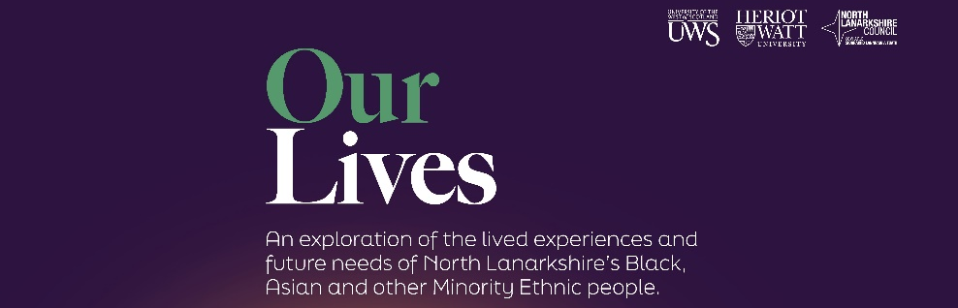
Our Lives newsletter
  - Issue 1 - November 2025
our lives PROgress update event
18th november 2025
We are hosting this community event to mark two years since the Our Lives Research was published, and asking "has anything changed because of it?"
This accompanying newsletter has lots of useful information about services and projects available in North Lanarkshire.
Thank you for reading!
Contents
Digital Skills and IT Support page 1
Employment Skills and Training page 4
Language Support and Skills page 7
Cultural Awareness and Celebration page 10
Culturally Competent and Sensitive Services page 14
Safety and Security page 18

Tap here to add a caption

digital skills and it support
The Digital Skills for Life project within the CLD Adult Learning team now has groups running across every town board in North Lanarkshire. These sessions support local people to develop digital skills that go beyond the basics including how to stay safe online, get more confident using phones and tablets, explore useful apps, spotting scams and understand emerging technologies such as AI.
Our experienced tutors make sure that learning is relevant to people’s everyday lives, helping them use their devices with confidence and engage more fully in digital society. This in turn improves opportunities, independence and wellbeing. Notably, between now and Christmas we are working in Lanarkshire Mosque within the Pearls Group to help participants gain new digital skills. We continue to reach out to voluntary organisations and community settings across North Lanarkshire to bring digital learning to the places where people come together, information can be found here - Digital Skills for Life

Laptops donated to support North Lanarkshire Muslim Women’s Alliance (NLMWA)
Thanks to the community benefits delivered through the council’s partnership with contractor Circular IT, five laptops have been generously donated to the North Lanarkshire Muslim Women’s Alliance. This contribution supports the group’s ongoing efforts to enhance digital inclusion and develop vital digital skills among its members.
Circular IT plays a key role in promoting digital sustainability by safely collecting and repurposing old IT equipment from council staff. Their service gives devices a second life—reducing waste, protecting the environment, and making technology more accessible to those who need it most.
This donation is more than just equipment, it will help women in the group gain essential digital skills, access online services, and unlock pathways to education, employment, and everyday life.
The council and its partners remain committed to delivering meaningful community benefits that create lasting impact. This initiative is a shining example of how public sector collaboration can foster inclusion and strengthen local communities.
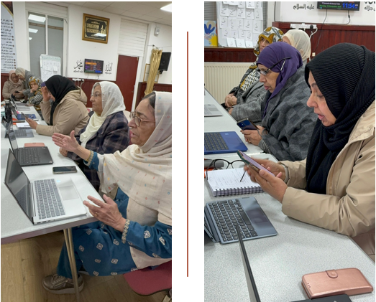

Community Hubs
Q Did you know that all the NLC hubs have public Wi-Fi? Each hub also has a diverse range of services located there which provides support for people to get online and access services through assisted self-service where needed. Other programmes, for example Digital Skills for Life, are also available.
Our current hubs are listed below, with more being developed:
- Chryston Community Hub, Cliffvale Road, Chryston G69 9DB
- Newmains & St Brigid’s Community Hub, Stewart Crescent, Wishaw, ML2 9DH
- Orbiston Community Hub, Babylon Drive, Bellshill, ML4 2FA
- Riverbank Community Hub, Paddock Street, Coatbridge, ML5 4PG
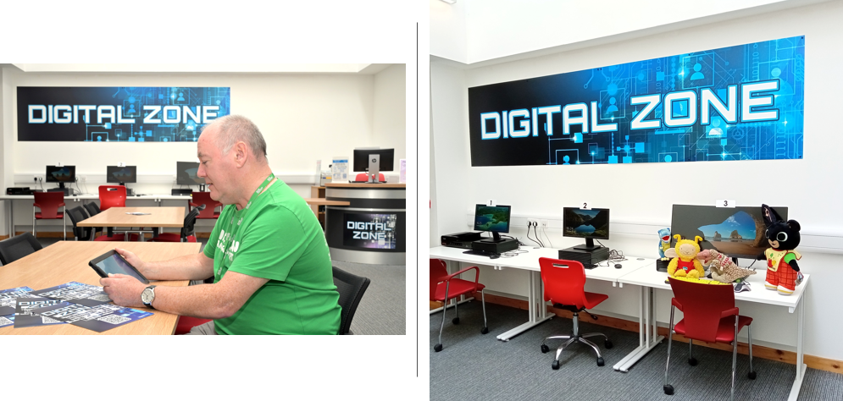

The community hubs publish regular newsletters which can be accessed online.
Chryston
Newmains & St Brigid’s
Riverbank


North Lanarkshire Libraries Service

Public Access Computers can be used at our network of Libraries. To find your nearest library and check what facilities are available please visit their website. Library staff use Google Translate to support customers.

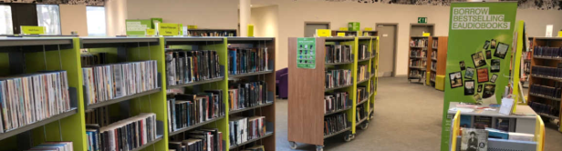
Employment skills and training

Routes to Work

Routes to Work have Case Workers to assess if qualifications gained abroad are recognised in the UK, and at what level. They can then signpost to retrain, up-skill, or re-qualify in Scotland. Visit the Routes to Work website to more information, or contact direct by email startyourjourney@routestowork.co.uk or telephone 0800 783 4731.

NLC Employability Team
There has been a significant increase in BAME registrations since pre-pandemic trends. In 2019, 4.6% of clients had a BAME background, but this was 11.0% in 2024. In addition the employability team and local employability partnership have directly engaged with local BAME groups from the African community and funded activity to continue this progress. The funds have supported low-income parents into work placements paid at the real living wage for 6 months with in-work support.

North Lanarkshire Council’s Community Learning & Development Team
The CLD Adult Learning & Resettlement Team delivered targeted ESOL and Employability courses at six locations throughout North Lanarkshire. These courses were designed to support residents whose first language is not English and who are looking for work. From these courses 20 learners were successfully appointed as NLC Early Learning Childcare Support Workers as part of the NLC Brighter Futures Programme and 31 learners gained SQA Employability awards.
As part of the most recent programme, participants also have the opportunity to gain valuable work experience through a placement within North Lanarkshire Council’s Facilities department.
For more information, please email: cld@northlan.gov.uk.

North Lanarkshire’s Working
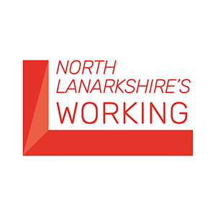
If you are unemployed, living in North Lanarkshire and looking to get into work – we can help. Over the last four years we have supported over 7000 people into work and will continue to do so through our various support programmes.
Working closely with our partners at Routes to Work we offer a wide range of support, training and advice including in-work support, training and confidence building, and other council services such as debt and money advice. We also support businesses throughout North Lanarkshire by offering a variety of programmes, help and advice. For more information visit their website, telephone 0800 0730 226, or email northlanarkshiresworking@northlan.gov.uk.

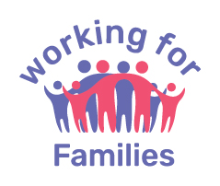
Working for Families
If you are a parent living in North Lanarkshire, we have a dedicated team who provide free, confidential support to help you to start a new chapter, increase your household income, provide funding for and advice about childcare, support you to improve your own wellbeing and learn new skills. For more information, visit their website, telephone 0800 0730 226, or email workingforfamilies@northlan.gov.uk.

New College Lanarkshire

Q: Did you know that New College Lanarkshire can offer a wide range of support and have resources available to assist students with English language support?
Visit their website, telephone 0300 555 8080 or email edi@nclan.ac.uk.

Scottish Asian Business Chamber
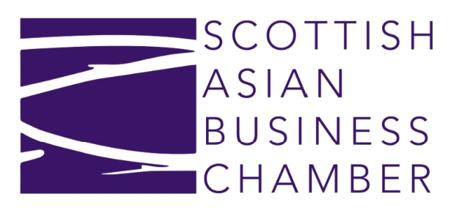
The Scottish Asian Business Chamber (SABC) is a membership organisation that advocates for the inclusion of minority ethnic led voices in the Scottish business community. They offer a wide range of support to members including free tax and legal advice services, access to over 100 opportunities to network, learn and innovate, and work with strategic partners to get you the best support for your business from website creation to financial expertise. They can be contacted through their website.

Volunteering Opportunities
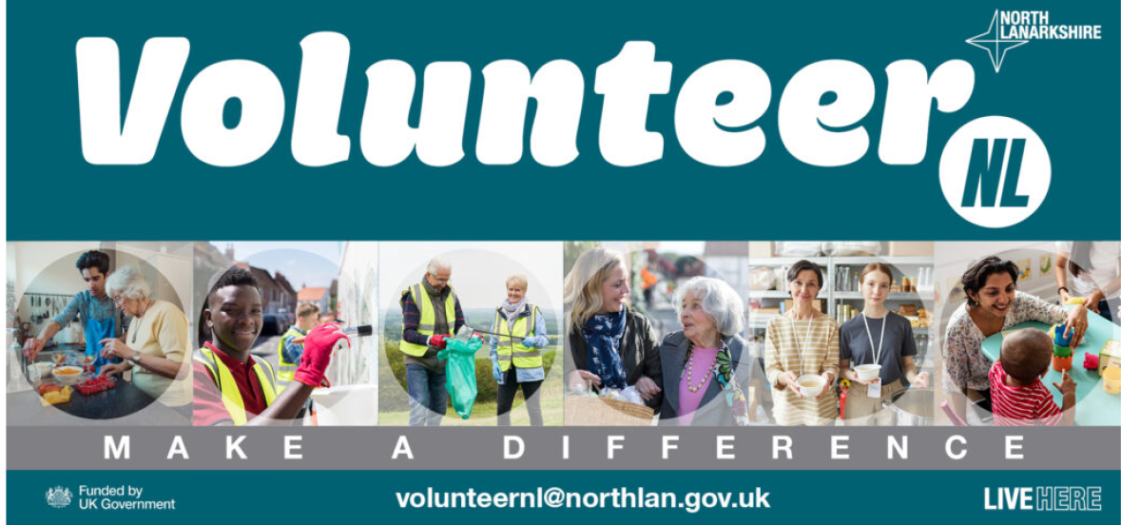
VolunteerNL is a new volunteering programme that empowers communities to give back and do something worthwhile to make a difference. You can search for opportunities online, or to get in touch with the team email volunteernl@northlan.gov.uk.

You can also find out more about volunteering opportunities with Voluntary Action North Lanarkshire (VANL). Volunteering is a powerful way to connect with your local community; support causes you care about and make a real difference. It’s also a great opportunity to gain valuable experience, develop new skills, and explore new interests. Whether you’re looking to enhance your CV, boost a college or university application, or simply give back, volunteering in North Lanarkshire offers something for everyone. Visit their website or contact them directly by telephone 01236 748011 or email info@VANL.co.uk.
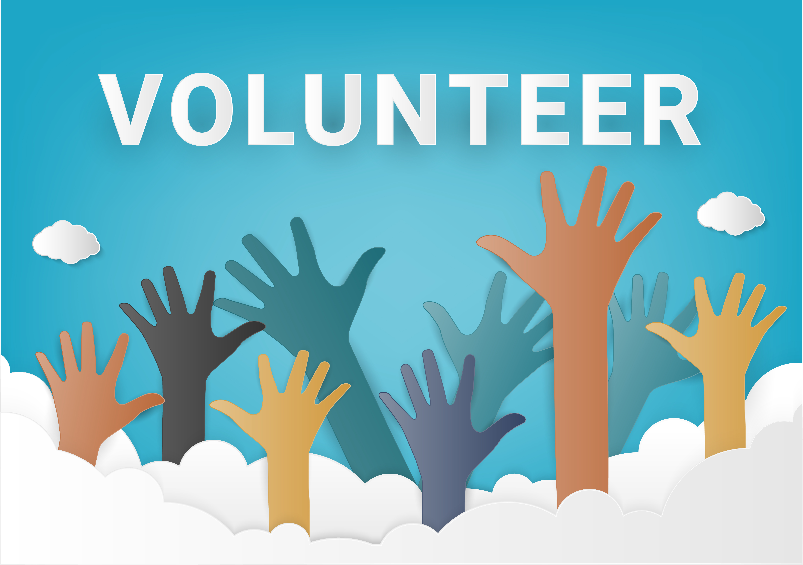

language support and skills

North Lanarkshire Council’s Community Learning & Development Team
Q: Did you know the Adult Learning & Resettlement Team in North Lanarkshire offer free ESOL classes in Cumbernauld, Airdrie, Coatbridge, Bellshill, Motherwell and Wishaw? These classes take place in local community venues and focus on practical English for everyday life—including reading, writing, speaking, and listening. You’ll also have the opportunity to work towards SQA-accredited qualifications. We also offer FREE online ESOL classes on a Tuesday evening for both beginners and intermediate learners.
In addition, the team run six Chat Cafés across North Lanarkshire. These are relaxed, friendly spaces where you can practice your English, meet new people, and build community connections.
For more information, email: cld@northlan.gov.uk.
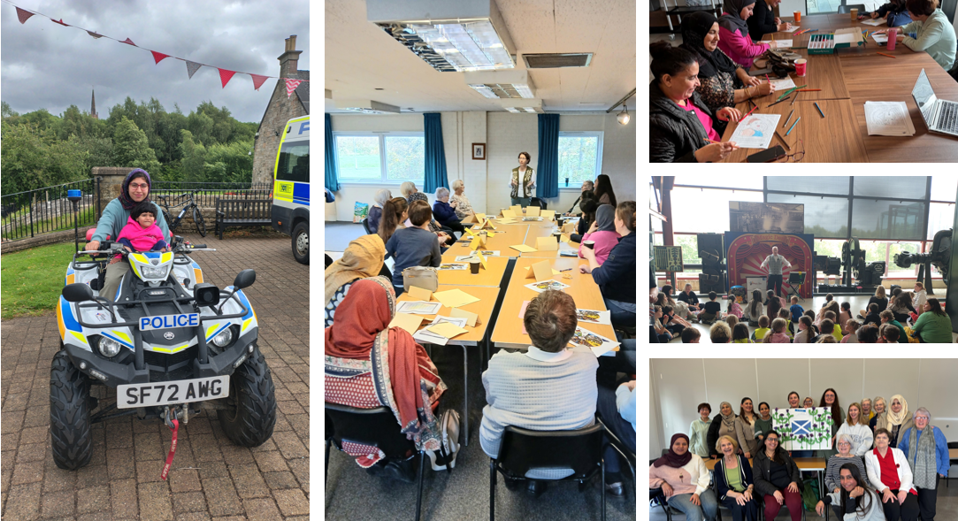

Interpretation and Translation Services
NHS Lanarkshire and North Lanarkshire Council have contracts with Language Line UK, Global Language Services and Clyde Interpretation Services. These services are invaluable in supporting local people access support, advice and services. In addition Police Scotland use Global Connects , Global Language Services and DA Languages.

Q: Did you know that the accessibility tools on the North Lanarkshire Council website include an option to translate the language?

The Recite Me Accessibility toolbar on the council website has a translation service, and this includes text to speech for a some of these. You can switch on this feature at the top of the page using this button:
From the toolbar you can then press: to select your chosen language from the options listed.

Q: Did you know that there are other ways to translate webpages, if a tool is not available?
You can follow the below steps to translate the page:
On any webpage, right click and select "Translate to English".
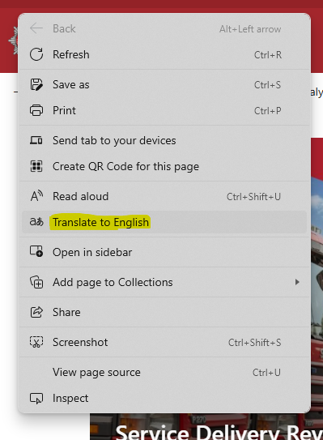
In the URL bar on the top right you will now have a translate icon. Clicking this gives you options to translate the page.
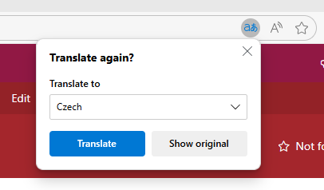
You can then print the page in your selected language or save it as a web page. This works for both the Chrome and Edge browsers and can also be used for any web page.

Carer Support Services
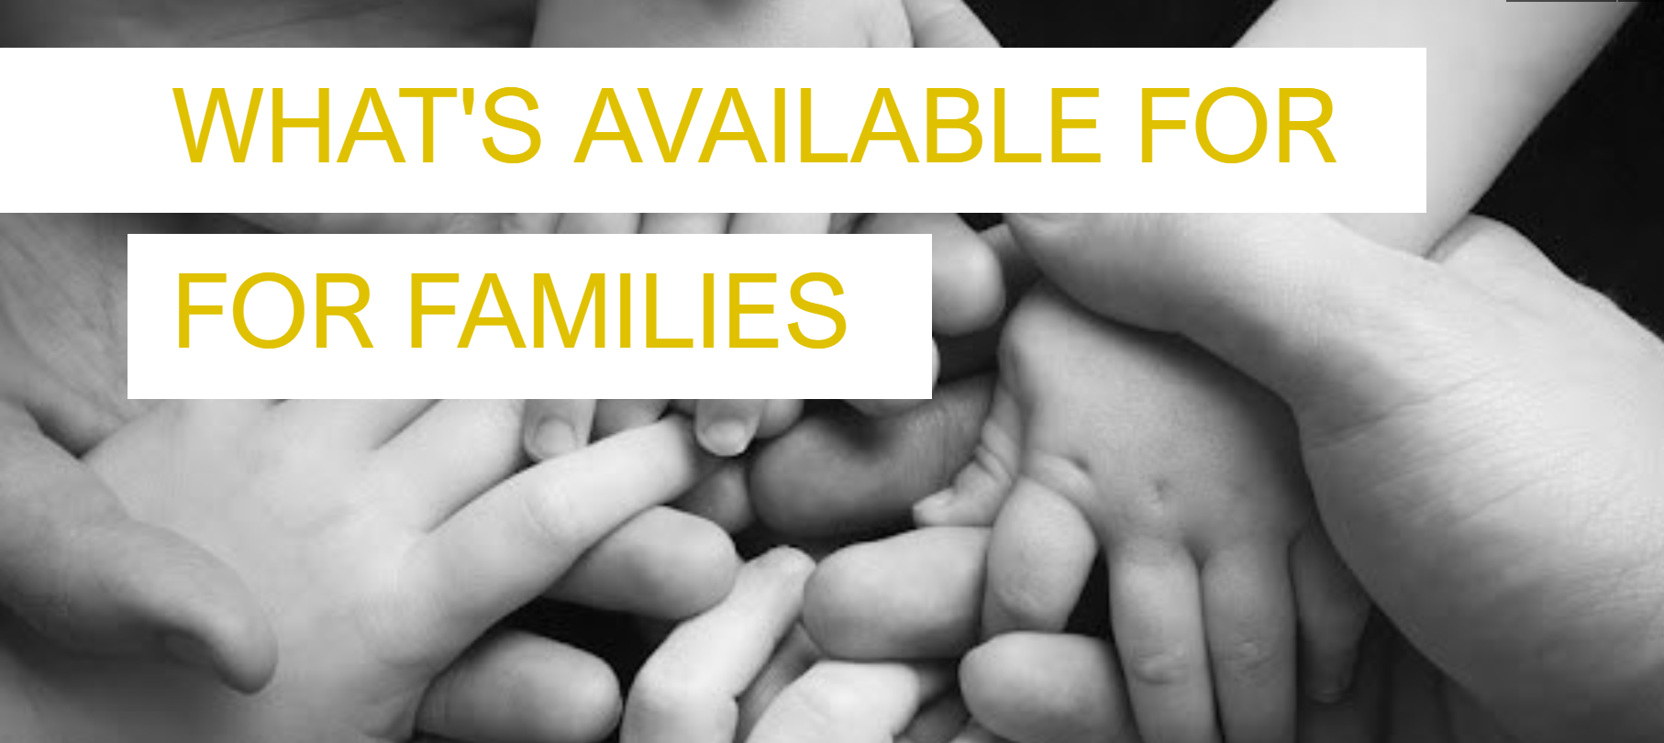
North Lanarkshire Council and its partners want to make sure families have information about the different types of help available and families can access this information at a time that suits their needs. The focus of this support builds on the strengths of children and parents to stop families reaching crisis and where possible improve families lives and wellbeing. Full details are available in “What’s available for families” online document.

Our local carers organisations provide invaluable support for carers and their families across Lanarkshire.

Lanarkshire Carers Centre has a dedicated phone line to support carers who speak Urdu, Punjabi or Hindi: 07780926595.
Visit their website for more information, contact by email info@lanarkshirecarers.org.uk, or telephone 01698 428090.

North Lanarkshire Carers Together are committed to ensuring that every carer, regardless of their background or circumstances, receives the understanding, respect, and support they deserve.
North Lanarkshire Carers Together Case Study
This case study highlights how the Getting It Right for Everyone (GIRFE) principles guide their work and measure the real impact of our support.
The case focuses on a male carer from an ethnic minority community who provides full-time care for both his mother, who has significant physical health needs, and his spouse, who is living with mental health challenges. With the dedicated support of our Carer Information and Engagement Worker (Equalities); role made possible through funding linked to the Our Lives research project, the man was able to access tailored advice, emotional support, and practical help that improved life for the whole family.
This case study demonstrates how culturally sensitive and collaborative approaches can lead to meaningful outcomes for carers and their families, ensuring that everyone’s voice is heard, respected, and valued.
Please visit their website for more information, or contact them by email enquiries@carerstogether.org, or telephone 01698 404055.

cultural awareness and celebration

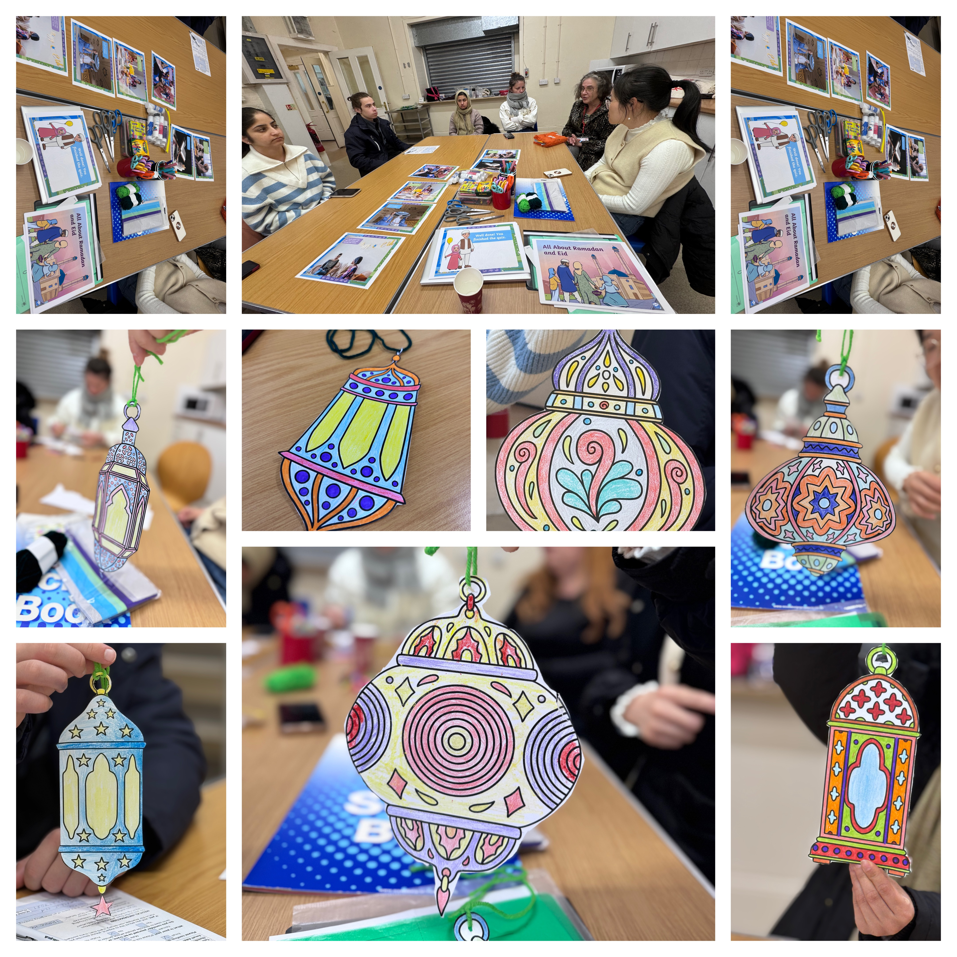
CLD – Learning & Integration in Action
The Resettlement Team have supported and organised events to mark cultural events including Eid, Nowruz, Chinese New Year, Ukrainian Independence Day, Christmas and International Women’s Day. In addition the team facilitated consultation events across North Lanarkshire to gain feedback on the experiences of refugees and displaced people to contribute to the New Scots Refugee Integration Strategy. The team also organise educational excursions to provide the opportunity to practice English language skills and learn about Scottish history and culture, recent trips have included visits to Culzean Castle, the Scottish Parliament, Dounan’s Activity Centre, and Blair Drummond Safari Park.
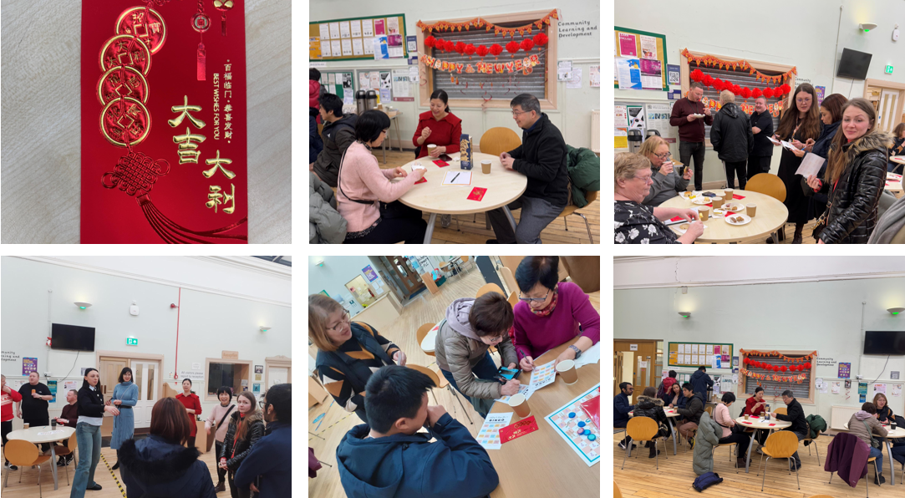

New Scots Integration Network
Following feedback from the Supporting New Scots in Lanarkshire Conference in June 2023, the Lanarkshire New Scots Integration Network was launched in October 2023. This network is organised by the Scottish Refugee Council in partnership with VANL, NHS Lanarkshire, and VASLan.
The purpose of the Lanarkshire New Scots Integration Network is to bring together third sector organisations and statutory partners to increase the level of support available to New Scots in Lanarkshire. The term New Scots includes asylum seekers, refugees, and displaced people.
The network aims to establish a forum for discussion to identify the needs and requirements of New Scots, and to mobilise and co-ordinate community assets to address these needs to support their integration.
Events are organised quarterly and the location of in-person meetings alternates between South and North Lanarkshire.
For further information on the Lanarkshire New Scots Integration Network, please contact Hazar Khalil hazar.khalil@scottishrefugeecouncil.org.uk.

New Scots Connect Map
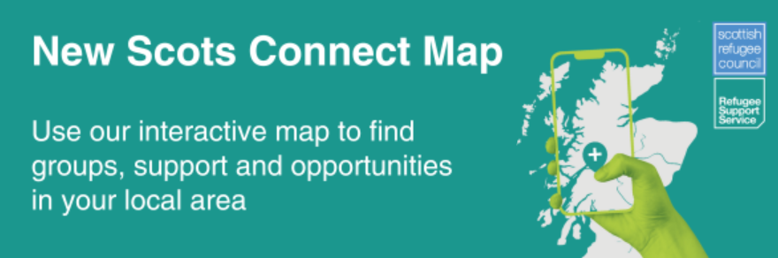
The Scottish Refugee Council has a feature on their website called New Scots Connect. This helps connect you to your community. Find groups and activities in communities across Scotland by visiting their website.

Black History Month – Talk and Tour – Summerlee Museum 2025
Summerlee Museum hosted a Talk & Tour as part of the Black History month Celebration on the 22nd & 29th of October 2025. Members of the public were invited to come along to the Museum and join in discussions relating to North Lanarkshire’s connections to the Transatlantic Slave Trade. Janiece Ndoye – the Engagement Officer, delivered an in-person talk describing the importance of embracing ethnic minorities’ lived experiences as part of the process of decolonising Museum curriculum, specifically reinterpreting the world collections. The community researchers’ contributions played a major role in this process and their individual, cultural perspectives aided in the gathering of evidence to describe the collections narratives by applying authentic and truthful context. Attendees offered inquisitive queries that sparked interesting conversations which led to a tour around the Museum’s current exhibitions. A clear description of the world collections and four new exhibits expected to be installed in January 2026 were introduced to the participants and was well received.
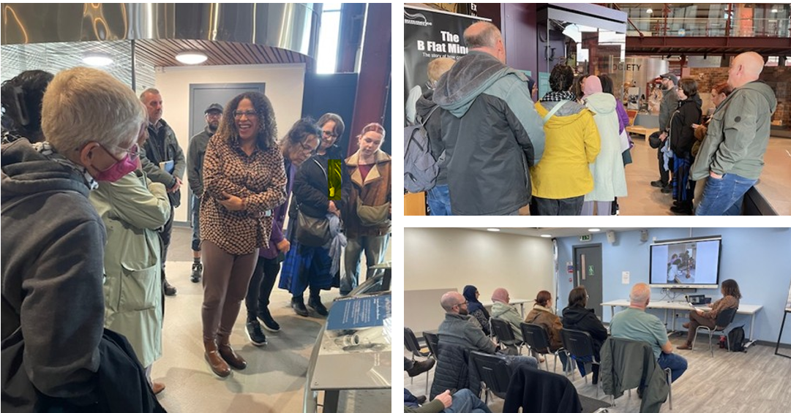
The Talk & Tour was intended as an introduction of engagement with the public to allow for the world collections preview to be informative, educational and significant; a crucial step towards correcting narratives and giving individuals from BAME backgrounds a voice. This was also a large contribution of the delivery of the Talk; assuring the attendees got to know the Community Researchers as individuals, the human behind the object.
The four new exhibits will feature interpretations of the Drumpellier Iron Gate, The weavers Loom, The Sugar Melting Pan and the Garnkirk vase. The World Collection display cabinet will feature a grand celebration of Black and Asian cultures by highlighting colourful artifacts that describe the true nature of the cultures described.
A panel with famous quotes from BAME historical contributors will inspire any viewer willing to engage with the beauty these items have to offer, as well as an accompanied glossary to aid in the process of better understanding terminologies and the rhetoric required to embracing our multi-cultural society.

North Lanarkshire Cultural Committee
The purpose of the North Lanarkshire Cultural Committee is to progress the recommendations of the 'Our Lives’ research, specifically in relation to 3 areas - Cultural Awareness, Community Cohesion and Celebration.
The committee is made up of local people, groups, statutory sector partners and other stakeholders within North Lanarkshire who play a key role in progressing the recommendations of the Our Lives research.
The committee recently hosted a Black History Month celebration in Jerviston Community Centre. The event featured a variety of entertainment, food, activities, and guest speakers.
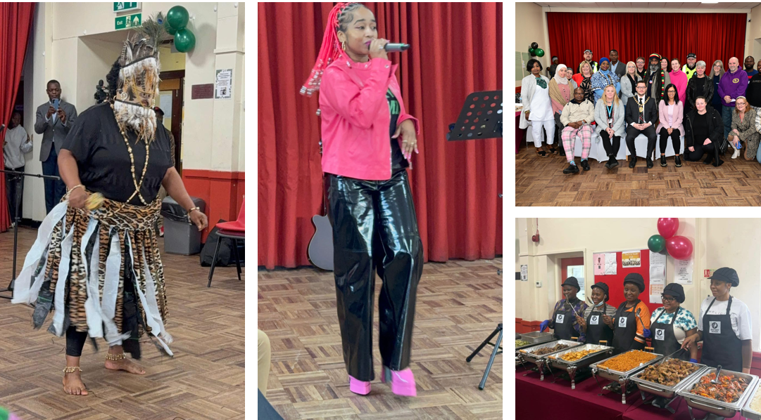

NL Schools Parent Councils
There will be an equality awareness raising session for Parent Councils as part of the programme of online sessions for the Parent Consultative Group, it is expected that this will take place in April 2026.

Community Learning and Development – Inclusive Youth Work
In addition to the wider Youth Work offer across North Lanarkshire, the Resettlement Team established the Connect Youth Groups—a tailored programme designed to support young people who are new to the area and whose first language is not English. There are two groups: a junior group for those aged 12 and over, and a senior group for those aged 16 and above. Both groups meet weekly in the evenings, providing a welcoming space to build friendships, develop skills, and have fun. Recently, in collaboration with colleagues from Active and Creative Communities, the young people have been enjoying sports sessions at the Time Capsule, adding an active element to their weekly meetups.
Over the summer, the groups took part in an outdoor-focused programme where they practiced navigation, strengthened their teamwork, and developed camp craft skills. Many participants have also begun their Duke of Edinburgh Award journey, working on their skills, physical activity, and volunteering sections. The Connect Youth Groups continue to grow and evolve, offering meaningful opportunities for young people to connect, learn, and thrive in their new community.
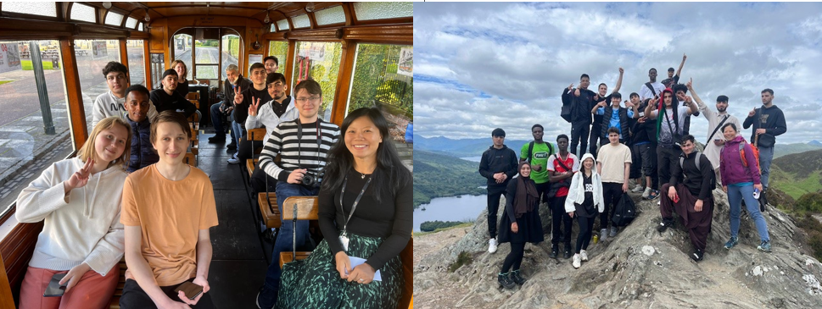

For more information, please contact: cld@northlan.gov.uk.

culturally competent and sensitive services

New NHS Lanarkshire Spiritual Care Assessment Tool ELSA
This new tool is being rolled across the three acute sites and around 300 employees have attended the training so far.
“ The ELSA model is a tool, a compass, for assisting in the assessment of spiritual need and leading to the better care of individuals.”

NHS Lanarkshire Anti-Racism Plan
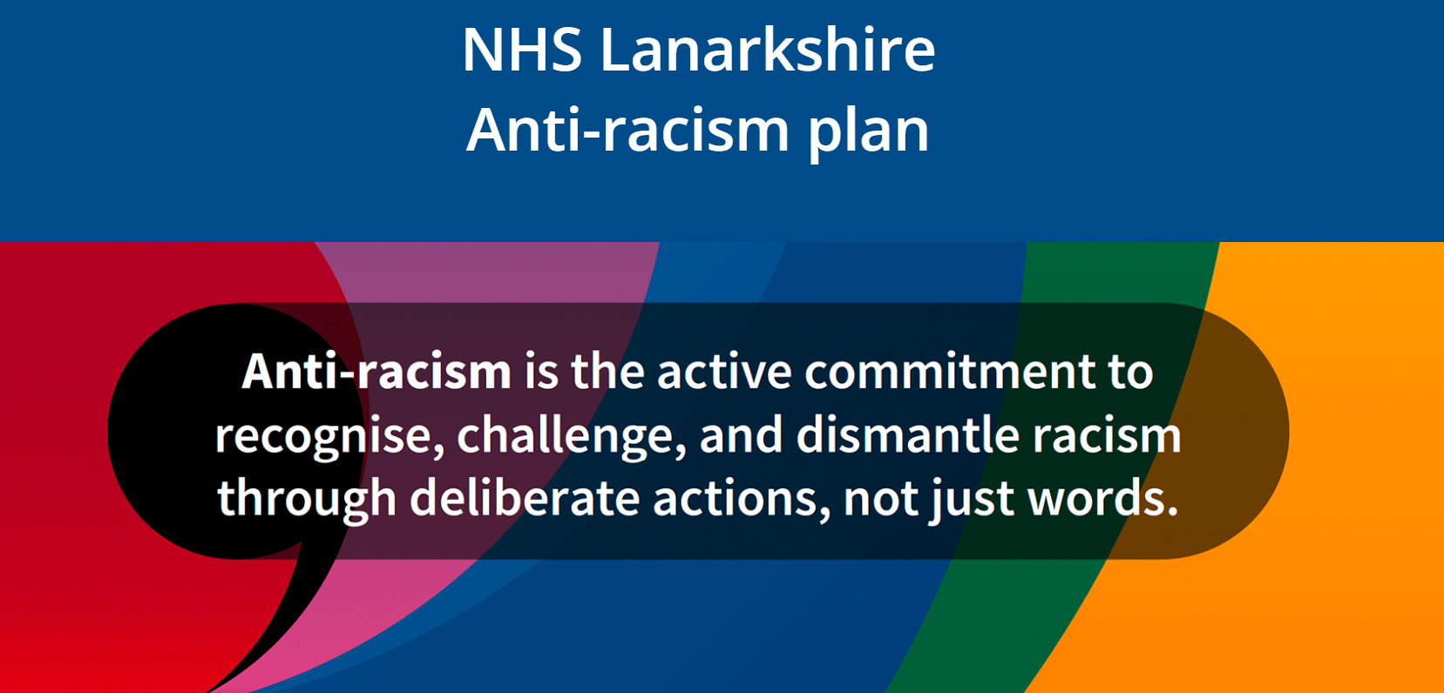
NHS Lanarkshire has recently published its Anti-Racism Plan. There are two core focus areas: Workforce Experience Aims to foster a safe, inclusive, and supportive environment for all staff. This includes training, leadership accountability, and mechanisms to report and address racism. Population Health Focuses on reducing health inequalities linked to racism. This promotes culturally competent care and equitable access to services for diverse communities.
NHS Lanarkshire provides information for staff on the health and wellbeing of refugees and asylum seekers.
This comes in response to the growing recognition of the unique challenges faced by these vulnerable populations and the need for tailored support within our healthcare services.

Community Partnership Team

General Services – Community Partnership Team
The Community Partnership Team Delivers a wide range of services for local communities across each of the 9 localities within North Lanarkshire. These are the areas of work we cover:
- Delivery of Community Boards ​
- Performance around Local Outcome Improvement Plan’s (LOIPs)​
- Local Development Programme (LDP)​
- Access to Free Sanitary Products Initiative ​
- Community Grants and Grant Award Programme ​
- Community Assets Transfer (CAT)​
- Community Safety Strategy
- Community Capacity Building​
- Participatory Budgeting ​
- Community Engagement planning with services and partners ​
- Local Partnership delivery approaches and processes ​
- Community Wealth Building ​
- Community Benefit Hub​
- Business Continuity/Resilience ​
- Lanarkshire Education Trust
This is the link to our website with some of the services we provide: your community - working with communities.
If you would like help with any of the above or have any enquiries for the team, please contact CommunityMatters@northlan.gov.uk.

Free Period Products (Sanitary Products)
North Lanarkshire Council provides free period products for anyone who needs them.
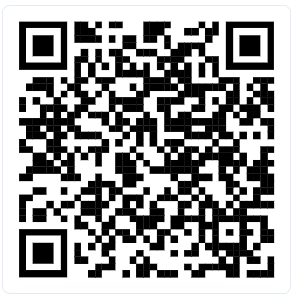
PickUpMyPeriod is an app provided by Hey Girls and the Scottish Government that maps out everywhere in the UK someone can get free period products, this is also available as an app on the App Store or Google Play Store.

NLC pick up points are listed on the council website.
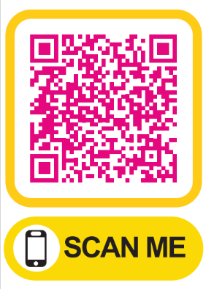

More information can be found online.
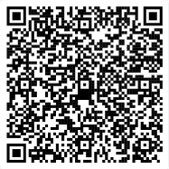

Partnership Working with New Scots

Birkshaw Tenants and Residents Association
In the Wishaw area, we work with Birkshaw Tenants and Residents Association, a group of Ukrainians who live in the Birkshaw tower in Gowkthrapple. The organisation came together to address an identified need of supporting Ukrainians integration into the local community and now run a number of services for their residents, planned in partnership with North Lanarkshire Council.
This group are a good example of successful community development and strong partnership working. Further information about this group and how you can start your own Tenants and Residents Association can be found here.

New Scots participate in Community Partnership Workshop
The Community Partnership Officer for Wishaw attended the Chat Café in Pather to deliver a workshop aimed at engaging and consulting with New Scots living in Wishaw. The participants learned about the Community Partnership Team and how to become more involved and integrated into community life and decision-making. Following learning about the team and what we do, they took part in group discussions to provide valuable insights and information into their cultures, traditions and skills they bring to their communities, the challenges and barriers they face, gaps in services, what we can do to make them feel more included, what form of consultation suits them best, and ideas for projects in their area.
Further consultation via a survey was undertaken and this has been shared to the ESOL class and on the Chat Café group chat to encourage others to participate and share their views. The involvement of this group is vital in helping us improve access for seldom heard groups to participate in civic life, influence local service design, funding priorities, and policy development, while contributing to the Local Outcome Improvement Priorities for Wishaw.

Community Engagement – Lanarkshire Mosque Bellshill
The Community Partnership Team (CPT) were invited to the Ladies coffee Morning Event held at Lanarkshire Mosque Bellshill on Monday 16th June. It was a valuable opportunity to engage with attendees and create more awareness on the North Lanarkshire’s Council’s Period Dignity Initiative (PDI) within the Mosque (also one of our over 100 community pick-up venues) and local communities of attendees across North Lanarkshire.
The team successfully engaged over 30 attendees highlighting and promoting the work of the CPT through the PDI. We demonstrated how to access free period products using the QR code included on all distributed leaflets, which links to locator maps of over 100 pick-up venues across North Lanarkshire. For attendees living outside North Lanarkshire, we promoted the PickUpMyPeriod app, which provides information on product pick-up locations across Scotland.

Community Engagement - Bellshill
The Community Partnership Team (CPT) were invited along to the Service User Forum yesterday which was held in Bellshill Cultural Centre. This event was run and organised by colleagues from the Bellshill & Motherwell Housing team. This was a good opportunity to engage with seldom heard voices and promote what CPT do as a team. The Community Partnership Officer was able to engage with approx. 25 people and advise how they can get involved in their local communities, contribute to local projects (LDP) and how to access free period products. A worthwhile event which was also supported by Scottish Fire & Rescue, Blue Triangle, the Wise Group, NHS Health & Homeless staff, the Simon Community and NLC's Tenant Participation Team.

Aura
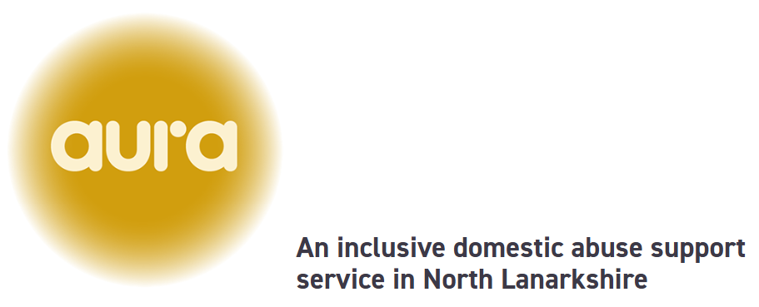
Working with adults affected by domestic abuse, Aura can provide emotional and practical support by providing outreach one to one support at a time and location that is suitable. Support is tailored to needs and will be regularly reviewed.
Their website has more information or contact them by telephone 01698 757667 or email aura@sacro.org.uk.

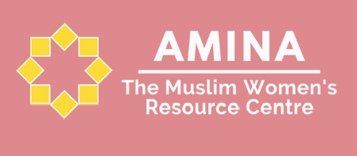
Amina Muslim Women’s Resource Centre
This is an intersectional organisation based in Scotland, which empowers and supports Muslim and Minority Ethnic women by serving as a vital link between them and the barriers they face every day.
Visit their website to find out more. You can contact them by telephone: 0141 212 8420 (Monday - Friday 9:30am-5pm) or call the Helpline 0808 801 0301 (Monday-Friday 10am-4pm). Or contact by email: info@mwrc.org.uk.

safety and security

Hate Crime Reporting
The Police Scotland website has information about hate crime reporting. It is important to report hate crime whether you are affected personally, or if you witness someone else being targeted. For example, you could be a friend, neighbour, family member, support worker or a passer-by.
You should tell the police if you think it happened because of disability, race, religion, sexual orientation or transgender identity. It may even be a combination of these things. This is important as it tells us that it could be a hate crime.
If something happens and you are not sure if it is a crime, please remember, if it feels wrong, report it and let us help.
Please visit their website for more information.

Ethnic Minority Law Centre
This is a charity which provides access to legal services and justice for our BAME communities. You can visit their website, or contact by telephone 0141 204 2888 or email admin@emlc.org.uk.

Community Safety Strategy
In 2025, the Community Partnership Team worked with Community Planning Partners to produce the Community Safety Strategy 2025-30 which outlines the council’s commitment to improving community safety.
The definition of community safety has changed over the years and has become increasingly broad and far reaching. Initially focussed on the prevention and reduction of crime and antisocial behaviour, community safety now encompasses all aspects that help people to be safe and feel safe in their communities, including important issues such as gender-based violence, community justice, serious organised crime, counterterrorism, home safety and fire safety amongst others.

You can find the Community Safety Strategy on the council website.

Scottish Fire and Rescue Service
Scottish Fire and Rescue Service have translated versions of useful leaflets, for example Fire Safety in the Home. Visit their website for more information.

