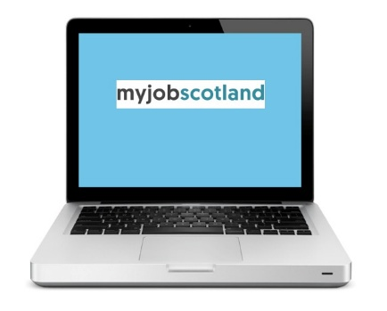  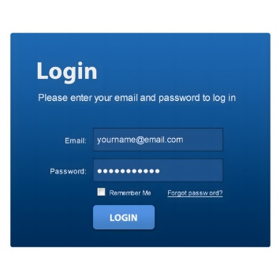 |  | 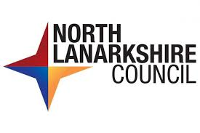  How to apply for a job  All our jobs are on the My Job Scotland website.  You will need to register with myjobscotland and set up your account.  To do this you will need internet access and an email account.
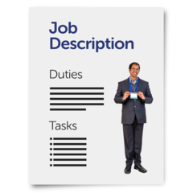 |  | Advert and Job Description  When you see a job you think you might want, you will see the Job Advert.
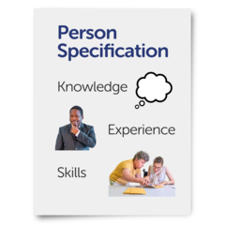 |  | You will also see a job description / employee specification.  This tells you what you should know and can do, to do the job.
 | The advert will  - Give you a short explanation of the tasks of the job.  - Tell you what you would be expected to do.  - Tell you the pay, hours and days you will have to work.  - Tell you where the job is.
 | This will help you to decide if you want to apply.  The job description / employee specification will go into more detail about the job. It will include  - The tasks and responsibilities of the job.  - The skills you need to do the job.
 | The employee specification will be in 2 parts.  - Part 1: Essential criteria - the things you must be able to do or be qualified for.
 | - Part 2: Desirable criteria – things that would be helpful to do the job.  If you do not have the desirable criteria you can still apply for the job.
 | Last Reviewed - 30th January 2026.
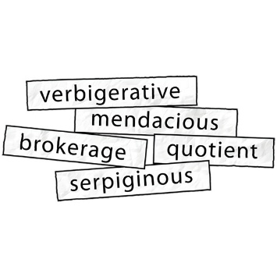 | Words to know  Job description – this tells you about the job.  Employee specification - this tells you what you should know and can do, to do the job.  Essential criteria – this explains the skills and experience you must have to apply.  Desirable criteria – this explains the skills and experience that would be good for you to have.

