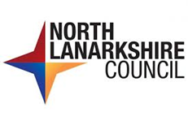
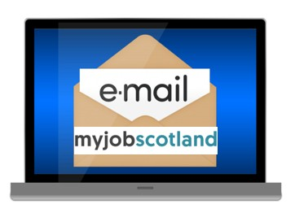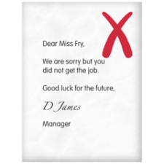     | Interview Outcomes  If you do not get the job you will get a formal email from MyJobScotland.  If you want feedback, contact the  People Help Desk on 01698 403 151.  They will ask the Hiring Manager to contact you. This gives you a chance to hear what went well and what you need to work on.
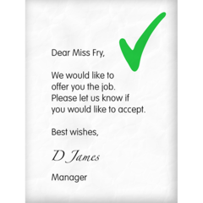 | If you are getting the job you will get a formal email from myjobscotland. This is called The Preferred Candidate Notification.  This means we are offering you the job.
  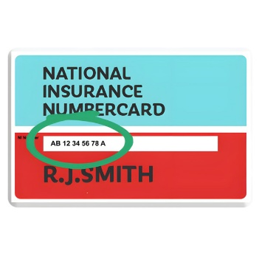  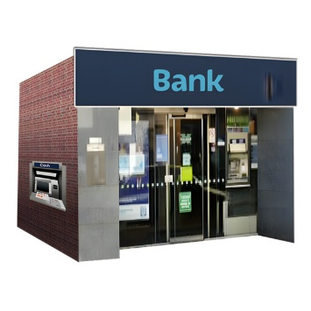  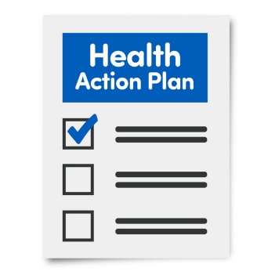  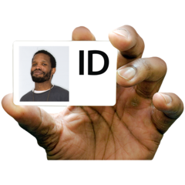   | Before you can start there are some things we need to do. These are called pre- employment checks.  These can include:  - Your bank details (for your wages).  - HMRC (checklist (for your tax and national insurance).  - Criminal Conviction form (to let us know if you have any previous convictions). This does not always mean you will not be offered the job.  - Health questionnaire. This is to help us support any needs you have so you can do the job).  - Disclosure – PVG (Protecting Vulnerable Groups). This is a check that is needed for certain jobs such as care.  - References. We will write to your referees, including your most recent employer.  - Additional information (this is proof of your identity and qualifications).
    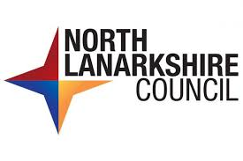 | When we get all the information needed, we will contact you with a start date.  We will then tell you  - The time,  - Date,  - Where to report,  - Who to report to.  Welcome to North Lanarkshire Council.
 | Last Reviewed - 30th January 2026.
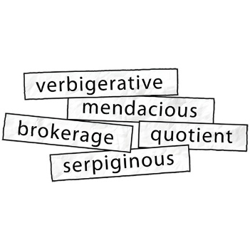 | Words to know  People Help Desk – this is the workers in the council who can answer questions about jobs.  Hiring Manager – this is the person looking for a worker.  Preferred Candidate Notification – this means we are offering you the job.  HMRC – The Government department responsible for wages and taxes.

