   | 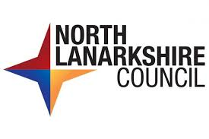  Jobs  All our jobs are advertised on the My Job Scotland website.  There are different kinds of jobs. These include:  - Education and Families  - Enterprise and Communities  - Health and Social Care  - Chief Executives Office
   | For example, you could work in a school as a support assistant, work in catering or cleaning.  You might decide you want to work in one of our offices.
 | All of our jobs are important. We work together to deliver services to everyone who lives here.
     | We need people who want to work and share our goals.  We are a Disability Confident Leader.  This means people will always get an interview if:  - They have a disability  - They have some of the skills needed for the job
 | We also support people who have been in the Armed Forces (veterans) and their families.
 | Veterans will always get an interview if:  - They have been in the armed forces  - If they have some of the skills needed for the job
 | We offer good wages, holiday time and a pension scheme. We offer other good benefits including our Work Well NL programme.
 | The Work Well NL Programme is a website which has support and offers for council employees.  This supports our colleagues to look after their health, money and mental health.
 | Last Reviewed - 30th January 2026.
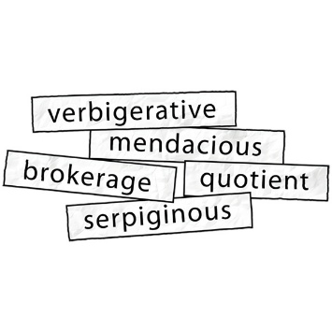 | Words to know  Disability Confident Leader – This means we are a disability champion for local businesses.  Veteran – is someone who has been in the armed forces. This is the army, navy or air force.  NL – this is a short way to say North Lanarkshire.

