 | 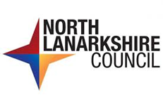  The Interview  The people interviewing you are called the Panel.  Each of the panel will introduce themselves. They will tell you what their job is. They will do their best to put you at ease.
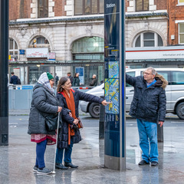  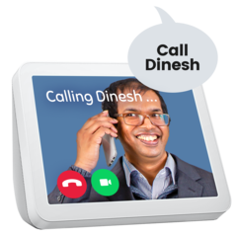  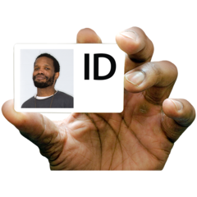  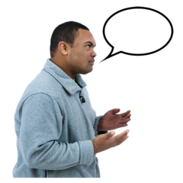   | Tips for interview  - Make sure you have time to get to the interview.  - Try to arrive 10 minutes early.  - Do a trial run before the day of your interview. This helps you to know where you are going.  - If your interview is online make sure you have a quiet place to do it.  - If it is a face-to-face interview bring proof of identity and qualifications.  - Do not panic – if you do not understand something ask for an explanation.  - Ask questions about anything you want to know more about or understand.
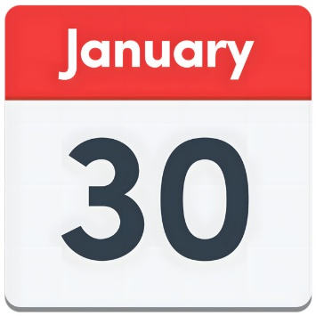 | Last Reviewed - 30th January 2026.

