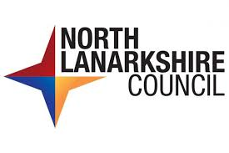



Working with North Lanarkshire
Council

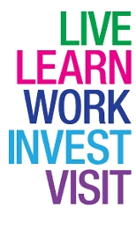

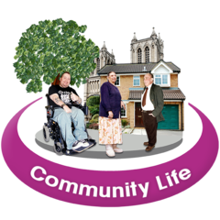 | Introduction  For people living in North Lanarkshire, we want it to be a good place to  - Live  - Learn  - Work  - Invest  - Visit
 | We want everyone to have better chances to earn money.  We want all children to do as well as they can.
 | We want to get better at making sure all our community has better health. We want people to be well looked after.
 | We want to get better at working with the community and other organisations.  To do this we need you.
 | Last Reviewed - 30th January 2026.

