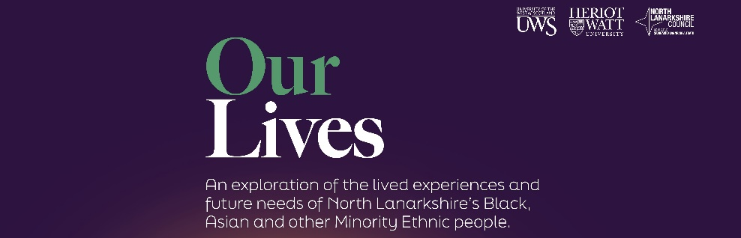
Our Lives newsletter

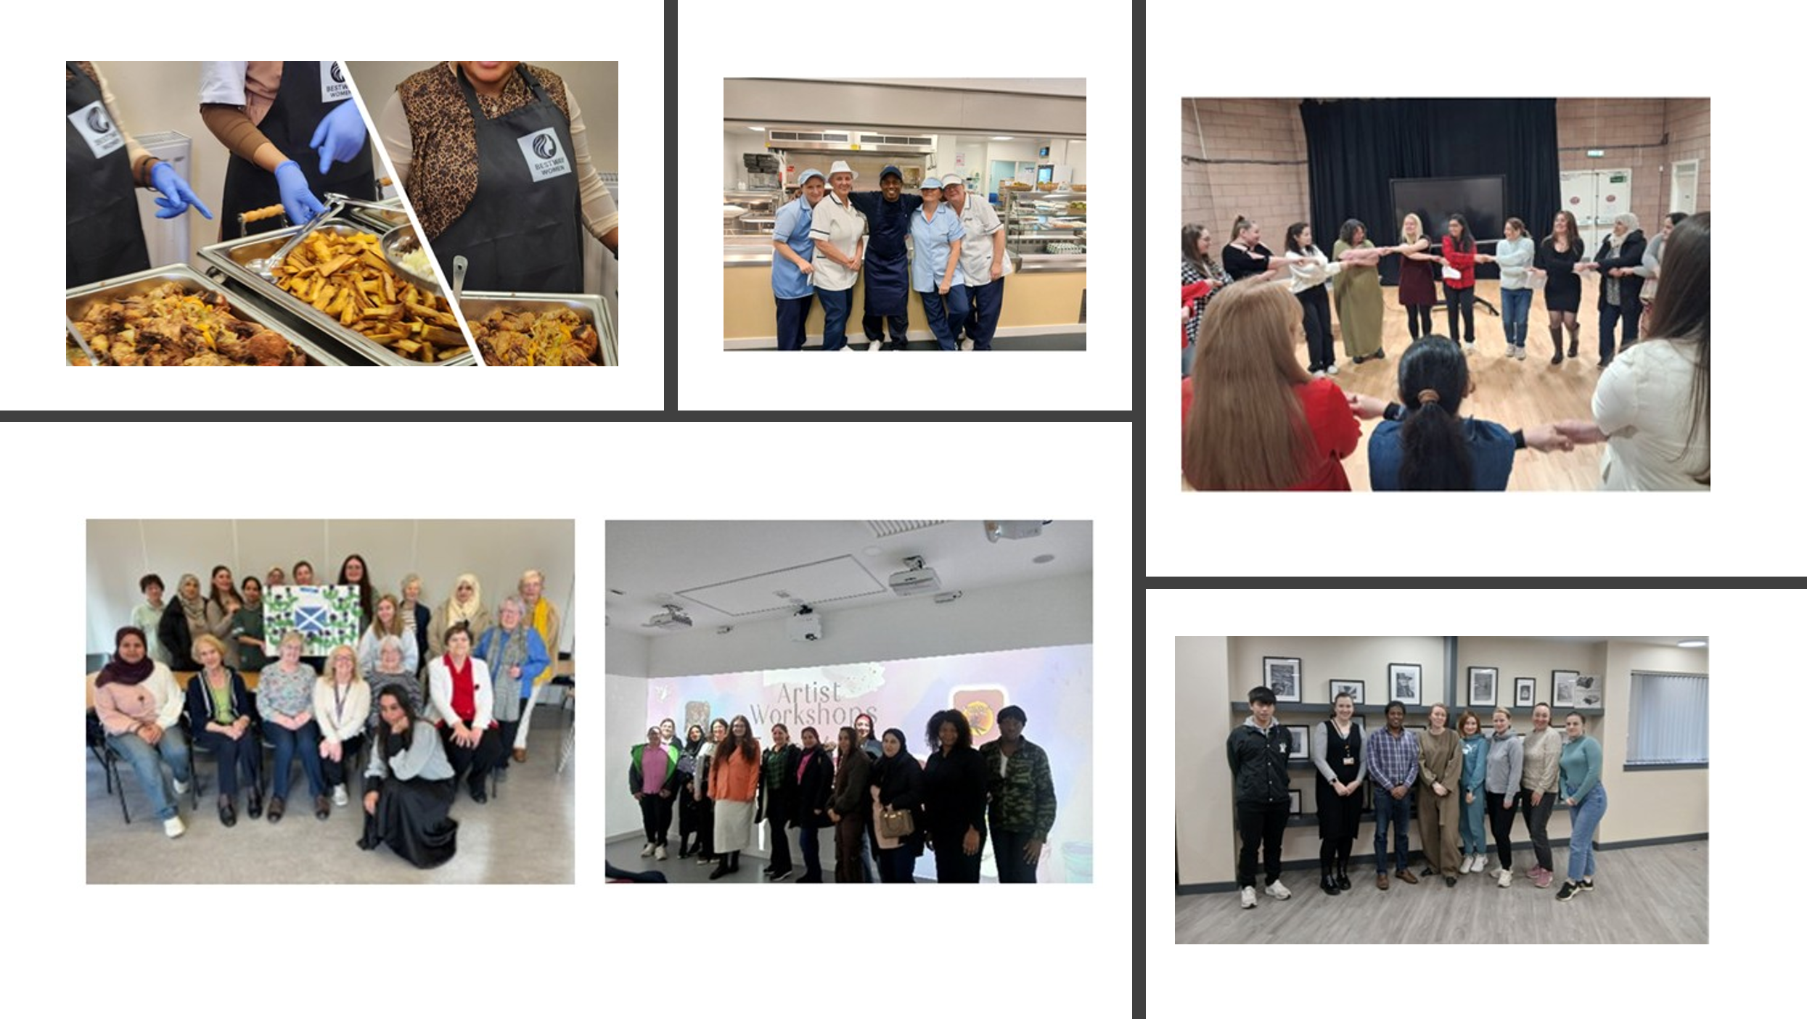
Issue 2 – May 2026

Contents
Our Lives Progress Update Event – Conference Report page 1
Service Spotlight – Incomes to Maximise Outcomes page 3
Service Spotlight – NLC Supported Enterprise Team page 4
Digital Skills and IT Support page 5
Employment Skills and Training page 6
Language Support and Skills page 9
Cultural Awareness and Celebration page 11
Culturally Competent and Sensitive Services page 14
Safety and Security page 20
Directory of Services page 21

OUR LIVES PROGRESS UPDATE EVENT – CONFERENCE REPORT
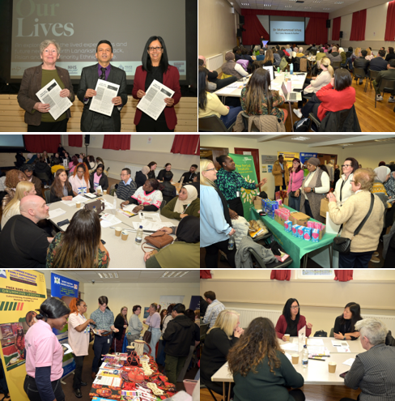
The Our Lives event held in November 2025 brought together more than 80 people from minority ethnic communities and local partner organisations to review progress since the publication of the 2022 Our Lives report.

The session focused on evaluating developments in key areas identified through the original research, including employment, language support, digital inclusion, health, wellbeing and community cohesion, while also acknowledging the persistent challenges that continue to affect minority ethnic residents across North Lanarkshire.

Feedback from the focus groups, where participants explored progress against these themes in greater depth was reviewed and reported to the Strategic Leadership Board.

Across all areas, several themes consistently emerge:

1. Services exist, but accessibility is uneven. Cultural, linguistic, financial, gendered and structural barriers continue to limit uptake of childcare, ESOL, digital support and employment programmes.

2. Representation matters. A lack of minority ethnic staff across NLC and partner agencies is perceived to limit cultural understanding and reduces trust.

3. Communication gaps persist. Information is often not translated, not widely promoted, or communicated in ways that do not reflect community contexts.

4. Transport and childcare remain fundamental barriers. These issues cut across language learning, volunteering, employment and access to services.

5. Women face distinct barriers. Gender roles, under-representation, safety concerns, limited pathways to leadership and inadequate domestic abuse support disproportionately impact women.

6. Multi-agency approaches are improving but still inconsistent. Where partnerships work well, outcomes improve. Where they are fragmented, barriers persist.

7. Communities report slow progress. Despite efforts since 2022, many issues remain unchanged or only partially addressed.

Conclusion

Overall progress has been made across several areas identified in the Our Lives report, particularly in strengthening multi-agency working, improving interpreting services and expanding ESOL pathways. However, progress remains uneven, with persistent gaps in cultural representation, accessibility, gender-responsive services, digital inclusion and community safety. Communities report that change is slow, and many of the same issues raised decades ago remain unresolved.

To achieve the ambitions of the Our Lives recommendations, partners must adopt a bold, collaborative, and equity-driven approach. By embedding co-production, strengthening representation, improving communication and ensuring consistent multi-agency leadership, the Lead Officers Group can drive meaningful, sustained improvements that reflect the needs, experiences and aspirations of North Lanarkshire’s diverse communities.

The event planning group would like to take this opportunity to thank key people, groups and organisations for their input and attendance on the day.
Our Speakers, Audrey Cameron, NLC Equalities Manager; Councillor Ayeshah Khan, NLC Equalities Champion; and Dr Mohammed Ishaq, Our Lives author.

Discussion Group facilitators from across our partner organisations and the local community.
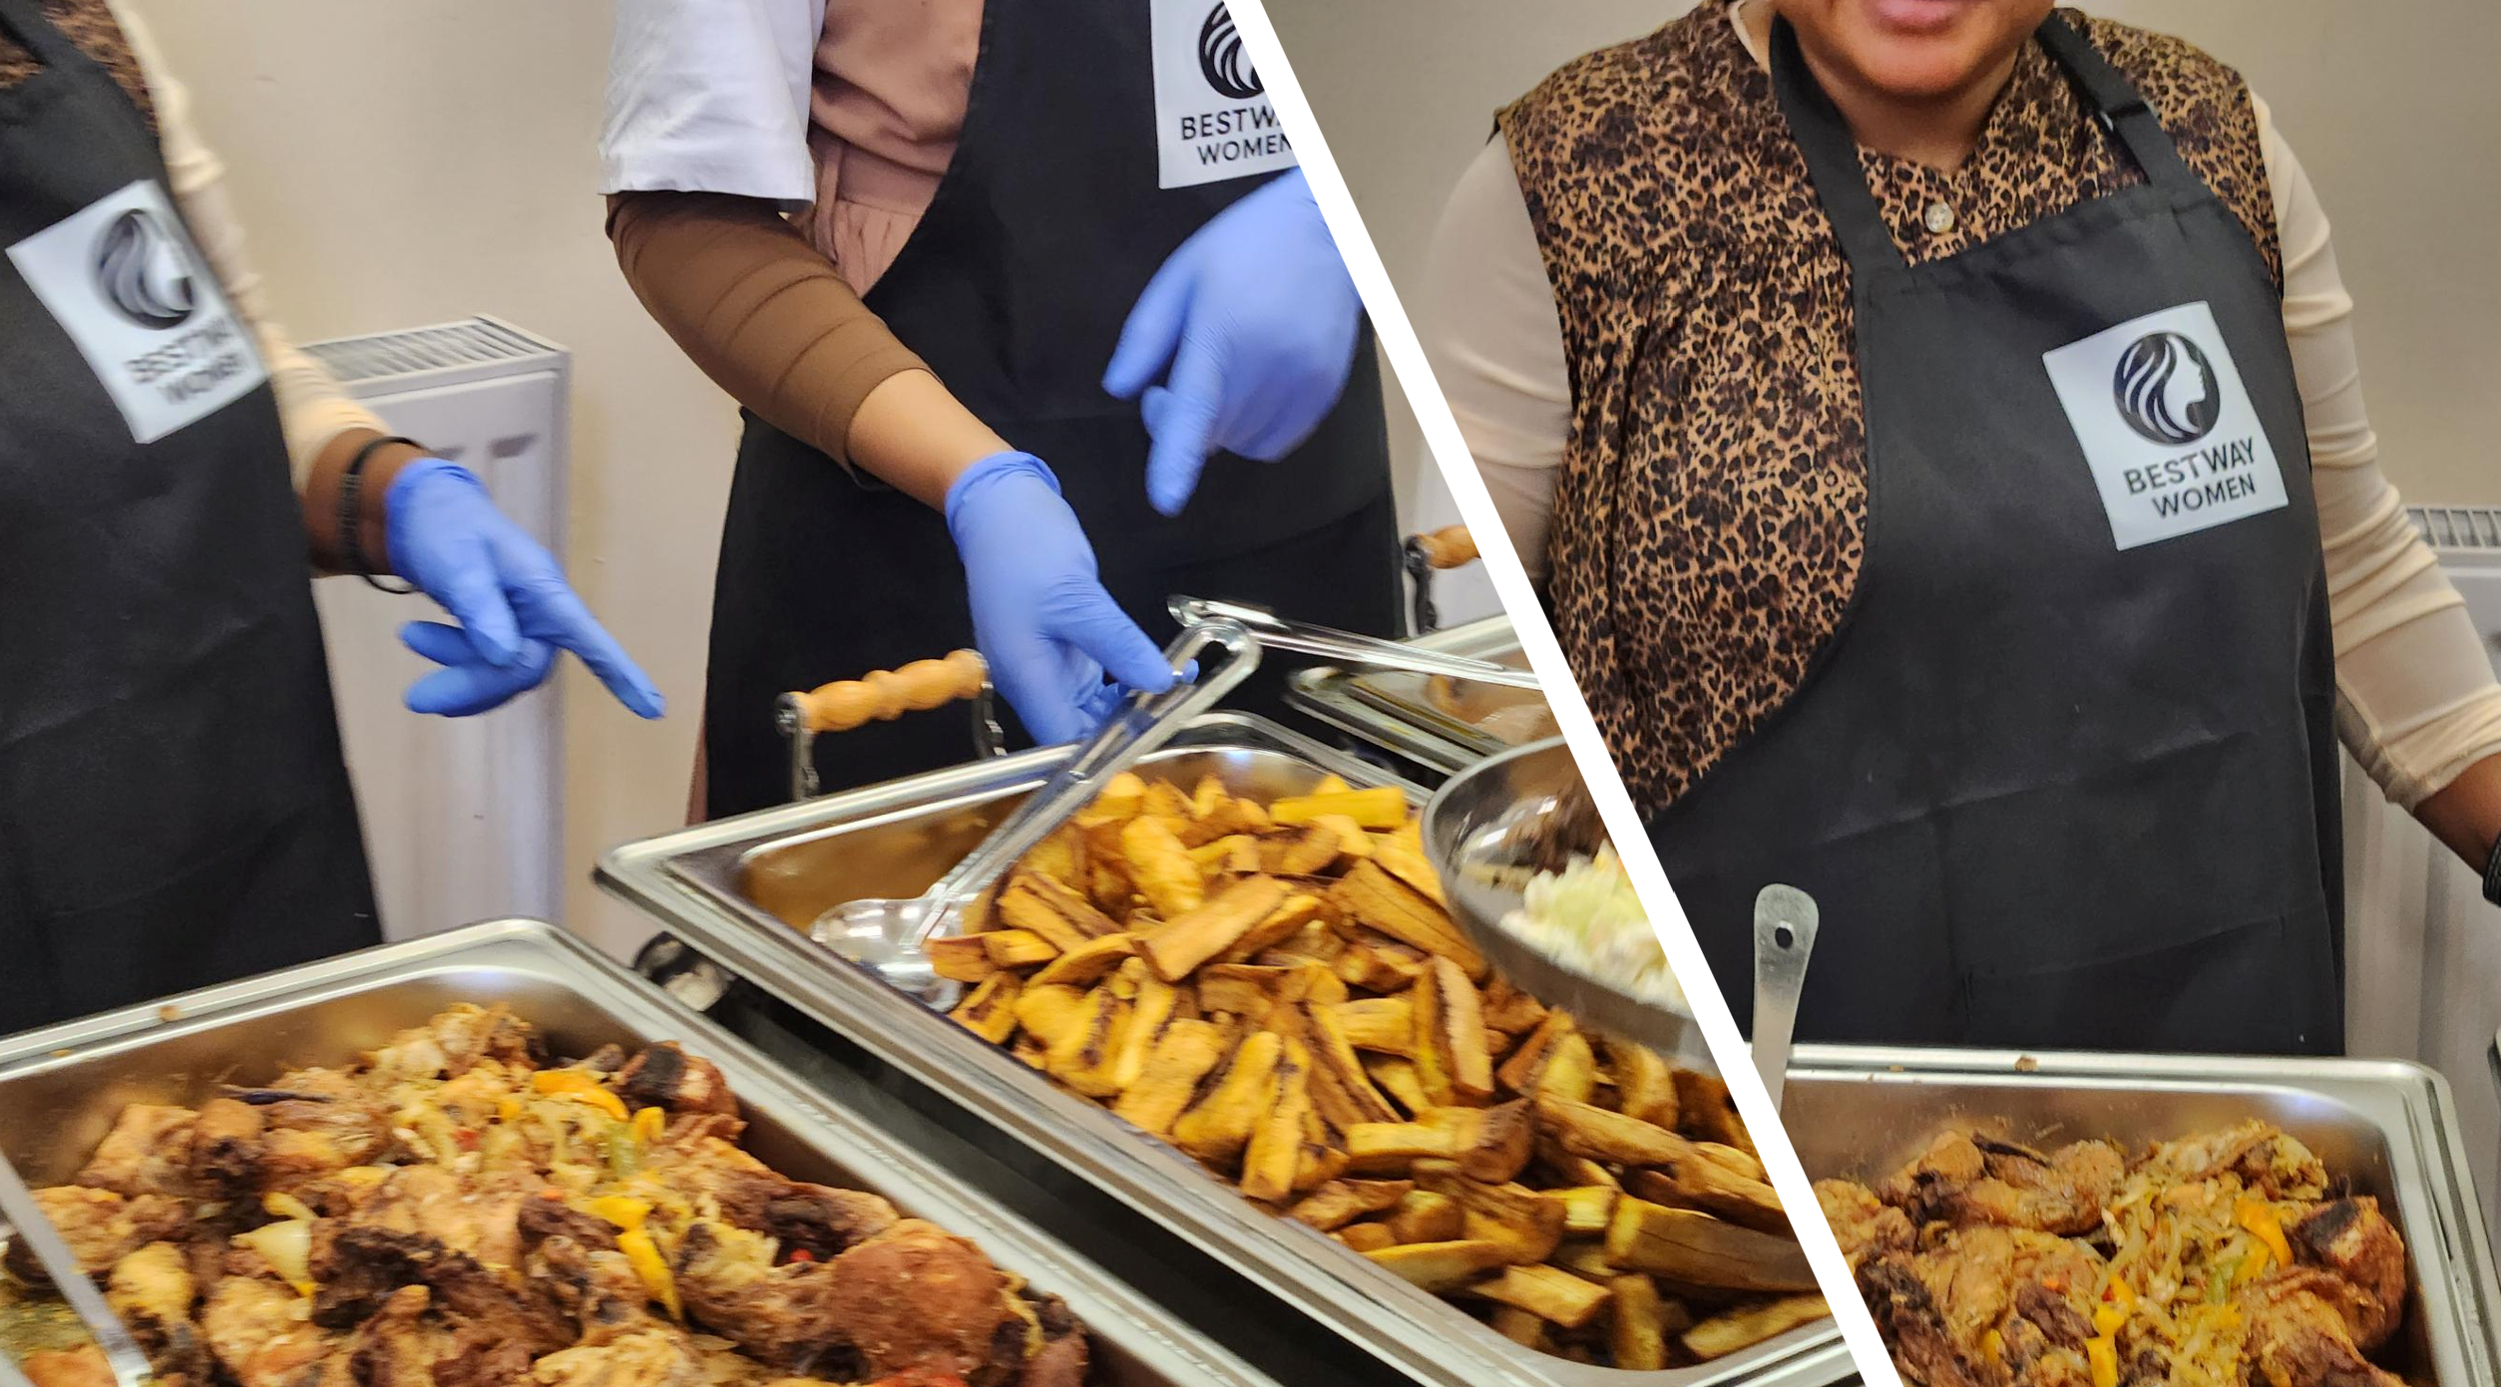
Our fantastic caterers, Bestway Women, who served a delicious lunch.

Our stall holders: NHS Keep Well Team; North Lanarkshire Carers Together; Lanarkshire Carers Centre; Routes to Work; Waverley Care; The Economic Forum for Family Empowerment Scotland; Voluntary Action North Lanarkshire (VANL); Police Scotland; Scottish Fire and Rescue Service; NL Cultural Committee; North Lanarkshire Council - Tackling Poverty Team; Period Dignity Project; Community Learning and Development and Resettlement Team; Home Support Recruitment; Digital Inclusion and Libraries; and Community Partnership Team.
Chat Café hosts, the NLC Resettlement Team.
Our creche providers, Childcare in the Community.
Our venue, the Jim Foley Community Facility, also technical and presentation support, NLC Events Team and Sound Acoustics Production Ltd.

SERVICE SPOTLIGHTS

Incomes To Maximise Outcomes
North Lanarkshire’s team of welfare rights officers and money advisors are able to offer you support, advice and assistance to ensure your household income is fully maximised.

We can provide help and support with:

- Carrying out a benefit check to ensure your income is maximised.
- Completing benefit application forms.
- Completing applications for free school meals and clothing grants.
- Representation and support to challenge benefit decisions.
- MacMillan Benefit Service for people and families affected by a cancer diagnosis.
- Independent money and debt advice.
- Budgeting advice to help reduce their outgoings, manage your money and maximise your income.

The Team can provide you with assistance on the phone or in person at one of Community Hubs or can arrange a home visit if necessary. They have helped thousands of people and families and have generated over £130 million in additional benefit income in the last three years.

To contact the Team by phone or email; you can call 01698 332551 or send an email to tpteam@northlan.gov.uk, with your name, address, date of birth, national insurance number (if you know it) along with a short explanation of what you would like the team to help you with.
“I am eternally grateful for the help that your service provided me, you have no idea the difference this has made to me. Your kindness has been unbelievable, you have taken a lot of worry, anxiety and stress from me. All the staff have been so kind from the moment I called to receiving a home visit. I am now in a position where I do not need to worry about money as much” Tackling Poverty Service User

NLC Supported Enterprise Team
No Limits is an employability programme delivered by NLC Supported Enterprise Team as part of its overall Employability service and is funded by No One Left Behind funds provided by the Scottish Government. It supports 20 young people with additional support needs in their employment journey by offering work experience, training and employability support. As well as undertaking a paid work placement for 25 hours per week for 9 months, all the trainees participate in industry training, workshops and fun outdoor activities to build confidence and skills, all preparing them for the world of work.

Referrals typically come from schools, careers advisors, colleges or social work and one of the barriers that participants and families face is the reduction in household welfare benefits if they join the programme as opposed to staying in education.

Like all employability services delivered in North Lanarkshire it is a voluntary service which is free to all residents. The overall purpose is to ensure that all residents have the opportunity to get the support they need to move towards and into employment and we have a specific focus on including those residents who, without our investment, would not be able to access these opportunities.

Not only are earnings from employment one of the key ways in which we can help tackle poverty, we also know that being in work brings a host of other social and economic benefits to people and their families. For more information, please email the Employability Team at northlanarkshiresworking@northlan.gov.uk.

The following case study is not untypical of how our young people with additional support needs can flourish and engage in the labour market with the right support and investment during their transition from school to the workplace.

Supported Enterprise Case Study
The No Limits Job Coaches provide 1-1 support for our young people and in this case the job coach was Mags. She first met Kate at Buchanan High School as she did not want to go to college and was passionate about a career in childcare. Mags worked with Kate in her last few months at school to build her vocational profile to identify the best possible placement/job matches based on her skills and abilities as well as gathering a better understanding of the support needed to be put in place to ensure it is successful.Kate was studying childcare at school and Mags was able to source some work experience in a local primary school. This led to a No Limits placement in a NLC school for Kate when she left where she was mentored and supported by amazing staff throughout.
When Kate’s placement came to an end, she was successful in securing a post within NLC working within a primary school and continues to thrive whilst getting support on the days that she needs some guidance and moral support. Recently she added to this 20 hours per week contract as she was successful in getting the early morning job as breakfast assistant in her school. Kate’s job coach supported her throughout with any job coaching requirements and moral support. She has had a full induction and completed all the mandatory NLC training and modules.
Kate is a valued member of staff and her Head Teacher says that she has learned so many different skills throughout her placement and job. Kate has also gained many different friendships with staff and she takes part in activities in her spare time with other staff members. Kate notices how much she has grown and developed, and she feels proud of the progress she has made.
After months of determination Kate recently passed her driving test and now has a car of her own. She says she loves the freedom to go anywhere that she wants to. Kate said this will give her independence and enhance her self-esteem. Her next goals are to continue to do amazing at work, keep learning and be able to apply for a promoted post in the near future.

digital skills and it support

Digital Skills for Life Project
The CLD Digital Skills for Life Project aims to build everyday digital skills and knowledge across North Lanarkshire communities.

Between October and December, we worked with a group of volunteers from Holytown Mosque, to improve group members’ digital abilities, with a particular focus on effective use of digital tools such as Outlook and Teams to support the sharing of information and planning for groups. Participants also improved their knowledge of using the internet safely.

We kicked off 2026 with a new piece of partnership work with Bestway Community Development in Jerviston, Motherwell. We worked with a small group of their learners over 8 weeks to build on their digital skills, increasing their confidence in using email safely; creating strong passwords; installing and using money saving apps; using cloud storage to back up information and increasing the group’s awareness of AI. On completion of the course, group members reported feeling much more confident in their ability to use digital devices independently.


North Lanarkshire Libraries Service – Digital Zones
We are excited to be the home of two Digital Zones as part of a pilot project.

Located within Coatbridge and Chryston Library, these spaces are designed to provide residents, partners, and local organisations with access to cutting-edge technology and resources, fostering digital skills and confidence.

Key features, which were developed by public consultation, include:

- Free Wi-Fi, printing, and scanning services.
- Devices for online learning and public services.
- Staff support to assist with digital needs.
- Flexible access—drop-in or bookable spaces.
- Adaptive technology such as large monitors, optical mice, noise-cancelling headphones, and voice recognition software.

Employment skills and training

Q Did you know that there is an online resource containing all of the council’s and partners’ employability and training information?
Resources and Information for North Lanarkshire Young People and Families
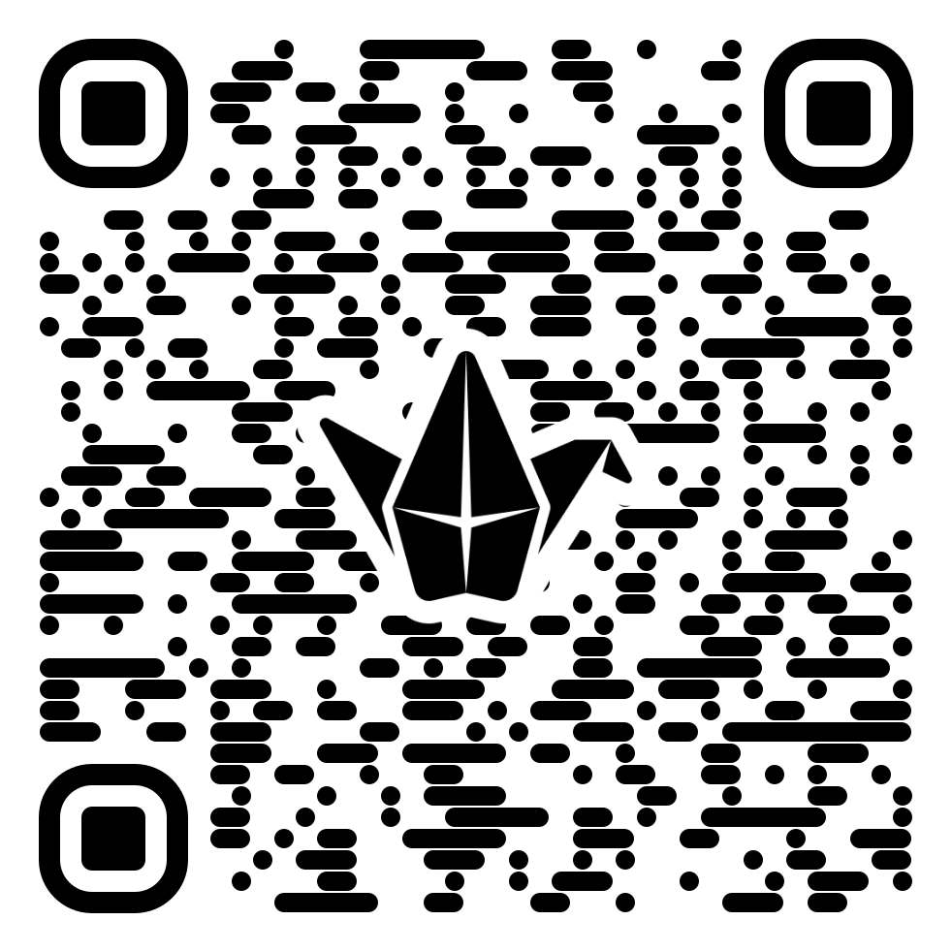

Studying at New College Lanarkshire
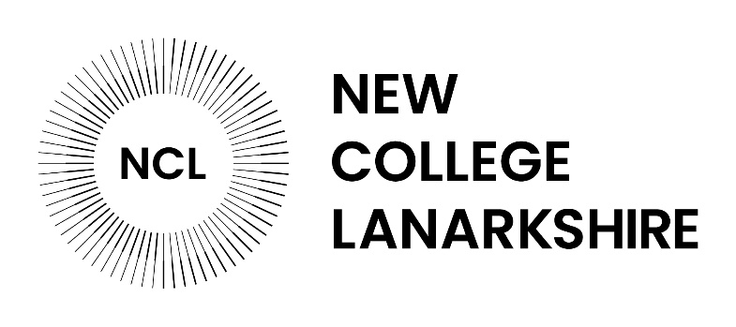
New College Lanarkshire is a brilliant choice if you're looking to get on in life without travelling far from home. With campuses in Motherwell, Coatbridge and Cumbernauld, you're never far from a class, and the range of courses is huge, everything from hairdressing and joinery to computing, childcare, business and access courses that can take you on to university.
The staff are approachable and supportive, so if you've not been in education for a while, or school wasn't really your thing, you won't feel out of place. Lots of students start nervous and leave with real confidence, a qualification and a clear idea of where they're heading.

On top of that, it's affordable and practical. Many full-time courses are free for eligible students, and there's bursary and childcare support to help you actually make it work alongside real life. The college has strong links with local employers, so you're not just sitting in a classroom, there are placements, apprenticeships and hands-on learning that give you a genuine shot at a job at the end of it. Whether you want to retrain, get your first qualification, or use it as a stepping stone to university, it's a place for you. More information can be found on the website - https://www.nclanarkshire.ac.uk/courses/.

ESOL Employability
The CLD Adult Learning and Resettlement Team recently delivered two successful ESOL and Employability programmes, combining classroom-based learning with supported workplace experience.
Working in partnership with colleagues in Facilities and HR, the team ran two six‑week programmes. Each programme focused on intensive ESOL learning, followed by a three‑week supported work placement with North Lanarkshire Council’s Facilities Team. This blended delivery model has had a significant positive impact on learners’ confidence, skills and readiness for employment.

The aim of the programme is to support learners to use the skills, experience and confidence gained to progress into employment, helping them build more secure futures for themselves and their families. This approach ensures lasting impact at both individual and community level.
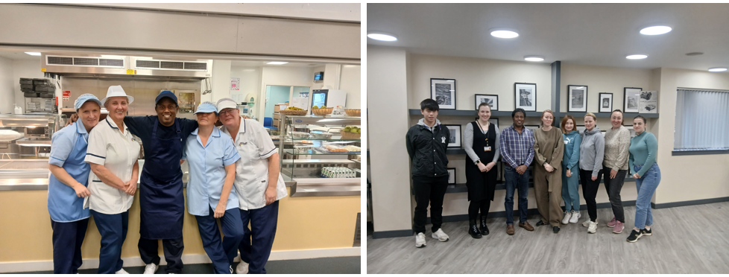

The programme is due to start again in August. For more information, please email cld@northlan.gov.uk.

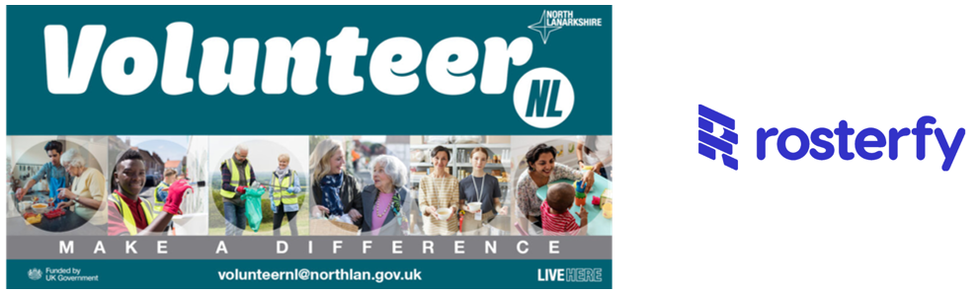
New volunteer app launches in North Lanarkshire
Volunteers across North Lanarkshire can now enjoy a simpler, more connected way to find opportunities, manage their shifts and stay up to date, following the launch of the new mobile app. Our creche providers, Childcare in the Community.

The Rosterfy app enables users to browse opportunities based on their location, availability and interests, complete onboarding and training while on the move, receive push notifications, and check in to volunteer shifts seamlessly.

The new mobile app allows volunteers to view and sign up for shifts, complete training, receive updates and manage their profiles. It also includes tools to recognise volunteers, such as certificates, e-badges and tangible rewards.

For more information, visit: Rosterfy Mobile App - Volunteer User Guide.

Increasing Diversity in Summer Placement Applications
The North Lanarkshire Summer Placement Programme is a paid work experience initiative aimed at young people aged 16–19 who live in North Lanarkshire or attend school or college within the area. Delivered over the summer period (late June to early August), the programme provides participants with valuable workplace experience within the council and with North Lanarkshire based businesses, helping them to develop skills, build confidence, and gain insight into future career pathways. It forms a key part of the wider Brighter Futures programme, supporting young people to progress into employment, education, or training.

The programme has seen a positive and steady increase in applications from Black, Asian and Minority Ethnic (BAME) candidates over the past three years, reflecting encouraging progress in widening access and engagement.

In 2024, 15.0% of applicants identified as being from BAME backgrounds. This rose slightly to 15.5% in 2025, followed by a more notable increase to 17.3% in 2026. This upward trend demonstrates growing awareness of the programme and suggests that outreach, inclusive recruitment practices, and targeted engagement efforts are beginning to have a measurable impact.
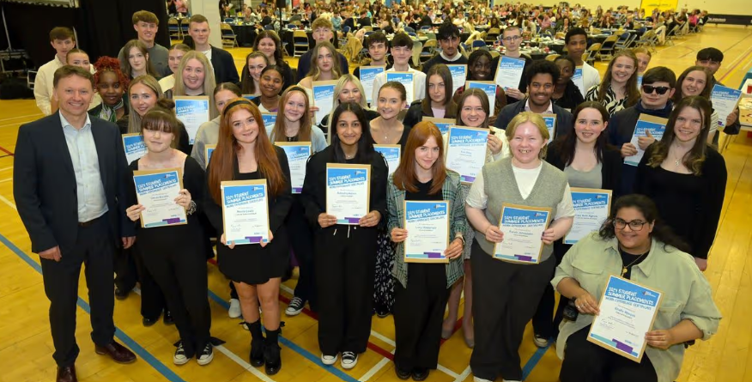

While the increase year-on-year is modest, the overall trajectory is clearly positive. The rise of more than two percentage points across the three-year period indicates gradual but meaningful progress towards a more diverse applicant pool. This is particularly important in ensuring that opportunities are accessible to individuals from a wide range of backgrounds and that the future workforce better reflects the communities of North Lanarkshire.

Continued focus on inclusive promotion, partnerships with schools and colleges, and removing barriers to access will be key to sustaining and building on this progress. Maintaining this momentum will help ensure that diversity and equity remain central to the programme and the wider ambitions of the Brighter Futures programme.

To find out more about the programme, please email SummerPlacements@northlan.gov.uk.

language support and skills

New College Lanarkshire ESOL
New College Lanarkshire offers a number of ESOL classes. All of our courses are part-time at Motherwell and Coatbridge campuses only (with the exception of the ESOL with Business course, which is full-time).

- ESOL Literacies Pre-beginner (Coatbridge only)
- Access 2 ESOL
- National 3 ESOL
- National 4 ESOL
- National 5 ESOL
- NQ Level 6 ESOL and Business (full-time, Coatbridge only)

If you are screened as suitable for the ESOL Literacies Pre-Beginner course, please note that this level is delivered at Coatbridge campus only. The ESOL Literacies Pre-Beginner course is suitable for those with very little/no English language skills.

For further information please visit www.nclanarkshire.ac.uk/courses/esol-all-levels/.

ESOL Forum
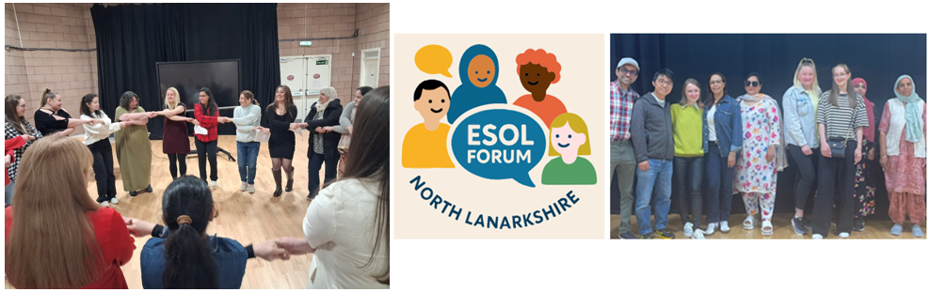
The ESOL Learner Forum is going from strength to strength. The forum is a group of ESOL learners from throughout North Lanarkshire who represent the voices of all ESOL learners. They work in partnership with the local authority to ensure that needs, ideas and experiences of ESOL learners are considered and understood.

The group recently held a Scottish New Year celebration and represented North Lanarkshire at a national ESOL conference and contributed to discussions and shared first hand reflections on their experiences of learning English in Scotland.

For more information on the ESOL Forum email cld@northlan.gov.uk.

Update on ESOL provision
North Lanarkshire Council’s Community Learning & Development Team offer free ESOL classes in Cumbernauld, Airdrie, Coatbridge, Bellshill, Motherwell and Wishaw. These classes take place in local community venues and focus on practical English for everyday life—including reading, writing, speaking, and listening. You’ll also have the opportunity to work towards Qualifications Scotland accredited qualifications. We also offer FREE online ESOL classes on a Tuesday evening for both beginners and intermediate learners.

In addition, the team run six Chat Cafés across North Lanarkshire. These are relaxed, friendly spaces where you can practice your English, meet new people, and build community connections. For more information, email: cld@northlan.gov.uk.

Resettlement Women’s Groups
The Resettlement Women’s Groups in Motherwell and Cumbernauld were established in September 2025 to address local learner-identified needs to provide a safe, female only space for learners who have barriers to accessing mainstream CLD provision or ESOL classes due to cultural barriers. This was identified as a need by women in families the Resettlement service support, who felt they lacked confidence to attend ESOL classes due to lack of experience in a classroom setting. Since forming, the groups have been keen to take part in partnership projects and inputs to enhance their knowledge of local community, learn new skills and have their voices heard throughout North Lanarkshire.

From September to December 2025 the groups focused on a creative project in partnership with NL Libraries service. Learners participated in bespoke Our Freedom: Then and Now artist-led workshops. Their creative journey culminated in an interactive public exhibition at Motherwell Library. The groups have since participated in SQA accredited numeracy and cooking course with the Sum It Up team, had inputs from NHS Health Improvement, taken part in information sessions on voting in the Scottish elections, and will soon be starting a creative textiles project with a local artist. For more information email cld@northlan.gov.uk.
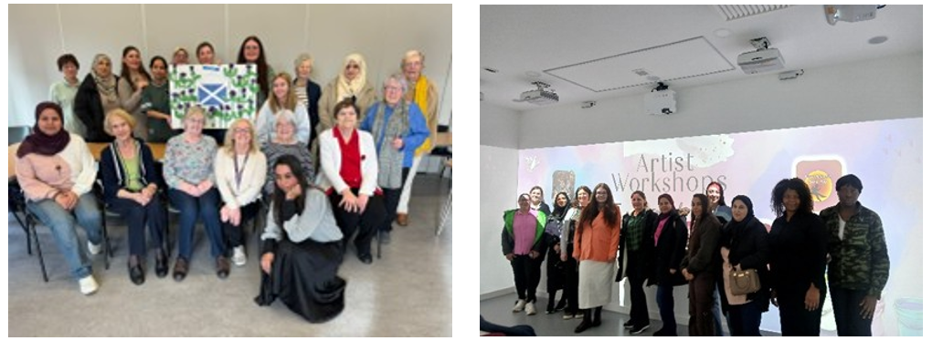

Active & Creative Communities Community Sports Hubs Partnership with Connect Youth Group
We’re delighted to share the launch of an inspiring new programme in partnership with Connect Youth Group, bringing together young people aged 15–24 who have English as a second language.

This fantastic initiative supports resettled New Scots from a wide range of countries including Vietnam, Ukraine, Afghanistan, Sudan, and Eritrea. While a small number of participants are here with family members, the majority are Unaccompanied Asylum Seeking Children, each with unique journeys and experiences.

This programme has been designed to:

- Build meaningful, lasting relationships among young people with shared experiences.
- Develop confidence and resilience through supportive group activities.
- Create a sense of belonging and community.
- Provide new and exciting opportunities to learn, grow, and thrive.

By bringing these young people together, we aim to create a safe and welcoming space where they can connect, support one another, and unlock their full potential.

A huge thank you to our partners at Connect Youth Group for helping make this vision a reality. We’re excited to see the positive impact this programme will have!

cultural awareness and celebration


Refugee Week
Motherwell Library will be running a series of films and events aimed at raising awareness and bringing communities together during refugee week (15-20 June). It will kick off with a showing of the award-winning documentary “Everybody to Kenmure Street”. Contact MotherwellLibrary@northlan.gov.uk for more details of the programme, or check out “What’s On” on their website www.northlanculture.co.uk/libraries/your-library/motherwell-library/.

North Lanarkshire Cultural Committee
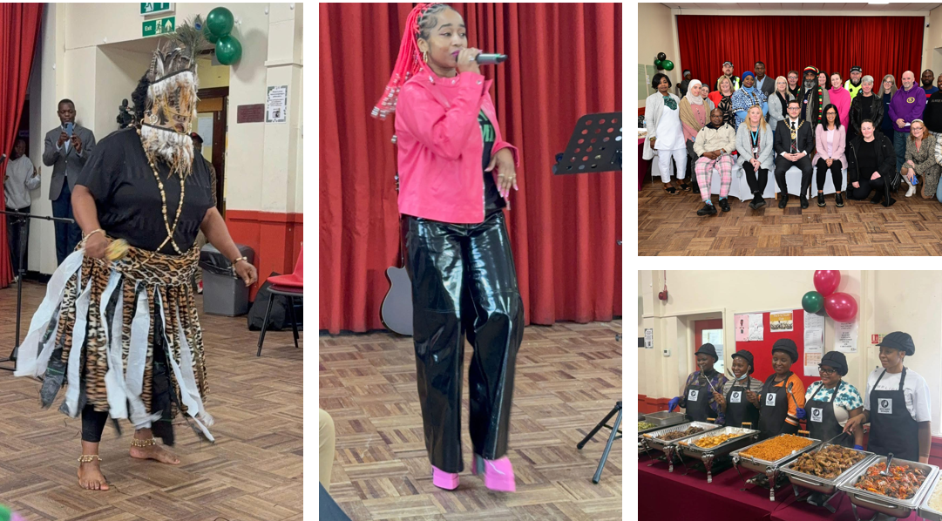
The purpose of the North Lanarkshire Cultural Committee is to progress the recommendations of the 'Our Lives’ research, specifically in relation to 3 areas - Cultural Awareness, Community Cohesion and Celebration.

The committee is made up of local people, groups, statutory sector partners and other stakeholders within North Lanarkshire who play a key role in progressing the recommendations of the Our Lives research.

The Committee are hoping to form as a constituted group and are looking for new members who would be interested in joining them to take this exciting development forward.
If you would like to find out more about the work of the North Lanarkshire Cultural Committee, please email equality@northlan.gov.uk.

Decolonising our Collections - New Interpretations of our objects from Africa and Asia
Four community researchers from BAME backgrounds contributed their lived experiences and interpersonal skills to capture truthful contexts. These stories contain narratives of colonialism and North Lanarkshire’s involvement with the Transatlantic slave trade. Understanding these objects with an unbiased account of history allows for a better understanding of why BAME individuals are a vital part of our community.

This project has been a contribution to inclusive Museum practices and reflects North Lanarkshire’s diverse society.

You can view the exhibition at Summerlee Museum of Scottish Industrial Life, Heritage Way, Coatbridge, ML5 1QD. Open 7 days, 10am – 4pm.
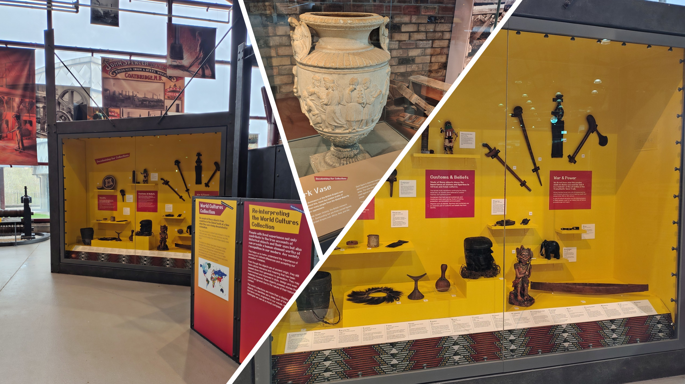

Summerlee Museum Redevelopment Project
The Summerlee: ‘New Stories, New Audiences, Better Lives’ redevelopment project is now reaching the conclusion of its initial development phase, having worked extensively with communities, partners, groups and organisations for the past two years to build our exciting collective plans to revitalise the Museum and greatly extend the scope of its exhibits. These plans are now being finalised ahead of a major funding submission to the National Lottery Heritage Fund later this Spring.

The project’s specific focus on the post-industrial period sees a whole new range of innovative installations planned for Summerlee, which include an immersive Miners’ Village, a community-centred Miner’s Welfare Hall and a reimagined outdoor Learning Landscape, all facilitated by enhanced accessibility and interpretation features.

Our communities sit at the heart of the project’s welcoming vision, which will tell compelling stories of their unique contributions to our shared history particularly during this post-industrial period of great social and cultural change. The project’s many partners, drawn from across the communities of North Lanarkshire and beyond, have worked hard together with the Museum to bring this vision to life, and we collectively can’t wait to share these with audiences in the years ahead.
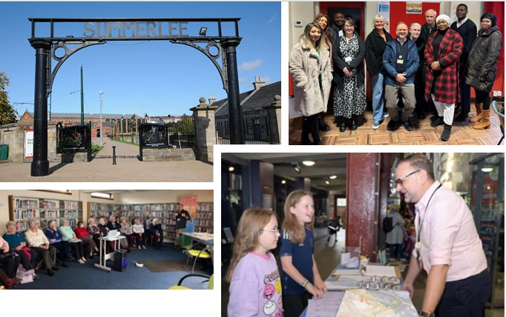

Interested in finding out more? We’d love to hear from you: SummerleeProject@northlan.gov.uk.

Eid Celebration
North Lanarkshire's Resettlement Team organised an EID celebration on 23rd March 2026. This event took place in Springfield Community Centre and was attended by our children and young people who have been separated from their families and are now resettled here in North Lanarkshire, and families who arrived in North Lanarkshire via other Resettlement Schemes.

The event was a great success with children, young people and families having an opportunity to celebrate together with lots of lovely food, and live music from Iranian musician Aref Ghobani.
North Lanarkshire's Creative Arts Team provided face painting, lantern making and other fun-filled activities for the children.
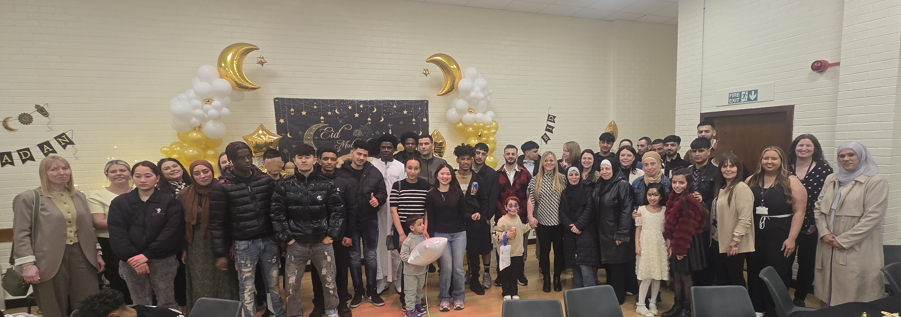

It was also lovely to see other teams including those from Children's Houses, Signs of Safety team, Volunteer NL, and Learning and Development team who all attended to support our children and young people.

Your Voice, Your Vote

In the run-up to this year’s Scottish Parliamentary elections on 7 May, the CLD Adult Learning and Resettlement Team delivered a Your Voice, Your Vote initiative over two dedicated weeks in March and April. This initiative provided an important opportunity to help learners understand the value of having their say and participating in the democratic process.
It also highlighted that people living in Scotland with refugee status or leave to remain are eligible to vote in Scottish elections. The team supported adult learning groups by providing ready‑to‑use materials covering how to register to vote and what to expect at the polling station.

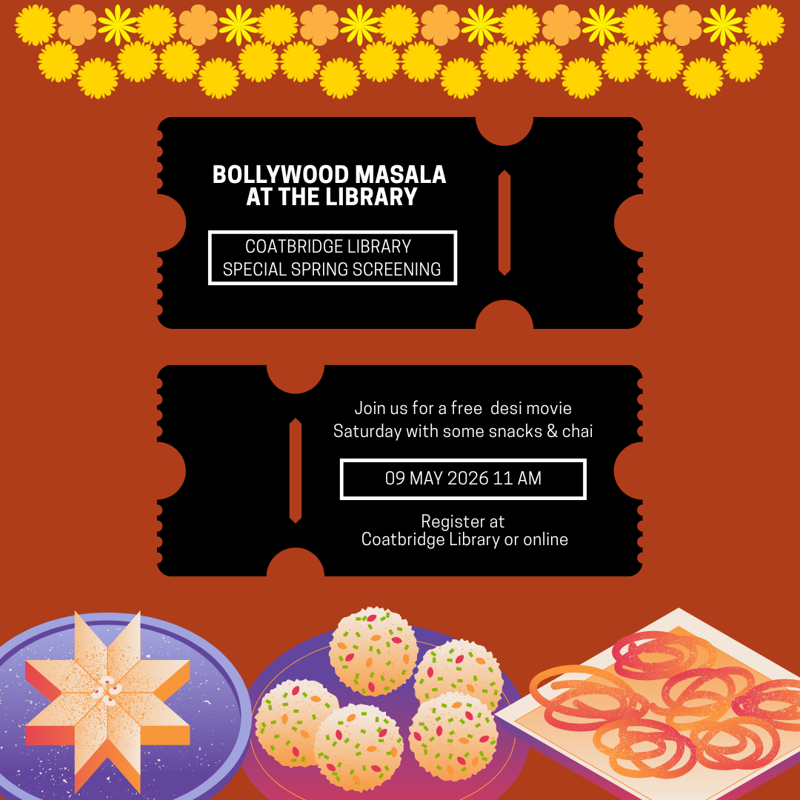
Bollywood Comes To Coatbridge Libary
Coatbridge library hosted the inaugural session of Bollywood Masala on Saturday 9th May. We screened Rocky Aur Ranii Ki Prem Kahani, a film that mixes romantic comedy with family drama. No moviegoing experience is complete without snacks so we offered a mix of savoury Indian crisps, biscuits and sweets as well as masala chai.

The very first event had a small but successful showing. It attracted a diverse crowd from the local community – some who were familiar with Bollywood movies and most of whom were watching one for the first time. The movie was in Hindi with English subtitles. The audience thoroughly enjoyed the choice of film as well as the food on offer. Plenty of laughter, a few tears and a smattering of outraged gasps accompanied the musical soundscape of the film.

With such an enthusiastic reception, we plan to make this a seasonal event. Keep an eye out for the next free screening at Coatbridge library this summer. The delighted audience members have promised to spread the word and we’ve promised to bring back their favourite snacks!

culturally competent and sensitive services

Resettlement Caseworker Roles
The Adult Learning and Resettlement Team have recently expanded with the introduction of new caseworker roles to support resettled individuals and families across North Lanarkshire. The caseworker roles provide day‑to‑day support, promoting learning and integration, offering signposting and referrals, and support health and wellbeing. Their role will help families build strong connections and a sense of belonging within their local communities.

The new case workers have already begun engaging with resettled individuals and families within their local communities and look forward to building strong relationships and contributing to positive outcomes, helping families make North Lanarkshire their home.

A Guide to Scots Law – New College Lanarkshire
A Guide to Scots Law Booklet has been a collaborative project with New College Lanarkshire's HND Legal Services Students, Fearless (Crimestoppers), Scottish Refugee Council, Scottish Government & Police Scotland to help New Scots settle within Scotland.

This is a friendly guide explaining how Scottish law works, especially for people who are new to Scotland, unfamiliar with the legal system, or learning English. The 2026 edition was recently updated and translated into multiple languages.

The booklet can be found on the college's website: www.nclanarkshire.ac.uk/scots-law.

Community Hubs
Chryston Community Hub has developed a programme called Right Routes to Health (RRTH), where people of all ages, including families together, focus on what are known as Lifestyle Medicines: sleep health, nutrition, movement, social connectedness, positive mental health, and creativity.
By utilising the skills, knowledge and expertise within our Hub board group, and through collaboration with the third sector and local community groups, we have developed RRTH as a holistic wellbeing programme, which will include the following:

- Fitness classes (family fitness classes, adult classes and health walks).
- Weigh 2 Go sessions.
- Cooking and nutrition awareness classes.
- Dealing with Stress sessions.
- Sleep health talks.
- Creative writing classes.
- Learn to grow your own veg.
- Bike hire/loan and free bike maintenance.
- Music and art sessions.
- Lifestyle – more than medicine – workshops.
- The benefits of exercise and movement to your health – workshops.

The RRTH programme will run from 4th May through to the end 2026 at the hub. To find out more about RRTTH or to book a place on any of our sessions, please contact Gerry, Community Hub Co-ordinator, on chrystoncommunityhub@northlan.gov.uk.

Sakoon Mind
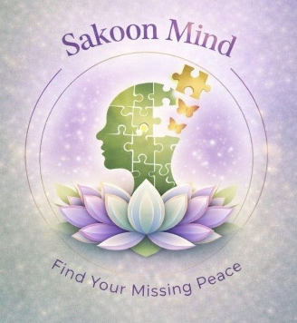
Sakoon Mind strongly resonates with the Our Lives research finding that a “one size fits all” western-centric approach does not effectively meet the mental health needs of diverse communities. This is something we see first-hand through our work.

Sakoon Mind is a grassroots, lived-experience-led mental health charity based in North Lanarkshire. Our work focuses on creating safe, culturally sensitive spaces where individuals particularly from South Asian and other underserved communities—can openly explore mental health, reduce stigma, and access support in a way that feels relatable and inclusive.
We take a community-led and pluralistic approach, recognising that mental health is deeply influenced by culture, identity, faith, language, and lived experiences. Through initiatives such as our “Chai & Samosa” sessions, workshops, and creative wellbeing activities, we aim to break down barriers and make conversations around mental health more accessible and less intimidating.

Our approach centres around:

- Culturally sensitive delivery (including language and cultural understanding).
- Informal, welcoming environments that encourage open dialogue.

- Blending practical tools (journaling, mindfulness, reflection) with community connection.
- Reducing stigma through conversation and shared lived experience.

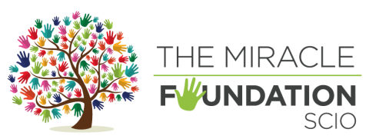
The Miracle Foundation – Together We Thrive

Group for mothers/carers and their teenage daughters in the BAME community

What it means for our community
At the heart of our work is a simple but powerful belief: support is most effective when it understands the people it serves. For many women and young people within Black, Asian and Minority Ethnic (BAME) communities, accessing mental health and wellbeing services can feel challenging. Cultural stigma, language barriers, faith considerations and generational differences can all make it difficult to seek help or feel fully understood.

That is why culturally competent and sensitive services are not just important, they are essential.

Understanding Cultural Competence in Practice
Cultural competence is more than awareness. It is about actively creating spaces where individuals feel safe, respected and able to express themselves without fear of judgement. It means recognising the unique experiences that shape people’s lives, including immigration, identity, faith, discrimination and intergenerational dynamics.

Our Together We Thrive program was built with this understanding at its core. Many participants that attended our group initially faced barriers such as stigma around mental health and limited access to culturally relevant support. By addressing these barriers directly, we have been able to create an environment where open conversations can begin.

Creating Safe and Inclusive Spaces
A key part of culturally sensitive practice is ensuring that people feel they belong. Our sessions have been intentionally designed to reflect the communities we serve. This includes:

- Incorporating culturally familiar activities, such as shared food, music and creative expression.

- Providing faith sensitive and respectful environments where beliefs are acknowledged and valued.
- Encouraging intergenerational participation, allowing mothers, daughters and even grandmothers to learn together.
- Offering non-judgmental, confidential support where individuals can speak freely.

Participants consistently described the group as a safe space where they felt heard and understood. This sense of safety has been a key driver in increasing emotional openness and confidence when discussing mental health.

Bridging Generational and Cultural Gaps
One of the most powerful outcomes of our work has been the strengthening of relationships between mothers/carers and daughters. Many families navigate differences in cultural expectations, especially when young people are growing up in a different social environment from their parents.
Through shared activities and guided discussions, families have been able to:

- Build mutual understanding and empathy.
- Improve communication and trust.
- Navigate identity and cultural expectations together.

Our findings show a significant increase in confidence when discussing mental health and wellbeing, alongside improved relationships and emotional connection within families.

Extending Support Through Drop-In Sessions
Building on the success of our program, we are proud to now offer Safe Space Wednesdays, a weekly drop-in service designed to provide accessible, flexible support for mothers, carers and teenage girls within the BAME community.

These sessions continue our commitment to culturally competent care by offering:

- A safe, welcoming environment to talk and be heard.
- One to one emotional and wellbeing support.

- Guidance on family, financial and personal challenges.
- Signposting to additional services where needed.

Importantly, these sessions require no booking, are free of charge and completely confidential, ensuring that support is accessible to those who may need it most.

Reducing Stigma and Building Confidence
In many communities, mental health and wellbeing can still feel like a difficult topic to approach. By embedding these conversations within culturally relevant and supportive settings, we have helped to normalise discussions around wellbeing.

Mothers and carers reported feeling more confident in supporting their children, while young people shared that they felt more comfortable expressing their emotions. This shift is vital, not only for individuals but for the wider community.

Why This Work Matters
Culturally competent and sensitive services are not an add on, they are fundamental to achieving meaningful and lasting impact. When people feel seen, understood and respected, they are more likely to engage, open up and seek support.

Our work has shown that when cultural identity is embraced alongside emotional wellbeing, the results are transformative: stronger families, increased confidence, reduced isolation and a deeper sense of belonging.

Looking Ahead
The overwhelming positive response from participants highlights a clear and ongoing need for services like ours.

As we move forward, we remain committed to listening to our community, adapting to their needs and ensuring that every woman and young person who walks through our doors feels supported, valued and empowered.

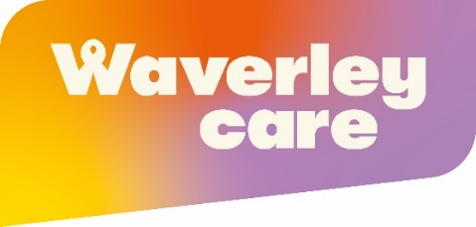
Waverley Care
Waverley Care’s Ethnic Minority Health service is playing a vital role across Lanarkshire, working to improve awareness, prevention, and support around blood borne viruses within diverse communities. Commissioned by NHS Lanarkshire, the service focuses on delivering culturally sensitive, accessible care that meets people where they are.

At the heart of the programme is a commitment to community-based support. This includes one-to-one assistance for individuals living with blood borne viruses, confidential and accessible testing within community settings, and tailored education sessions designed to raise awareness and reduce stigma. By working closely with statutory services, third sector organisations, faith groups, and local community partners, the team ensures that support is both inclusive and effective.

A key part of this approach is ongoing investment in collaborative initiatives such as cultural committees, which strengthen connections between organisations and improve visibility within communities. These partnerships are essential as we contribute to the wider national ambition led by the Scottish Government to end new HIV transmissions by 2030.

Waverley Care is calling on individuals and organisations to support this important work. There are many ways to get involved: whether by inviting the team to deliver awareness sessions within your community or by volunteering as a Health Ambassador to help spread vital information.

To learn more or get involved, visit www.waverleycare.org or use the contact details provided in the directory. Together, we can build healthier, more informed communities and move closer to ending new HIV transmissions in Scotland.

Community Engagement at the Lanarkshire Mosque Bellshill Winter Warmer Event
Building on previous engagement with community members who attend the Lanarkshire Mosque in Bellshill, the Community Partnership Team supported the 2026 Winter Warmer event in partnership with the NHS Lanarkshire Health Improvement team.
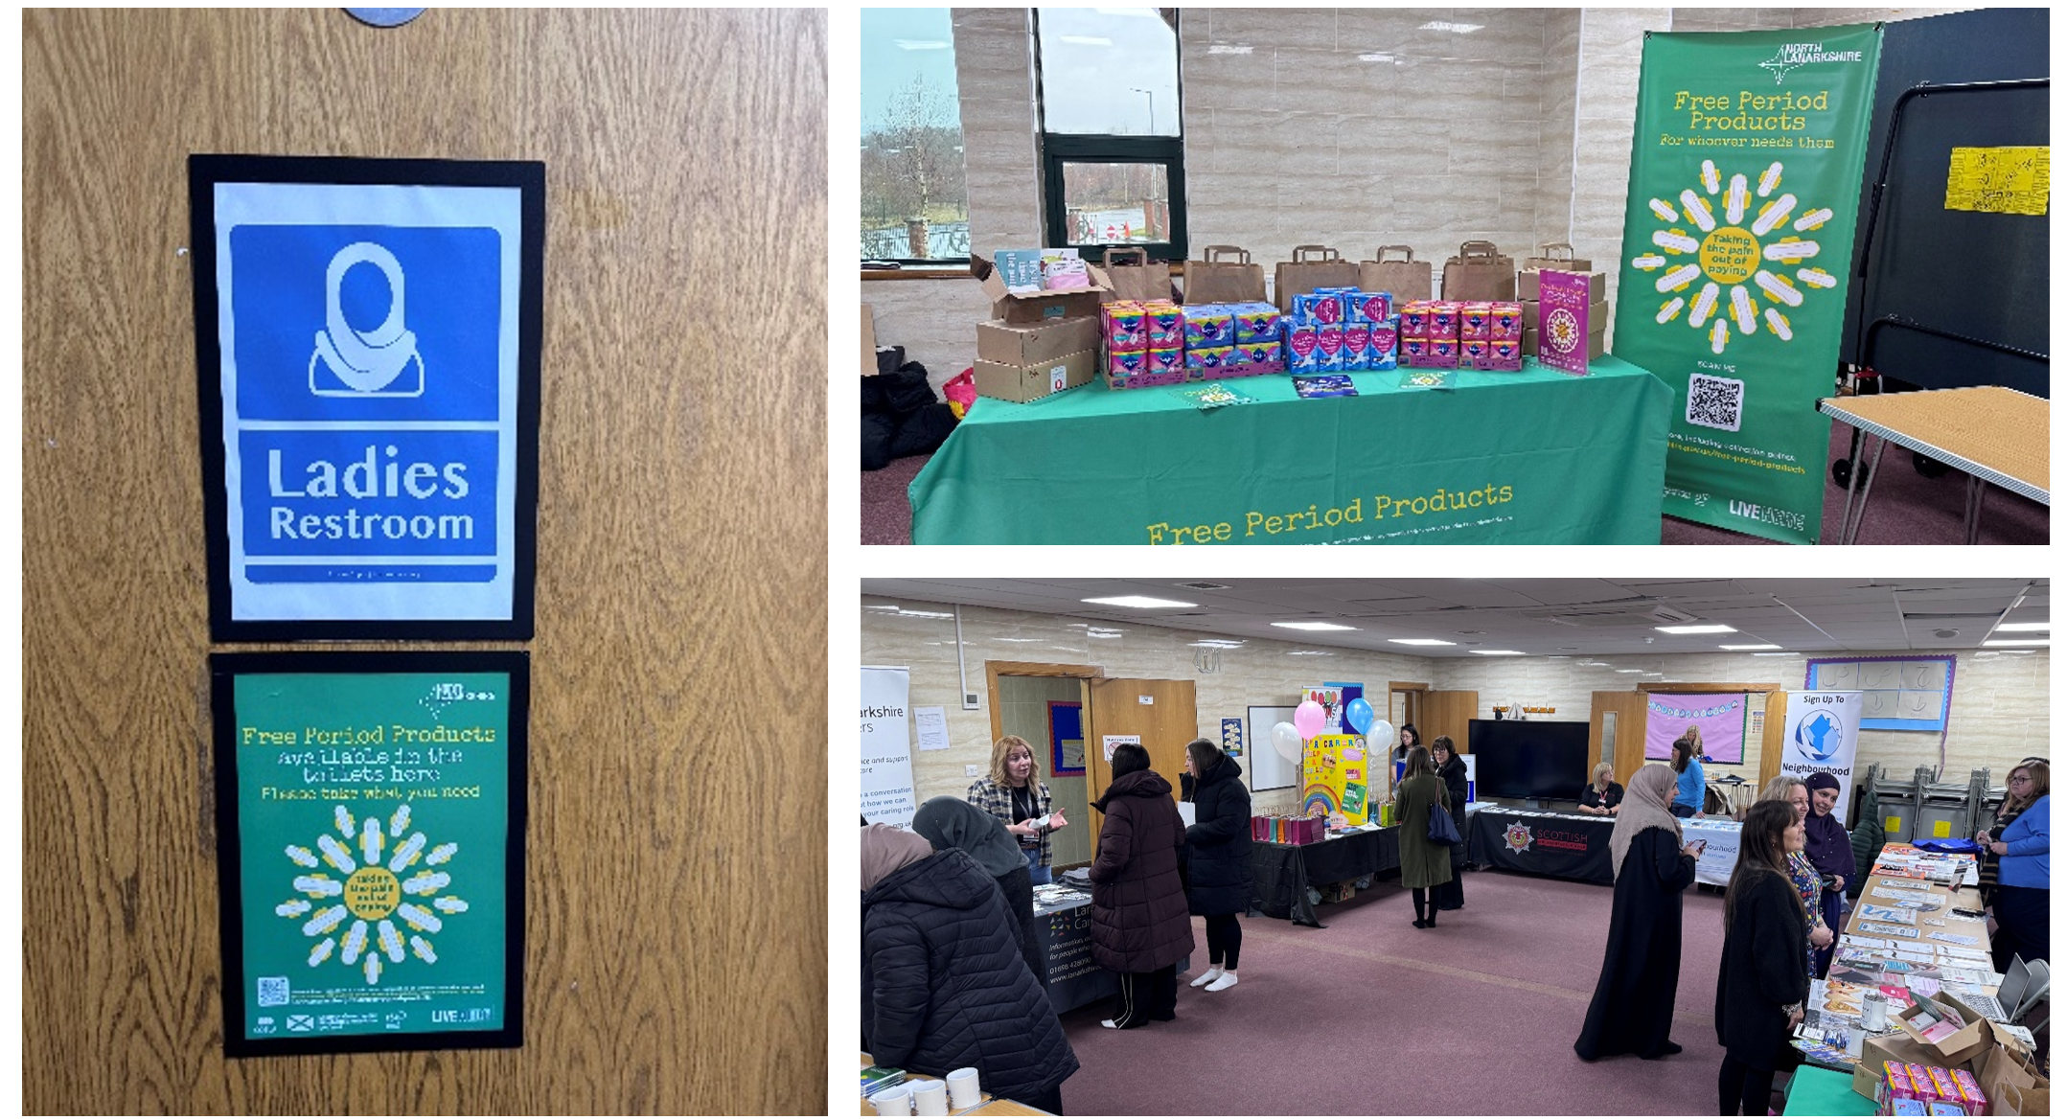
Participants were provided free period products and informational resources on obtaining more products when needed from our over 100 community locations by scanning the QR code which links to our online interactive map. Over 1,300 individual period products were distributed, and participants were more aware of the Mosque as a community location for accessing free period products year-round.

Positive feedback was received on the successful use of previously provided first period kits in engaging and supporting young girls in the mosque as they prepare to start their period. Campaign signage was also noted in strategic locations of the mosque to increase awareness.

Read more about Community events we support | North Lanarkshire Council.

Free Period Products
North Lanarkshire Council provides free period products for anyone who needs them.

The PickUpMyPeriod app (by Hey Girls and the Scottish Government) shows locations across the UK where free products are available.
📱 Available on App Store and Google Play.
🌐 Council pick-up points are also listed on the North Lanarkshire website.

Proposal for a new mural on the Pavilion at King George V Park
The Community Partnership Team are working closely with the Ukrainian community of the Birkshaw Tenant & Resident Association to develop a project proposal to improve the disused pavilion building at King George V Park. This project is proposed to make the building more attractive to the community with a mural painted on all sides of the pavilion.

To date the local Community Partnership Officers for Wishaw and Motherwell have delivered consultation with the local community involving a community wide survey, interactive workshops with children and young people in two local primary schools and engagement with the older generation at Beechwood Care Home, with the purpose of gathering a range of views and opinions on what types of artwork the community would like to see included in the mural. This engagement has provided positive feedback and suggestions to include themes relating to the local area such as local heritage, sports, nature and words of kindness in a range of languages.

This project is still under development and will be completed over the summer months. We will report on the completed project to keep you up to date.

Communication Boards in Play Areas
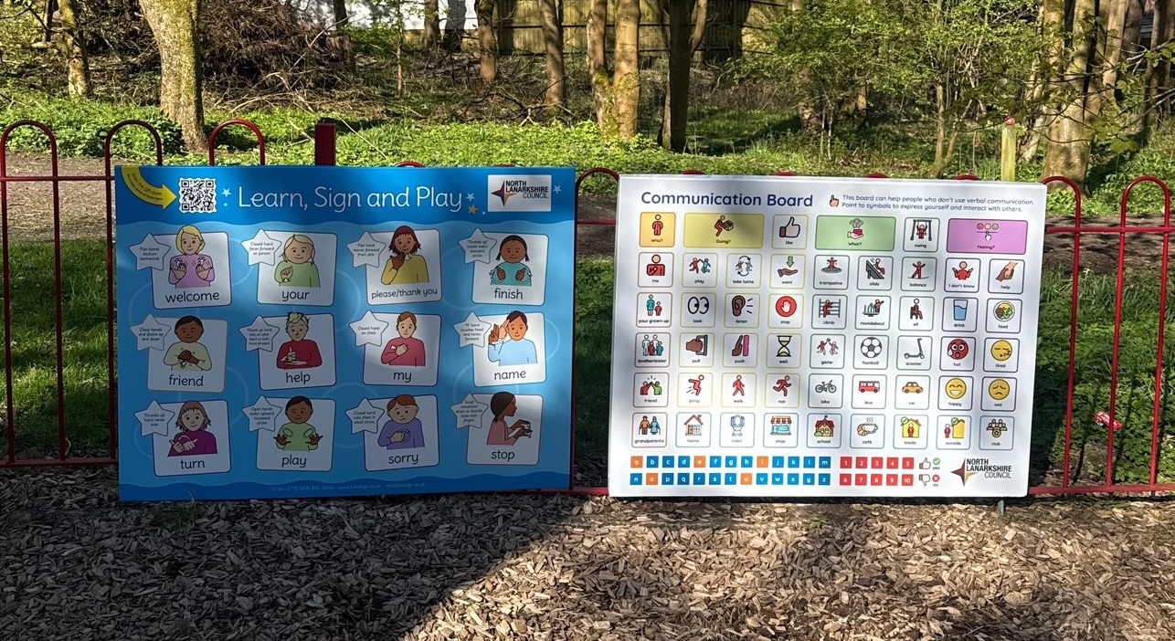
The Community Partnership Team worked with a range of key stakeholders to develop the design and commissioning of communication boards to be installed within a number of Local Development Programme funded capital investments in play areas across North Lanarkshire Council. These communication boards are to support children, young people, parents and carers using the play areas who have communications and speech differences.

The project was piloted in Wishaw and Motherwell, where the local Community Partnership Officers consulted with Education, NHS, children and staff within Innerleithen Family learning Centre, St Aidan’s LCSC and Firpark School. Results combined from this extensive consultation resulted in the final design of the communication boards to be displayed within play areas.

These have now been installed in 40 play areas, and the overall feedback is positive, indicating how supportive these are for children and young people to communicate while visiting these play areas. The Communication boards have been paired with BSL words and symbols boards to ensure further equity for children and young people with communications differences.

safety and security

Community Safety Hub supporting vulnerable residents
Our Community Safety Hub continues to play a vital role in protecting residents and supporting communities, with new figures highlighting the scale and impact of the service over the past year.

Operating 24 hours a day, 365 days a year, the Hub monitors 1,376 public space CCTV cameras across the area. During 2024/25, the team recorded 4,360 incidents, including 1,856 criminal incidents and 1,325 community safety incidents. CCTV footage supported 508 apprehensions, cautions or fixed penalties and helped assist in 137 missing persons cases.

The team also produced 570 evidence disks and processed more than 1,700 review requests to support Police Scotland and other partner agencies.

Support for vulnerable residents is another key part of the service. The Out of Hours Homeless Service responded to 8,764 calls from people asking questions about homelessness and their options, including how to access emergency help and accommodation.

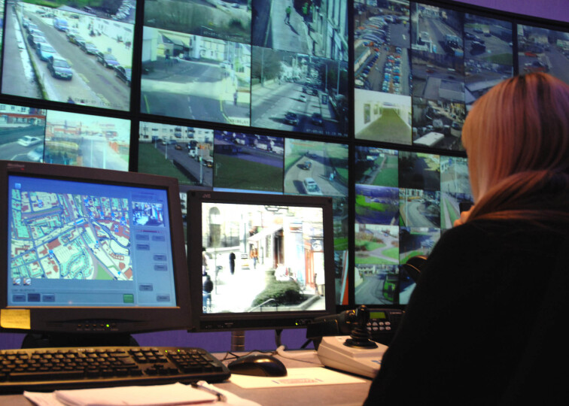
All analogue housing CCTV cameras have now been upgraded to high-definition digital systems, improving image quality and supporting crime prevention. Deployable CCTV trailers continue to be used to assess hotspots before permanent cameras are installed.

DIRECTORY OF SERVICES

North Lanarkshire Council
🌐 www.northlanarkshire.co.uk

Community Hubs
Chryston Community Hub
✉️ chrystoncommunityhub@northlan.gov.uk

Newmains & St Brigid’s Community Hub
✉️ newmains&stbrigidscommunityhub@northlan.gov.uk

Orbiston Community Hub
✉️ orbistoncommunityhub@northlan.gov.uk

Riverbank Community Hub
✉️ riverbankcommunityhub@northlan.gov.uk

Community Learning & Development Team
✉️ cld@northlan.gov.uk

Community Partnership Team
✉️ communitymatters@northlan.gov.uk
🌐 www.northlanarkshire.gov.uk/your-community/working-communities

Enterprise Team
🌐 www.northlanarkshire.gov.uk/business/support-businesses-north-lanarkshire

Equalities Team
✉️ equality@northlan.gov.uk

Housing Offices
🌐 www.northlanarkshire.gov.uk/directories/housing-offices

Libraries Service
🌐 www.culturenl.co.uk/libraries/your-library

NL Academies Team
✉️ nlacademies@northlan.gov.uk
✉️ summerplacements@northlan.gov.uk
🌐 www.northlanarkshire.gov.uk/jobs-and-training/nl-academies

North Lanarkshire’s Working
🌐 www.northlanarkshiresworking.co.uk
📞 0800 0730 226
✉️ northlanarkshiresworking@northlan.gov.uk

Tackling Poverty Team
✉️ tpteam@northlan.gov.uk
📞 01698 332551
Working for Families
🌐 www.workingforfamilies.co.uk
✉️ workingforfamilies@northlan.gov.uk
📞 0800 0730 226

VolunteerNL
✉️ volunteernl@northlan.gov.uk

Partner Organisations
Business Gateway Lanarkshire
🌐 www.bgateway.com/local-offices/lanarkshire
📞 01698 442827
Ethnic Minority Law Centre
🌐 www.emlc.org.uk
📞 0141 204 2888
✉️ admin@emlc.org.uk

NHS Lanarkshire
🌐 www.nhslanarkshire.scot.nhs.uk
🌐 www.nhslanarkshire.scot.nhs.uk/contact-us

New College Lanarkshire
🌐 www.nclanarkshire.ac.uk
📞 0300 555 8080
✉️ edi@nclan.ac.uk

Police Scotland Lanarkshire Diversity Team
✉️ LanarkshireEqualityDiversityInclusion@scotland.police.uk

Routes to Work
🌐 www.routestowork.co.uk
📞 0800 783 4731
✉️ startyourjourney@routestowork.co.uk

Scottish Fire and Rescue Service
🌐 www.firescotland.gov.uk

Voluntary Action North Lanarkshire (VANL)
🌐 www.voluntaryactionnorthlanarkshire.org
✉️ info@VANL.co.uk
📞 01236 748011

Carers Organisations
Getting Better Together Ltd – Community Liaison Service
🌐 www.shottshealthyliving.com/our-Services-community-liaison
📞 07802 880 479
✉️ hdsp@lanarkshire.scot.nhs.uk

North Lanarkshire Carers Together
🌐 www.carerstogether.org
📞 01698 404055
✉️ enquiries@carerstogether.org

Lanarkshire Carers Centre
🌐 www.lanarkshirecarers.org.uk
📞 01698 428090
📞 Urdu, Punjabi or Hindi support: 07780 926595
✉️ info@lanarkshirecarers.org.uk

North Lanarkshire Young Carers Service
🌐 www.northlanarkshireyoungcarers.org
📞 01698 337607

Lanarkshire Brain Health & Dementia Resource Centre
🌐 www.alzscot.org/centre/lanarkshire
📞 01698 275300
✉️ LanarkshireServices@alzscot.org

Community & Voluntary Organisations
African Collaboration Group
✉️ africancollaboration@yahoo.com

Amina Muslim Women’s Resource Centre
🌐 www.mwrc.org.uk
📞 0141 212 8420 (Mon–Fri, 9:30am–5pm)
📞 0808 801 0301 (Mon–Fri, 10am–4pm)
✉️ info@mwrc.org.uk
Aura
🌐 www.aura.scot
📞 01698 757667
✉️ aura@sacro.org.uk

Bestway Community Development
🌐 www.bestwaycd.org
✉️ admin@bestwaycd.org
Diamonds in the Community
🌐 www.diamondsitc.com
✉️ diamondsitc@hotmail.com

Health and Wellbeing Community Group
✉️ healthandwellbeing5@outlook.com

Jerviston Community Centre
✉️ mail@jervistoncentre.co.uk

The Miracle Foundation
🌐 www.themiraclefoundation.org.uk
✉️ enquiries@themiraclefoundation.org.uk

North Lanarkshire Muslim Women & Family Alliance
🌐 www.nlmwa.co.uk
📞 07445 405350
🌐 www.facebook.com/share/1GMKeEYRPo
✉️ info@nlmwa.co.uk

Overtown & Waterloo Community Council
✉️ overtownwaterloocc@gmail.com

Sakoon Mind
🌐 www.sakoonmind.com
✉️ sakoonpeace@gmail.com
Society of St Vincent de Paul
🌐 www.ssvpmotherwelldiocese.org.uk
📞 07990 280 844

Voice of Experience Forum
🌐 www.voef.org.uk
✉️ info@voef.org.uk

Waverley Care
🌐 www.waverleycare.org
📞 07853 041130 (Lanarkshire contact)

