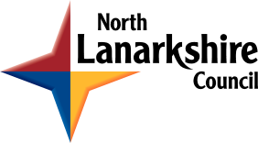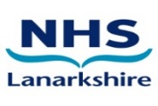
NORTH LANARKSHIRE INTEGRATION JOINT BOARD
ANNUAL ACCOUNTS 2025/26

Notice is hereby given, in terms of Section 101(1) of the Local Government (Scotland) Act 1973, and Regulation 9(1) of the Local Authority Accounts (Scotland) Regulations 2014 that:
An unaudited copy of the Accounts of North Lanarkshire Integration Joint Board for the year from 1 April 2025 to 31 March 2026 will be available to view electronically from Friday 26 June 2026 at the following website: North Lanarkshire University Health and Social Care Partnership (hscnl.org.uk)
The Annual Accounts will be open for inspection free of charge by any person interested, between Monday 29 June 2026 and Friday 17 July 2026 (inclusive). All such persons interested may inspect the unaudited accounts and all books, deeds, contracts, bills, vouchers, and receipts relating thereto and make copies of all or any part of the accounts and those other documents. This can be done in person during office hours, Monday to Friday or otherwise requested by email to IJBannualaccounts@northlan.gov.uk
Any person interested may make objections to the Accounts or any part thereof, together with a statement of the grounds of complaint, to North Lanarkshire IJB’s auditor, Mr John Boyd, Audit Director, Audit Scotland by email to jboyd@audit.scot . Objections can be submitted until the end of the first working day that follows the inspection period which is Monday 20 July 2026.
A copy of the objection and the statement should be sent to the Officer concerned and to the Chief Officer of North Lanarkshire IJB. Any person who makes any such objection has the right to appear before and be heard by the Auditors, Audit Scotland, either personally or by a representative with respect to that objection. The format of any such hearing would be at the choice of the objector, either conducted in person or remotely using appropriate electronic communication.
Claire Rae
Chief Officer
North Lanarkshire University Health and Social Care Partnership

