Case Study
“CCG Supports Kirkshaws Neighbourhood Centre with Exterior Transformation through NLC's Community Benefits Hub.”
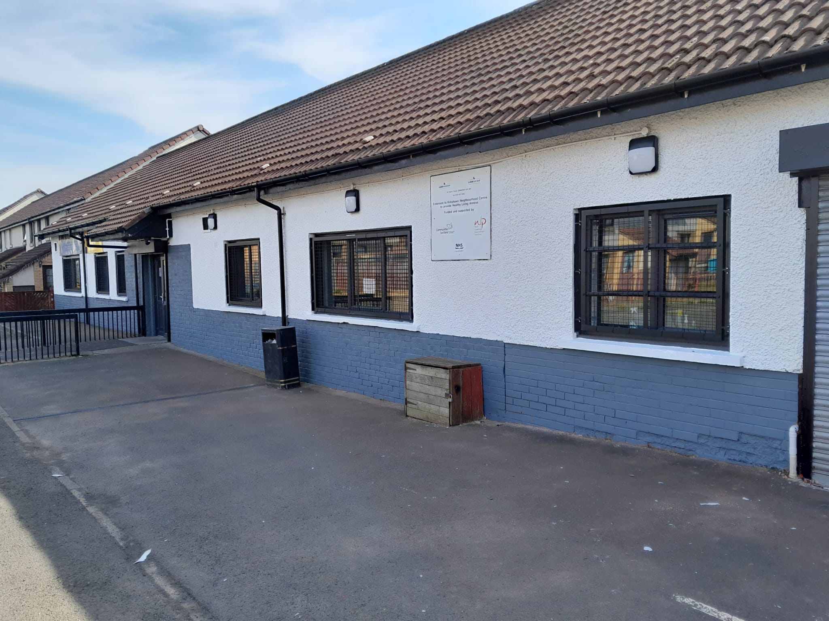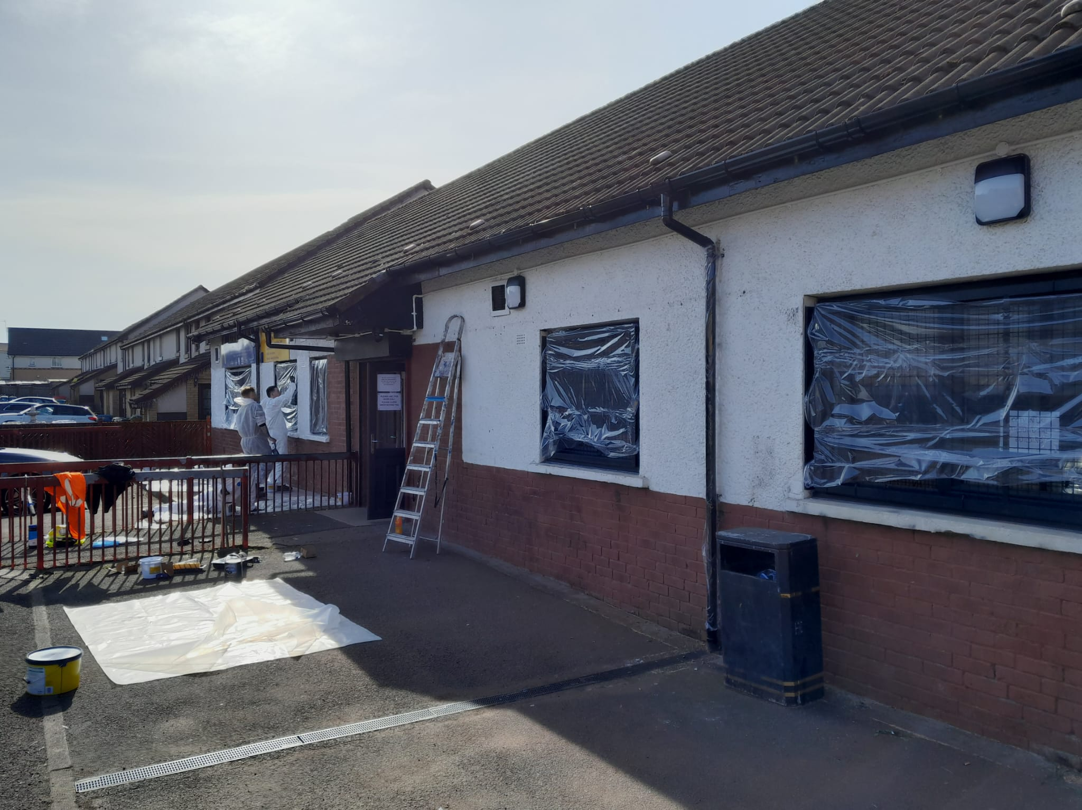

Community partnership delivers a fresh new look for a vital local hub
Kirkshaws Neighbourhood Centre (KNC) is a valued community hub in Coatbridge, providing a welcoming and supportive environment for residents. The centre offers a wide range of services and facilities, including a popular community café, computing courses, meeting spaces, childcare services, a food bank and community fridge. Its work focuses on preventing and relieving poverty and unemployment and advancing citizenship for individuals experiencing disadvantage due to age, ill health, disability, financial hardship or other challenges. KNC is supported through funding from NHS Lanarkshire and North Lanarkshire Council.
Through North Lanarkshire Council's Community Benefits Hub, Kirkshaws Neighbourhood Centre submitted a request for assistance to repaint the exterior of its building. The aim was to improve the appearance of the facility and create a more welcoming environment for the many residents who use its services each week.
CCG, the main contractor delivering the new-build housing development at School Street, Coatbridge, responded to the request as part of its community benefits commitment associated with the project. The company volunteered its time and expertise to support the centre and help enhance an important community asset.

On Friday 11 April 2025, a team of eight CCG employees dedicated their day to preparing and repainting the exterior of the neighbourhood centre. By contributing their professional decorating skills, the team significantly improved the appearance of the building and helped extend the lifespan of the external finish.
The impact of the work was immediately noticeable. The refreshed exterior has enhanced the overall look of the centre, creating a brighter and more inviting space for residents, visitors and service users.
A representative from Kirkshaws Neighbourhood Centre said:
"The building is looking fresher and more inviting to its users and is a more welcoming space."
The project highlights how community benefit initiatives can deliver meaningful improvements to local facilities while strengthening relationships between contractors and the communities in which they work. By responding to requests through the Community Benefits Hub, businesses can make a lasting difference and support organisations that play a vital role in the wellbeing of local people.
The before and after photographs below demonstrate the significant transformation achieved through this collaborative effort.

Community Benefit Delivered
- Organisation supported: Kirkshaws Neighbourhood Centre, Coatbridge
- Contractor: CCG
- Project: School Street New Build Housing Development
- Community benefit activity: Voluntary painting and decorating works
- Date delivered: 11 April 2025
- Employees involved: 8
- Outcome: Refreshed and revitalised exterior, creating a more welcoming environment for community members and visitors.

