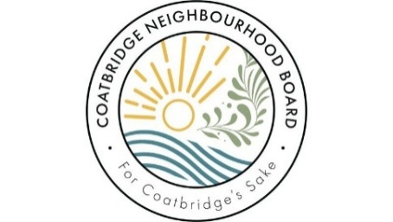 | 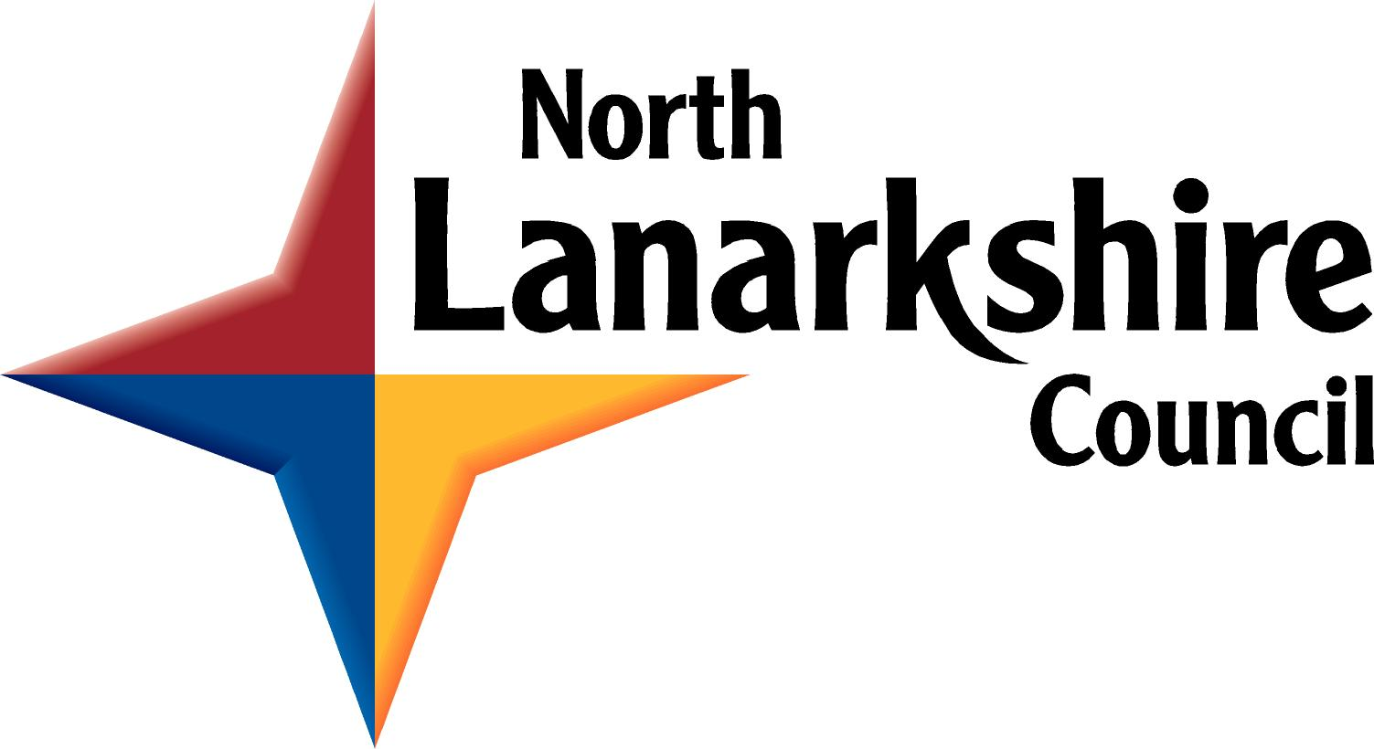 | 
COATBRIDGE NEIGHBOURHOOD BOARD
PROJECT CATALYST FUND 2026-27
Stage 1: Registration of Interest (ROI)
This is a short, first step to help you check whether the Project Catalyst Fund is right for your idea and to help you apply at the right stage of your project. Registering an interest is not competitive. No funding decisions are made at this stage. Feedback and support will be provided.
Section 1: Your organisation’s details
Organisation name:
Contact name and role:
Contact Email address:
Contact Telephone number:
Organisation type: | Choose an item.
Other ( please describe):

Has your organisation completed Community and Voluntary Sector (CVS) Registration with North Lanarkshire Council? |  | Choose an item.
If yes, please provide your CVS Registration Number:
Section 2: Your project idea (briefly)
Working title of your project idea:
(if you have one)
Where is the project located? (e.g. building name, street, neighbourhood, post code)
In no more than 150 words, please tell us about your idea.
What space or place are you thinking about, and what do you hope to improve or explore?
Section 3: Why does this project matter to your group?
In no more than 150 words, please tell us:
- What local issue, opportunity or need your idea aims to respond to
- How local people have been involved so far, or how you plan to involve them
(This can be informal – bullet points are fine.)
Section 4: What stage of the project development journey is your project currently at?
Which option best describes where your project is right now?
Choose an item.
Briefly explain why you chose this option (max 100 words).
Section 5: What support are you seeking?
How do you think funding could help you take the very next step with your project? (e.g. feasibility study, surveys, design work, cost planning, professional advice) Max 100 words
Section 6: Approximate scale of funding
Approximately how much do you think you might need for this next stage? (This is indicative only – it won’t be treated as a final figure.) | Choose an item.
Section 7: Support and accessibility
Would you like any support or adjustments if you are invited to make a full application? (For example, help completing the form or extra time.) | Choose an item.

HOW TO SUBMIT YOUR REGISTRATION OF INTEREST:
Please submit this form by:
5pm on Friday, 23 October 2026
by email to both of the following email addresses:
CommunityEmpowermentNL@northlan.gov.uk
and
coatbridgetownplan@northlan.gov.uk
What happens next?
Once you submit this Registration of Interest we will review it to check fit with the Project Catalyst Fund eligibility criteria.
We may:
- Invite you to submit a full Stage 2 application
- Offer feedback and suggest changes
- Suggest a different stage or next step
- Signpost you to other support or funding
Privacy Statement (Data Protection)
How will your information be used?
1. The data you supply to us is held and processed under the terms of the UKGDPR and the Data Protection Act 2018. The information provided on this form, including personal details, is only used in the processing of your grant application. Your information will not be used for any other purpose and will only be shared with other organisations in the circumstances detailed in paragraph 3 below. It is not used for profiling or for automated decisions.
2. What personal details will be held?
In processing your grant application, we may hold any of the following personal information on the individuals identified within the form and any other individual subsequently identified as assisting in the grant process (e.g. an admin worker):
- Name
- Address
- Telephone numbers (home and work)
- Mobile phone numbers
- Email addresses
- Position within the organisation
3. Who will have access to your information?
This information may be provided to individuals or other sections within the Council and partner organisations that are helping us assess applications or monitor grant awards.
This information may also be shared with other grant funders and partner agencies to help prevent fraudulent applications and co-ordinate the process of complementary applications.
4. How long will we keep your information?
Information on individual grant applicant signatories and any other organisational contacts provided is held both in paper form and electronically on computer for up to seven years.
5. Lawful basis for having your information.
The basis on which the Council holds and processes personal information in relation to grant applications and subsequent grant awards is that of Legal Obligation i.e. the data held is necessary in the administration and processing of the grant applications.
6. Your legal rights regarding this information.
Individuals have the legal right to know and manage the personal data we hold, and you have the following rights in terms of this data: -
- The right to know what data we hold on you personally
- The right to have this information updated or amended
- The right to have this information deleted – although this right is limited by our need to retain information on who received grants.
7. Who to contact if you wish to update your information
If you wish to update your information, retrieve it or have it removed from our records you should send an e-mail detailing your request to: CommunityEmpowermentNL@northlan.gov.uk
If you are dis-satisfied with how your request to update, retrieve or have your information removed has been handled by the Council, you may raise a complaint using the Council’s complaints procedures. Details of how to do so are on the Council's website www.northlanarkshire.gov.uk
The Council’s response to your complaint will involve the input of the Council’s Corporate Data Protection Officer, its Head of Business for Legal & Democratic Solutions. If you are dis-satisfied with the outcome of your complaint, you can raise the matter with the Information Commissioner’s Office, who can be contacted at casework@ico.org.uk
Your signature on this form is treated as confirmation that you understand how North Lanarkshire Council may use the information you have supplied to us under the terms of the UKGDPR and the Data Protection Act 2018. If information about this grant application is requested under the Freedom of Information Act, we will release it in line with our Freedom of Information Policy.

